[API Security]

1. A screenshot of a computer

   Description automatically generated[1 point] Capture your Postman screen to show that you logged out successfully. An example is in Slide#12.
2. [1 point] Capture your Postman screen to show that you prevent SQL injection successfully. An example is in Slide#16.

1. A screenshot of a computer

   Description automatically generated[1 point] Capture your Postman screen to show that you apply Helmet successfully. An example is in Slide#19.
2. [1 point] Capture your Postman screen to show that you prevent XSS successfully. An example is in Slide#23.

1. 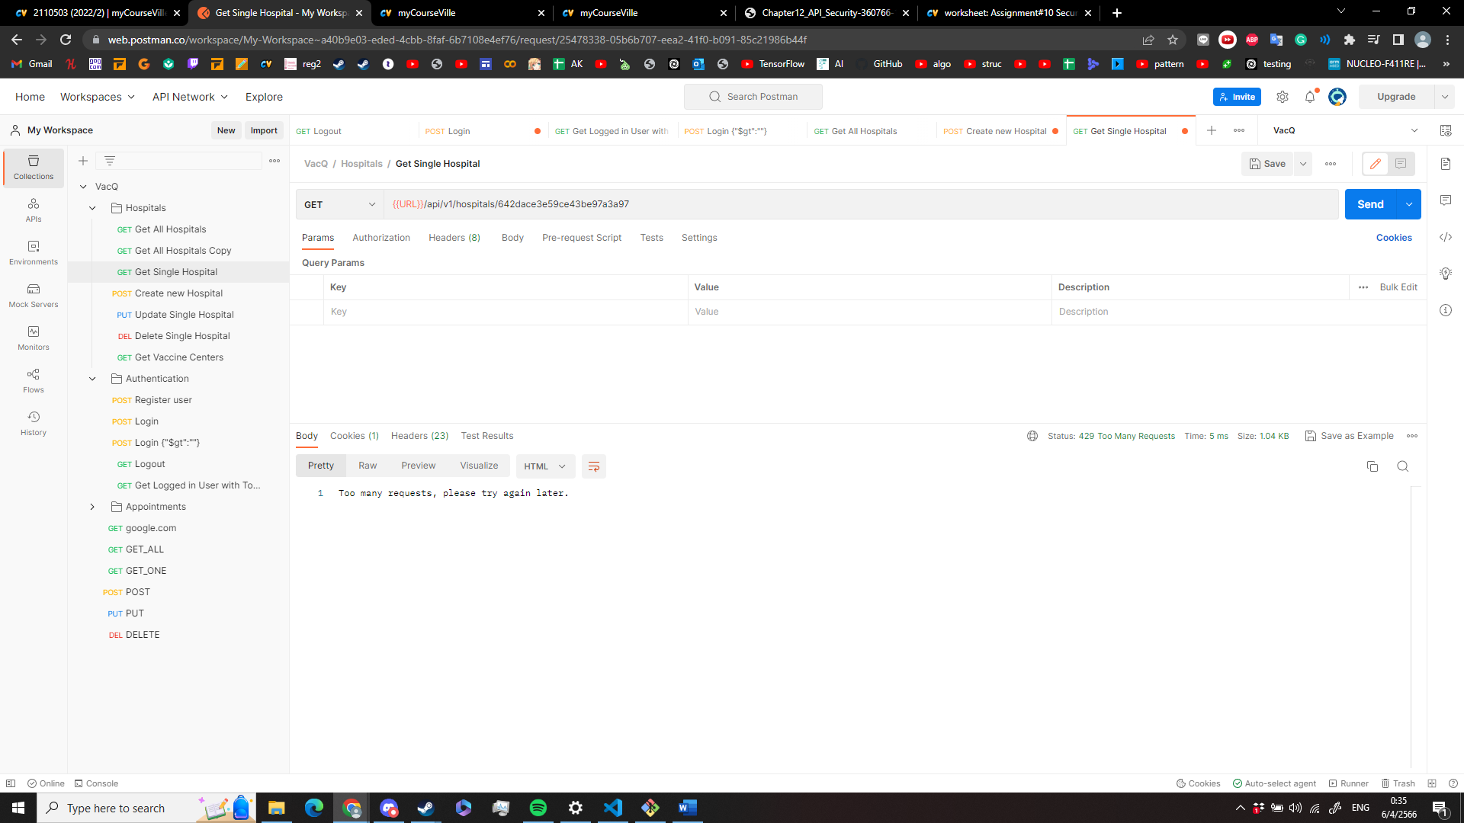[1 point] Capture your Postman screen to show that you apply Express-rate-limit successfully. An example is in Slide#26

[Open API]

1. A screenshot of a computer

   Description automatically generated[1 point] Capture your Swagger Hub screen to show that you create a API using "Petstore" template successfully. An example is in Slide#10.
2. [3 points] Capture your Api-docs screen to show that you add the following items:
   1. Hospital tag

* 1. A screenshot of a computer

     Description automatically generatedget all hospitals
  2. get one hospital

* 1. add one hospital

* 1. update the hospital

* 1. delete the hospital   
     to your OpenAPI document successfully. An example is in Slide#33.

1. [1 point] Capture your Api-docs screen to show that you add the server url to your OpenAPI document successfully. Also show that you can excute the get-all-hospitals API using your Api-Docs. An example is in Slide#35 and 37.

