1. [2 points] Capture your browser screen to show that you can successfully sign up for a Heroku account. An example is in Slide#14.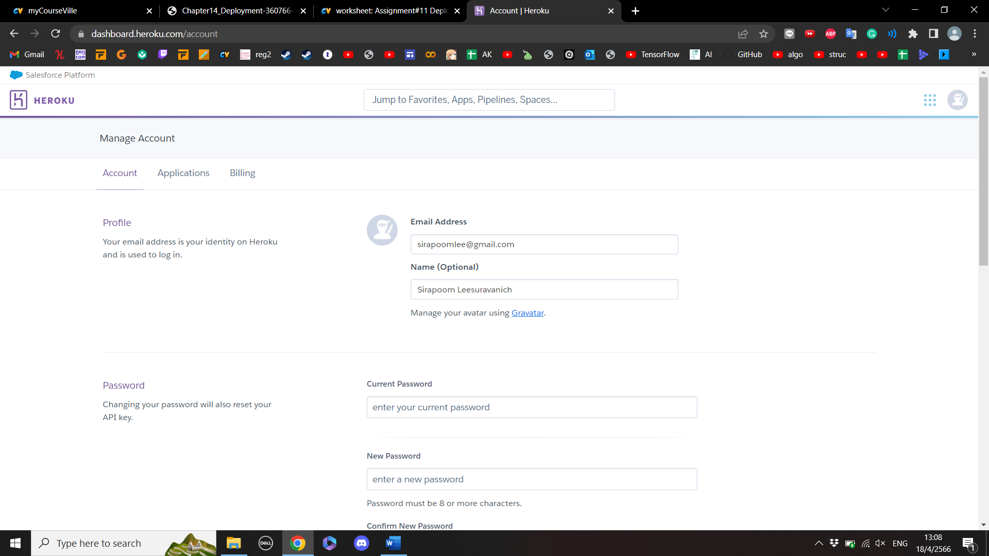
2. [2 points] Capture your terminal screen to show that you can successfully "cdk bootstrap" the AWS account by following Slide#60.Text

   Description automatically generated
3. [2 points] Capture your AWS CloudFormation Console to show that you can successfully deploy your web application. An example is in Slide#65.A screenshot of a computer

   Description automatically generated
4. 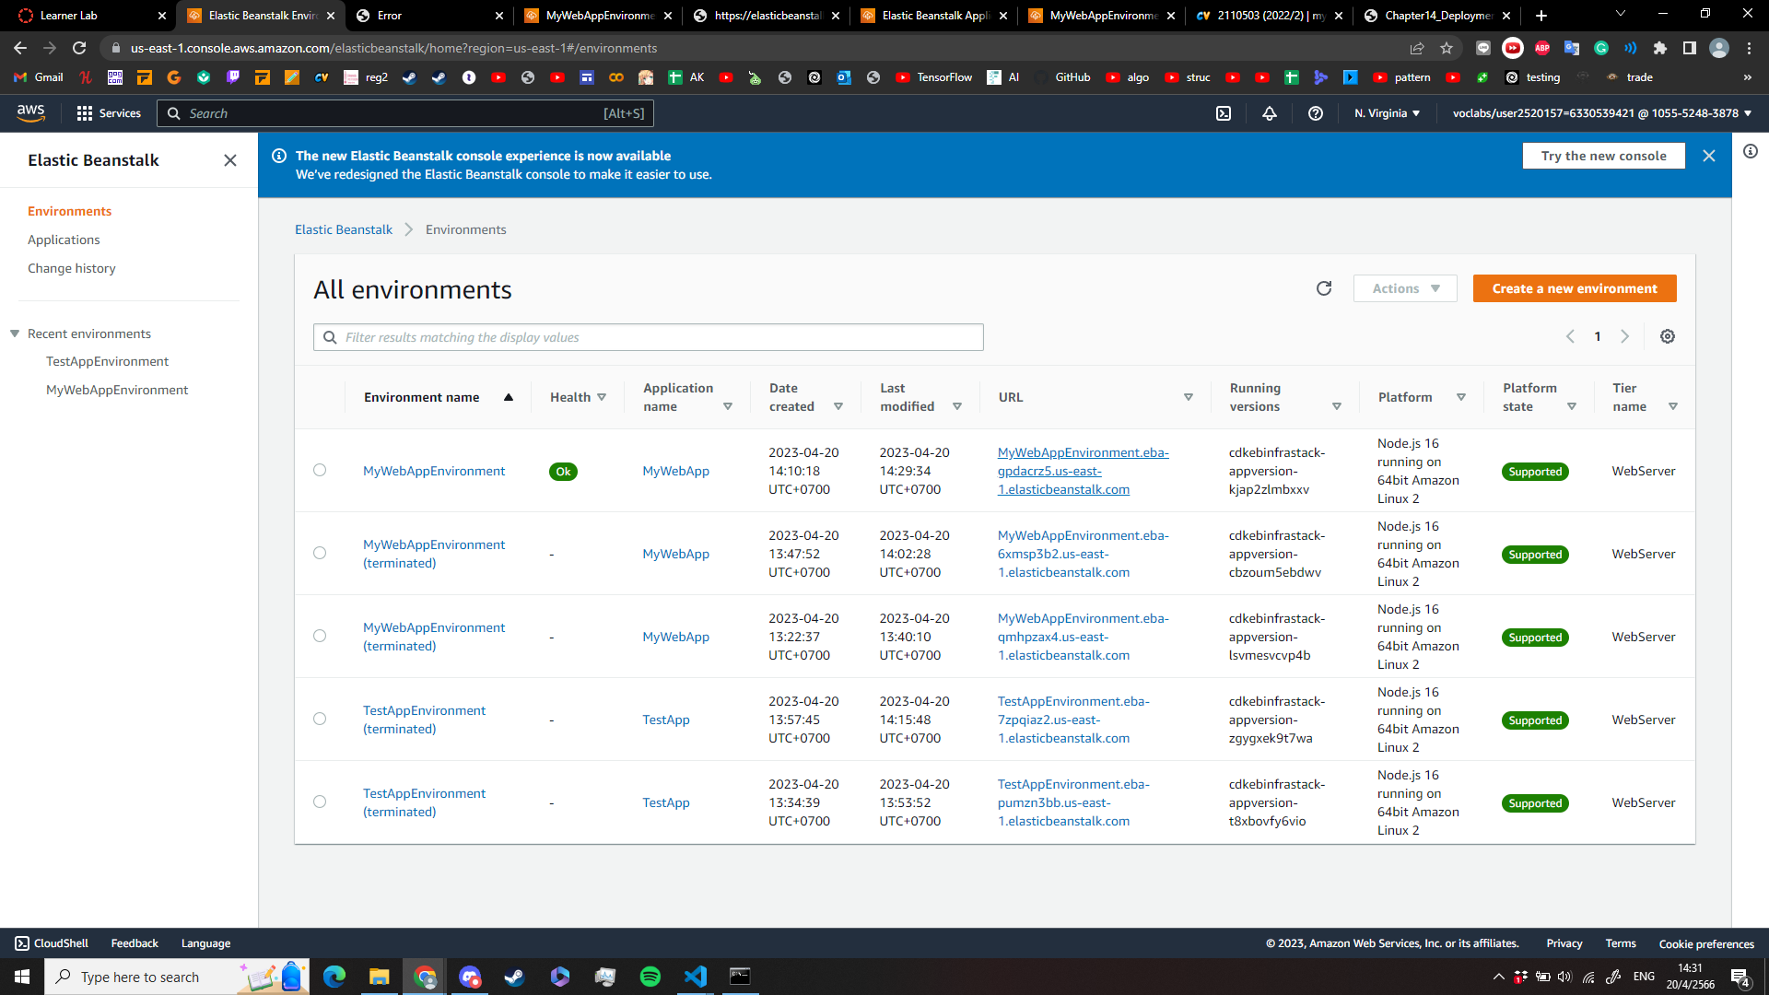[2 points] Capture your Elastic Beanstalk > Environments console to show that you can successfully deploy your web application. An example is in Slide#66.

[2 points] Capture your browser screen to show that you can successfully call the "Get All Hospitals" API from AWS Elastic Beanstalk. An example is in Slide#67.

