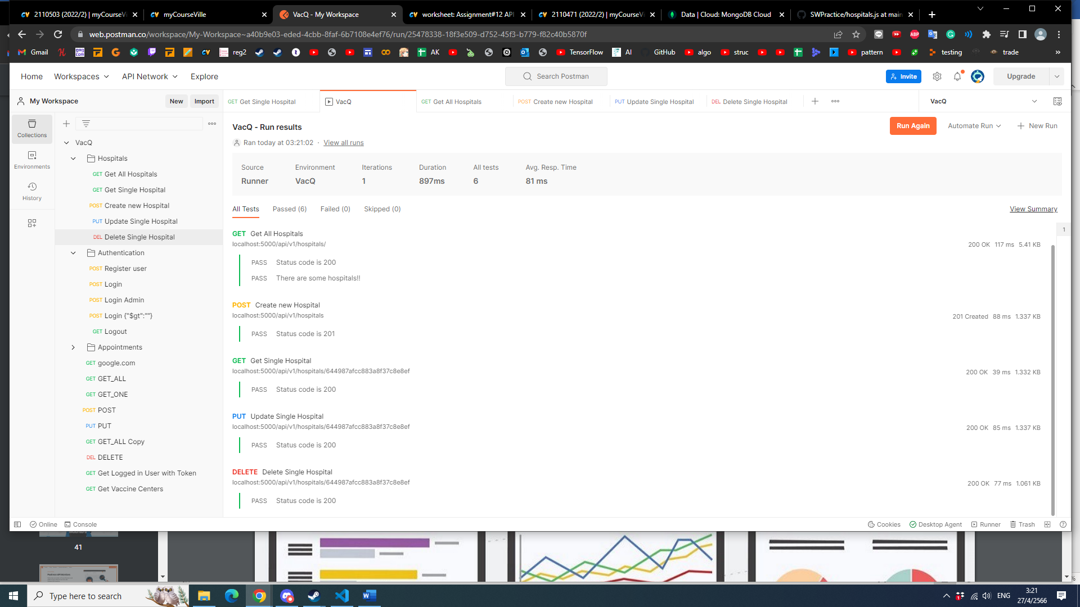 [3 points] Capture your Postman screen to show that you can successfully use Runner to run Hospitals Api Collection. An example is in Slide#33 or #40.

[3 points] Capture your Postmam screen to show that you can successfully use Monitor to run Hospitals Api Collection. An example is in Slide#52.

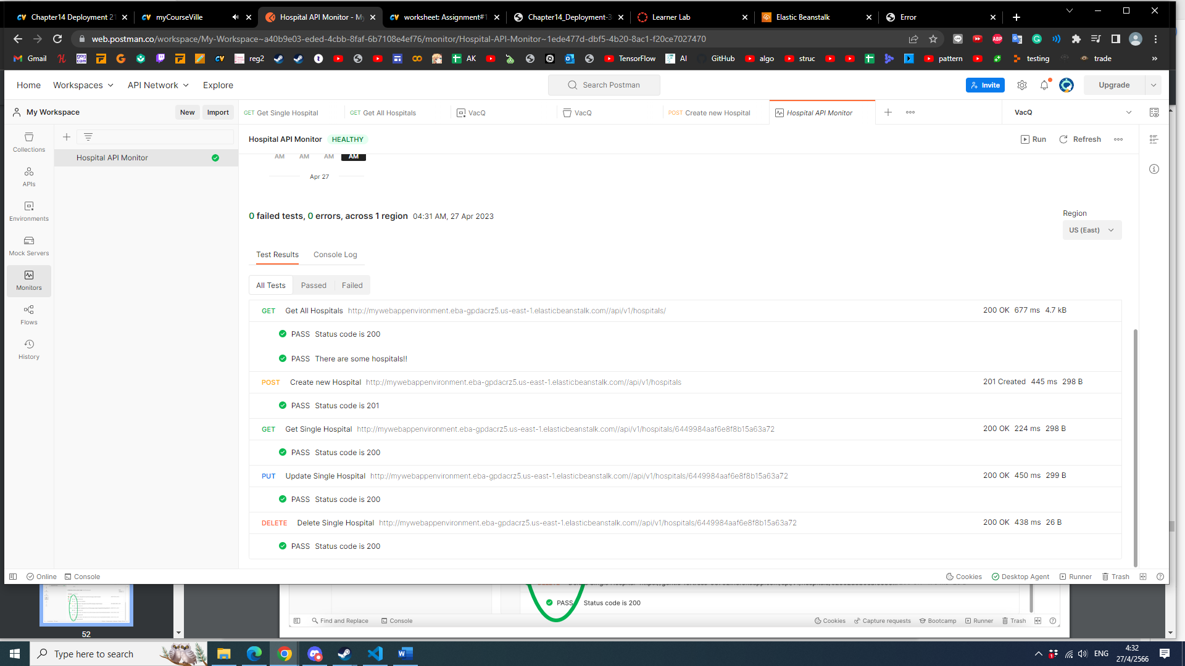

[2 points] Capture your VS code terminal screen to show that you can successfully use Newman to monitor your Hospitals Api. An example is in Slide#57.

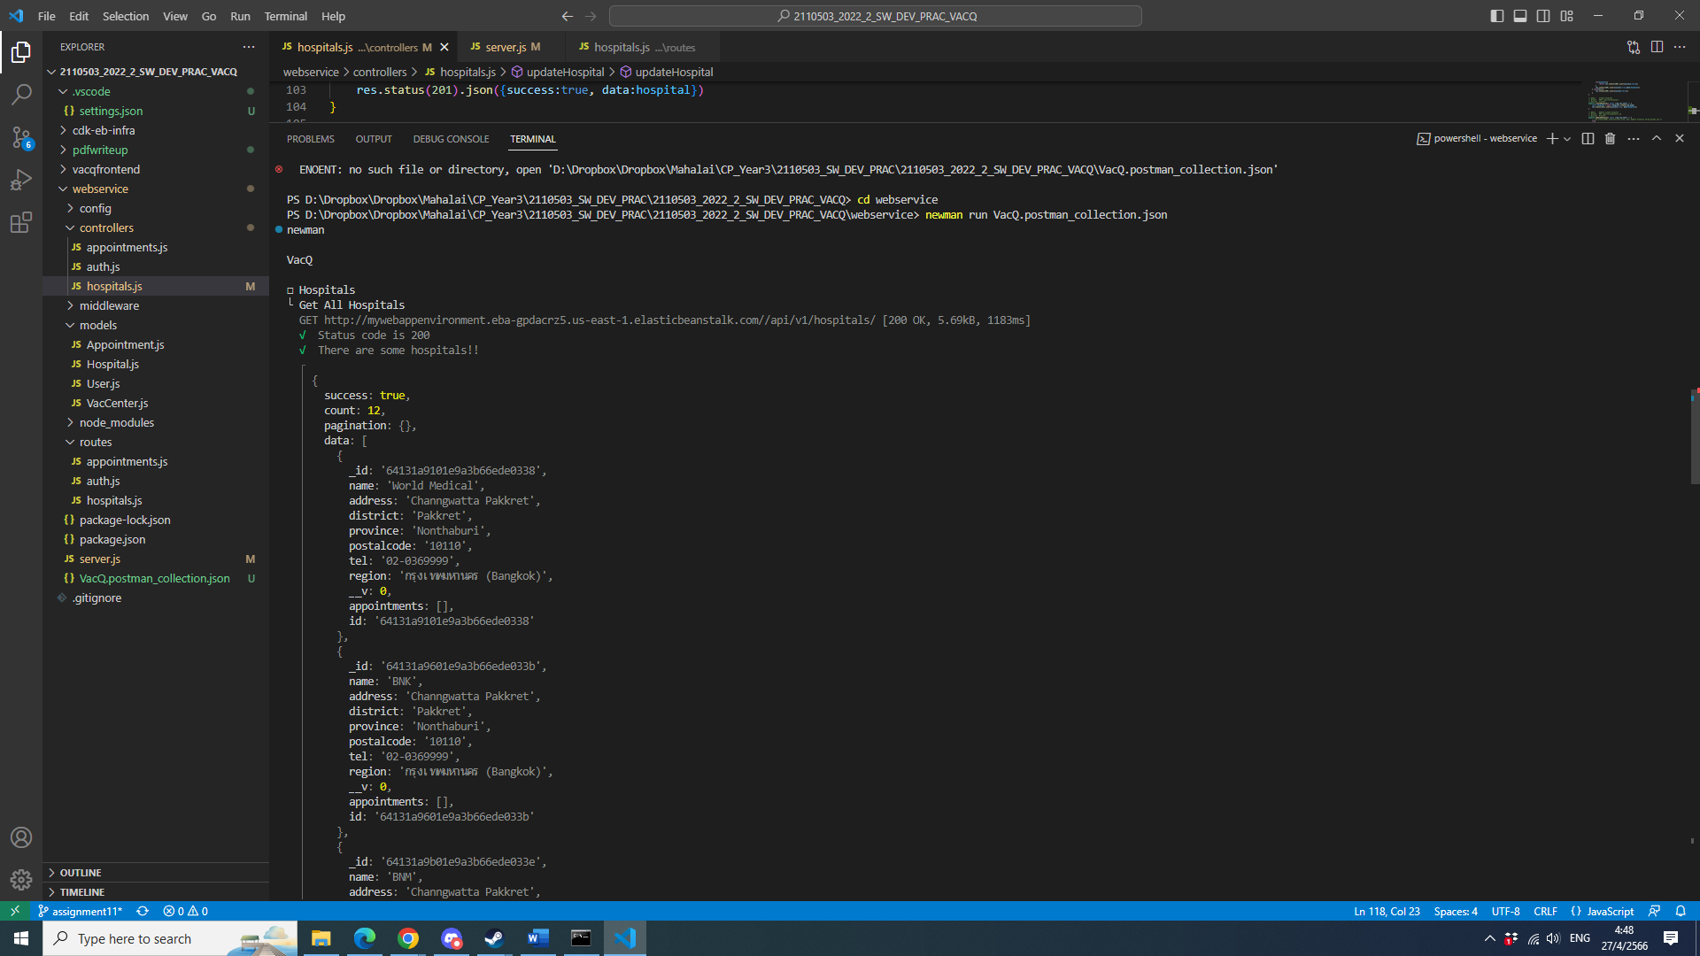

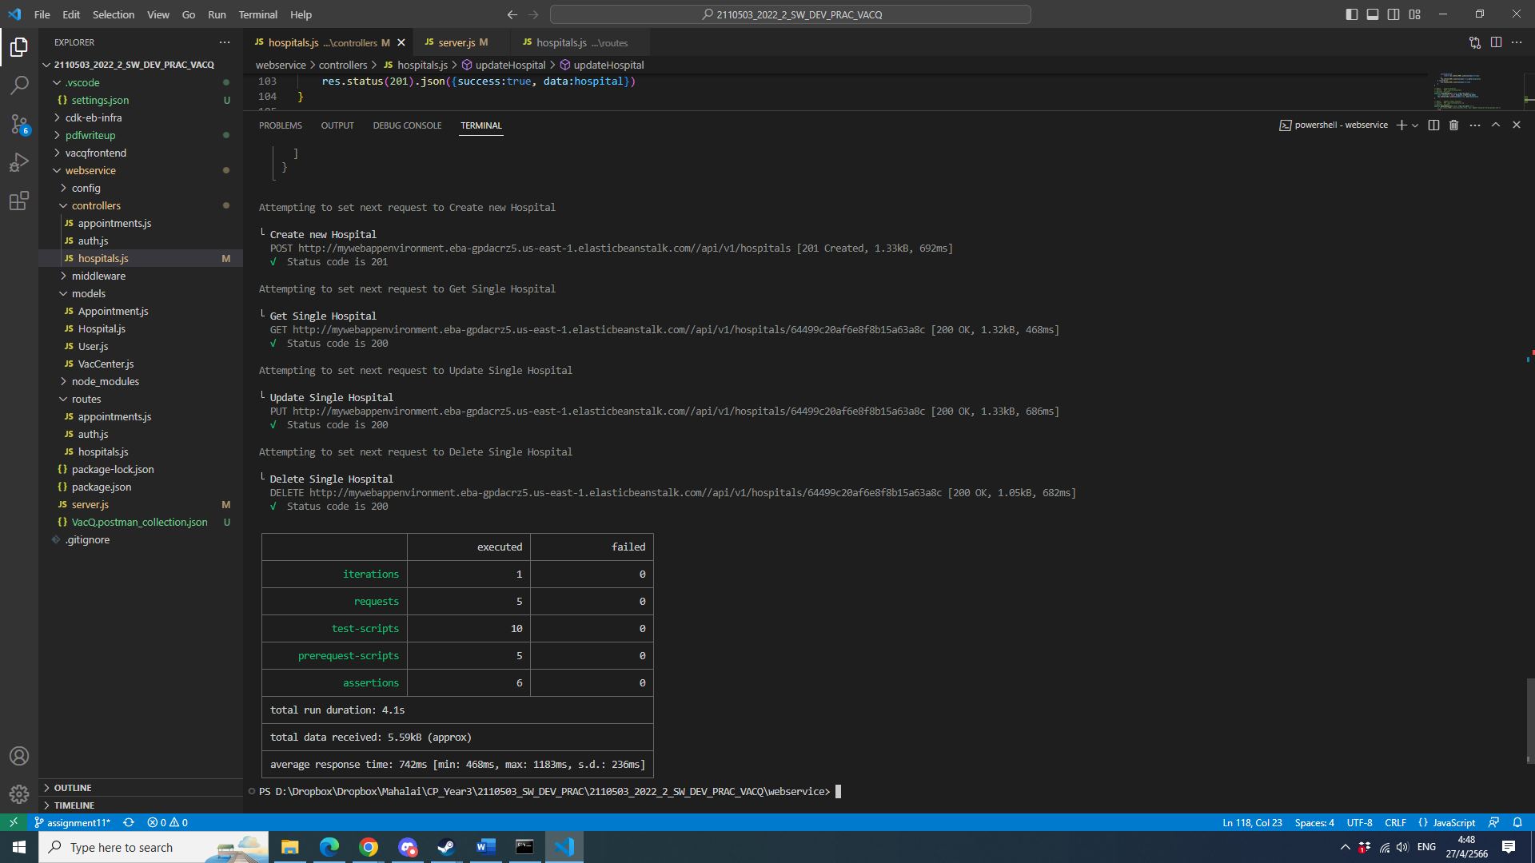

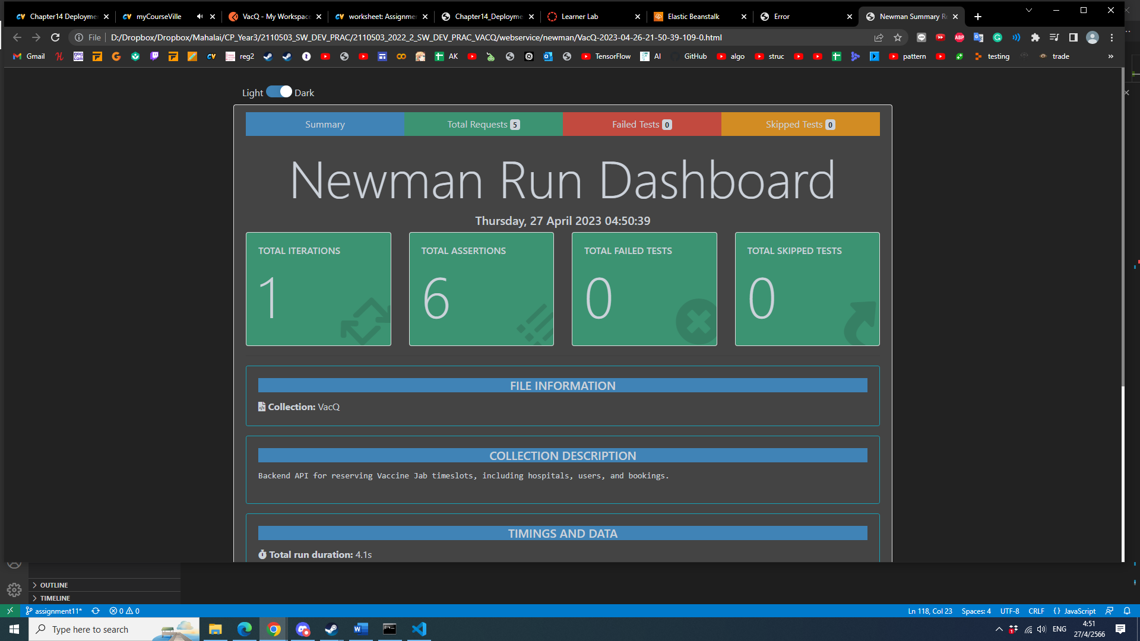[2 points] Capture your browser screen to show that you can successfully use Newman-report-htmlextra to create Hospitals Api monitoring report. An example is in Slide#61.