**1**

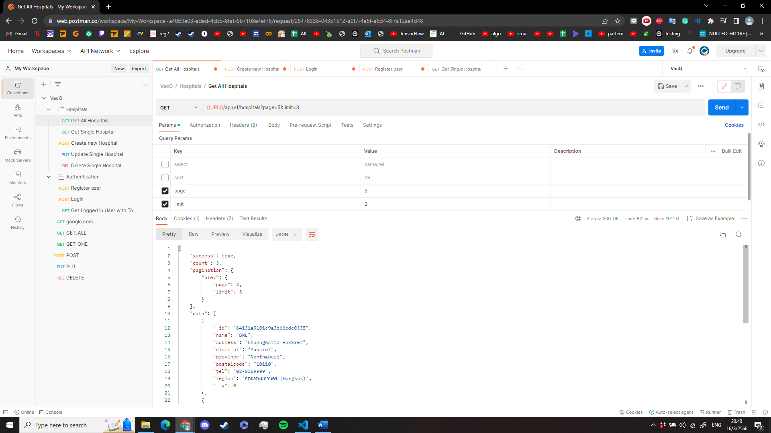**2**

**3**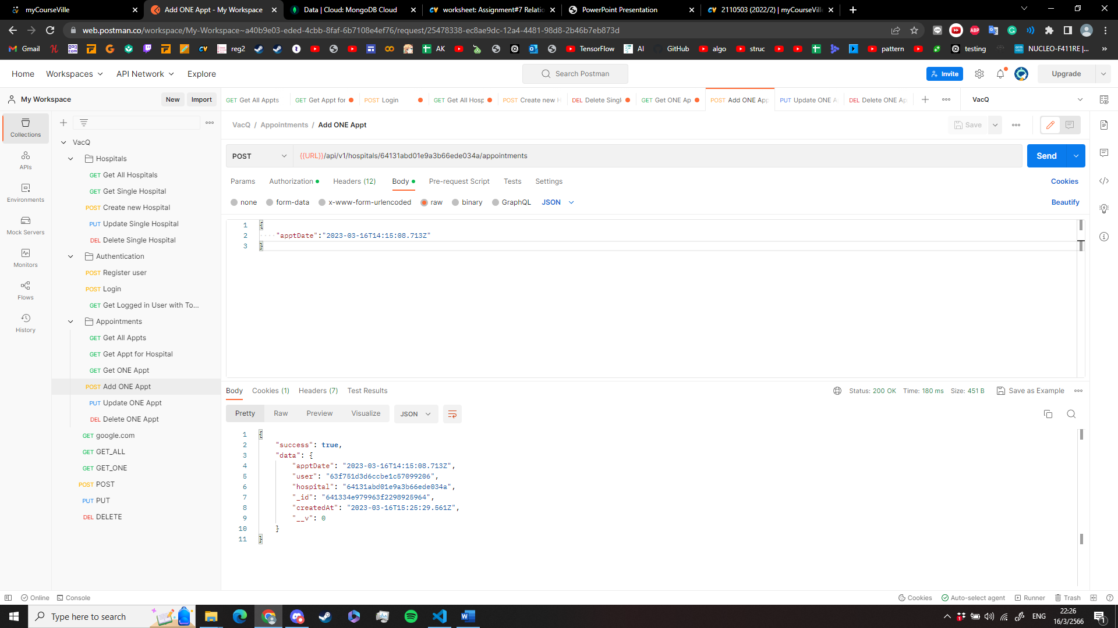

****5**

**6**

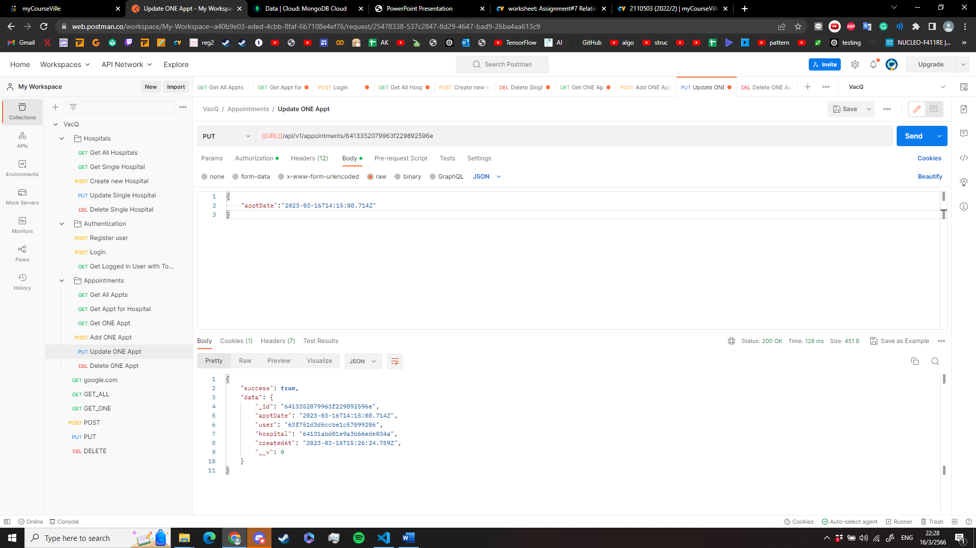**7**

**8**