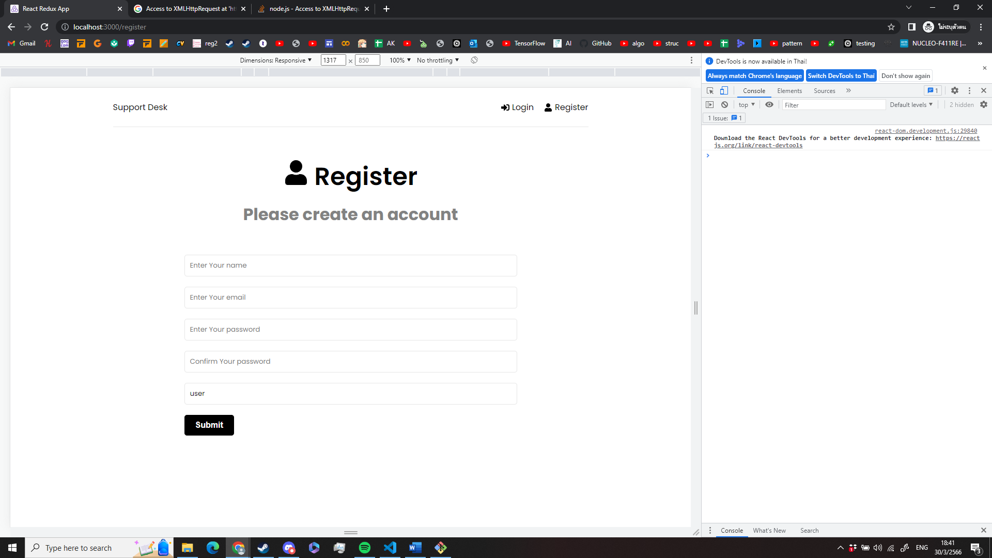3

4

