**Hotel Information**

Use Case Overview

Use Case Diagram Level 0 : Hotel Information

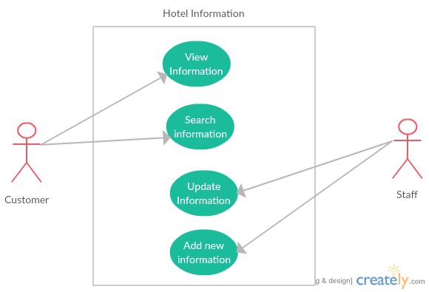

Use Case Diagram Level 1 : View Information

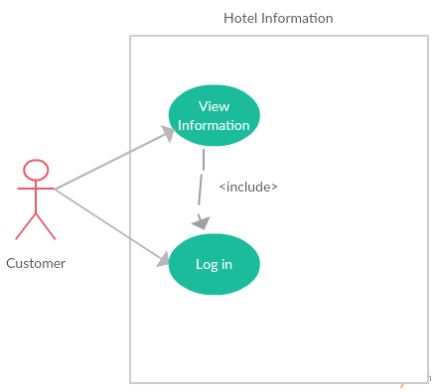

Use Case Diagram Level 1 : Search information

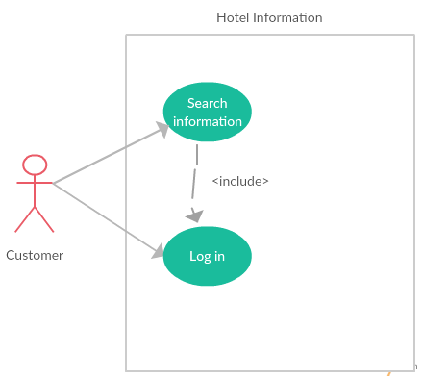

Use Case Diagram Level 1 : Update Information

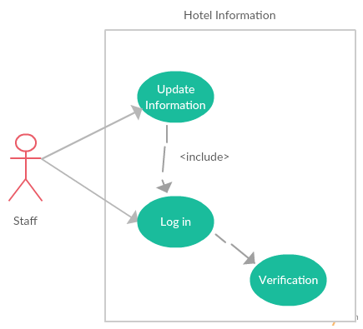

Use Case Diagram Level 1 : Add new information

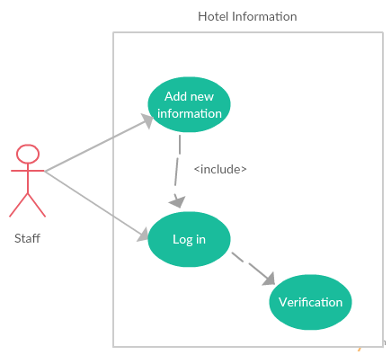

Static Structure and Data Analysis

View Information



Search Information



Update Information



Add new information



System Behavior Model

Sequence Diagram demonstrating operation “View Information”



Sequence Diagram demonstrating operation “Search Information”



Sequence Diagram demonstrating operation “Update Information”



Sequence Diagram demonstrating operation “Add new Information”

