**Use Case Diagram Level 1: Setting management**

use case

**1. Setting management**

**1.1 Set Daily**

**s1**

**1.2 Set Monthly**

**s2**

**1.3 User settings**

**s3**

**1.4 The previous user**

**s4**

**1. Setting management**

1.1 Set Daily

cs1

1.2 Set Monthly

cs2

1.3 User settings

cs3

1.4 The previous user

cs4

1. **Revision History**
2. **Use Case Overview**

use case.png

Use Case Diagram Level 1: Setting management

ตั้งค่า.png

Use Case Diagram Level 1: Report management

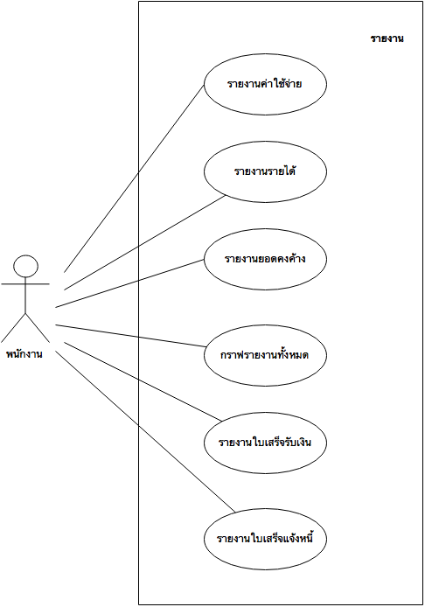

1. **System Structure**

**4. Static Structure and Data Analysis**

**5. System Behaviour Model**