

Management Apartment System
Apartment System

Version 1.1

Prepare by

Sirasit Molee Project Manager
Chutima Chaisena
Narawit Kaewbun
Siranee Buengbua
Panyawat Raksawong
Rachaneewan kachinrot

31/October/2016

Table of Contents
1. Revision History………………………………………………………………………………………………………………..…………………....1
2. Use Case Overview……………………….……………………………………………………………………………………………………...…1
Use Case Diagram Level 0: Management Apartment System …………………………..……...…….…..1
Use Case Diagram Level 1: Setting Management ……………………………………………...………….….…….2
Use Case Diagram Level 1: Report Management …………………….……………………………………….....…2
Use Case Diagram Level 1: Management Daily ………………………………………………………………..….….3
Use Case Diagram Level 1: Management Monthly ……………………………………………………….….……..3
Use Case Diagram Level 1: Customer Management System ………………………………..….…….……..4
Use Case Diagram Level 1: Apartment Data ………………………………………..…………..…………..…….4
Use Case Diagram Level 1: Booking Management System ………………….…………………….………….9
3. System Structure……………………………………………………………………………………………………..………………………………..5
4. Static Structure and Data Analysis…………………………………………………………………………………….……………………6
4.1 Model-View-Controller (MVC) Model……………………………………………………………………..…………….………6
4.1.1 Setting Management ………………………………………………………………………….…….……..………….……..6
4.1.2 Report Management ……………………………………………………………………………………………………….…..8
4.1.3 Management Daily ……………………………………………………………………………………………………….……10
4.1.4 Management Monthly ………………………………………………………………………..……………………….……12
4.1.5 Customer Management System ……………………………………………………….…………………….….……14
4.1.6 Apartment Data …………………………………………………….………………………………………………..…….….16
4.1.7 Booking Management System ………………….………………….……………………………………….…….….16
4.2 Entity Class Model………………………………………………………………………………………………………….……….………….18
4.2.1 Management Apartment System ………………………………..………………………….…….……….……….18
1. Setting Management …………………………………….……………….….….……………….…..……………..6
2. Report Management …………………………………………………….….…………………………………….…..8
3. Management Daily …………………………….…………………………………………………………….….……10
4. Management Monthly …………………………………………………….…..……………………….…….……12
5. Customer Management System ………………….…………………………………………………….….…14
6. Apartment Data …………….….……………………….……………………………….………………..….….….16
7. Booking Management System ……………………………….….…………..…………….…………….….16
5. System Behavior Model………………………………………………………………………………………………..…….………..…….22
1. Setting Management …………………………………………………………..………………….….……...…………………..6
2. Report Management …………………………………………………………….……….…………………………………….…..8
3. Management Daily …………………………………………………………………………………………………………….……10
4. Management Monthly ………………………………………………………………………..…..……………………….……12
5. Customer Management System ……………………………………………….………………………………….….……14
6. Apartment Data …………………………………………………….……………………………….…….……………..…….….16
7. Booking Management System ………………………………………………..…………………..…………….…….….16

1.Revision History
Revision History identify changes to the Design Document
Name | Date | Description | Version
Apartment system | 31/09/2559 | Make to Apartment System | Apartment Management

2. Use Case Overview

Use Case Diagram Level 0: Management Apartment System

Use Case Diagram Level 1: Setting management

Use Case Diagram Level 1: Report management

Use Case Diagram Level 1: Management daily

Use Case Diagram Level1 : Management monthly

Use Case Diagram Level 1 : Customer Management System

Customer Management Sub - System
Insert Customer
Update Customer
Delete Customer
Report Customer

Customer Service
Staff

3.System Structure
This should use structure chart to express the breakdown of the system to the lowest
manageable levels. It is used to show the hierarchical arrangement of the subsystems in a
system. Each rectangular box represents a subsystems. The names of the subsystems are written
inside the box. An arrow joins two subsystems that have an invocation relationship.

4. Static Structure and Data Analysis
4.1 Model-View-Controller (MVC) Model

1. Setting management
1.1 Set Daily

1.2 Set Monthly

1.3 User settings

1.4 The previous user

2. Report management
2.1 Expense Report

2.2 Earnings Reports

2.3 Outstanding reports

2.4 Report receipts

3. Management daily

3.1Check in

3.2 Check out

3.3 Search room

3.4 Select data customer

4. Management monthly

4.1Check in

4.2 Check Out

4.3 Covenant rent

4.4 Select customer data

5 Customer Management System

5.1 Insert Customer

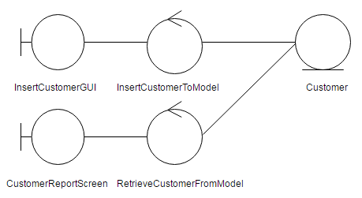

5.2 Update Customer

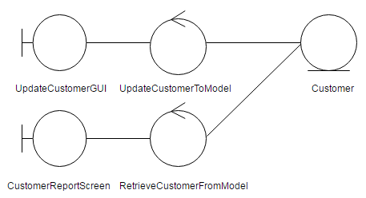

5.3 Delete Customer

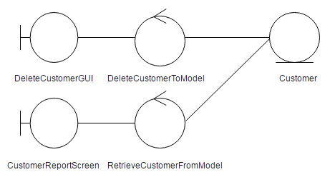

5.4 Report Customer
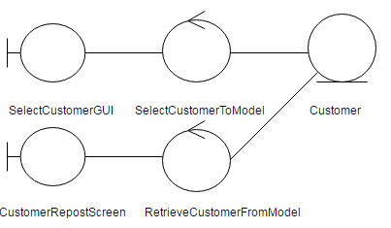

4.2 Entity Class Model

5. System Behavior Model
1. Setting management

1.1 Set Daily

1.2 Set Monthly

1.3 User settings

1.4 The previous user

2. Report management

2.1 Expense Report

2.2 Earnings Reports

2.3 Outstanding reports

2.4 Report receipts

3. Management daily
3.1 Check in

3.2 Check out

3.3 Search room

3.4 Select data customer

4. Management monthly

4.1 Check in

4.2 Check out

4.3 Select data customer

5 Customer Management System

5.1 Sequence Diagram demonstrating operation “add new customer”
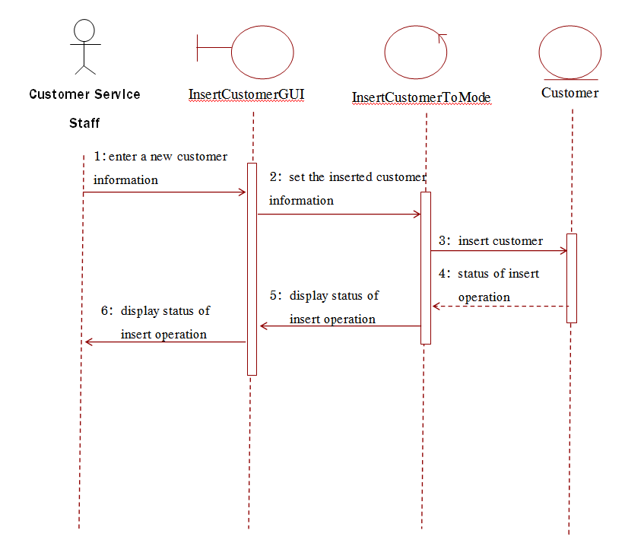

5.2 Sequence Diagram demonstrating operation “Update customer”

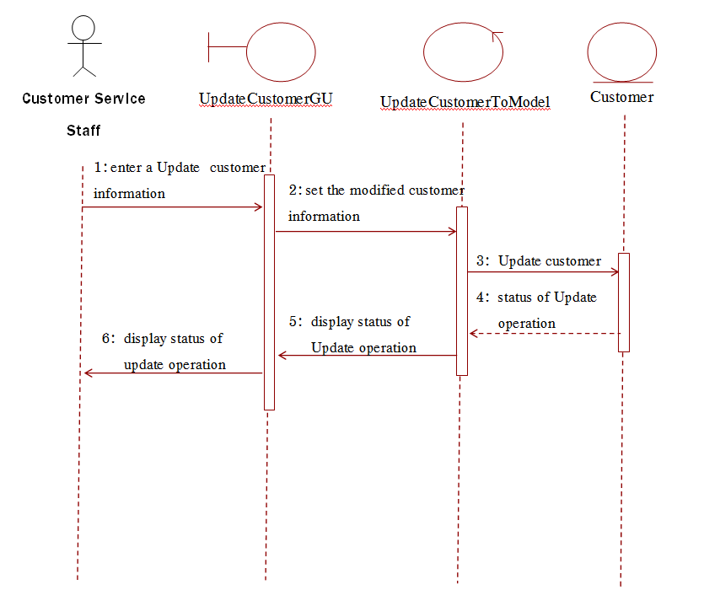

5.3Sequence Diagram demonstrating operation “delete customer”

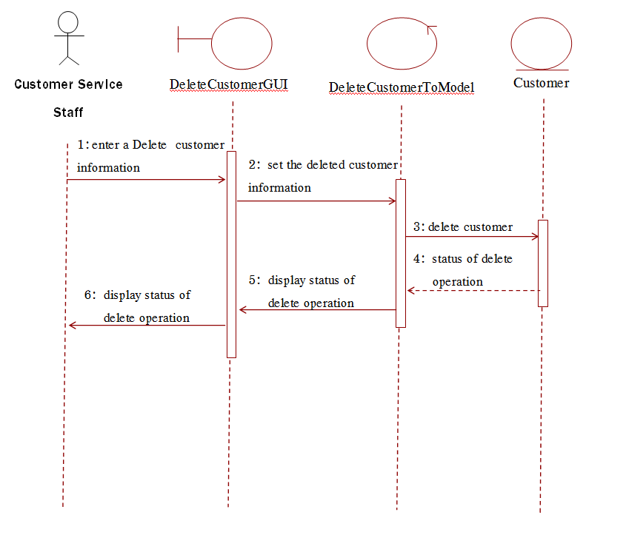

5.4 Sequence Diagram demonstrating operation “Report customer”

