**API Name** : http://localhost:3000/delete-Color/3

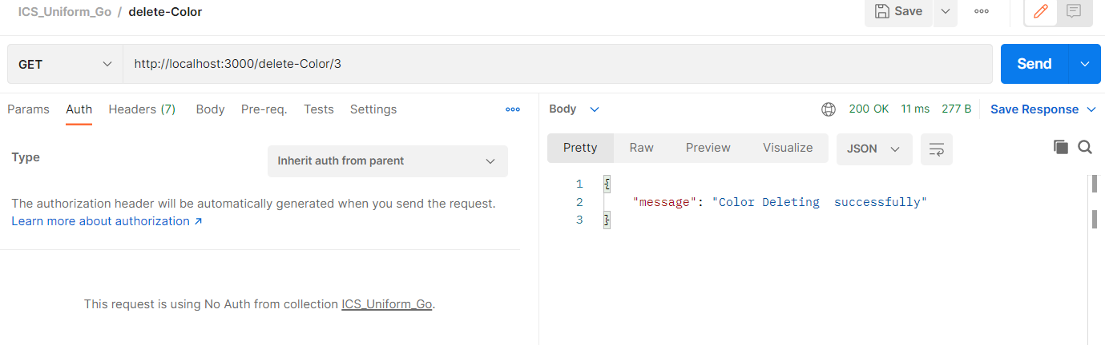

API Name : http://localhost:3000/delete-Figure/3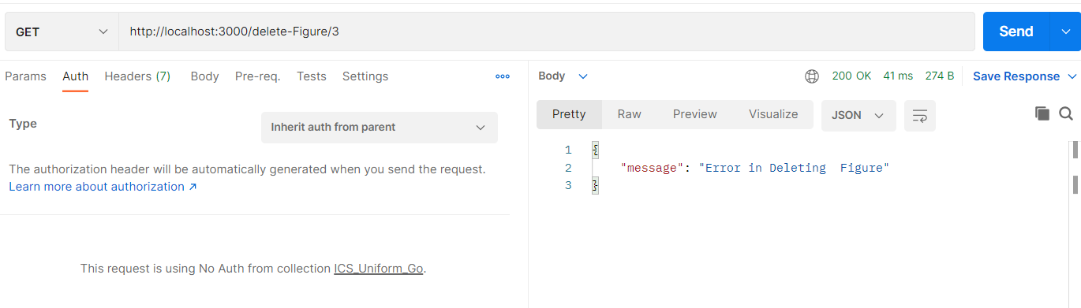

API Name : <http://localhost:3000/delete-Pattern/6>

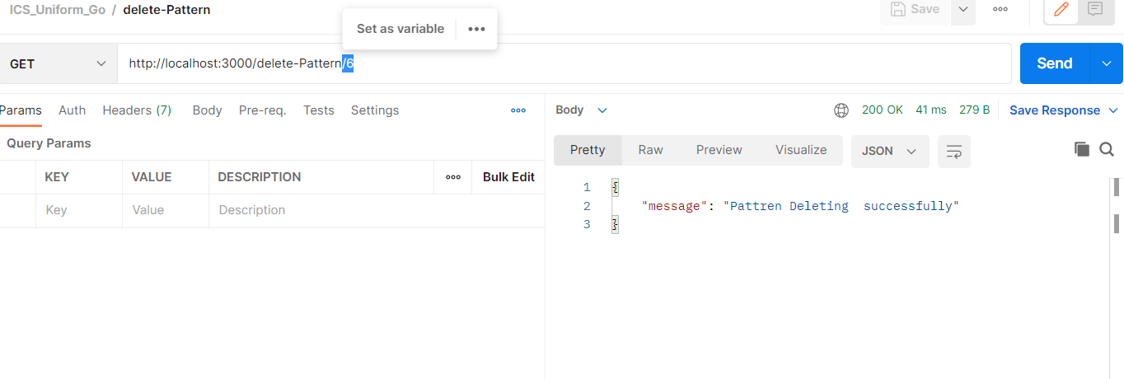

API Name : [http://localhost:3000/delete-Product/6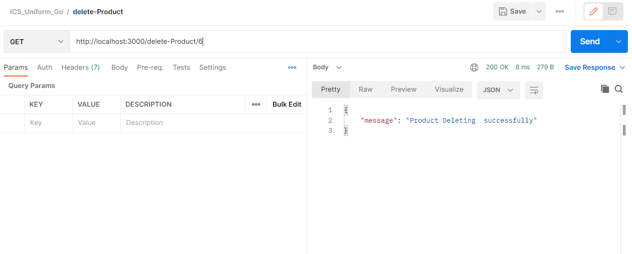](http://localhost:3000/delete-Product/6#)

API Name : <http://localhost:3000/delete-ProductList/5>

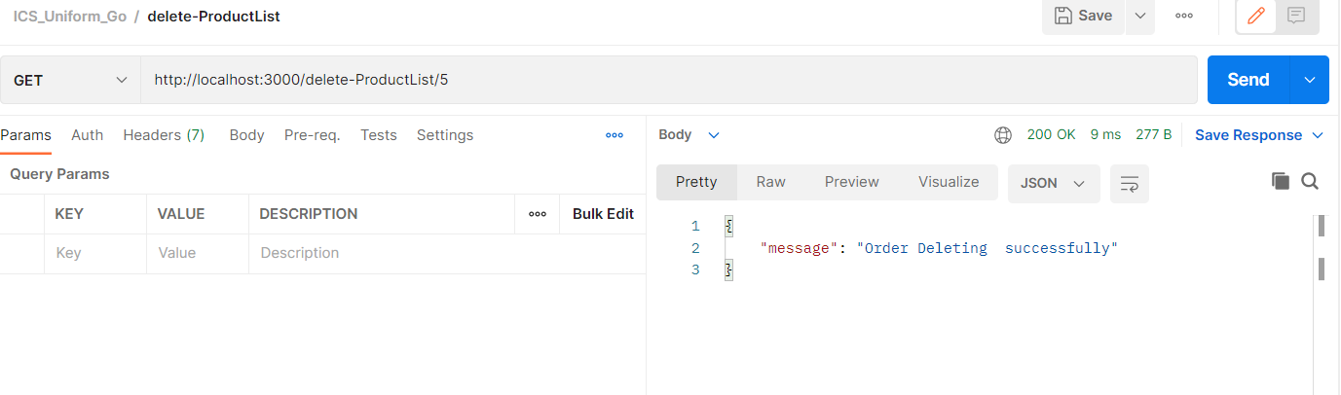

API Name : <http://localhost:3000/delete-Order/2>

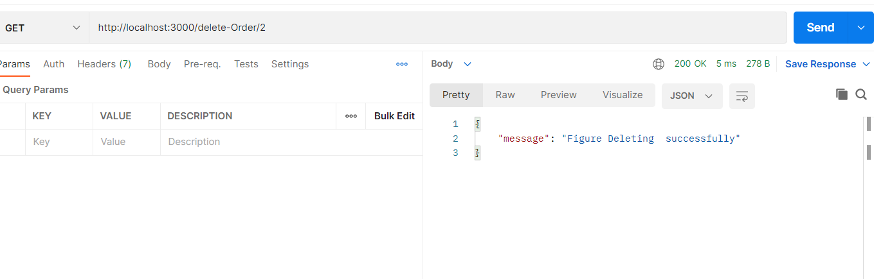

API Name : <http://localhost:3000/delete-OrderDetail/2>

