**API Name** : <http://localhost:3000/select-Color>

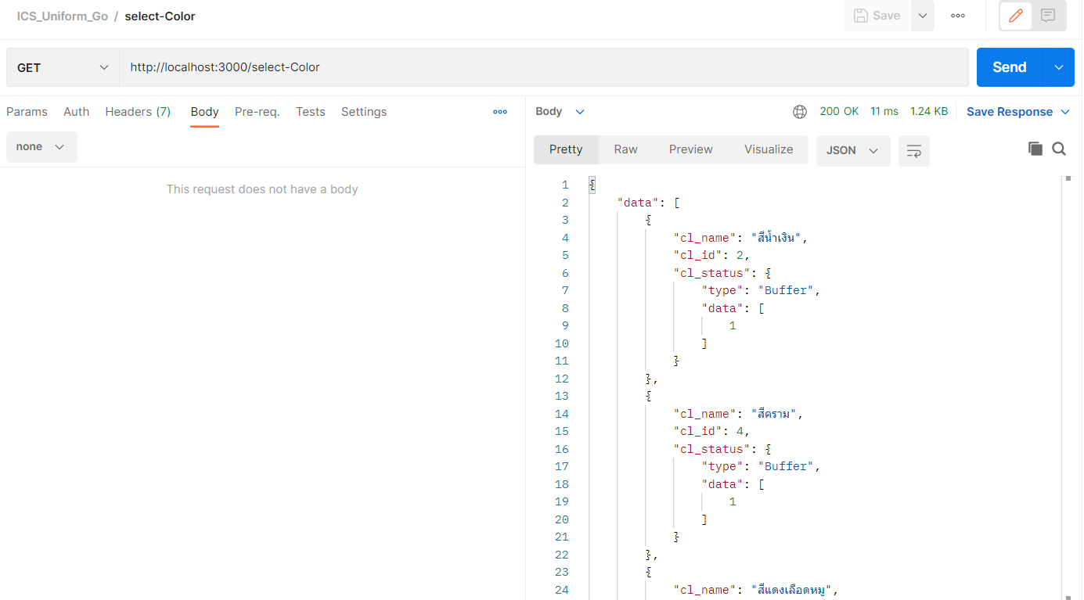

**API Name** : http://localhost:3000/select-Figure

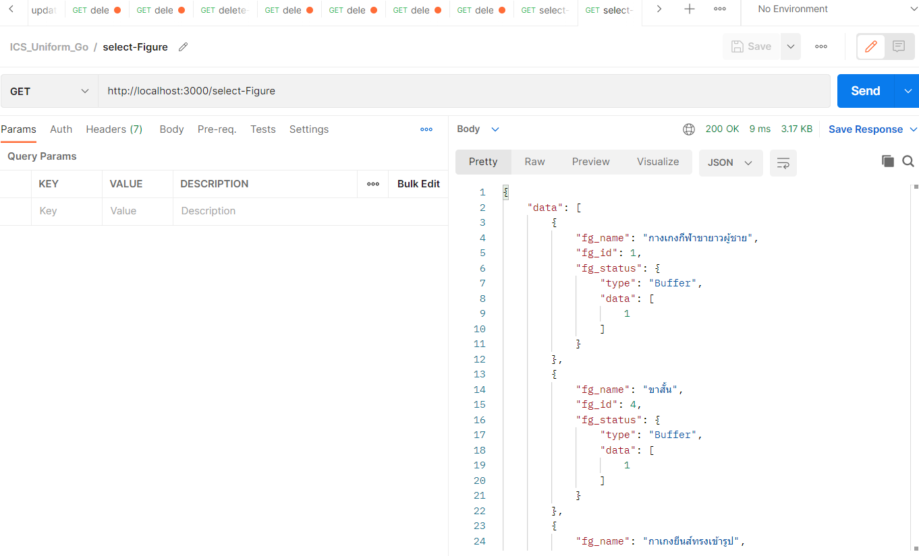

**API Name** : <http://localhost:3000/select-Pattern>

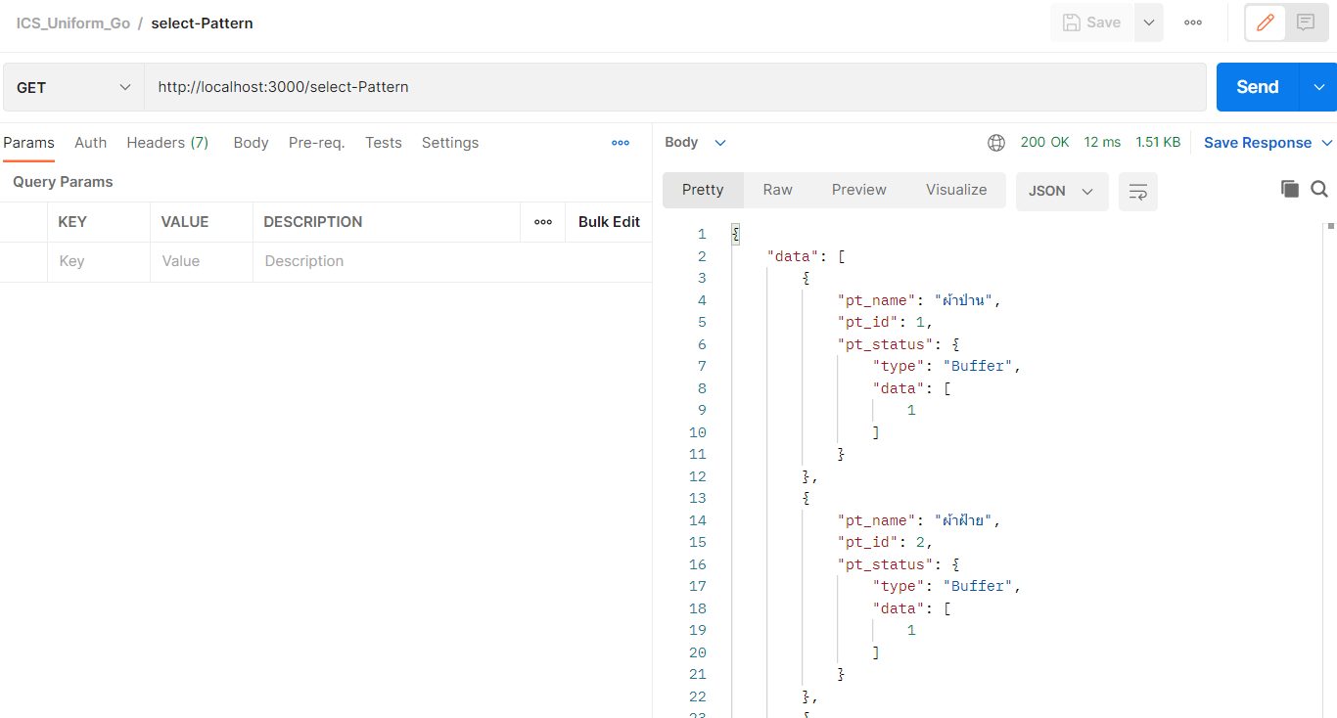

**API Name** : http://localhost:3000/select-Productlist

**Request Parameter Data**

{

    "gd_name":"หญิง",

    "cl_name":"",

    "pt_name":"",

    "fg_name":"",

    "sz_name":"",

    "pageon": 2,

    "pagesize":3

}

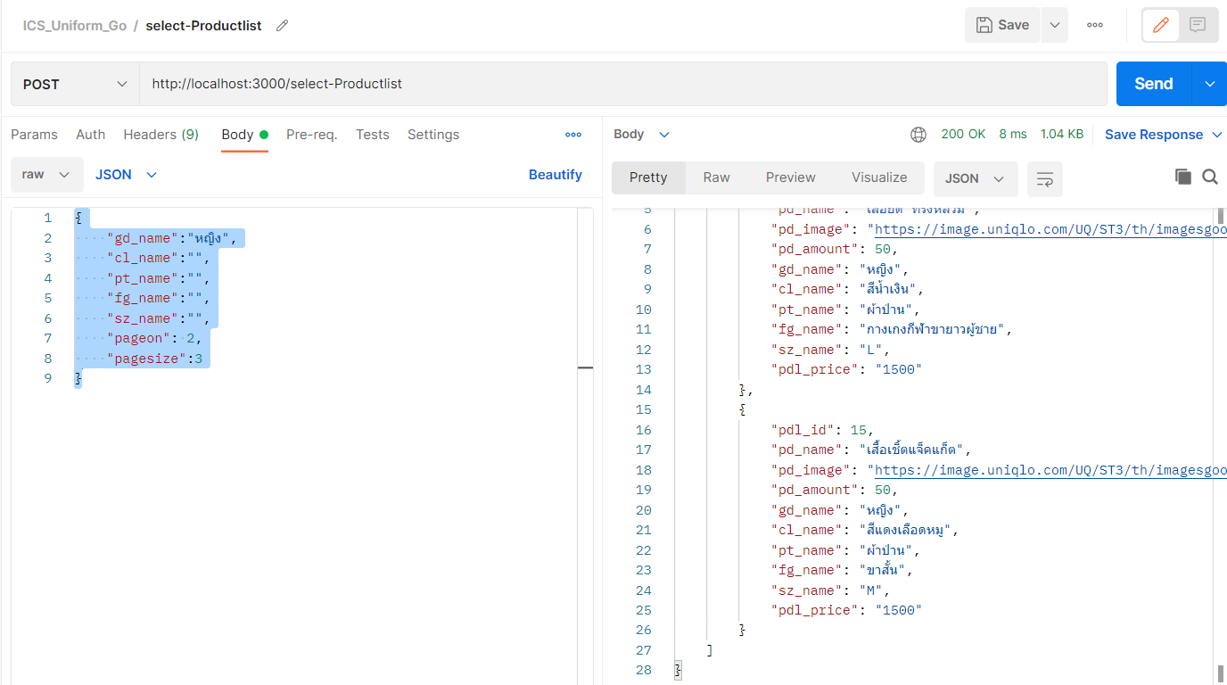

**API Name** : http://localhost:3000/select-OrderDetail

**Request Parameter Data**

{

    "od_id": 1

}

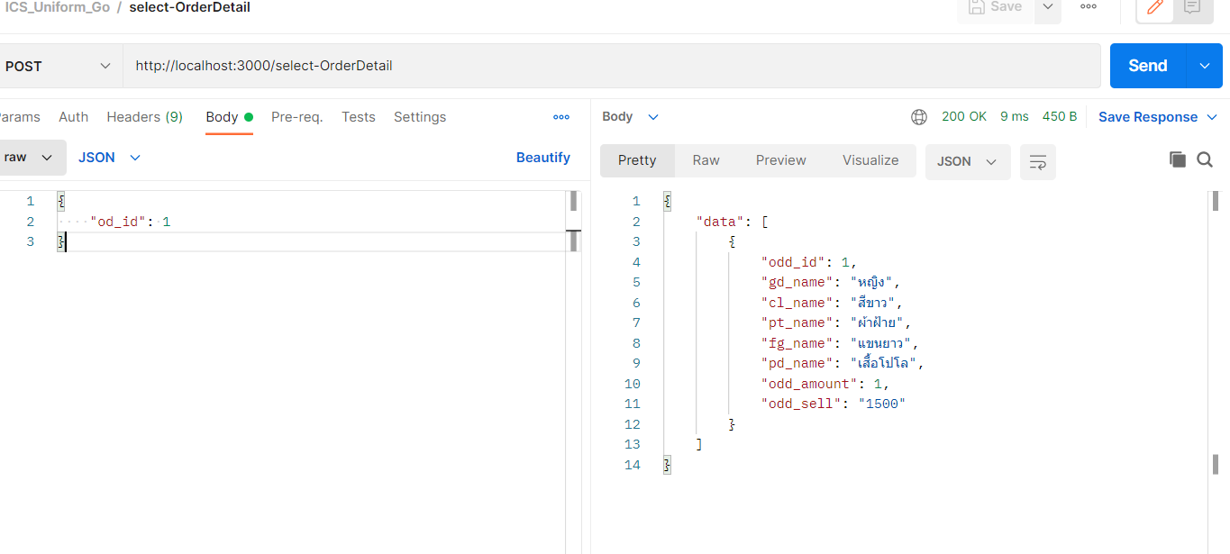

**API Name** : http://localhost:3000/select-Order

**Request Parameter Data**

{

    "od_date_start": "2022-05-12",

    "od_date_end":"2022-05-20" ,

    "od_status": "กำลังจัดส่ง",

    "pageon": 1,

    "pagesize": 4

}

