**API Name** : http://localhost:3000/update-Color

**Request Parameter Data**

{

    "cl_name": "สีคราม",

    "cl_status": **true**,

    "update_by": "test",

    "update_date": "2022-05-13",

    "cl_id":4

}

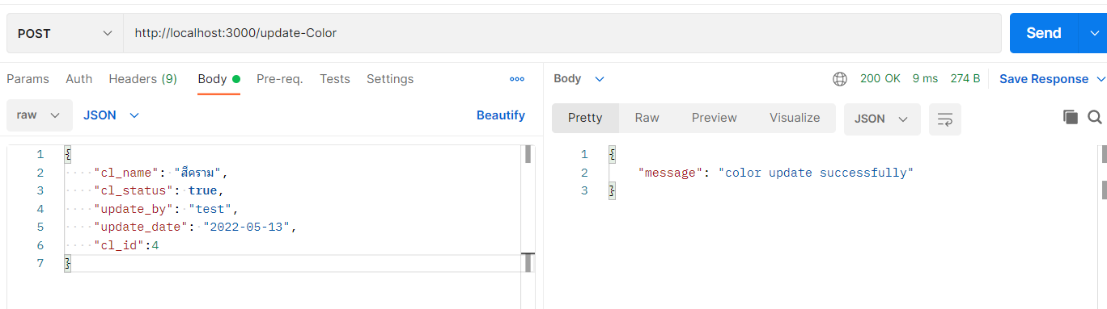

**API Name** : http://localhost:3000/update-Pattern

**Request Parameter Data**

{

    "pt_name": "ผ้าป่าน",

    "pt_status": **true**,

    "update_by": "test",

    "update_date": "2022-05-13",

    "pt_id": 1

}

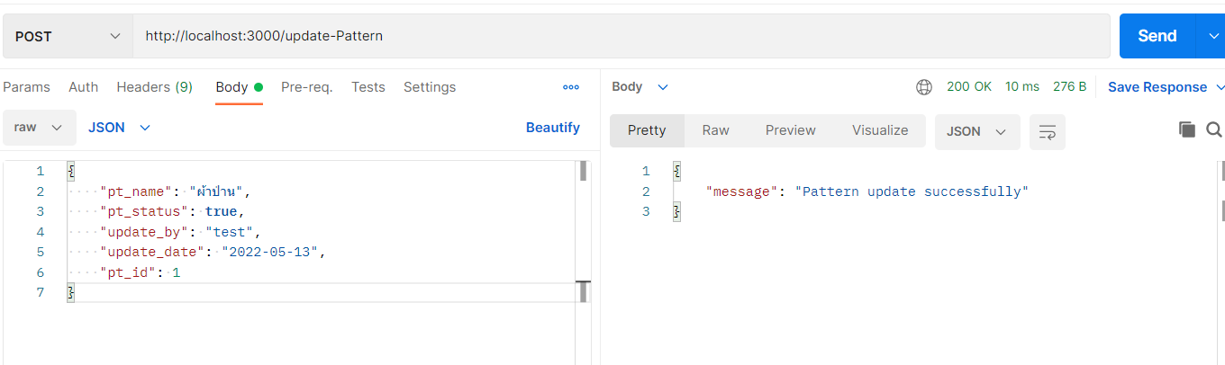

**API Name** : http://localhost:3000/update-Figure

**Request Parameter Data**

{

    "fg_name": "กางเกงกีฬาขายาวผู้ชาย",

    "fg_status": **true**,

    "update_by": "test",

    "update_date": "2022-05-13",

    "fg_id": 1

}

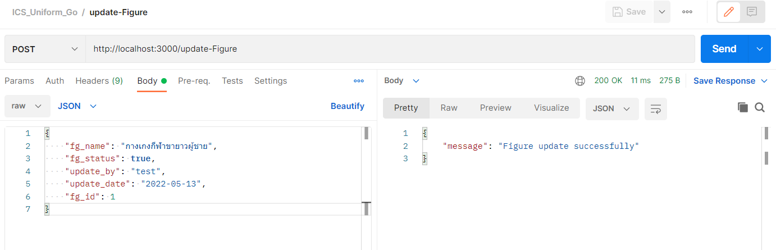

**API Name** : http://localhost:3000/update-Product

**Request Parameter Data**

{

    "pd_name" : "กระโปรงทรงบานนิดหน่อย",

    "pd_image": "https://img.ltwebstatic.com/images3_pi/2021/06/16/1623807875133db989cca37d2ffa9fd0d994963896_thumbnail_900x.webp",

    "pd_status": **true**,

    "pd_amount": 10,

    "pd_detail": "95% เส้นใยสังเคราะห์, 5% แปนเด็กซ์",

    "update_by": "test",

    "update_date": "2022-05-13",

     "pd_id":1

}

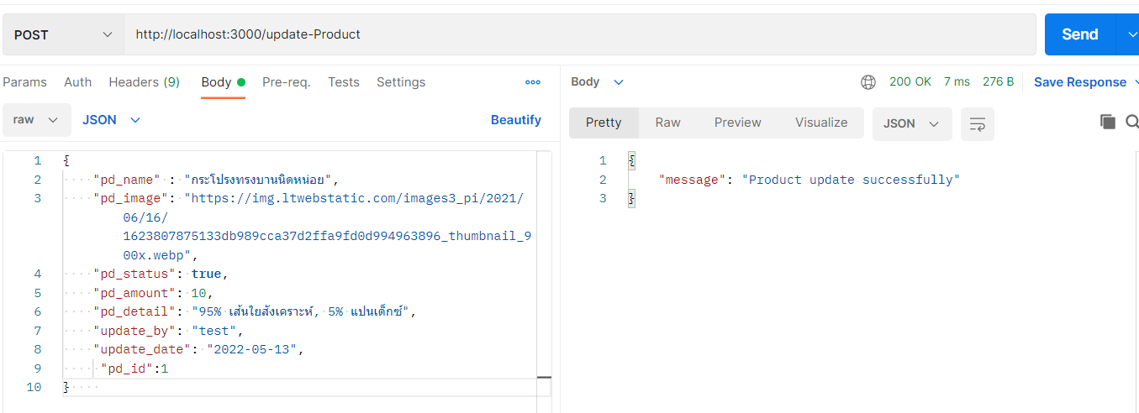

**API Name** : http://localhost:3000/update-ProductList

**Request Parameter Data**

{

    "pd_name" : "กระโปรงทรงบานนิดหน่อย",

    "pd_image": "https://img.ltwebstatic.com/images3_pi/2021/06/16/1623807875133db989cca37d2ffa9fd0d994963896_thumbnail_900x.webp",

    "pd_status": **true**,

    "pd_amount": 10,

    "pd_detail": "95% เส้นใยสังเคราะห์, 5% แปนเด็กซ์",

    "update_by": "test",

    "update_date": "2022-05-13",

     "pd_id":1

}

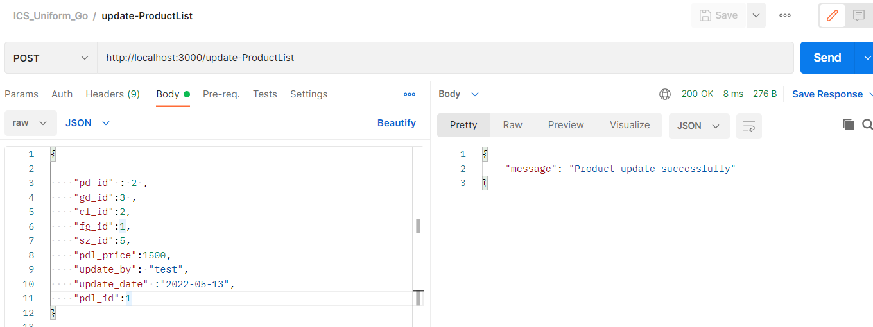

**API Name** : http://localhost:3000/update-Order

**Request Parameter Data**

{

    "od_status": "กำลังจัดส่ง",

    "od_active":**true**,

    "od_sell":1600 ,

    "od_address": "ปางประกง",

    "od_phone": 23456789 ,

    "od_date": "2022-05-20",

    "update_by": "test",

    "update_date": "2022-05-20",

     "od_id":1

}

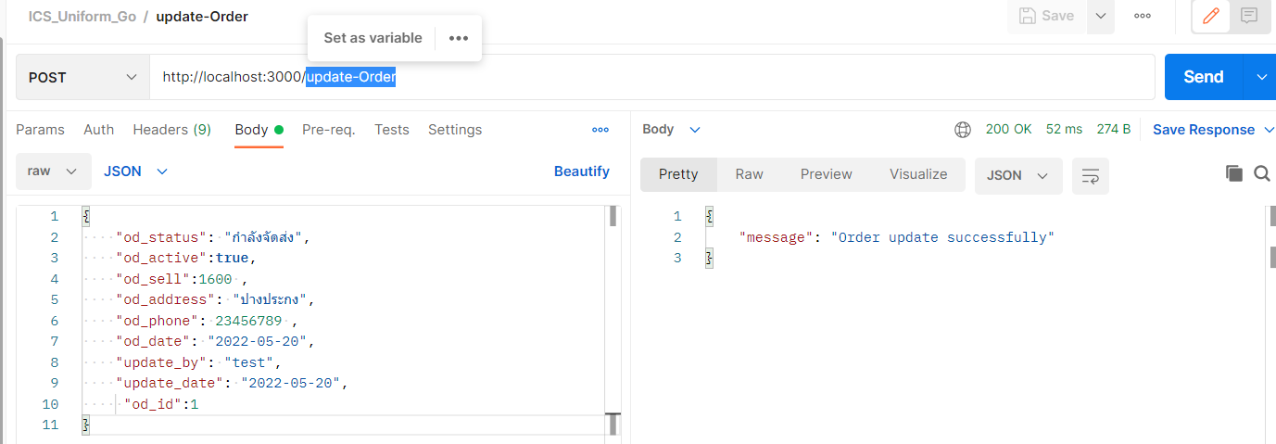

**API Name** : http://localhost:3000/update-OrderDetail

**Request Parameter Data**

{

    "od_id": 1,

    "pd_name":"เสื้อโปโล",

    "gd_name": "หญิง",

    "cl_name": "สีขาว" ,

    "pt_name": "ผ้าฝ้าย",

    "fg_name": "แขนยาว",

    "odd_amount": 1,

    "odd_sell": 1500,

    "update_by":"tesr1",

    "update_date":"2022-05-13",

    "odd_id":1

}

