

Lab 6
Pointers, Dynamic Memory Allocation
and their Applications

Name: Bader Fallaj Almutairi

Module ID : CX-202
Problem Solving Skills using C
Instructor : Dr. Abid Rafique

Task 1:
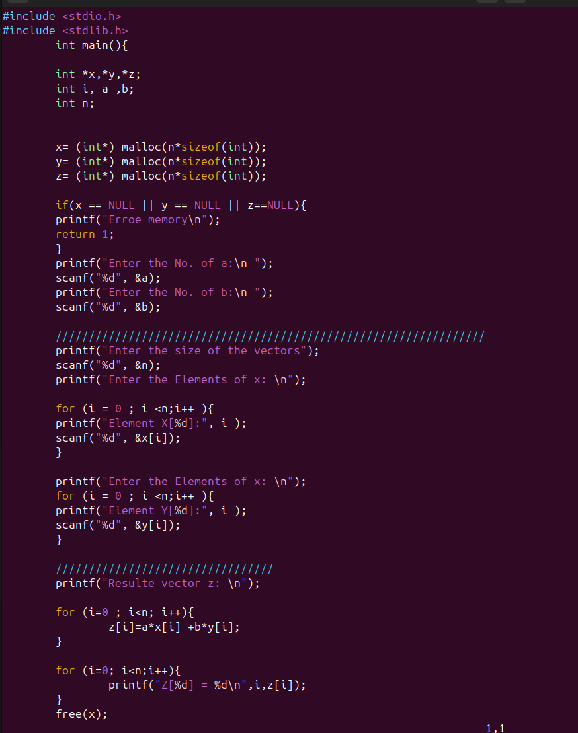
.

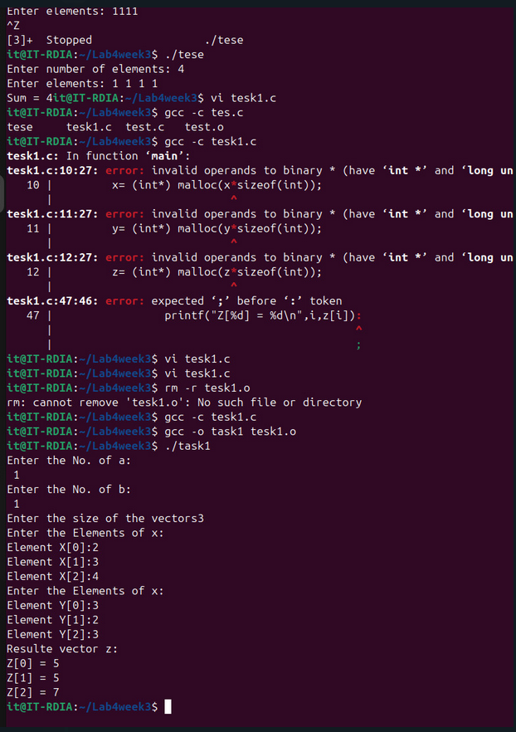

Task 2:

