Jeffrey Reid Module 1.2 May 29, 2024

GitHub Repository Setup

Link: <https://github.com/Sirbossman0/csd-310>

GitHub Repository Screenshot:

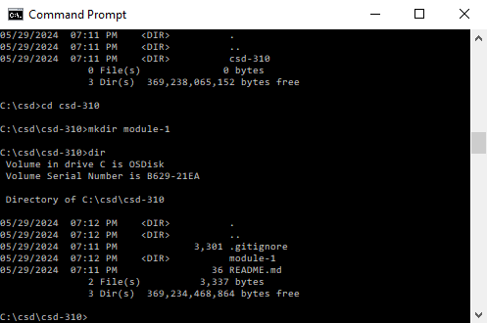

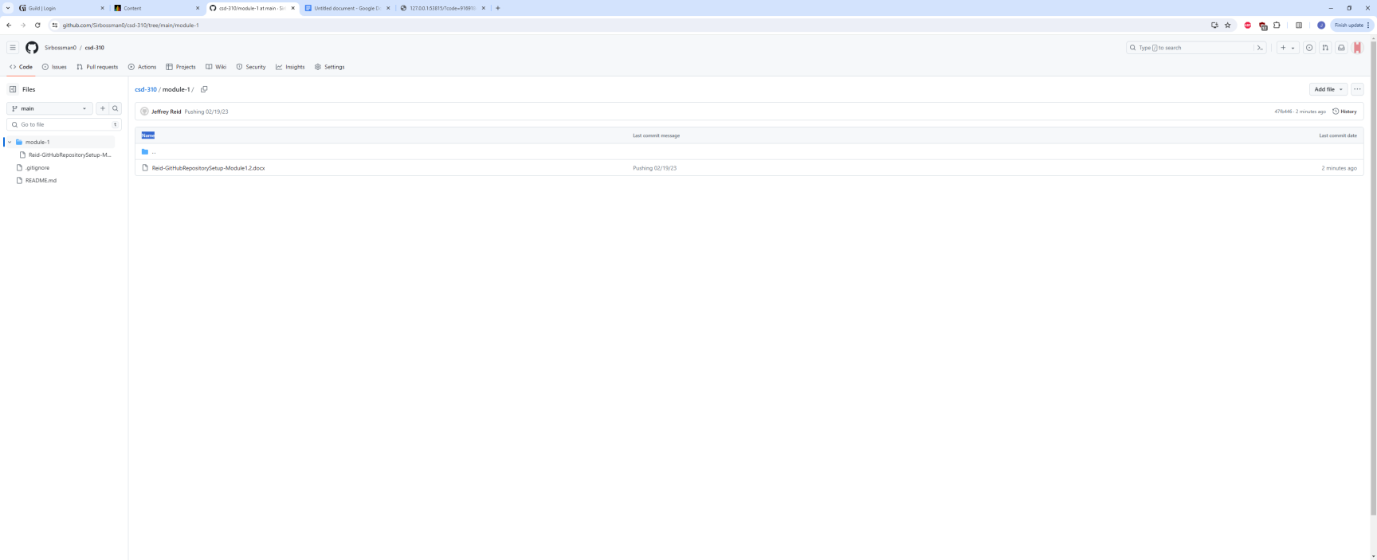Local Directory: