Jeffrey Reid Module 2.3 June 5, 2024

Data Models

Diagram:

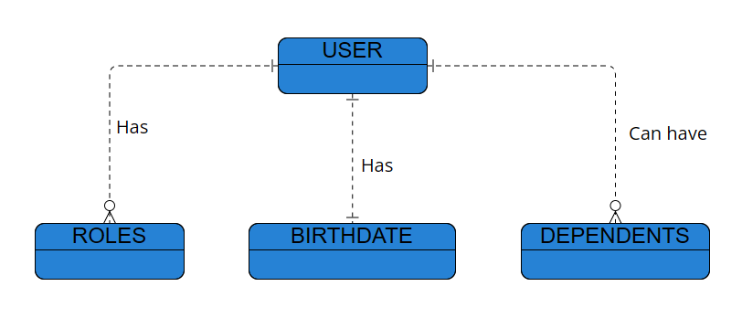

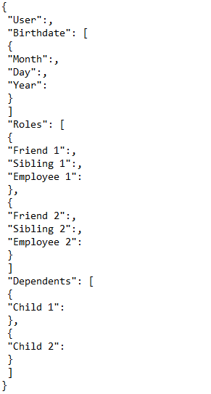NoSQL Data Structure: