Jeffrey Reid Module 4.2 June 20, 2024

MySQL Install

Initial Connection:

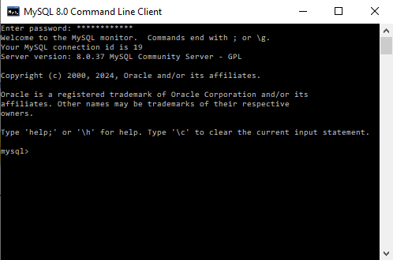

Output Screenshot:

