Jeffrey Reid Module 5.2 June 20, 2024

MySQL Functions

Local Time Function: This function returns the current time. This is very useful when needing to record current timestamps for record keeping. I find it interesting that the time is given in military time/24 hour time. This is likely to get around the am/pm problem when returning the time. The statement to run this function is “SELECT LOCALTIME();”

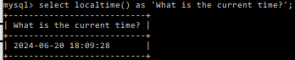

Current User Function: This function returns the current username that is connected to the client. This may be used when reporting user access information for documentation. The statement to run this function is “SELECT CURRENT_USER();”.

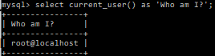

Concat Function: Much like Java or Python, the concat function in MySQL concatenates two or more strings together. This is very useful when merging multiple strings together, especially when the strings are related to one another. The statement to run this function is “SELECT CONCAT(expression1, expression2, …);.

