Jeffrey Reid Module 6.2 June 29, 2024

Movies: Setup

Setup Screenshot:

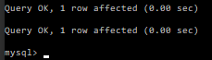

Show Tables Result:

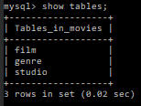

Test File Results:

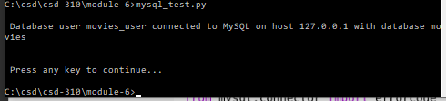

Link to Github repository: https://github.com/Sirbossman0/csd-310