Jeffrey Reid Module 7.2 July 6, 2024

Movies: Table Queries

Screenshot:

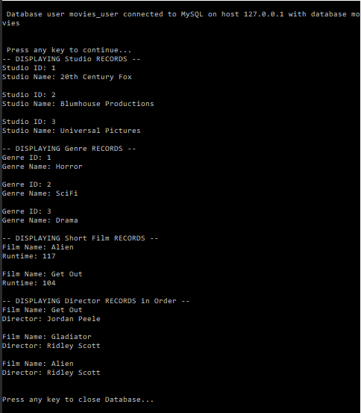

Link to Github repository: https://github.com/Sirbossman0/csd-310