Jeffrey Reid Module 8.2 July 6, 2024

Movies: Update & Deletes

Screenshot:

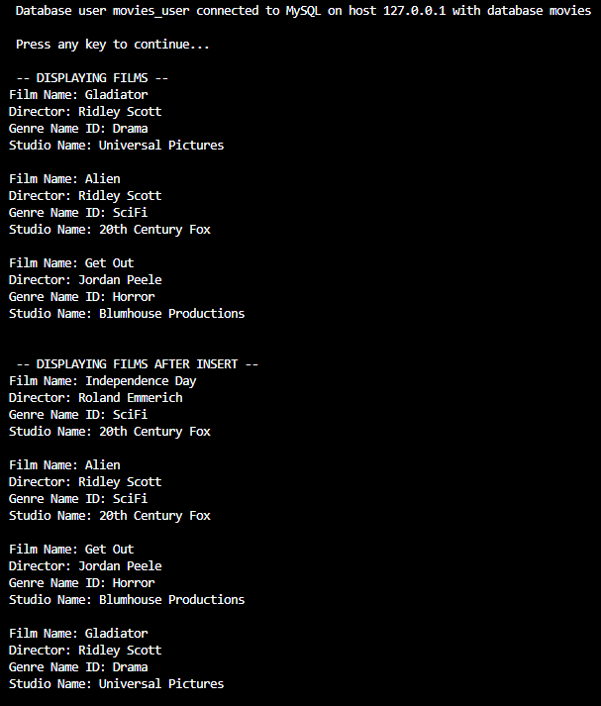

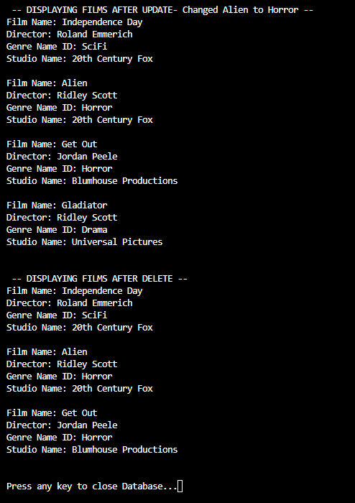

Link to Github repository: https://github.com/Sirbossman0/csd-310