Jeffrey Reid Module 1.3 August 12, 2024

Building a Webpage Exercise, Part 1

Link to Repository:

https://github.com/Sirbossman0/csd-340

Initial Validation Screenshot:

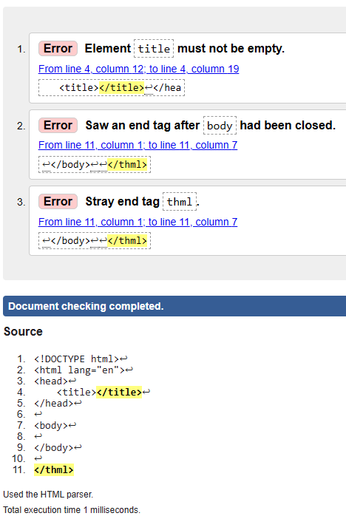

Update 1 Screenshot:

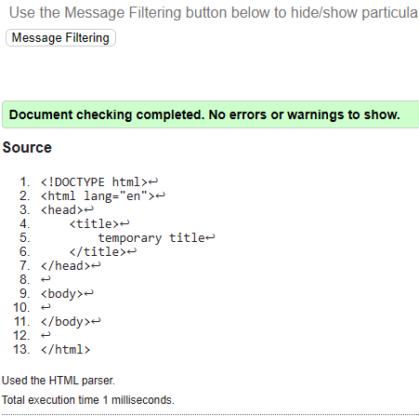

Update 2 Screenshot:

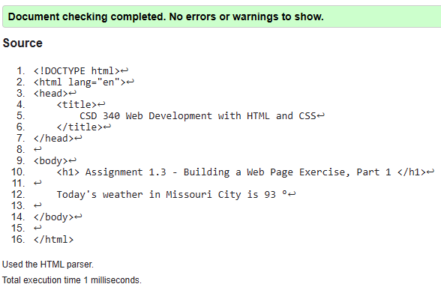

Web Page Screenshot:

