Business chart ERD Document



ONONUJU GIFT

# 1. Business\_chart ERD

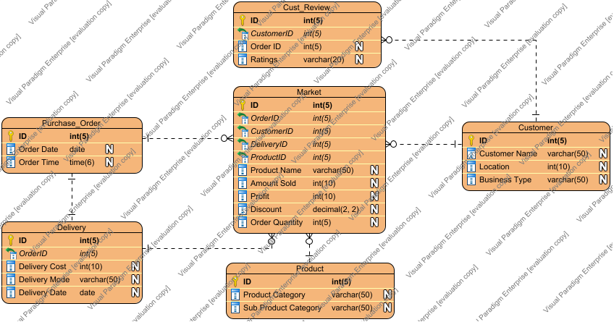

# 2. Cust\_Review

## 2.1. CustomerID:int(5)

## 2.2. ID:int(5)

## 2.3. Order ID:int(5)

## 2.4. Ratings:varchar(20)

Primary Keys:  ID

Foreign Keys:  CustomerID

Master Entities:  [Customer](#t17UWIGD.AAAAUJf)

# 3. Customer

## 3.1. Business Type:varchar(50)

## 3.2. Customer Name:varchar(50)

## 3.3. ID:int(5)

## 3.4. Location:int(10)

Primary Keys:  ID

Detail Entities:  [Market](#zjiomIGD.AAAASYG),  [Cust\_Review](#p4zmWIGD.AAAAV.B" \o "Cust_Review)

# 4. Delivery

## 4.1. Delivery Cost:int(10)

## 4.2. Delivery Date:date

## 4.3. Delivery Mode:varchar(50)

## 4.4. ID:int(5)

## 4.5. OrderID:int(5)

Primary Keys:  ID

Foreign Keys:  OrderID

Detail Entities:  [Market](#zjiomIGD.AAAASYG)

# 5. Market

## 5.1. Amount Sold:int(10)

## 5.2. CustomerID:int(5)

## 5.3. DeliveryID:int(5)

## 5.4. Discount:decimal(2, 2)

## 5.5. ID:int(5)

## 5.6. Order Quantity:int(5)

## 5.7. OrderID:int(5)

## 5.8. Product Name:varchar(50)

## 5.9. ProductID:int(5)

## 5.10. Profit:int(10)

Primary Keys:  ID

Foreign Keys:  CustomerID,  DeliveryID,  OrderID,  ProductID

Master Entities:  [Purchase\_Order](#4Pg1mIGD.AAAATPa" \o "Purchase_Order),  [Customer](#t17UWIGD.AAAAUJf),  [Product](#TAHsWIGD.AAAAVBc),  [Delivery](#_0DiWIGD.AAAAVgZ)

# 6. Product

## 6.1. ID:int(5)

## 6.2. Product Category:varchar(50)

## 6.3. Sub Product Category:varchar(50)

Primary Keys:  ID

Detail Entities:  [Market](#zjiomIGD.AAAASYG)

# 7. Purchase\_Order

## 7.1. ID:int(5)

## 7.2. Order Date:date

## 7.3. Order Time:time(6)

Primary Keys:  ID

Detail Entities:  [Market](#zjiomIGD.AAAASYG)