HR Analytics Dashboard with Attrition Prediction

Name: Ch Sai Sireesha
BATCH: DA-BN010

INDEX

- Project Overview
- Project Context & purpose
- Objectives
- Data Collection & Source
- Data Cleaning & Transformation
- Data Model – Star Schema
- Dashboard Development
- Key Insights
- Business Recommendations
- Conclusion

1.PROJECT OVERVIEW
The HR Analytics Dashboard with Attrition Prediction project focuses on analysing employee data to uncover patterns in workforce composition, departmental distribution, salary structures, employee progress, and attrition risk. The interactive Power BI dashboard transforms raw HR data into actionable business intelligence for HR managers and organisational leadership.
The analysis is performed on a dataset of 1,200 employee records that captures demographics, job roles, departments, salary bands, overtime, tenure, education, hiring trends, and inter-company mobility. The project delivers three interconnected dashboard pages that empower data-driven HR decision-making.
- Analyse the company's workforce across 8 departments and 24 job roles.
- Identify patterns in employee attrition, salary, and performance.
- Build interactive dashboards for HR decision-making.
- Provide data-driven predictions on which employee segments are at highest attrition risk.

Tool/Technology | Purpose
Microsoft Power BI Desktop | Dashboard development and visualisation
Microsoft Excel(.xlsx) | Source data file (4 sheets)
DAX (Data Analysis Expressions) | Calculated columns and measures
Power Query | Data transformation and cleaning

What Can We Find in This project?

Employee Distribution Insights | Understand how employees are distributed across departments, job roles, and education levels.
Attrition Risk Analysis | Identify which employee groups are most likely to leave and the key drivers of attrition
Salary Band Analysis | Explore salary distribution (High, Good,  Higher, Low) and its relationship to department and overtime
Tenure & Retention | Measure average years in the company  And understand when employees are  most at risk of leaving
Hiring Trend Analysis | Track employee count hired by year  to identify growth patterns
Departmental Performance | Compare distance from home,  companies worked, and tenure across departments.

2.PROJECT CONTEXT & PURPOSE
What Is HR Analytics with Attrition Prediction?
HR Analytics with Attrition Prediction involves collecting and analysing employee behavioural and demographic data to identify patterns that lead to voluntary attrition. By combining descriptive analytics (who is leaving) with predictive reasoning (why they might leave), HR teams can proactively intervene to improve retention.

Use of This Project
HR Managers & People Teams | Monitor workforce health, identify  high-risk attrition profiles, and plan  targeted retention initiatives
Senior Leadership | Gain a high-level view of headcount,  salary equity, and departmental  performance.
Data Analysts | Practice real-world data cleaning,  Star Schema modeling, and DAX in  Power BI.
Business Decision Making | Make evidence-based decisions on compensation, hiring, and talent  development
Data Cleaning | Power Query in Excel

3.OBJECTIVES

- Analyse employee distribution by department, job role, and education level.
- Understand salary band distribution and its correlation with overtime and department.
- Measure average employee tenure and identify attrition risk factors.
- Track hiring trends over time to understand organisational growth.
- Identify which employee segments are most likely to leave the organisation.
- Provide actionable recommendations to improve employee retention and satisfaction.
- Build an interactive, filtered Power BI dashboard that enables self-service HR analytics

4.DATA COLLECTION & SOURCE
- Source : Claude(Raw Data)
- Initial File: HR_Analytics_Raw_Dataset_Dirty_Data.xlsx
- Cleaned File: HR_Analytics_Raw_Dataset_Cleaned_Data.xlsx
- Rows Used: 1,200 Employee Records
- Import Method: Loaded the cleaned data file via get data and created DAX measures and columns.
- Data Modeling: Created a star Schema by designing Fact and Dimension tables.
- Analysis Method: Created easy understandable visuals to get useful insights(Employee data analysis by department, job role and education etc..).
- Dashboard Tool: Microsoft power BI
- Data Cleaning Tool: Power Query in Excel
- Dashboard Pages: 3 Pages: Employee Details, Employee Progress, Attrition prediction.

5.DATA CLEANING & TRANSFORMATION
Data Cleaning Steps
- Removed duplicate Employee records which are identified via EmployeeID
- Corrected data types — Date columns formatted as Date; numeric columns as Whole Number / Decimal.
- Identifying the missing values and handling them.
- Replacing the missing value in the numeric data type column with the average value of entire that column range.
- Filling the missing values of the text related columns by using Fill up or Fill Down.
- Corrected inconsistent department name spellings and standardised casing using Trim() function and replace in power query.

Missing values handling in the data
Replaced average values from the  column range | TrainingTimesLastYear,  WorkLifeBalance,  JobSatisfaction,  PerformanceRating,  DistanceFromHome,  Age
Corrected inconsistent to consistent | Attrition,  OverTime,  Gender,  MaritalStatus,  Education,  JobRole,  Department
Split column | Full name to First name and  last name

Data Transformation Steps
- Created a calculated column for Salary Status (High / Good / Higher / Low) based on MonthlyIncome thresholds.
- Implemented normalization for the main and created fact table(Fact_table) and dimension tables(Dim_emp_dep_details, Dim_emp_details, Dim_emp_salary_details)
Table Name | Rows | Key Column | Description
Fact_table | 1,200 | EmployeeID | Core metrics: years, rating, training, distance
Dim_emp_details | 1,200 | EmployeeID | Demographics: age, gender, education, hire date
Dim_emp_salary_details | 1,200 | EmployeeID | Salary, overtime, satisfaction, attrition
Dim_emp_dep_details | 1,200 | EmployeeID | Department and job role assignments

Column Reference

Fact_table
- EmployeeID ---- key column Employees ID number
- YearsAtCompany ---- Total years the employee has worked at the company
- YearsInCurrentRole ---- Year in the current job role
- NumCompaniesWorked ---- Number of companies worked at before joining
- DistanceFromHome ---- Distance from home to office (in KM)
- PerformanceRating ---- Rating score (scale 1–6)
- WorkLifeBalance ---- Work-life balance score (scale 1–4)
- TrainingTimesLastYear ----- Number of training sessions attended

Dim_emp_details
- EmployeeID ---- Unique identifier for each employee
- FirstName ---- Employees first name
- LastName ---- Employees last name
- HireDate ---- Date the employee was hired
- Age ---- Employee age in years
- Gender ---- Male / Female
- MaritalStatus ---- Single / Married / Divorced
- Education ----- Below College / College / Bachelor / Master / Doctor

Dim_emp_dep_details
- EmployeeID ---- key column Employees ID number
- Department ---- 8 departments: Engineering, Sales, IT, Marketing, Finance, Operations, HR, Legal
- JobRole ---- 24 job roles (e.g. Software Engineer, Account Manager, Tech Lead)

Dim_emp_salary_details
- EmployeeID ---- key column Employees ID number
- MonthlyIncome ---- Monthly salary of the employee (numeric)
- OverTime ---- Whether the employee works overtime: Yes / No
- JobSatisfaction ---- Satisfaction score (scale 0–7)
- Attrition ---- Whether the employee has left the company: Yes / No
- salary_status ---- Calculated column created based on the MonthlyIncome column. (Low salary,good salary,high salary,Higher salary)
- Emp Work Status ---- Calculated column created based on the Job Satisfaction column.(Good work, Hard work)

- Created the DAX – Calculated Measures, Calculated columns
Calculated Measures:
- Total number of employees
- Average years of the employee in the company
- Number of employees as per the department

Calculated Columns:
- Employee work status as per the JobSatisfaction and over time column

- Salary Status column created by using the MonthlyIncome column
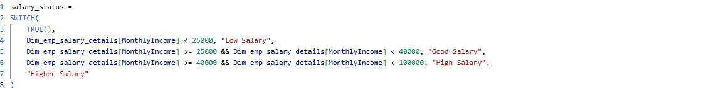
- The Fact_table linking all dimension tables by using employee ID Primary key.

6.DATA MODEL ---- STAR SCHEMA
All four tables are connected in Power BI using a Star Schema pattern. The EmployeeID column in each dimension table links back to the Fact_table. All relationships are both-directions (Dimension Fact).
Support interactive cross-filtering in Power BI
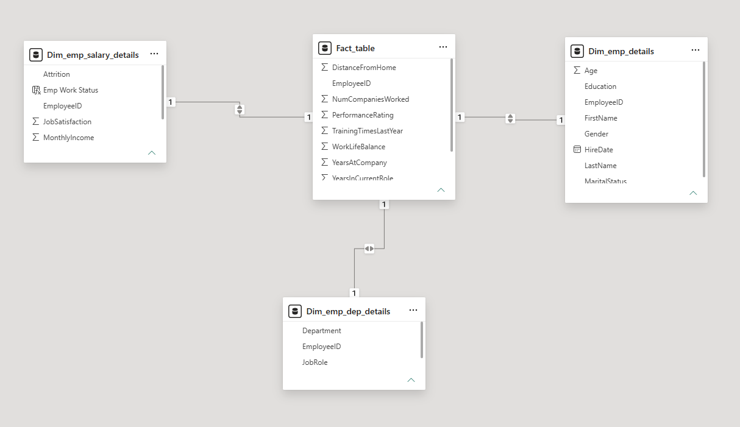
Relationships

From table | To Table | Join Key | Cardinality
Dim_emp_details | Fact_table | EmployeeID | One-to-One
Dim_emp_dep_details | Fact_table | EmployeeID | One-to-One
Dim_emp_salary_details | Fact_table | EmployeeID | One-to-One

Important Model Rules
- All relationships use both-directions filtering (Dimension to Fact).
- EmployeeID must be the primary key with no duplicates in dimension tables.

7.DASHBOARD DEVELOPMENT
Here we have created 3 pages in the Report view which includes --

- Employee_Details_Dashbord
- Employee_progress_Dashboard
- Attrition_Prediction
In the first two page we have included the visuals and the last is included the prediction points.

Employee Details Dashboard
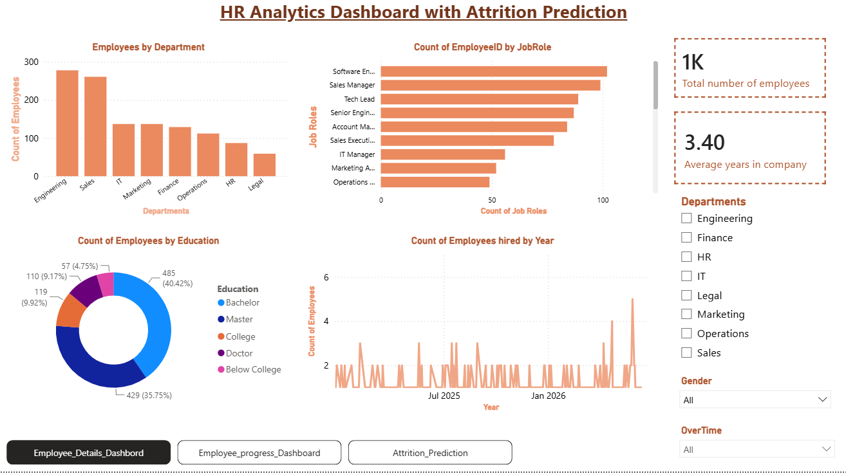

Purpose:
The Employee Details Dashboard provides a high-level overview of the entire workforce — headcount, average tenure, department distribution, job role breakdown, education profile, and hiring trend over time. It includes slicers for Department, Gender, and OvertTime to enable deep-dive filtering.

Key KPIs:
- Total Employees In the company.
- Average years of experience in the company in the company

Visualisations Used:
Employees by Department | Vertical bar chart comparing headcount  across Engineering, Sales, IT, Marketing, Finance, Operations, HR, and Legal. Engineering leads with ~275 employees.
Count of EmployeeID by JobRole | Horizontal bar chart ranking job roles by count. Software Engineers,  Sales Managers, and Tech Leads are  the top three roles
Count of Employees by Education | Donut chart showing education  distribution: Bachelor (40.42%),  College (35.75%), Master (9.92%),  Below College (9.17%), Doctor (4.75%).
Count of Employees Hired by Year | line chart tracking new hires  over time, with a visible spike towards  Jan 2026 indicating recent hiring growth

Slicers:
- Department (multi-select checkboxes)
- Gender (dropdown — All / Male / Female)
- OvertTime (dropdown — All / Yes / No)

Employee progress Dashboard
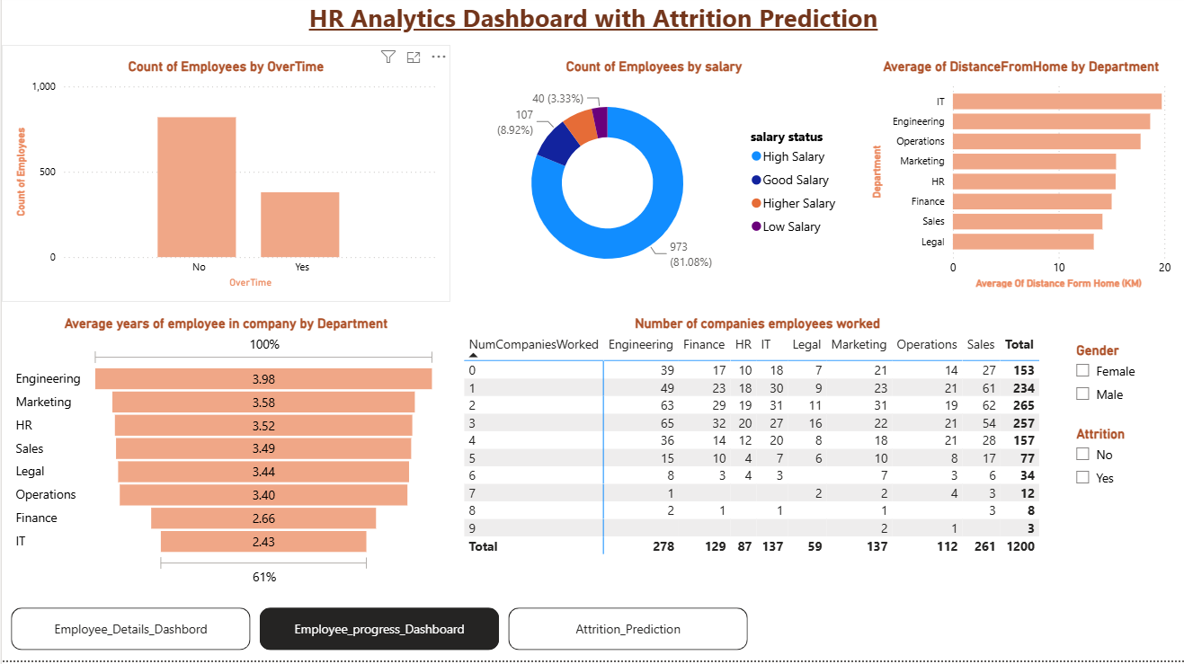

Purpose:
The Employee Progress Dashboard dives into workforce dynamics: overtime load, salary distribution, distance from home by department, average company tenure per department, and inter-company mobility. It helps HR teams understand workload distribution, compensation equity, and commute-driven attrition risk.

Visualisations Used:
Count of Employees by OverTime | Bar chart showing ~750 employees work  no overtime vs ~350 who do. High-salary  IT employees predominantly work  overtime.
Count of Employees by Salary | Donut chart: Low Salary (81.08%, 973 employees), High Salary (8.92%, 107),  Higher Salary (3.33%, 40). Highlights a compensation skew.
Average of DistanceFromHome by Department | Horizontal bar chart — IT employees  have the highest average commute  distance, followed by Engineering and Operations.
Average Years of Employee in Company  by Dept | Funnel chart showing Engineering (3.98 yrs)  has the highest average tenure;  IT (2.43 yrs) the lowest, signalling  attrition risk in IT.
Number of Companies Employees  Worked | Cross-tabulation matrix showing prior  company count vs department vs  total headcount (1,200 total).

Slicers:
- Gender (Female / Male checkboxes)
- Attrition (No / Yes checkboxes)

Attrition Prediction Dashboard
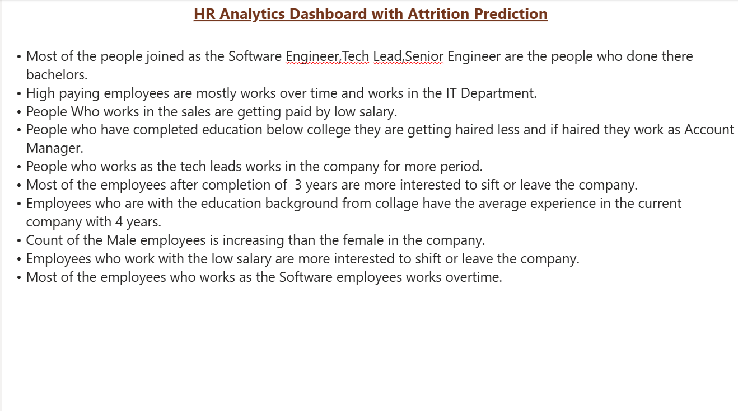
Purpose:
The Attrition Prediction page presents consolidated, narrative-style business insights derived from the first two dashboard pages. Rather than additional charts, this page synthesises the data story into human-readable conclusions that decision-makers can act on immediately.
The following prediction points are directly sourced from the Attrition Prediction page of the Power BI dashboard (as shown in the screenshot below). Each point represents a data-driven observation derived from the HR dataset analysis
8.KEY INSIGHTS
Employee Details Insights:
- The total workforce comprises 1,000+ employees across 8 departments
- Engineering is the largest department, followed closely by Sales.
- 40% of employees hold Bachelor's degrees, making it the most common education level.
- Software Engineers are the most common job role, followed by Sales Manager and Tech Lead.
- Hiring trends show a recent uptick, with the highest hiring volume recorded near early 2026.
- Average employee tenure stands at 3.40 years, indicating moderate retention.

Employee Progress Insights:
- Over 68% of employees do not work overtime; however, the 32% who do are concentrated in high-salary IT roles.
- 81% of employees fall in the Low Salary band — a critical risk factor for attrition.
- IT department employees face the longest commutes, which may contribute to their lower average tenure (2.43 years).
- Engineering employees show the highest average tenure (3.98 years) and may serve as a benchmark for retention.
- The majority of employees have worked at 1–3 companies previously, indicating a mobile talent pool.
- Employees who have worked at 0 prior companies (153 total) are likely fresh graduates or early-career hires.

Attrition Prediction Insights:
- The 3-year tenure mark is the primary attrition trigger — employees leaving between years 2–4 represent the highest risk cohort.
- Low-salary employees are the most likely to leave, regardless of department or role.
- IT employees face a double risk: highest commute distance AND lowest average tenure.
- Overtime-heavy roles (Software Engineers, IT staff) are susceptible to burnout-driven attrition.
- Sales employees face both low pay AND high-pressure roles, making them another high-risk group.
- Below-college educated employees who do join are typically in Account Manager roles and may lack career growth visibility.

9.BUSINESS RECOMMENDATIONS
Salary Restructuring | Review and revise compensation bands — particularly for Sales and IT employees.  With 81% in the Low Salary band,  competitive benchmarking against  industry standards is essential to reduce attrition
3-Year Retention Programme | Launch targeted retention initiatives  (bonuses, promotions, role enrichment) at  the 2.5–3 year mark, when employees are statistically most likely to consider  leaving.
Overtime Managemen | Monitor and cap overtime for Software Engineers and IT staff to reduce burnout  risk. Consider headcount expansion in overloaded teams
IT Commute Support | Introduce hybrid work or transport  allowances for IT department employees  who face the longest average commutes
Sales Compensation Review | Low salary in Sales combined with high attrition risk calls for a commission  restructure or base salary increase to  improve motivation and retention
Career Pathing for Below-College Staff | Develop clear career ladders for Account Managers and below-college educated employees to improve their engagement  and tenure
Gender Diversity Initiative | The male-to-female imbalance across the organisation should prompt targeted recruitment and inclusion programmes.
Focus on Engineering Best Practices | Engineering's high tenure (3.98 years) and satisfaction levels should be studied and replicated in other departments

10.CONCLUSION
This project successfully designed and built a three-page interactive Power BI dashboard — HR Analytics Dashboard with Attrition Prediction — that transforms raw HR data into actionable workforce intelligence.
Through structured data cleaning, Star Schema modeling, and insightful visualisations, the dashboard reveals that low compensation is the primary driver of attrition risk, that the 3-year tenure mark is the most critical retention window, and that the IT department faces compounded risk from commute distance and below-average tenure.
The Attrition Prediction page consolidates these findings into narrative business insights that HR leaders can act on without needing to interpret complex charts — making the dashboard accessible to all stakeholders.
The recommendations derived from this analysis — salary restructuring, targeted 3-year retention programmes, overtime management, and IT-specific support — provide a clear roadmap for reducing voluntary attrition and improving overall organisational health.

