Submitted By: Kella Sireesha
Date : 17/05/2026
R-squared score: 0.3369

Section 3: Data Visualization
Chat 1: Bar Chart – Top 5 EV Makes 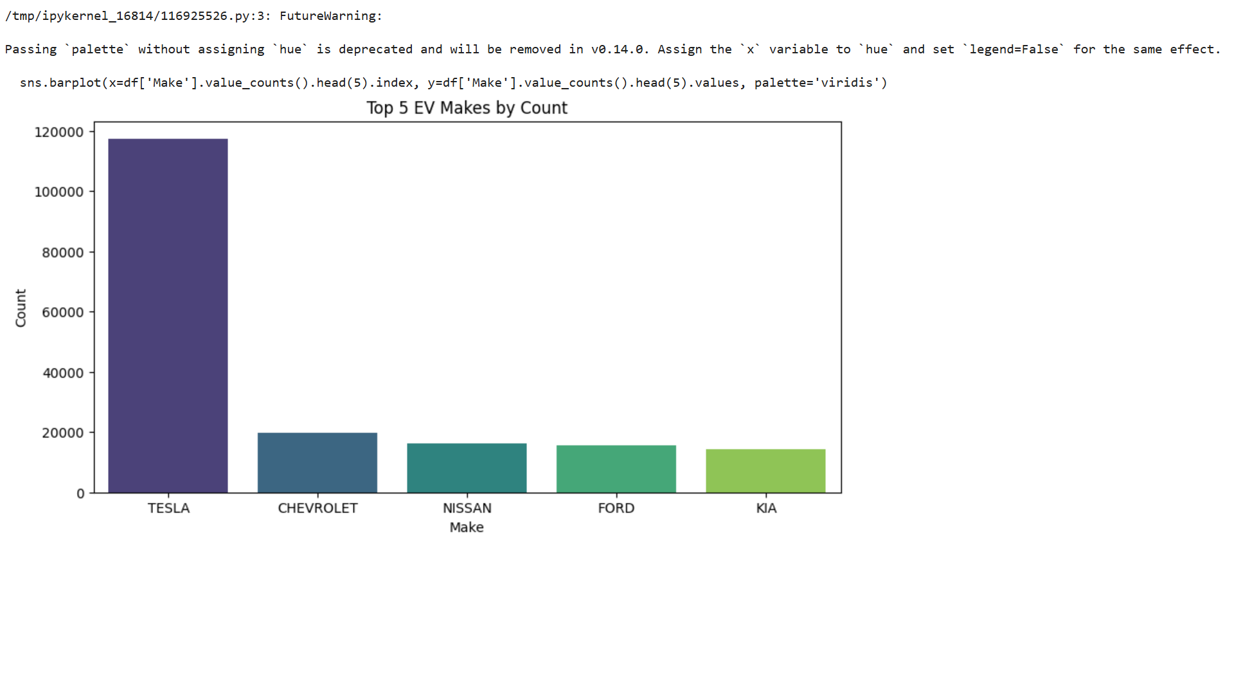

Chart 2: Line Graph – EV Adoption Trend
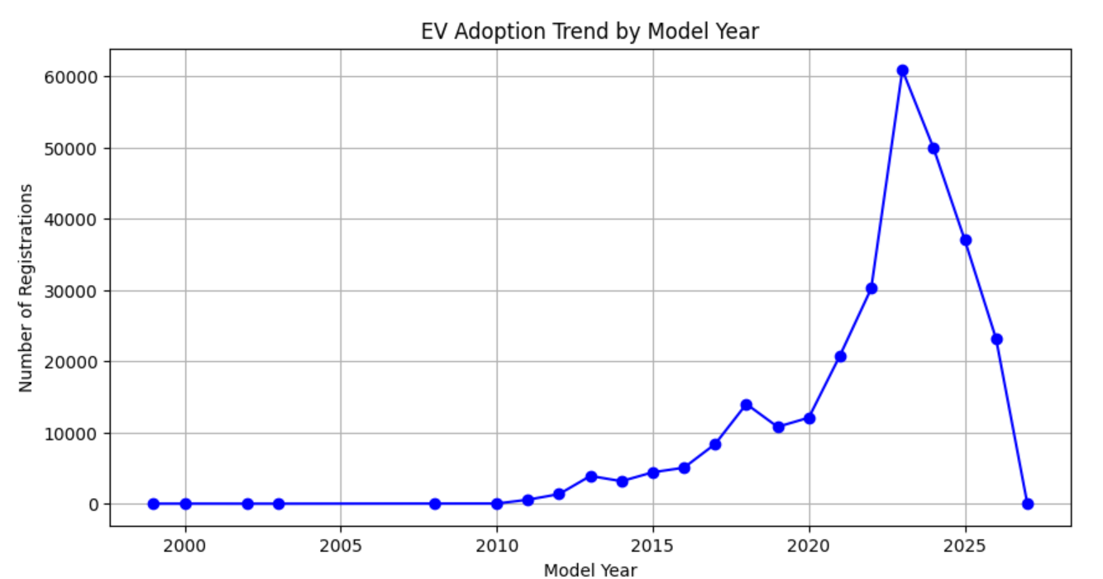

Chart 3: Pie Chart – CAFV Eligibility 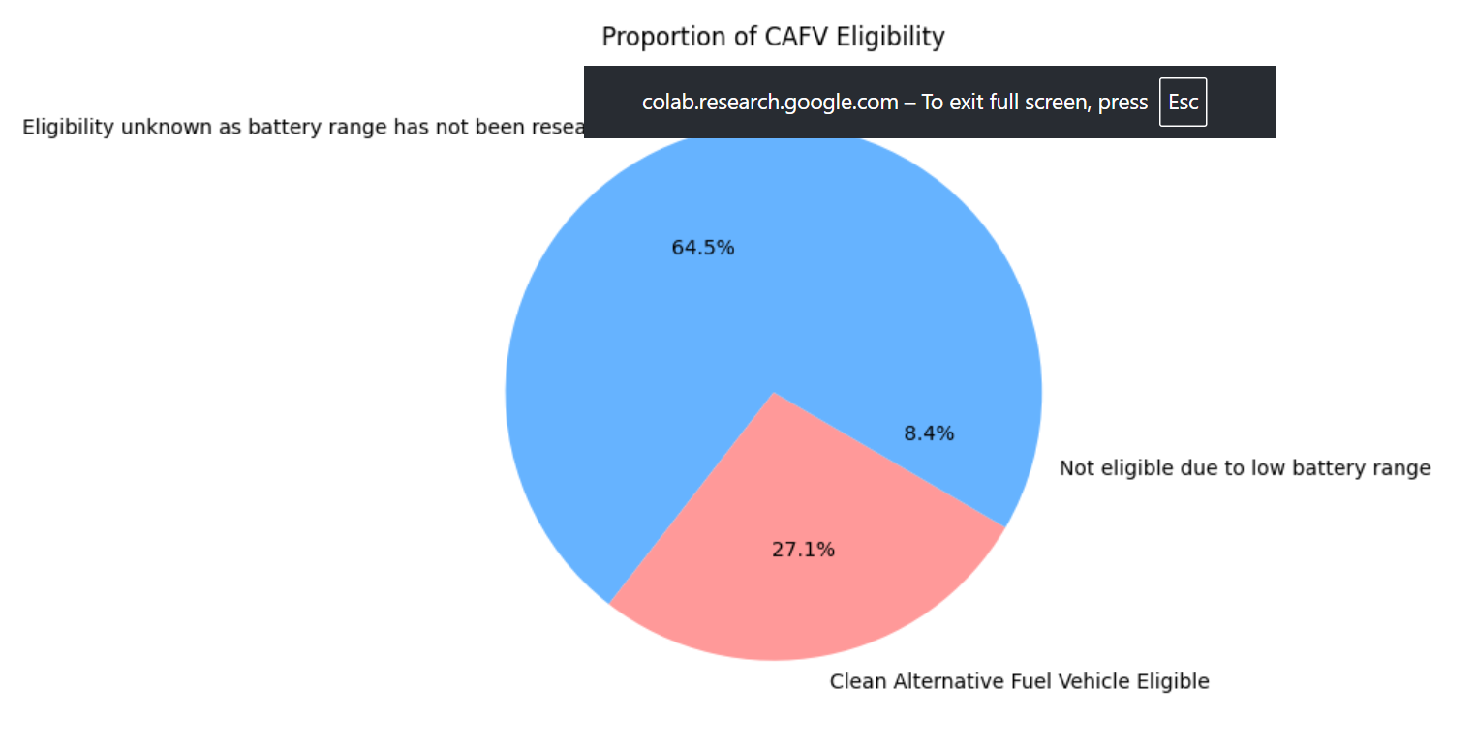

Section 4: Linear Regression Model Results & Interpretation
- Model Features: Model Year, Make
- Target Variable: Electric Range
- Model R² (R-squared) Score: 0.3369
- Interpretation : Our Linear Regression model achieved an R² score of 0.3369. This means that approximately 33.69% of the variance in the vehicle's Electric Range can be explained by its Model Year and Manufacturer (Make).
- Influence of Base MSRP: Since the Base MSRP column was missing in the latest dataset version, the prediction relied heavily on the vehicle's production year and brand. Newer models and specific premium brands statistically show a trend towards higher electric ranges.
- Steps to Improve Accuracy :
- Introduce more technical features like Battery Capacity (kWh) if available.
- Use non-linear or ensemble machine learning algorithms like Random Forest Regressor or Gradient Boosting (XGBoost).
- Perform hyperparameter tuning to optimize model parameters.

