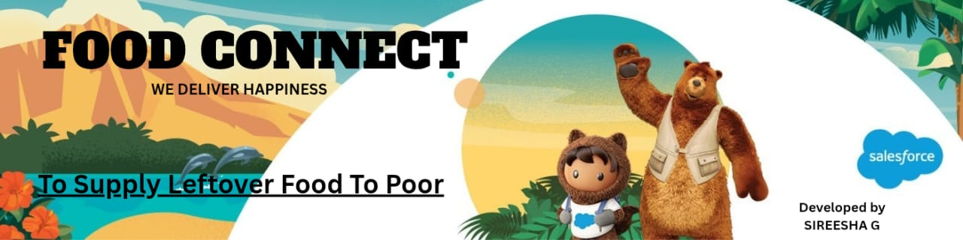

FOOD CONNECT

TO SUPPLY LEFTOVER FOOD TO THE POOR

**INTRODUCTION**

Iam **SIREESHA G**

Branch **- CSE**

I am a final year B.Tech student at Annamacharya Institute of Technology and Sciences (AITS), Rajampet.

I have gained experience in Salesforce CRM, including creating apps, automations, and custom solutions.

This project, "Food Connect", is a reflection of my interest in social innovation and technical development.

Purpose: Reduce food wastage and supply leftover food to the poor.

**Project Overview**

**CRM System for Leftover Food Distribution to the Needy – FOODCONNECT CRM**

The **FOODCONNECT CRM** initiative aims to develop a centralized, technology-driven platform that facilitates the redistribution of surplus food from donors—such as restaurants, food businesses, hotels, event organizers, and households—to charitable organizations and individuals in need. The primary goal is to reduce food waste while addressing food insecurity within underserved communities.

This Salesforce-based CRM system will manage the end-to-end lifecycle of food donations, including donor registration, donation tracking, logistics coordination, and impact reporting. It will streamline processes that are traditionally manual and fragmented, ensuring timely and equitable food distribution.

**Key Features**

* **Donation Management**: Comprehensive tracking of food donations, including donor details, food types, quantities, expiration dates, and availability.
* **Recipient Coordination**: A structured database for managing and categorizing recipient organizations (e.g., NGOs, shelters, food banks) and individual beneficiaries to ensure fair and need-based distribution.
* **Delivery Logistics**: Integrated scheduling and route optimization for food pickups and deliveries to minimize delays and prevent spoilage.
* **Volunteer and Resource Management**: Tools to onboard, assign, and manage volunteers involved in collection, packaging, and distribution operations.
* **Impact Tracking and Reporting**: Real-time dashboards and analytics to measure the volume of food redistributed, number of people served, geographic coverage, and donor/partner engagement.

**Business Value**

The FOODCONNECT CRM addresses key social and operational challenges:

* Reduces food waste by capturing and redistributing surplus food.
* Supports underprivileged communities with consistent food access.
* Enhances operational efficiency for NGOs and volunteer groups.
* Builds trust and transparency with all stakeholders through real-time reporting.
* Encourages donor engagement through automated acknowledgments and impact visibility.

**Project Objectives**

The primary objective is to create a scalable and reliable CRM system using Salesforce that:

* Enables systematic tracking of food donations and recipients.
* Automates the logistics of food pickup and delivery.
* Maintains accurate historical data and generates insights.
* Enhances stakeholder engagement through transparent reporting and communication.
* Establishes a replicable model that can be expanded to new regions or partners.

**Phase 1: Requirement Analysis & Planning**

**Understanding Business Requirements**

The platform must serve as a bridge between surplus food sources and distribution agents such as NGOs and volunteer networks. Key requirements include:

* Real-time tracking of available food donations and inventory.
* Scheduling mechanisms to ensure timely pickup and delivery.
* Monitoring and logging of delivery completion and recipient reach.
* A system that minimizes manual intervention and supports operational transparency.

**Project Scope and Objectives**

* Develop a custom Salesforce CRM to manage donor and recipient profiles.
* Automate scheduling of pickups based on food type, quantity, and location.
* Maintain historical records of donations and deliveries for tracking and compliance.
* Implement real-time notifications for pickups and automated acknowledgments for donors.
* Create dynamic dashboards to visualize impact metrics and donor participation.

**Data Model Design**

The data architecture includes the following custom Salesforce objects:

| **Object** | **Description** |
| --- | --- |
| **Donor** | Stores information about organizations or individuals contributing food. |
| **Food Donation** | Logs details of donated food including quantity, type, preparation and expiration dates. |
| **Pickup Schedule** | Links food donations with scheduled pickup time, volunteer, and route. |
| **Recipient** | Maintains records of NGOs, shelters, or individual beneficiaries. |
| **Distribution Record** | Captures delivery details, recipient feedback, and confirmation. |

Relationships:

* **Donor → Food Donation**: One-to-many
* **Food Donation → Pickup Schedule**: One-to-one
* **Distribution Record → Recipient**: Many-to-one

**Security Model Design**

To ensure data confidentiality and role-based access, the following Salesforce security components are implemented:

* **Profiles and Permission Sets**: Define specific access levels based on user roles.
* **Role Hierarchies**: Allow upper-level users to view subordinate data where applicable.
* **Sharing Rules**: Enable controlled data visibility across partners when collaboration is required.

**Roles Defined**:

* **Restaurant Managers** – Can view and manage their donations.
* **NGO Coordinators** – Can manage deliveries and beneficiary records.
* **Volunteer Drivers** – Can view assigned pickups and update statuses.
* **Admins** – Have full system access for configuration and support.

**Phase 2: Salesforce Development – Backend & Configuration**

**Environment Setup & DevOps Workflow**

A dedicated **Salesforce Sandbox Environment** was established to facilitate initial development and testing. This approach ensures that customizations, configurations, and object designs can be implemented without impacting live data or users.

To manage deployments:

* **Change Sets** are used for migrating metadata from Sandbox to Production in a controlled manner.
* Version control practices are followed for structured deployments and rollback capability.
* The sandbox is refreshed periodically to maintain alignment with production data structures and configurations.

**Core Configuration Activities Completed:**

* Custom objects and fields created for donors, donations, recipients, schedules, and distribution records.
* Validation rules and workflows implemented to enforce data integrity.
* Role-based access and sharing models configured.
* Basic page layouts and list views customized for user-friendliness.