**TESTING**

**Create ACL:**

**Create ACL:**

|  |  |
| --- | --- |
| Date | **25 June 2025** |
| Team ID | **LTVIP2025TMID29036** |
| Project Name | **Streamlining Ticket Assignment for Efficient Support Operations** |
| Maximum Marks | **5 Marks** |

1. Open service now.
2. Click on All  >> search for ACL.
3. Select Access control(ACL) under system security.
4. Click on new
5. Fill the following details to create a new ACL.

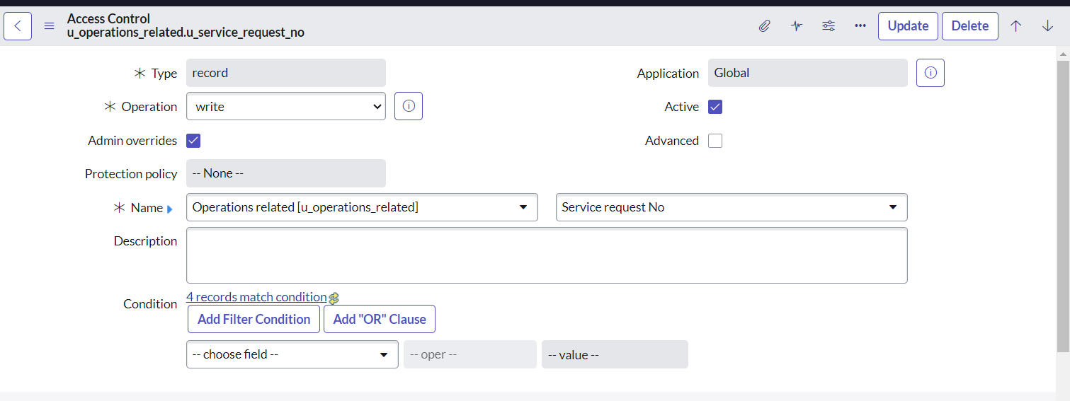

1. Scroll down under requires role.
2. Double click on inserta new row
3. Give admin role
4. Click on Submit
5. Similarly create 4 ACL for the following fields.

