**INTERNSHIP AT SERVICENOW ADMINISTRATOR**

**USERS**

|  |  |
| --- | --- |
| Date | **25 June 2025** |
| Team ID | **LTVIP2025TMID29036** |
| Project Name | **Streamlining Ticket Assignment for Efficient Support Operations** |
| Maximum Marks | **5 Marks** |

* 1. **Create Users:**

1. Open service now.
2. Click on All  >> search for users
3. Select users under system security
4. Click on new
5. Fill the following details to create a new user
6. Click on submit and make current

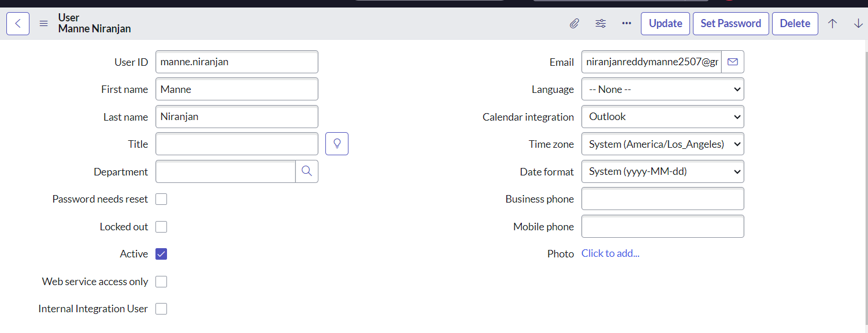

1. Click on submit.
2. Create one more user with the same details.
3. And next,Click on submit.