**GROUPS**

|  |  |
| --- | --- |
| Date | **25 June 2025** |
| Team ID | **LTVIP2025TMID29036** |
| Project Name | **Streamlining Ticket Assignment for Efficient Support Operations** |
| Maximum Marks | **5 Marks** |

**create Groups:**

1. Open service now.
2. Click on All  >> search for groups
3. Select groups under system security
4. Click on new
5. Fill the following details to create a new GROUP.

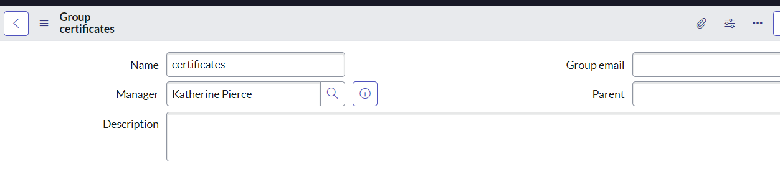

1. Click on Submit.
2. Create one more Group with the following details.



1. Click on submit.