**ROLES**

**Create Roles:**

|  |  |
| --- | --- |
| Date | **25 June 2025** |
| Team ID | **LTVIP2025TMID29036** |
| Project Name | **Streamlining Ticket Assignment for Efficient Support Operations** |
| Maximum Marks | **5 Marks** |

1. Open service now.
2. Click on All  >> search for Roles.
3. Select roles under system security
4. Click on new
5. Fill the following details to create a new Role.

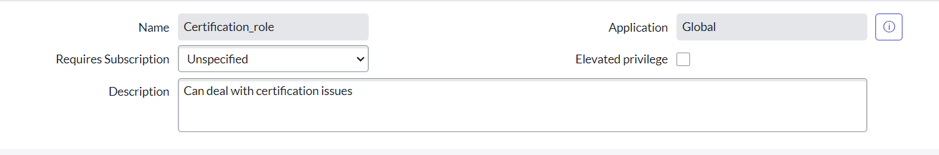

1. Click on submit.

Create one more role:

1. Create another role with the following details



1. Click on submit.