**TABLES**

**Create table:**

|  |  |
| --- | --- |
| Date | **25 June 2025** |
| Team ID | **LTVIP2025TMID29036** |
| Project Name | **Streamlining Ticket Assignment for Efficient Support Operations** |
| Maximum Marks | **5 Marks** |

1. Open service now.
2. Click on All  >> search for tables
3. Select tables under system definition.
4. Click on new
5. Fill the following details to create a new table.

Label: Operations related

Check the boxes Create module & Create mobile module.

1. Under new menu name:

Operations related

1. Under table columns give the columns.

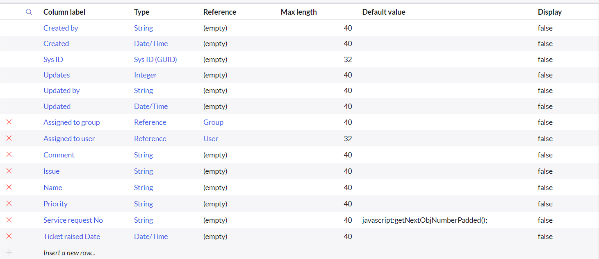

1. Click on Submit.

Create choices for the issue filed by using form design

Choices are

* Unable to login to platform
* 404 error
* Regarding certificates
* Regarding user expired