**Core PHP to Laravel conversion**

Installation on local host:-

First we have installed Composer initially for using Laravel.

1. $ sudo php -r "copy('https://getcomposer.org/installer','composer-setup.php');"

By using this and a bunch of commands we have downloaded and installed composer.

The composer’s directory is set to Applications/XAMPP/htdocs.

1. We verified the installation by running the command “ composer” in Terminal.

For installing Laravel we have run the below command in terminal.

1. “composer global require Laravel/installer”.

Then, for creating a new laravel project in the folder “htdocs”in XAMPP we use the command:

1. Composer create-project -prefer-dist laravel/laravel Godithi_Challagundla.

To test the installation we launch the browser and go to the localhost/Godithi_challagundla/public.

We have then made changes in the .env file to make a database connection by using the already existing database in project4. We changed to “DB_DATABASE=sxg6288_MIJARES” and USERNAME =root AND PASSWORD= null.

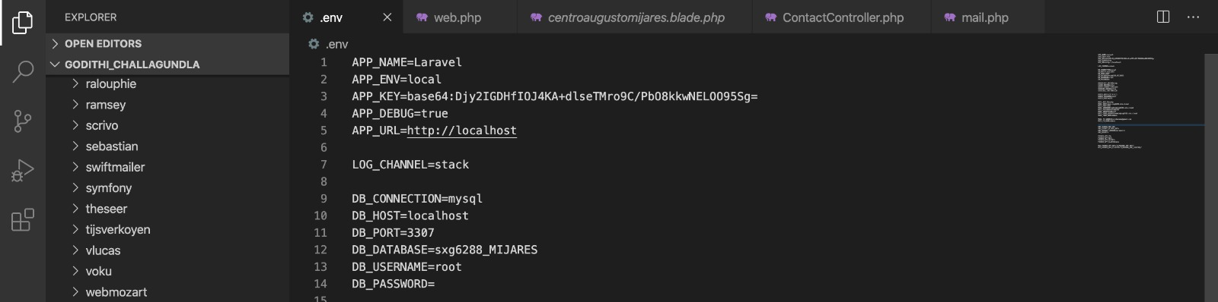

After that we have converted the project 4 into MVC Laravel pattern. We put the PHP code in the view folder that is located in the resources folder.

We have created different folders for different modules like : User, Admin, Project, Video, Auth,E-mail,Pages,Layouts,Events.

Admin folder has dashboard, Registration and User list pages. For user/registration we have used command php artisan ui vue –auth

The auth folder we have included the login page , the registration page and also the new user verification mail page.

The auth folder also has a passwords folder, where we have created pages for when user forgets his/her passwords.

The Event folder has the add, edit event pages for the admin module and also a list of events page for the user side.

The pages folder includes all the pages in the website excluding the registration and login pages.

In the routes folder we have specified routes accordingly for user and admin.

For the controller part, which contains the logic and handling the requests of the route files. Controllers are typically stored in the app/Http/Controller’s directory. In this folder we have controller pages for Admin, Video, Event, Project, Home, contact and also a separate folder for the “auth” which has controller pages for verification and resetting passwords.

 The model usually, interfaces with a data storage like an SQL database. Migration lets developers make and undo changes to a project’s database. the Model is usually a class with properties that match the columns in the database. Migrations can be used to make managing databases easy and predictable. Migration lets developers make and undo changes to a project’s database. Migrations can be used to make managing databases easy and predictable. Our schema is stored in database/migrations directory.

For running the migrations, we already made a connection between Laravel and the database in the .env file.

$ php artisan migrate is the command we used to run the migrations in terminal.

Our database we used to make connections to Laravel is:

The screenshot for verification of mail for a new registered user:

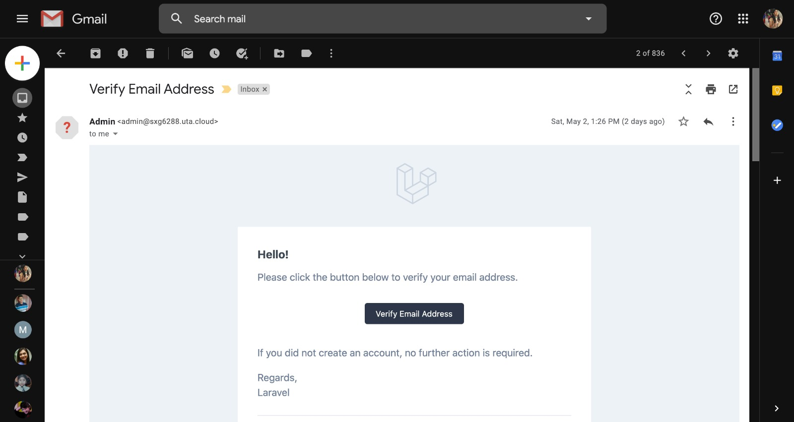

The reset password link is sent to the user after they choose to reset the password if they forget it.

The mail is sent to the admin after any user fills out the contact form in the website.

