***page i***

# SOFTWARE REQUIREMENTS SPECIFICATION

**for**

**The coffee club**

**Under the supervision of**

**Dr. P. NAGA BABU**

**Assistant Professor**

**Team: B9**

**22BQ1A12A0 – M.SIREESHA**

**22BQ1A1273 – K.MEGHANA**

**22BQ1A12B5 – P.SAI PRANITHA**

**23BQ5A1211 – N.NAGASWAPNA**

**Table Of Contents**

**1.Introduction**

### Purpose 1

***page ii***

1. Intended Audience and Reading Suggestions 1
2. Project Scope 1
3. References 1
4. Overall Description
   1. Project Perspective 3
   2. Project Functions 3
   3. User Classes and Characteristics 3
   4. Operating Environment 4
   5. Design And Implementation Constraints 4
   6. User Documentation 4
   7. Assumptions And Dependencies 4
5. External Interface Requirements
   1. User Interface 5
   2. Hardware Interface 5
   3. Software Interfaces 5
   4. Communication Interfaces 5
6. System Features
   1. Data Ingestion 6
   2. Data Preprocessing 6
   3. Historical Data Analysis 6
   4. Prediction Result and Visualization 6
7. Non-functional Requirements
   1. Performance Requirements 7
   2. Safety Requirements 7
   3. Security Requirements 7
   4. Software Quality Attributes 8
   5. Business Rules 8
8. **Introduction**

### Purpose

The purpose of the Smart Mini Cafe Web Development Project is to create an automated online platform for a modern cafe. It aims to provide a seamless ordering experience using QR codes, optimize operations with minimal human intervention, and promote sustainability through eco- friendly practices. The system integrates advanced technologies such as secure payment gateways, real-time order tracking, and admin tools for inventory and analytics. By catering to small and medium-sized cafes, this platform provides an affordable, scalable solution to help businesses compete effectively and grow sustainably.

### Intended Audience and Reading Suggestions

This document is intended for project stakeholders, including business owners, cafe administrators, developers, and testers.

* Developers should focus on technical requirements and system architecture.
* Admins and managers can review features like the admin dashboard and inventory tools.
* Testers can use this document to understand expected system functionalities.

### Project Scope

The Smart Mini Cafe project aims to deliver a responsive, user-friendly online platform that simplifies order management and enhances customer engagement. Key features include dynamic menu customization, real-time updates, personalized recommendations, and data-driven insights. The project focuses on small and medium-sized cafes, ensuring cost-efficiency while offering robust features typically available to larger establishments.

### References

* + - Java JDK Documentation: https://docs.oracle.com/en/java/javase/11/
    - Apache Tomcat Documentation: https://tomcat.apache.org/tomcat-10.0-doc/
    - MySQL Documentation: https://dev.mysql.com/doc/

1

## Overall Description

### Project Perspective

The Smart Mini Cafe project aims to enhance the efficiency of cafe operations through a comprehensive digital system. It serves as an integrated solution that manages menu items, orders, payments, and inventory, providing a streamlined experience for both customers and staff. By leveraging modern web technologies and secure payment gateways, the project ensures real-time data processing and inventory management for a seamless café experience. This solution caters to a wide range of stakeholders, including customers, staff, and management.

### Project Functions

The system will provide various functionalities, including:

1. **Menu Management:** Easy creation and updates to the menu items.
2. **Order Processing:** Efficient handling of customer orders from placement to fulfillment.
3. **Payment Processing:** Secure transactions through integrated payment gateways.
4. **Inventory Tracking:** Real-time inventory updates and alerts for restocking.
5. A dynamic online ordering system for customers.
6. An admin dashboard for managing menus, inventory, and orders.
7. Secure payment gateway integration.
8. Real-time updates for order tracking and notifications.

### 3. User Classes and Characteristics

The project targets several user classes:

1. **Customers**: End-users who place orders through a user-friendly interface.
2. **Staff Members**: Cafe employees who receives orders, inventory, and customer service via an admin dashboard.
3. **Management**: Users overseeing business operations, analyzing reports, and making strategic decisions using analytics tools.

Each user class has varying access levels and functionality tailored to their needs and

responsibilities.

2

### Operating Environment

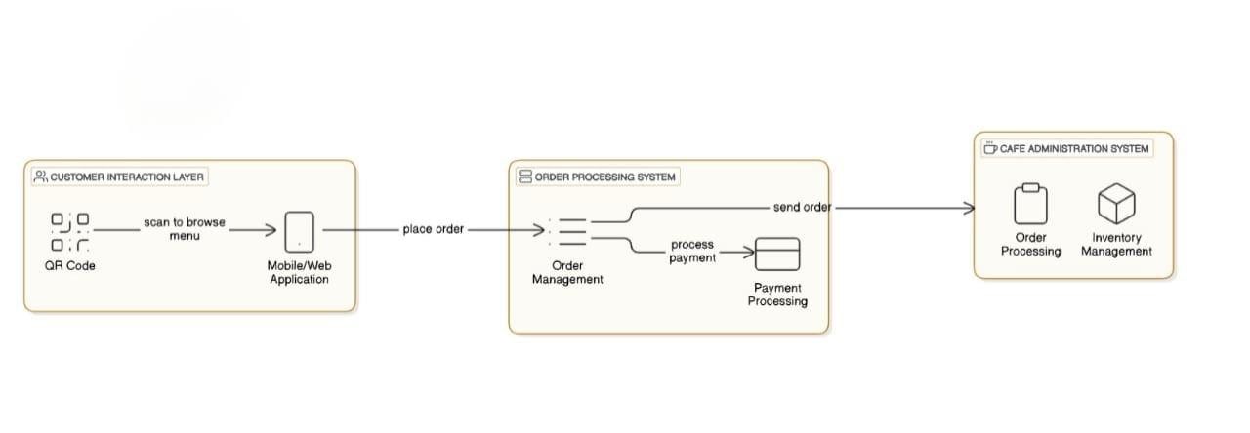

The system operates on web browsers and mobile devices, compatible with Windows, Linux, and macOS. It requires a stable internet connection, Apache Tomcat server, and XAMPP for hosting the database and backend services.

### Design And Implementation Constraints

The system is designed to function within a web-based environment, relying on HTML, CSS, JavaScript, Servlets/JSP, and MySQL. It must meet performance benchmarks while handling simultaneous user interactions.

### User Documentation

User documentation for the Smart Mini Café will be comprehensive and user- friendly, catering to various user classes. It will include:

* 1. **Customer User Manual**: A guide detailing how to scan QR codes, browse the menu, customize orders, and complete payments. It will also cover troubleshooting tips for common issues.
  2. **Staff Training Manual**: Documentation for café staff on managing orders, updating the menu, and handling inventory through the admin dashboard. This will include best practices for customer service and system navigation.

### Assumptions And Dependencies

The project assumes users have access to mobile devices or browsers with QR scanning capabilities. Dependencies include Apache Tomcat for hosting, MySQL for database management, and reliable internet for seamless functionality.

3

## External Interface Requirements

### User Interface

The UI includes an intuitive layout with a header displaying the cafe logo, menu, cart, and payment options. Features like a search bar, QR code scanner, and real-time notifications enhance the user experience. The platform will feature an intuitive and responsive design optimized for desktop, tablet, and mobile devices. Customers will interact with a visually appealing online menu, customization options, and real-time order tracking. Administrators will access a clean dashboard to manage orders, menus, and analytics. The interface will utilize modern front-end technologies, ensuring accessibility and ease of use.

#### b. Hardware Interface

The system will require basic hardware components such as:

* For customers: Smartphones, tablets, or computers with an internet connection.
* For administrators: Desktops or laptops with at least 8GB RAM, Intel i5/i7 processors, and 256GB SSD.
* Optional hardware includes printers for receipts and tablets for staff use in the cafe.

### Software Interfaces

The system interacts with MySQL for data storage, Apache Tomcat for web hosting, and third- party payment gateways for transactions. Servlets and JSP handle backend processing and dynamic web content.

### Communication Interfaces

#### Internet Connectivity:

Requires stable internet connectivity for bo5th the client and admin, with a minimum bandwidth of 2 Mbps to ensure smooth ordering ang receiving the orders.

#### User Feedback Mechanism:

Provides users with an easy way to submit feedback, including options to correct or suggest improvements to responses.

4

## System Features

### 1. Data Ingestion:

The system collects user inputs, such as order details, via QR-based scanning and forms.The platform will collect data from multiple sources, including customer orders, payment transactions, inventory updates, and feedback forms. APIs and secure protocols will ensure seamless and accurate data transfer from the customer portal, admin dashboard, and third-party systems such as payment gateways.

### 2. Data Preprocessing:

Validates input data, ensuring accurate order and payment processing. Collected data will be cleaned and structured to ensure consistency and usability. This includes:

* Categorizing and labeling data such as customer preferences, order patterns, and inventory levels.

### 3. Historical Data Analysis:

Analyzes previous orders to provide personalized recommendations, such as peak order times, popular menu items, and customer preferences. This data will help administrators make data-driven decisions, such as adjusting inventory levels or offering targeted promotions.

### 4. Prediction Result and Visualization:

Displays real-time order tracking and insights in a user-friendly interface.

### QR-Based Ordering:

Users scan QR codes at their tables to browse menus and place orders. The system sends order

details to the cafe's administration panel for real-time processing.

### Inventory Management:

Administrators can monitor inventory levels, receive low-stock alerts, and update menu items.

This ensures efficient resource utilization and minimizes wastage.

### Real-Time Order Tracking:

Customers can track their order status in real-time, from preparation to delivery, enhancing

transparency and user satisfaction.

5

## Non-functional Requirements

### Performance Requirements

* + - The platform ensures fast response times and supports concurrent user sessions.
    - The system ensures real-time order processing with minimal delay and supports high concurrency for multiple users.

### Safety Requirements

* + - Incorporates measures to prevent order errors and ensure reliable payment processing.
    - Implements safety protocols to prevent unauthorized access to the admin dashboard and user data.

### Security Requirements

* + - Implements HTTPS, data encryption, and user authentication to protect sensitive information.
    - Utilizes encryption for sensitive data (e.g., payment details).

### Software Quality Attributes

* Ensures maintainability, and a seamless user experience.
* Ensures scalability, reliability, and usability with regular testing and adherence to coding standards.

### Business Rules

* Follows compliance standards for digital transactions and privacy policies.
* Covers pricing policies, refund handling, and inventory restocking automation to enhance business efficiency.

6