The Causes of the Civil War
Teacher: Mr. Maue - Global History 10R | Lesson 1 | March 27, 2026
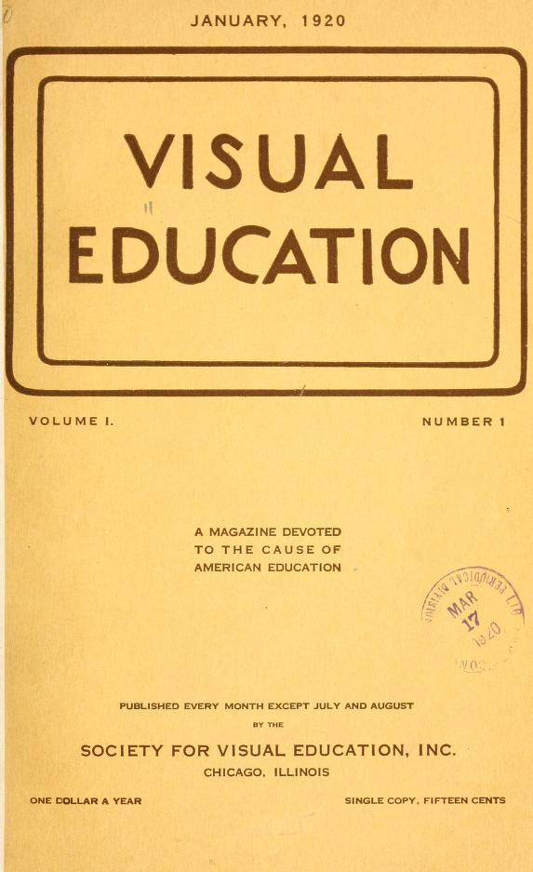
The Causes, Civil War Students

Standards Addressed
Standard
D1.1.9-12
D2.His.1.9-12
D3.1.9-12
D4.1.9-12

Objective (SWBAT)
Students will be able to identify and analyze the key causes of the Civil War by examining primary source documents and constructing an evidence-based argument about why the nation fractured in 1861.

Materials Needed
- Do Now handout with Documents A and B (two maps: enslaved population distribution 1860, industrial development 1860)
- Lincoln Inaugural Address excerpt (printed or projected)
- Document C: South Carolina Declaration of Causes of Secession excerpt
- Document D: Republican Party Platform 1860 excerpt
- HAPP Analysis graphic organizer (pre-filled historical context column)
- SECC Framework note-taking sheet
- Independent Practice packet with scaffolded writing frames
- Exit Ticket (3 questions, printed half-sheet)
- Homework assignment written on board/Google Classroom: Castle Learning link
- Highlighters (yellow for vocabulary clarification)
- Bilingual vocabulary reference sheet (English/Spanish key terms)

Lesson at a Glance
Section | Time
Do Now / Warm-Up | 5 min
Direct Instruction | 20 min
Guided Practice | 15 min
Independent Work | 10 min
Exit Ticket | 5 min
Total | 55 min

Do Now / Warm-Up (5 min)
Examination Compare: Students will receive two documents side-by-side.
DOCUMENT A: Map showing the distribution of enslaved population in the United States, 1860 (shaded by percentage). Note the heavy concentration in the Deep South.
DOCUMENT B: Map showing industrial development in the United States, 1860 (showing factories, railroads, and manufacturing centers concentrated in the Northeast and Midwest).
Written Response (3 minutes): In your own words, describe ONE key difference between these two maps. Then, predict: How might this difference create tension between the North and South? Write 2-3 sentences.
Comparación: Examine los dos mapas. Escriba una diferencia importante en 2-3 oraciones.

Direct Instruction (20 min)
Alright historians, gather round! Today we're diving into one of the most consequential moments in American history — the causes that led to the Civil War. Before we crack open our sources, let me give you the framework we'll use to organize our thinking.
Slide 1 - The FOUR CAUSES Framework:
I call this our SECC Framework for the Civil War:
• SECTIONAL ECONOMIC DIFFERENCES (Diferencias Económicas Sectionales)
• EXPANSION AND SLAVERY'S SPREAD (Expansión y la Esclavitud)
• CONSTITUTIONAL INTERPRETATION DISPUTES (Disputas de Interpretación Constitucional)
• CULTURAL AND SOCIAL DIVERGENCE (Divergencia Cultural y Social)
Write this down. We'll return to these categories throughout our document analysis.
Now, let's establish some context. By 1860, the United States had developed two distinct societies. The North was industrializing rapidly — factories in Pennsylvania, textile mills in New England, railroads connecting cities. The South, meanwhile, remained agricultural and dependent on a plantation system that relied on enslaved labor to produce cotton, tobacco, and other cash crops.
Here's a key term for you: SECESSION — the formal withdrawal of a state from the Union. When South Carolina did this in December 1860, followed by six other Deep South states by February 1861, they claimed it was their constitutional right.
Check for understanding: Turn to your neighbor. Person A — explain in ONE sentence why the South claimed secession was legal. Person B — explain in ONE sentence why the North rejected this claim. You have 60 seconds. Go!
Now, let's examine our first primary source — President Abraham Lincoln's Inaugural Address from March 4, 1861:
PRIMARY SOURCE EXCERPT:
"I hold that in contemplation of universal law and of the Constitution the Union of these States is perpetual. Perpetuity is implied, if not expressed, in the fundamental law of all national governments. It is safe to assert that no government proper ever had a provision in its organic charter for its own termination... It follows from these views that no State upon its own mere motion can lawfully get out of the Union."
Highlight in YELLOW any words you need clarified. I'll come around.
Key terms defined IN CONTEXT:
• Perpetuity = lasting forever, without end
• Contemplation = careful thought and consideration
• Organic charter = the foundational document that establishes a government
• Mere motion = simply by deciding to do so
Now we apply our HAPP Analysis — but remember, for this class I use it with historical thinking skills:
H — HISTORICAL CONTEXT: Lincoln gave this speech just weeks before Confederate forces attacked Fort Sumter. Seven states had already seceded. The nation was on the brink.
A — AUDIENCE: Who was Lincoln speaking to? BOTH the loyal states of the North AND the newly formed Confederacy. He needed to appeal to both.
P — POINT OF VIEW: Lincoln was the newly inaugurated President. He had just taken office after a deeply divided election where he won only 40% of the popular vote. He had NO electoral support in the South.
P — PURPOSE: Lincoln's purpose was to reassure the North that he would not start a war, while simultaneously asserting that secession was illegal and that the Union was permanent.
Pause. What do I see hands? Yes, question from the back...
Students often ask: 'But wasn't this just about slavery?' Excellent question — and the answer requires us to examine multiple perspectives. The institution of slavery was central, but different groups had different motivations. Let's build this complexity together.
Check for understanding: According to Lincoln's speech, what is his LEGAL argument against secession? Call on three students to complete this sentence frame:
Lincoln argues that the Union is __________ (perpetual/indestructible) because __________ (implied in the Constitution) and therefore __________ (no state can lawfully leave).
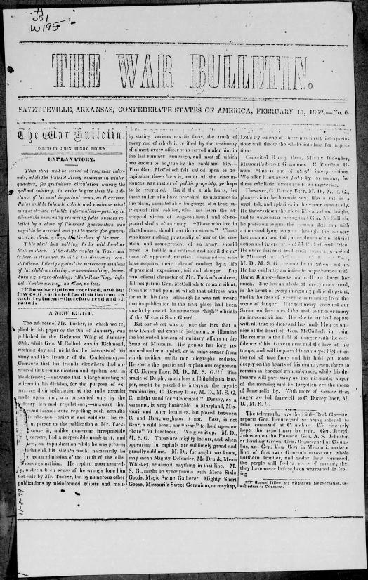
Civil War, I hold that in contemplation of universal law and of the Constitution the Union of these States is perpetual. Perpetuity is implied, if not expressed, in the fundamental law of all national governments. It is safe to assert that no government proper ever had a provision in its organic charter for its own termination... It follows from these views that no State upon its own mere motion can lawfully get out of the Union.

Guided Practice (15 min)
Now we're moving to WE DO territory. You'll work in PAIRS to analyze two additional primary sources using our SECC Framework and HAPP method.
INSTRUCTIONS (both English and Spanish):
English: With your partner, analyze Documents C and D. Complete the HAPP analysis for EACH document. Then, answer the analysis questions below using our SECC framework. You have 12 minutes for this activity.
Español: Con su compañero, analice los Documentos C y D. Complete el análisis HAPP para CADA documento. Luego, responda las preguntas de análisis usando el marco SECC.
DOCUMENT C - Source: South Carolina Declaration of Causes of Secession, December 24, 1860
EXCERPT:
"We affirm that these ends for which this Government was instituted have been defeated, and the Government itself has been made destructive of them by the action of the non-slaveholding States. Those States have assume the right of deciding upon the propriety of our domestic institutions; and have denied the rights of property established in fifteen of the States and recognized by the Constitution..."
"...The Constitution of the United States, in its fourth article, provides that 'the Citizens of each State shall be entitled to all privileges and immunities of Citizens in the several States.' We think that in one of these articles of that instrument, the right of property in slaves is recognized..."
DOCUMENT D - Source: Republican Party Platform, 1860
EXCERPT:
"That the new dogma that the Constitution of its own force carries slavery into any or all of the territories of the United States, is a dangerous political heresy... That the normal condition of all the territory of the United States is that of freedom..."
PAIR ACTIVITY - TURN AND TALK STRUCTURE:
• Person A: First 3 minutes — Explain to your partner what South Carolina's main grievance is (use the document!).
• Person B: Next 3 minutes — Explain what the Republican Party's position is on slavery in the territories.
• Together: Final 6 minutes — Complete the written analysis below.
ANALYSIS QUESTIONS:
1a. According to Document C, what RIGHT is South Carolina claiming has been violated by Northern states? (1 point)
1b. According to Document D, what 'new dogma' are Republicans rejecting about slavery? (1 point)
1c. COMPLETE THE FRAME: "Both South Carolina and the Republican Party claimed the Constitution supported their position on slavery. However, they disagreed about whether the Constitution protected __________ (the right to own slaves / the right to prohibit slavery) in the territories."
2. CLASSIFICATION: Using our SECC framework, which category BEST explains why Southern states seceded? Provide evidence from Document C to support your classification.
Sentence Frame for Support:
"The secession of South Carolina demonstrates __________ (SECTIONAL ECONOMIC DIFFERENCES / EXPANSION AND SLAVERY'S SPREAD / CONSTITUTIONAL INTERPRETATION DISPUTES / CULTURAL AND SOCIAL DIVERGENCE) because __________."
3. SYNTHESIS: In what ways do these documents reveal that the North and South had developed different interpretations of the same constitutional principles?
Sentence Frame (fill in the blanks):
"Both sides claimed the Constitution supported their position. However, the South argued that the Constitution protected __________, while the North interpreted it to mean __________. This demonstrates how the same document was being used to support __________ (opposite / similar) conclusions."
I'll be circulating during this activity. I'm looking for:
• Are partners actually discussing — not just dividing the work?
• Are they using TEXT EVIDENCE from the documents, not just their prior knowledge?
• Are they correctly identifying the constitutional dispute at the heart of secession?
Circulate and listen for: Students who say 'they disagreed about slavery' without specifying HOW they disagreed — redirect them to the documents for the specific constitutional argument.

Independent Work (10 min)
INDEPENDENT PRACTICE — 10 MINUTES
Instructions: Complete this activity INDIVIDUALLY. You may not collaborate with your neighbor. Show your thinking by writing in complete sentences and citing evidence from the documents we analyzed today.
PART A: Document-Based Question (DBQ) - Scaffolded Writing Frame
Using our SECC framework and evidence from ALL documents discussed in class (A, B, C, D, and Lincoln's Inaugural Address), construct a response to the following question:
QUESTION: Why did the United States erupt into civil war in 1861?
THESIS STATEMENT FRAME (Complete this first):
"The United States erupted into civil war in 1861 because __________ (identify 2-3 causes from the SECC framework). Specifically, __________ (explain the first cause with specific evidence), and __________ (explain the second cause with specific evidence)."
BODY PARAGRAPH SENTENCE STARTERS:
"The first major cause of the Civil War was __________ (choose from SECC). This is demonstrated in Document __________ (letter) which states that '__________ (insert relevant quote or paraphrase from document).' This shows that __________ (explain what the evidence proves)."
"Additionally, the second cause was __________. This is supported by Document __________ which provides evidence that __________. This reveals that __________."
PART B: CONCEPTUAL ANALYSIS
4. Which of the four SECC causes do you believe was the MOST SIGNIFICANT cause of the Civil War? Defend your choice with specific evidence from at least TWO documents analyzed in class. (5 points)
Sentence Frame:
"I argue that __________ (SECC category) was the most significant cause because __________. This is proven by Document __________ which shows __________ and Document __________ which demonstrates __________. While other causes like __________ were also important, the evidence most strongly supports that __________."
EARLY FINISHER EXTENSION:
If you complete Part A and Part B with quality evidence, complete this additional challenge:
5. CONNECT TO TODAY: How might the constitutional disputes of the 1850s-1860s inform debates about federal vs. state power today? Provide one specific modern example where similar constitutional tensions exist.
Work to be submitted: Place your completed work in the tray at the front of the room. Remember to write your NAME and PERiOD on your paper.

Exit Ticket
1. Identify the FOUR causes of the Civil War using our SECC framework. (4 points)
2. According to President Lincoln's Inaugural Address, why did he argue that secession was unconstitutional? Provide specific textual evidence from the document. (4 points)
3. Analyze how the documents we examined today reveal that the North and South had developed fundamentally different interpretations of the Constitution regarding slavery and states' rights. Your answer should reference at least TWO documents. (5 points)

Differentiation
Struggling  Learners | Sentence frames provided for ALL written responses — students complete blanks rather than generating full sentences independently, HAPP Analysis graphic organizer pre-filled with historical context information to reduce cognitive load during document analysis, Reduced question count option: Students may complete Questions 1, 2, and 3a/3b only, OR complete all questions with the assistance of a partner

Advanced  Learners | Extension: Students analyze an additional document (Frederick Douglass's 1852 speech 'What to the Slave is the Fourth of July?') and write a comparative analysis of how Douglass's perspective on the causes of the Civil War differs from Lincoln and the secessionists, Challenge: Construct a counterargument — What evidence might support the claim that the Civil War was NOT primarily about slavery? How would you refute this using our documents?, DBQ bonus: Write an additional body paragraph analyzing a SECOND secondary cause of the Civil War, connecting it to the Long-Term vs. Short-Term causation concept

ELL  Support | Key vocabulary displayed with bilingual definitions: Secesión (Secession), Esclavitud (Slavery), Constitutional/Constitucional, Perpetuo (Perpetual), Derechos de los estados (States' Rights), Graphic organizers available with visual representations of the SECC framework — students can match evidence to categories rather than writing extensively, Partner pairing: ELL students paired with bilingual partner or strong academic English speaker who can help clarify document meaning during turn-and-talk

Homework
Weekly Docket Assignment - Castle Learning (Posted on Google Classroom)
Complete the following before our next class:
1. Read the attached excerpt from the Lincoln-Douglas Debates (1858) — specifically the 'House Divided' speech.
2. Answer the corresponding questions on Castle Learning. This assignment is worth 15 POINTS and will be checked for completion.
3. COMING ATTRACTION for next class: We will examine how the Kansas-Nebraska Act and the caning of Senator Charles Sumner further escalated sectional tensions.
Record any questions you have from tonight's reading. Bring these questions to class — we'll address them in our Do Now discussion.
Recordatorio: Lea los documentos de la tarea semanal. Responda las preguntas en Castle Learning antes de la próxima clase.

Generated by Claw-ED

