The Causes of the Civil War
Mr. Mac | March 27, 2026
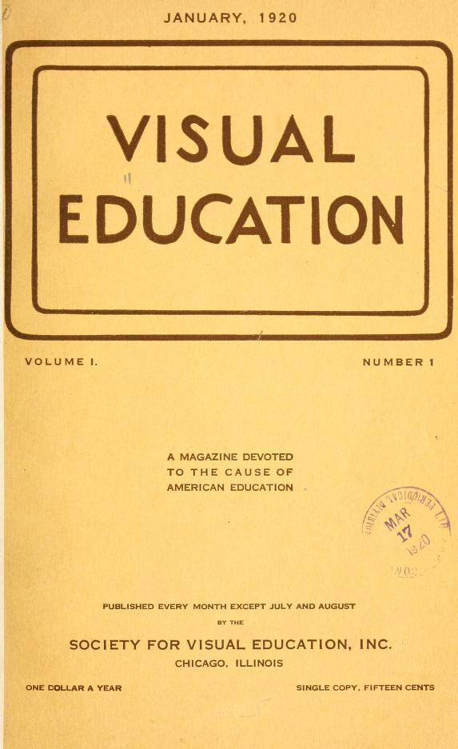
The Causes, Civil War Students
Do Now
Do Now (5 minutes):
Post on screen: A political cartoon showing a house divided in half, with a caption reading "The United States: One Nation Under God?"
Directions: Examine the political cartoon above and answer the following questions independently in your notes:
1. What visual elements suggest conflict or division? (1-2 sentences)
2. Based on what you observe, predict what this cartoon might be critiquing or warning about. (2-3 sentences)
3. Turn to your partner (30 seconds each): Share your prediction. Do you agree or disagree? Why?
Transition: Alright historians, you just analyzed a primary source without knowing the context. Today, we're stepping into the shoes of 19th century Americans who watched their nation tear itself apart. Your job is to figure out why these divisions became so (致命 means deadly/destructive) that war became inevitable. Ready? Let's dig in.
Aim
Students will be able to identify and analyze the key economic, political, and social factors that contributed to the outbreak of the Civil War, citing evidence from primary sources to support their conclusions.
Key Content
Direct Instruction (20 minutes):
SLIDE 1 - AIM: Analyze the economic, political, and social factors that led to the Civil War.
SLIDE 2 - Key Terms (Box Notes): Distribute Box Notes sheet with the following terms and definitions:
- SECTIONALISM: Loyalty to one's own region over the nation as a whole
- SLAVERY: Legal ownership of human beings as property
- ABOLITION: Movement to end slavery entirely
- COMPROMISE: Agreement where each side gives up something
- SECESSION: Formal withdrawal from the Union
- MANIFEST DESTINY: Belief that the US was destined to expand across North America
Say: Copy these into your notes. These terms will be your weapons today. Understand them, own them, use them.
SLIDE 3 - The Economic Divide
Display a T-Chart comparing North and South economic systems:
NORTH: Factories, railroads, immigration, wage labor, protective tariffs
SOUTH: Plantation agriculture, cotton export, slave labor, free trade, agricultural economy
Say: Look at this comparison. I want you to identify one way these economies were in direct competition with each other.
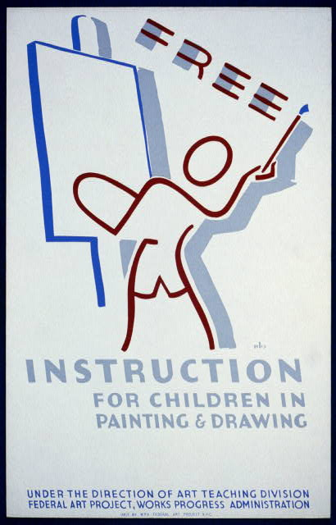
Direct Instruction, Civil War
Activity
Guided Practice (15 minutes):
Teacher and students work through Document Analysis using CAPP Framework together.
DISTRIBUTE: CAPP Graphic Organizer
CAPP FRAMEWORK COLUMNS:
- CONTEXT: When and where was this source created? What is the historical situation?
- AUTHOR: Who created this source? What is their background and position?
- PURPOSE: Why was this source created? What was the creator trying to achieve?
- POINT OF VIEW: What biases or perspectives are present? What is left unsaid?
DOCUMENT FOR ANALYSIS (display on screen):
Document E: From the Articles of Secession, Mississippi, 1861:
"Our position is thoroughly identified with the institution of slavery—the greatest material interest of the world. Its labor supplies the product which constitutes by far the largest and most important portions of commerce of the earth... These products are peculiar to the climate belt of the Northern Hemisphere; and cannot be produced to any important extent in the Northern Hemisphere except in the United States."
Say: I'm going to model how to complete the CAPP framework. Watch how I think through this.
MODELING - Teacher completes first row:
CONTEXT: Mississippi seceded from the Union on January 9, 1861, after Lincoln's election but before his inauguration. The Civil War was about to begin.
AUTHOR: The convention of Mississippi delegates who wrote the secession document. They represented the planter class and political elite of the Deep South.
PURPOSE: To justify and explain to other Southern states why secession was necessary. To build support for the Confederacy.
POINT OF VIEW: They view slavery as essential to their economic survival and identity. They do not consider the perspective of enslaved people. They frame secession as defensive, not aggressive.
Say: Notice I didn't just copy facts—I inferred. I'm thinking about what the author is NOT saying as much as what they ARE saying.
Now your turn. Complete CAPP for Document F with your partner.
DOCUMENT FOR ANALYSIS (distribute as half-sheet):
Document F: From Abraham Lincoln's First Inaugural Address, March 4, 1861:
"This country, with its institutions, belongs to the people who inhabit it. Whenever the people shall grow weary of the existing government, it is their right and duty to throw off such government and to provide new guards for their future security."
Say: You have 6 minutes. Complete all four columns. Remember: reword don't copy. Underline the question being asked in your notes.
Circulate: Check that students are:
- Identifying the author (Lincoln) and context (just before war begins)
- Noting the contradiction: Lincoln quotes the Declaration of Independence but applies it to preserving the Union, not ending slavery
- Recognizing Lincoln's rhetorical strategy: he's trying to prevent war by appealing to shared values
MONITORING QUESTIONS to ask students while circulating:
- Who is Lincoln's audience here? What does he want them to do?
- Why might he quote the Declaration of Independence?
- What is he NOT addressing in this passage?
After 6 minutes, say: Tables, share your CAPP with the group next to you. Find one point of agreement and one point of disagreement. (3 minutes)
Whole class: Who wants to share a key insight from their analysis? (Take 2-3 responses)
Transition: Based on your analysis, we now have multiple perspectives on why this nation fractured. Let's synthesize what we've learned.

Independent Practice
Independent Work (10 minutes):
DISTRIBUTE: TEA Writing Frame for Constructed Response
TEA FRAMEWORK:
- TOPIC SENTENCE: Clear thesis that answers the prompt and previews evidence
- EVIDENCE: Specific, cited facts from documents analyzed today
- ANALYSIS: Explanation of WHY this evidence supports your thesis
PROMPT: Based on your analysis of the documents and discussion today, explain why the Civil War became inevitable despite previous attempts at compromise. Your response should:
1. State a clear thesis identifying the primary factors that made war unavoidable

2. Cite evidence from at least TWO documents analyzed in class

3. Explain how that evidence supports your argument
SENTENCE STARTER FOR STRUGGLING LEARNERS:
"The Civil War became inevitable because...
[Document Name] demonstrates that...
This evidence proves..."
EXPECTED RESPONSE FORMAT:
"The Civil War became inevitable because economic interests, political failures, and the expansion of slavery created an irreconcilable conflict between North and South. Document E shows that Mississippians viewed slavery as 'the greatest material interest of the world,' demonstrating that Southern identity was tied to the institution. Similarly, Document D reveals Lincoln's recognition that 'a house divided against itself cannot stand,' proving that even political leaders understood compromise was no longer possible. These sources reveal that once slavery became the central issue, peaceful resolution became impossible."
Say: You have 8 minutes to write. Use your CAPP notes and the documents. If you finish early, add a counterargument paragraph explaining what might have prevented war.
COLLECT: All TEA frames at the end of the period.
Differentiated Options:
- Struggling students may use the sentence starter
- Advanced students write the full essay including counterargument
- All students must include at least 2 cited documents

Exit Ticket
1. Identify one economic factor and one political factor that contributed to sectional tensions between the North and South before the Civil War.
2. Using the CAPP framework, explain how the author of Document F (Lincoln's Inaugural) and Document E (Mississippi Secession) would disagree about the right to leave the Union.
3. Predict: If you were a Northern businessman in 1860, how might your economic interests influence your position on slavery's expansion? Would you prioritize the Union or economic gain? Explain using evidence from today's lesson.

Name: _______________ | Date: _______________ | Period: ______
Generated by Claw-ED

