Lab Assignment – 1.4
AI Assisted Coding
K Siri Chandana – 2303A52256
Batch-43
Task 0
● Install and configure GitHub Copilot in VS Code.
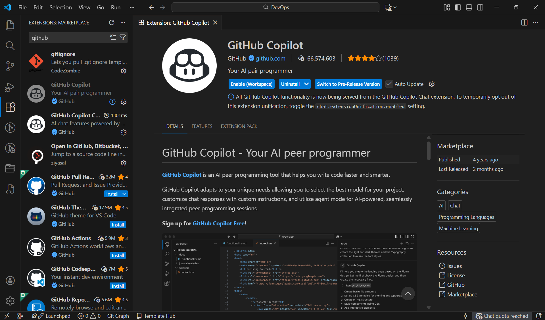

Task 1: AI-Generated Logic Without Modularization (Prime Number Check Without Functions)
Prompt:
Generate code to check whether a number is prime using user input without using function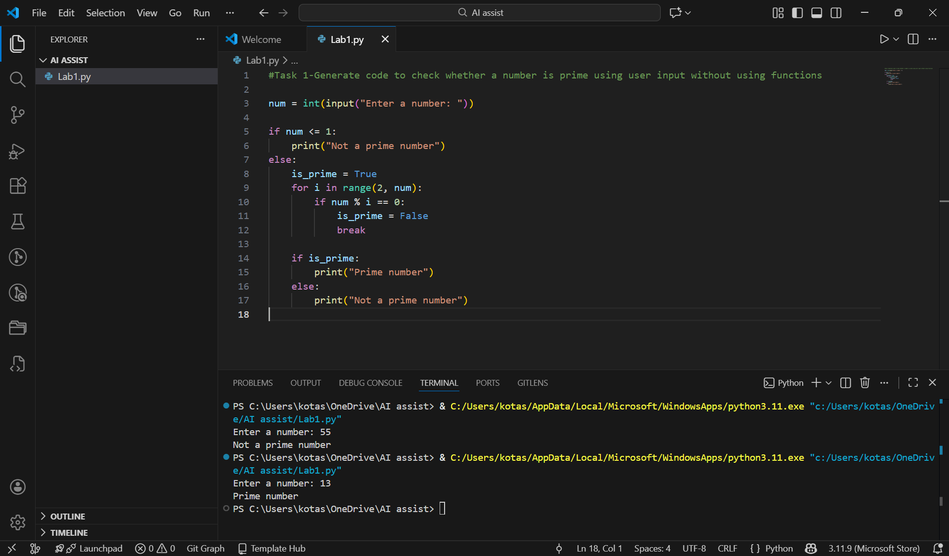

Code Explanation
- User input is taken using input()
- Numbers less than or equal to 1 are not prime
- Loop checks divisibility from 2 to n−1
- Output is printed based on divisibility result
Sample Input and Output
Input Output
55 not a prime number
13 Prime number

Task 2: Efficiency & Logic Optimization (Cleanup)
Prompt: Optimize prime number checking logic and improve efficiency
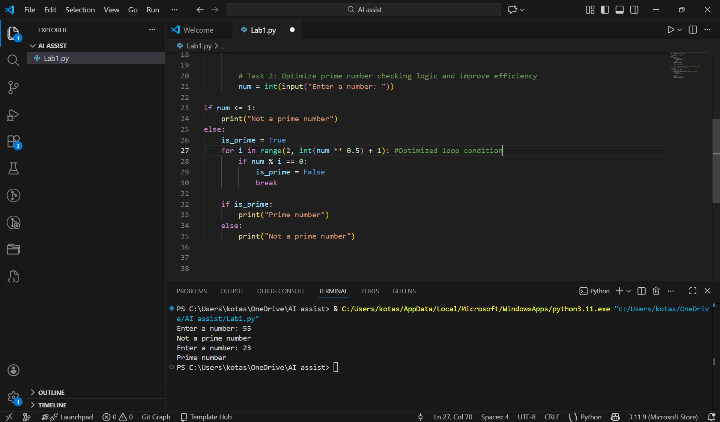
Code Explanation
- User input is taken using input()
- Numbers less than or equal to 1 are immediately marked as non-prime
- Instead of checking till num, the loop runs only till √num
- If any divisor is found, the loop terminates early using break
- This reduces unnecessary iterations and improves performance
Sample Input and Output
Input Output
23 Prime number

Task 3: Modular Design Using AI Assistance (Prime Number Check Using Functions)
Prompt: Generate Prime number check using a user-defined function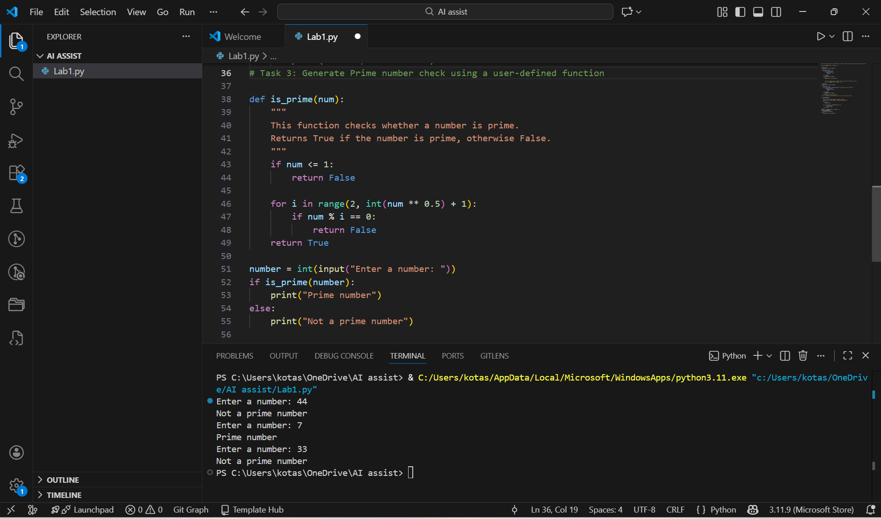
Code Explanation
- A function is_prime() is defined to check primality
- The function returns True if the number is prime, else False
- Loop runs only up to √n for efficiency
- Main program calls the function and prints the result
- This approach improves readability and reusability
Sample Input and Output
Input Output
33 not a prime number

Task 4: Comparative Analysis –With vs Without Functions
Prompt: Compare the above two programs based on code clarity, reusability, debugging ease, and scalability
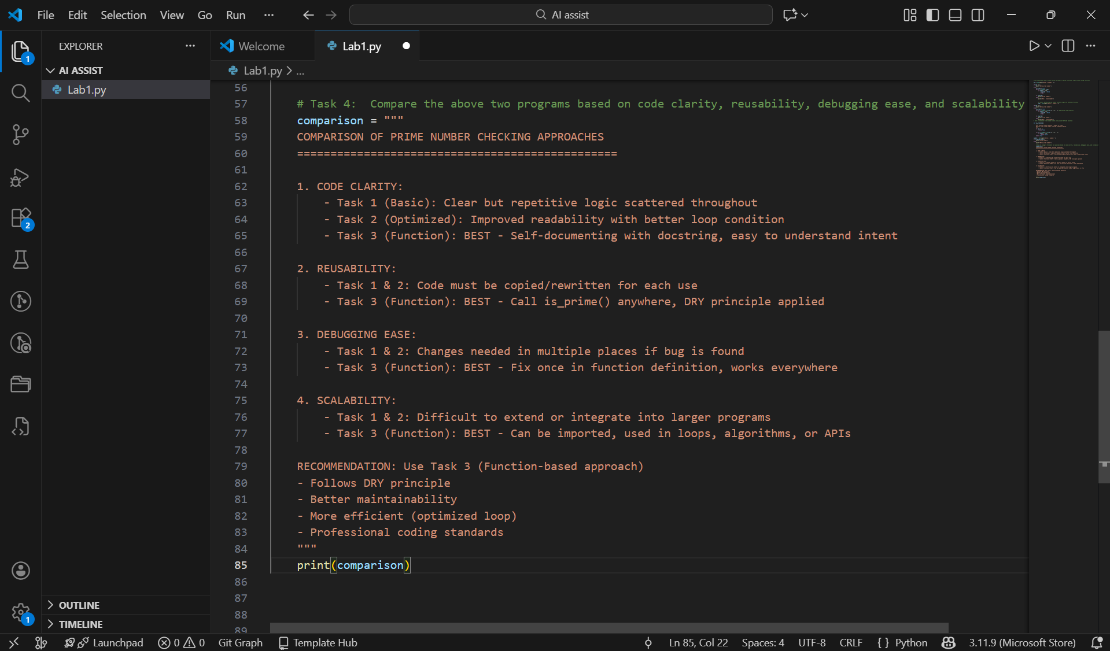

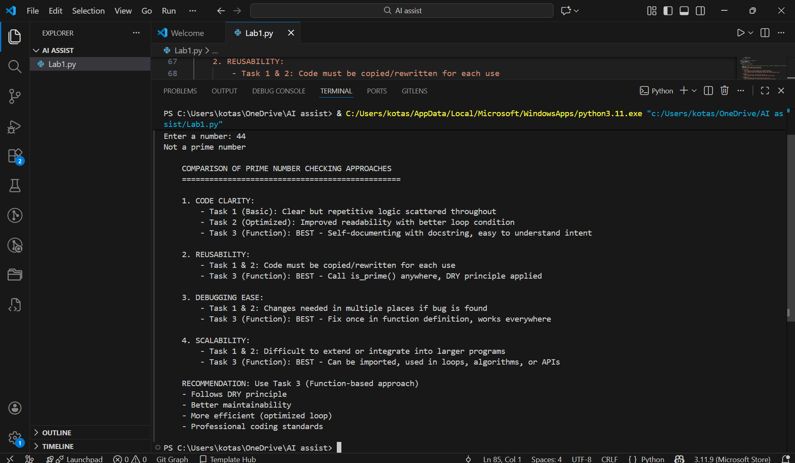
Analysis
- The program without functions is simple and suitable only for small tasks.
- The function-based program improves readability and modularity.
- Using functions allows code reuse and easier debugging.
- Function-based design is preferred in real-world and large-scale applications.

Task 5: AI-Generated Iterative vs Recursive Fibonacci Approaches (Different
Algorithmic Approaches to Prime Checking)
Approach 1: A basic divisibility check approach
Prompt: Write a basic prime number checking program using divisibility

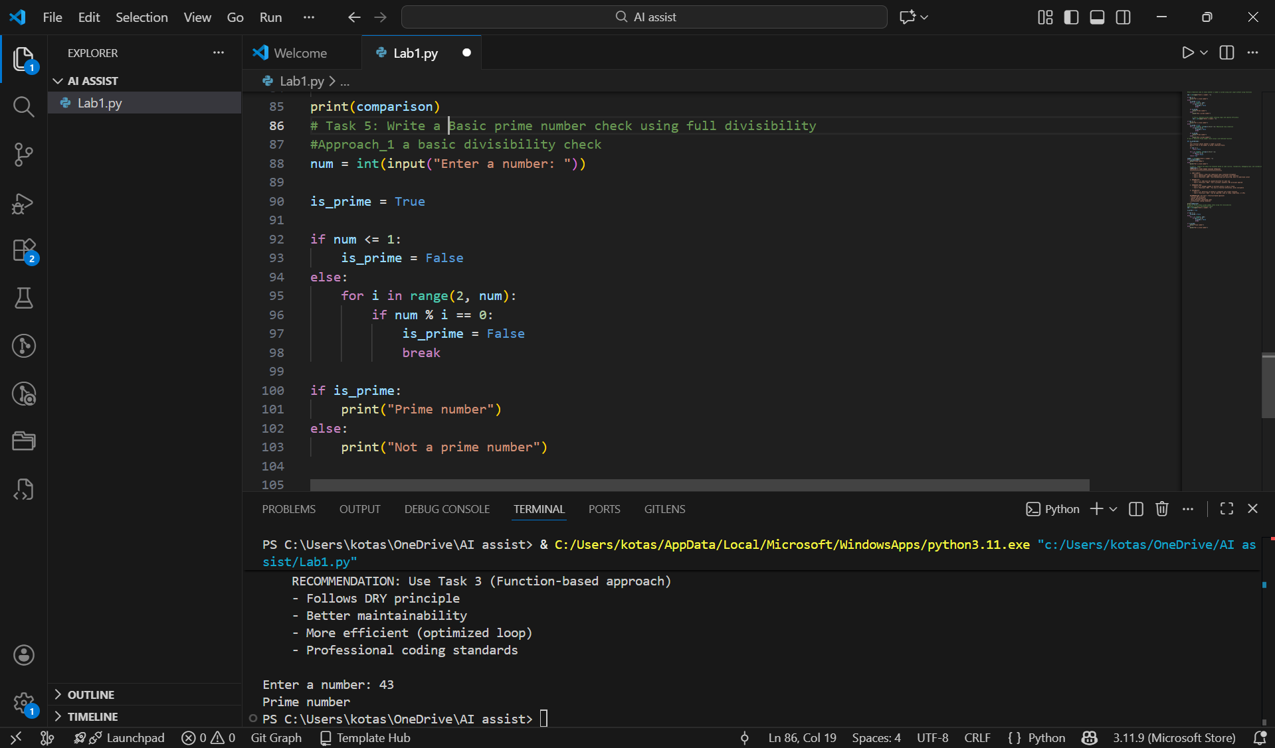

Code Explanation
- Takes user input
- Checks divisibility from 2 to n−1
- Stops when a factor is found
- Simple but inefficient for large numbers

Sample Input and Output
Input Output
43 Prime number

Approach 2: An optimized approach (e.g., checking up to √n)
Prompt: Optimized prime number check using square root method

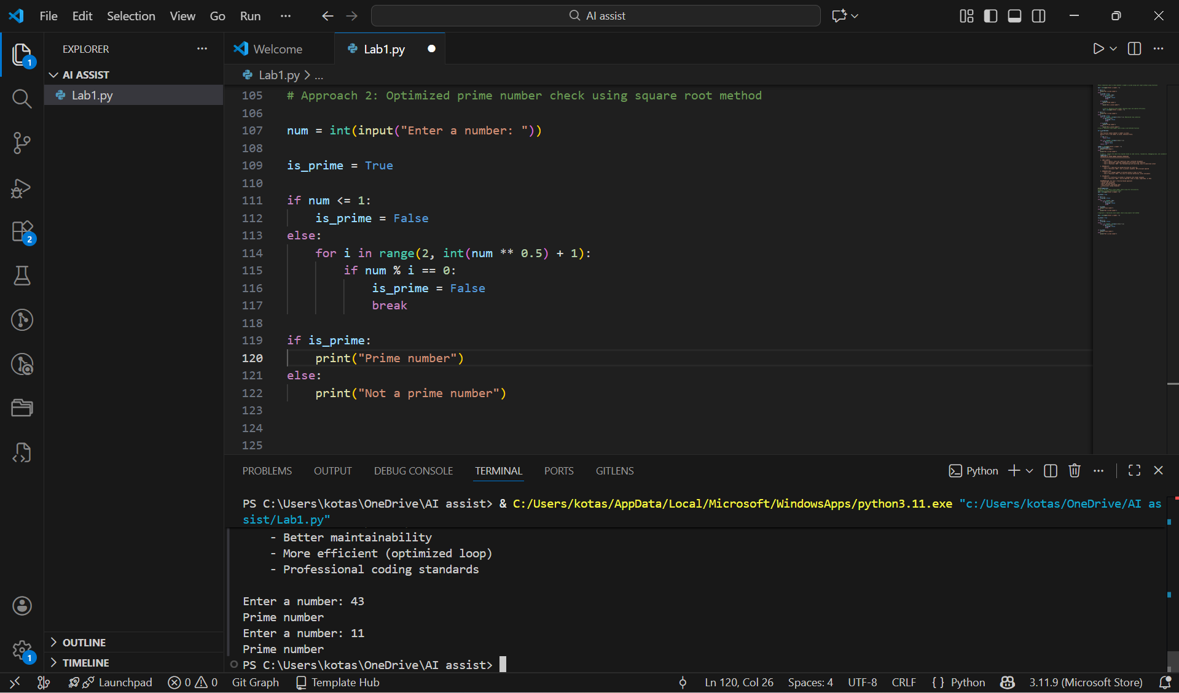

Code Explanation
- Loop runs only till √n
- Reduces unnecessary checks
- Efficient for large inputs
- Preferred in real applications

Sample Input and Output
Input Output
11 Prime number

