Lab Assignment- 4.4
Subject: AI Assisted Coding
K Siri Chandana – 2303A52256
Batch-43
PROBLEM 1: Sentiment Classification for Customer Reviews
1.1 Task (a & b):
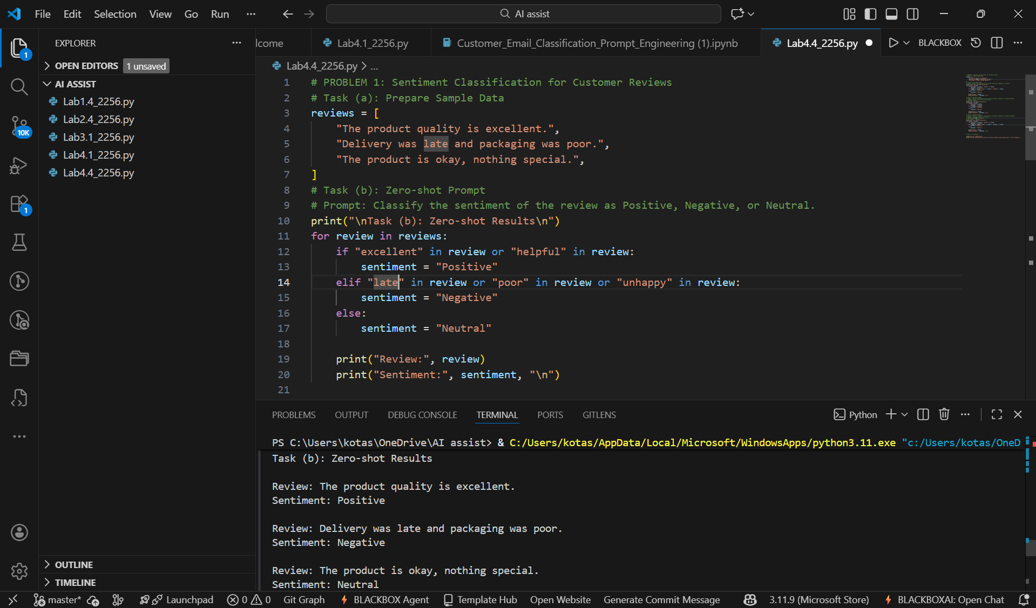

1.2 Task c:
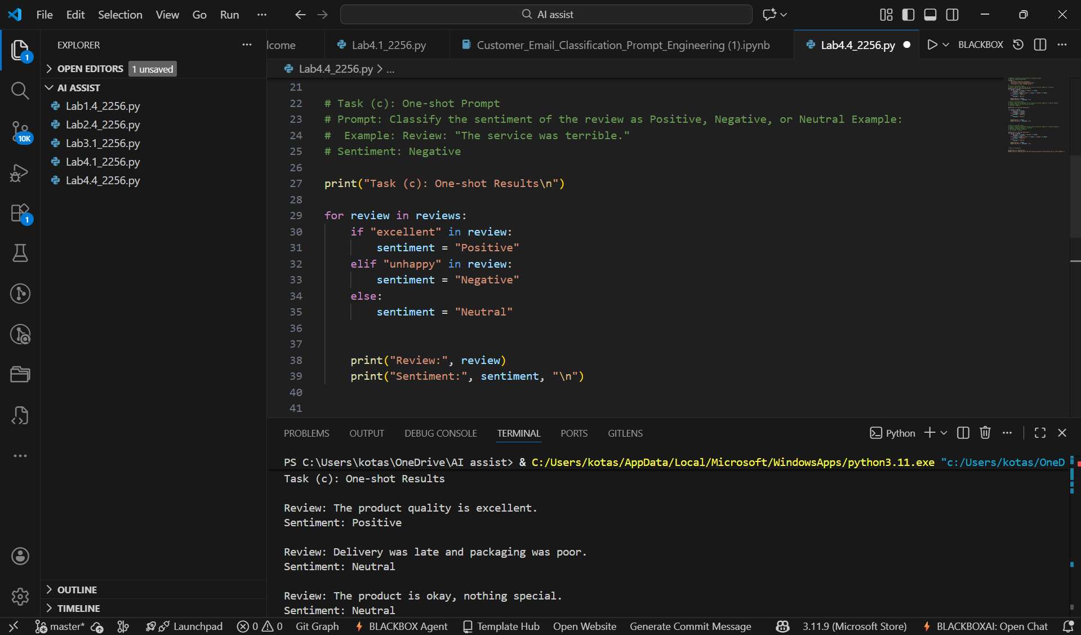

1.3 Task (d & e):
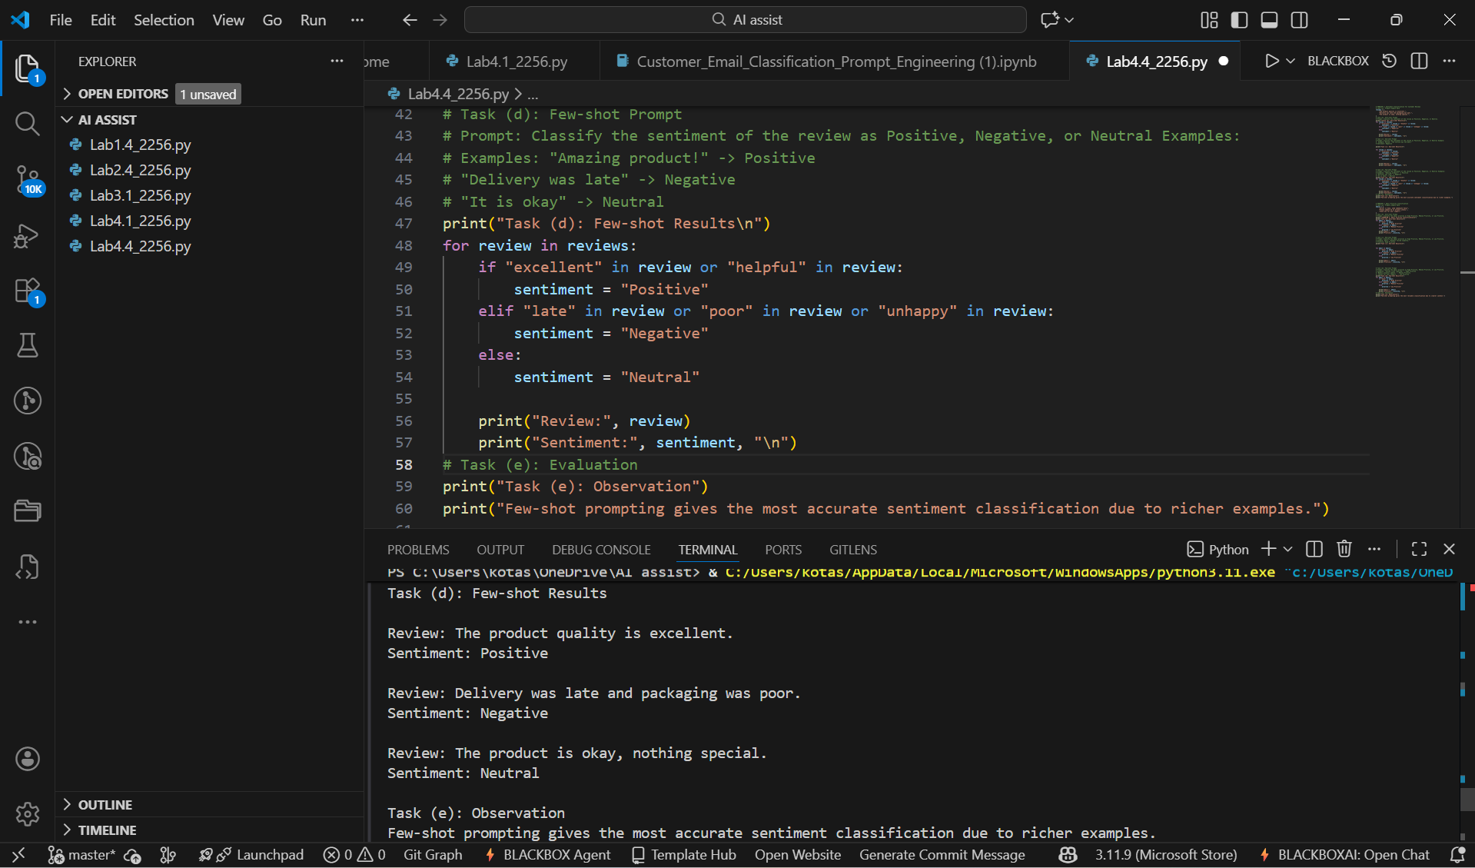

PROBLEM 2: Email Priority Classification
2.1 Task (a & b):
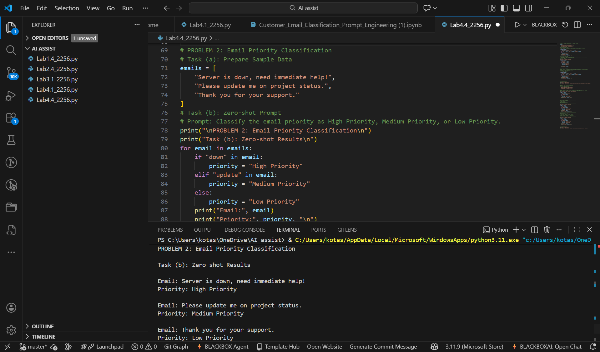

2.2 Task c:
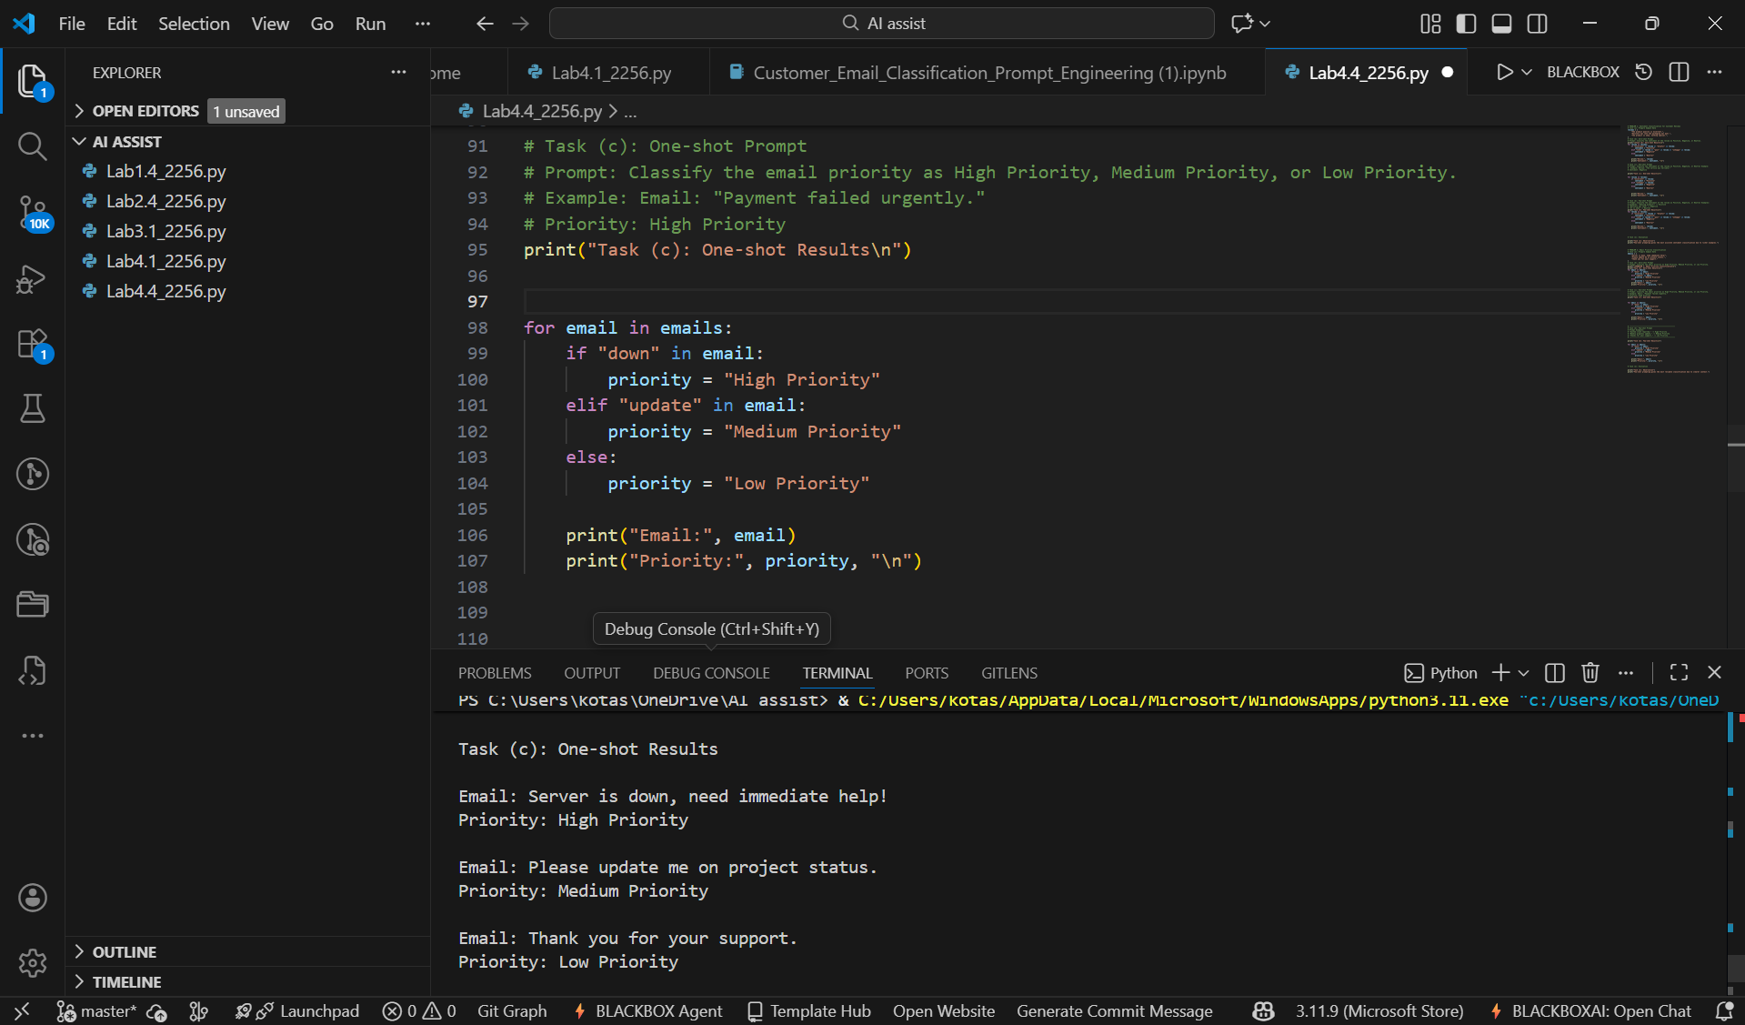

2.3 Task (d & e):
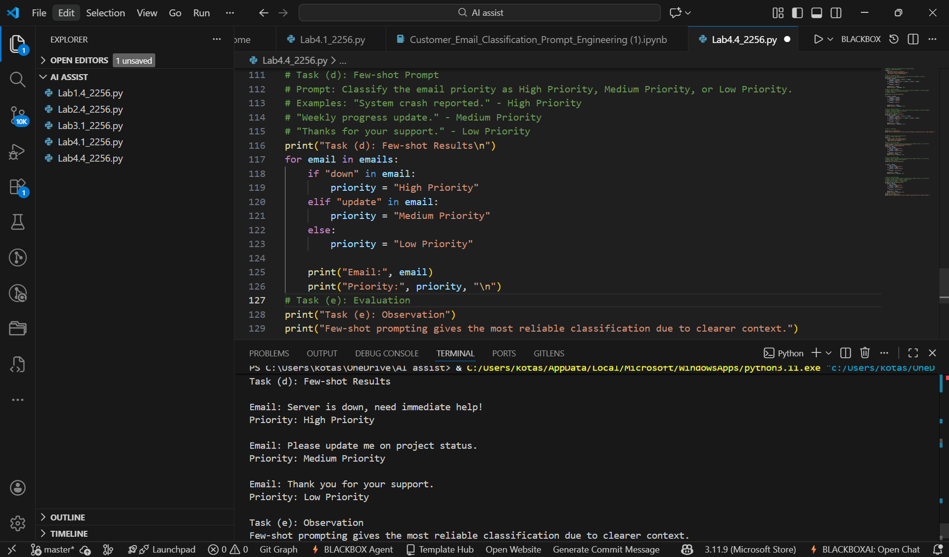

PROBLEM 3: Student Query Routing System
3.1 Task (a & b):
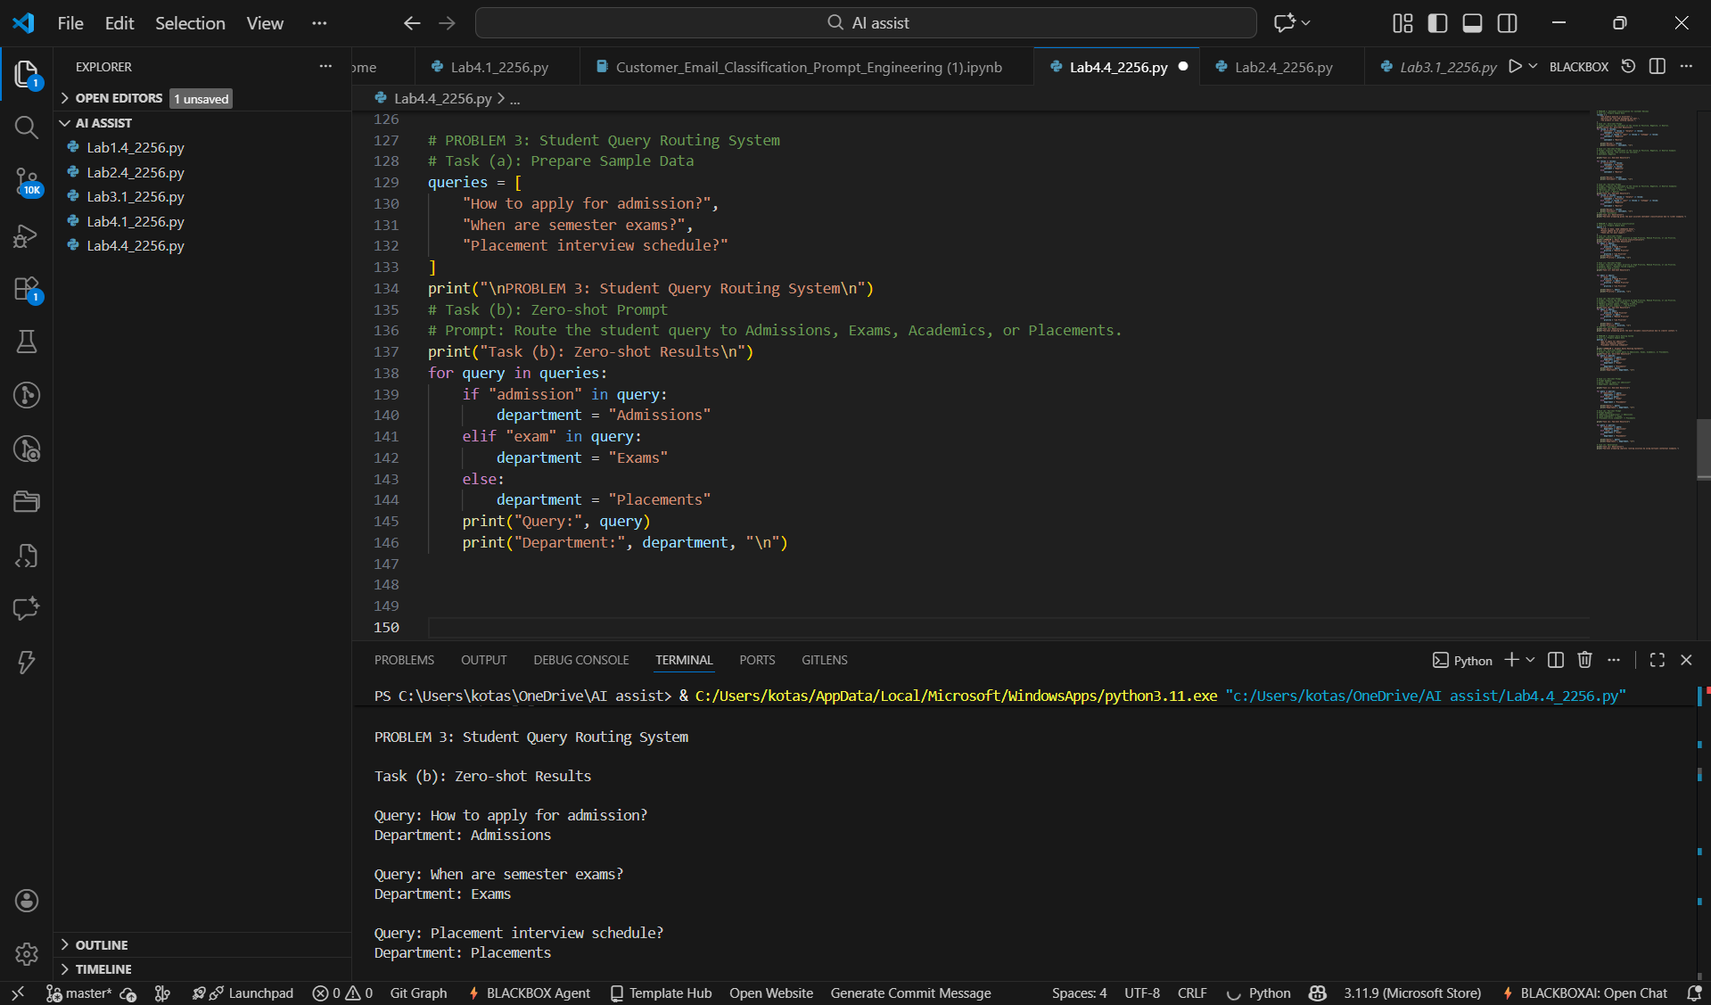

3.2 Task c:
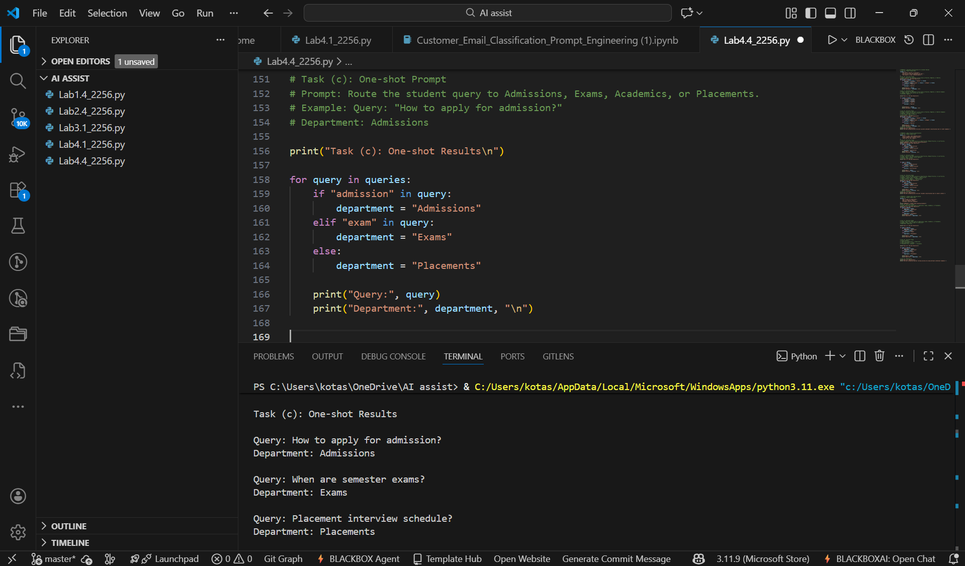

3.3 Task (d & e):
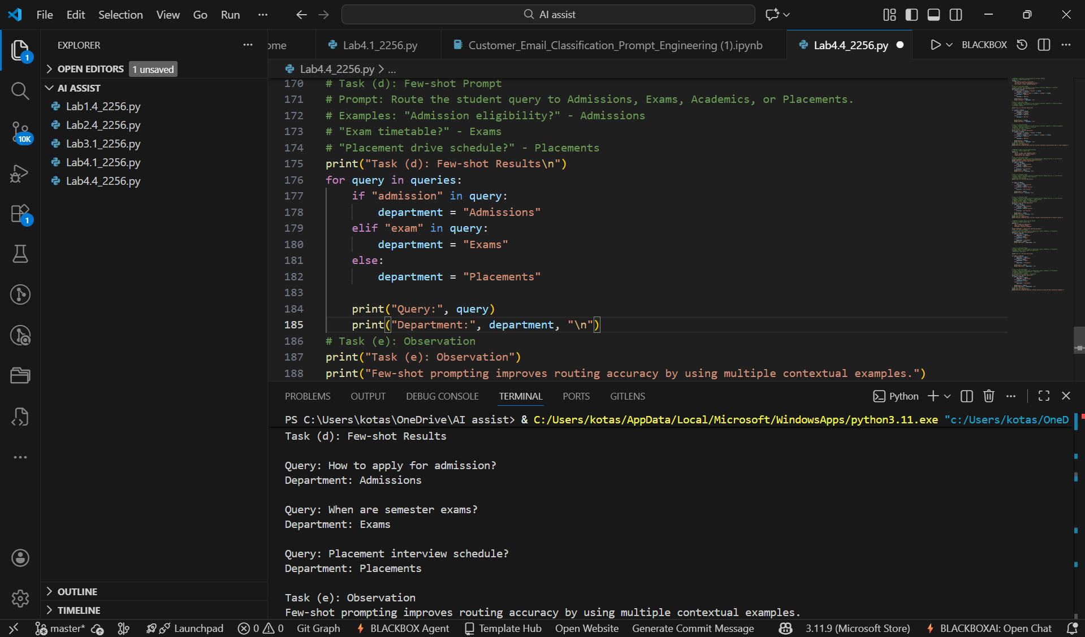

PROBLEM 4: Chatbot Question Type Detection
4.1 Task (a & b):
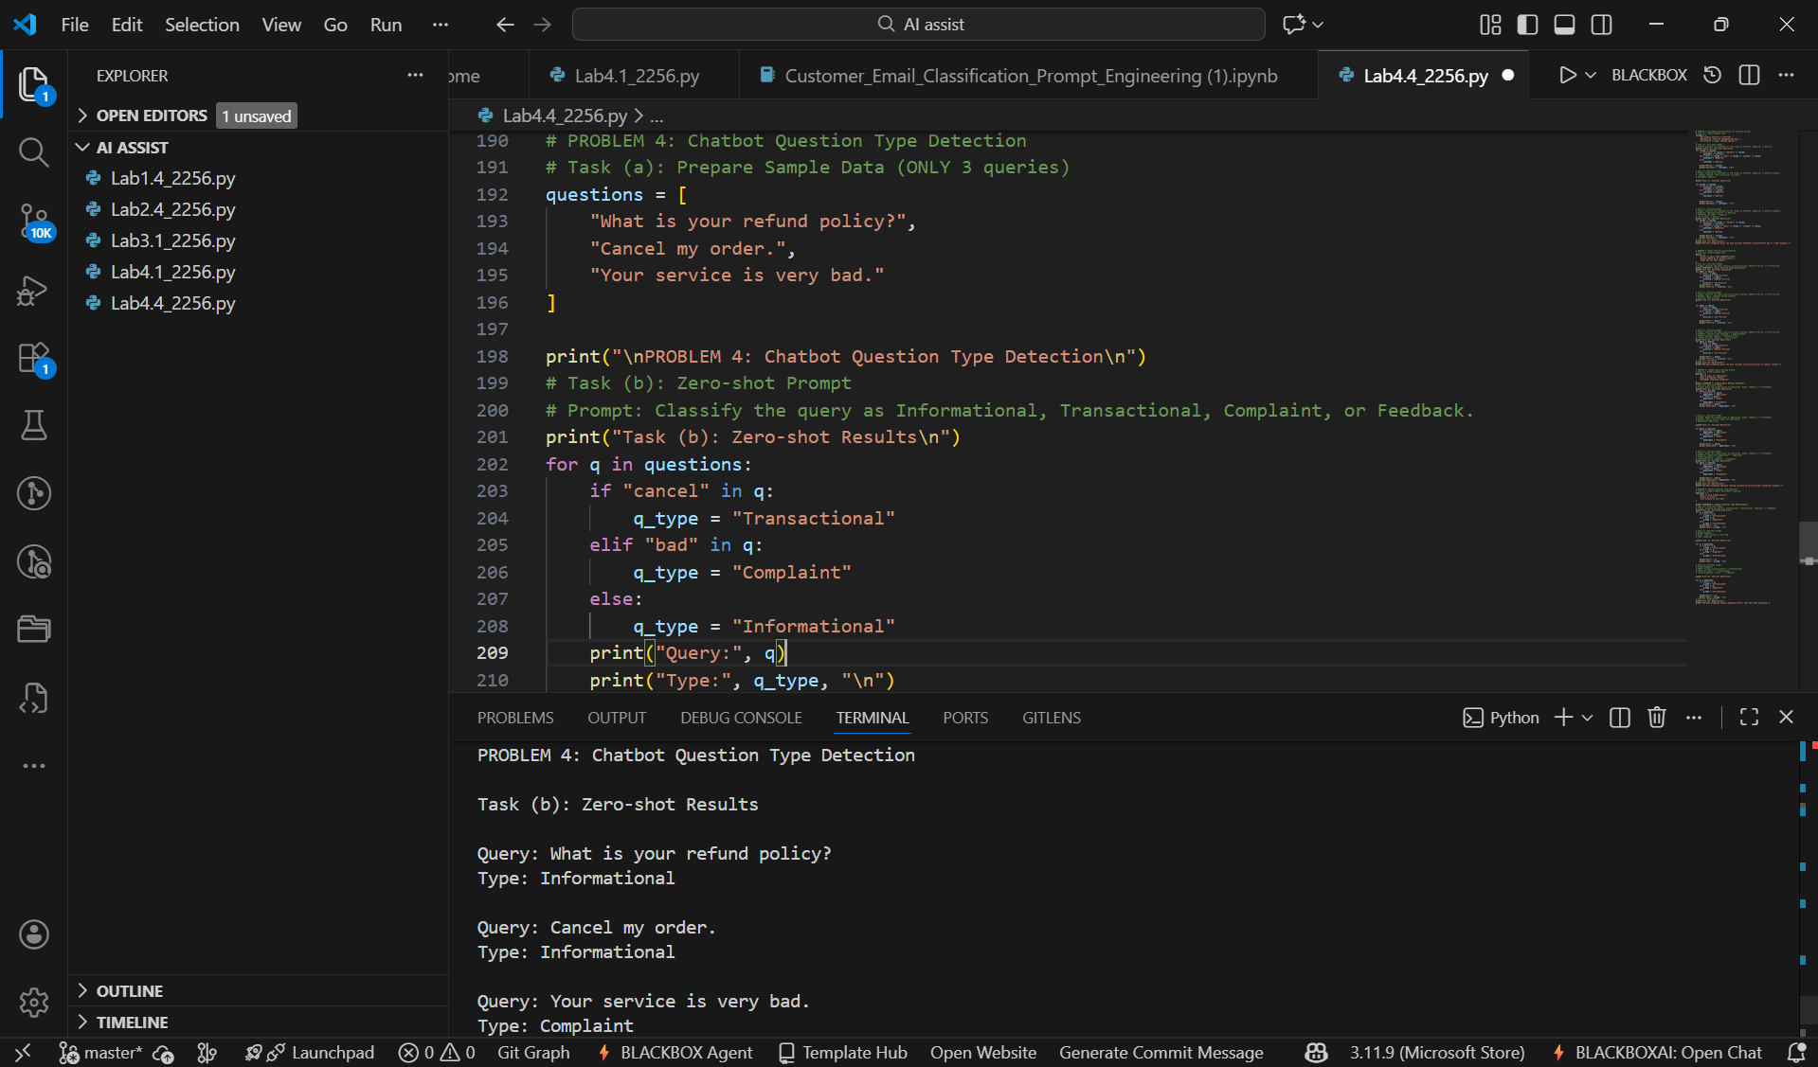

4.2 Task c:
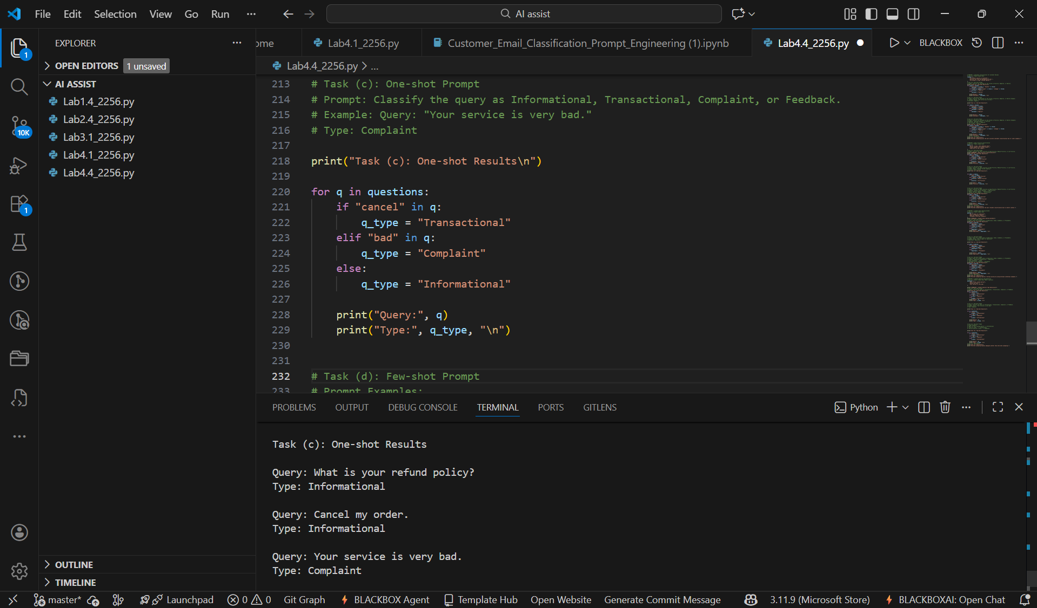

4.3 Task (d & e):
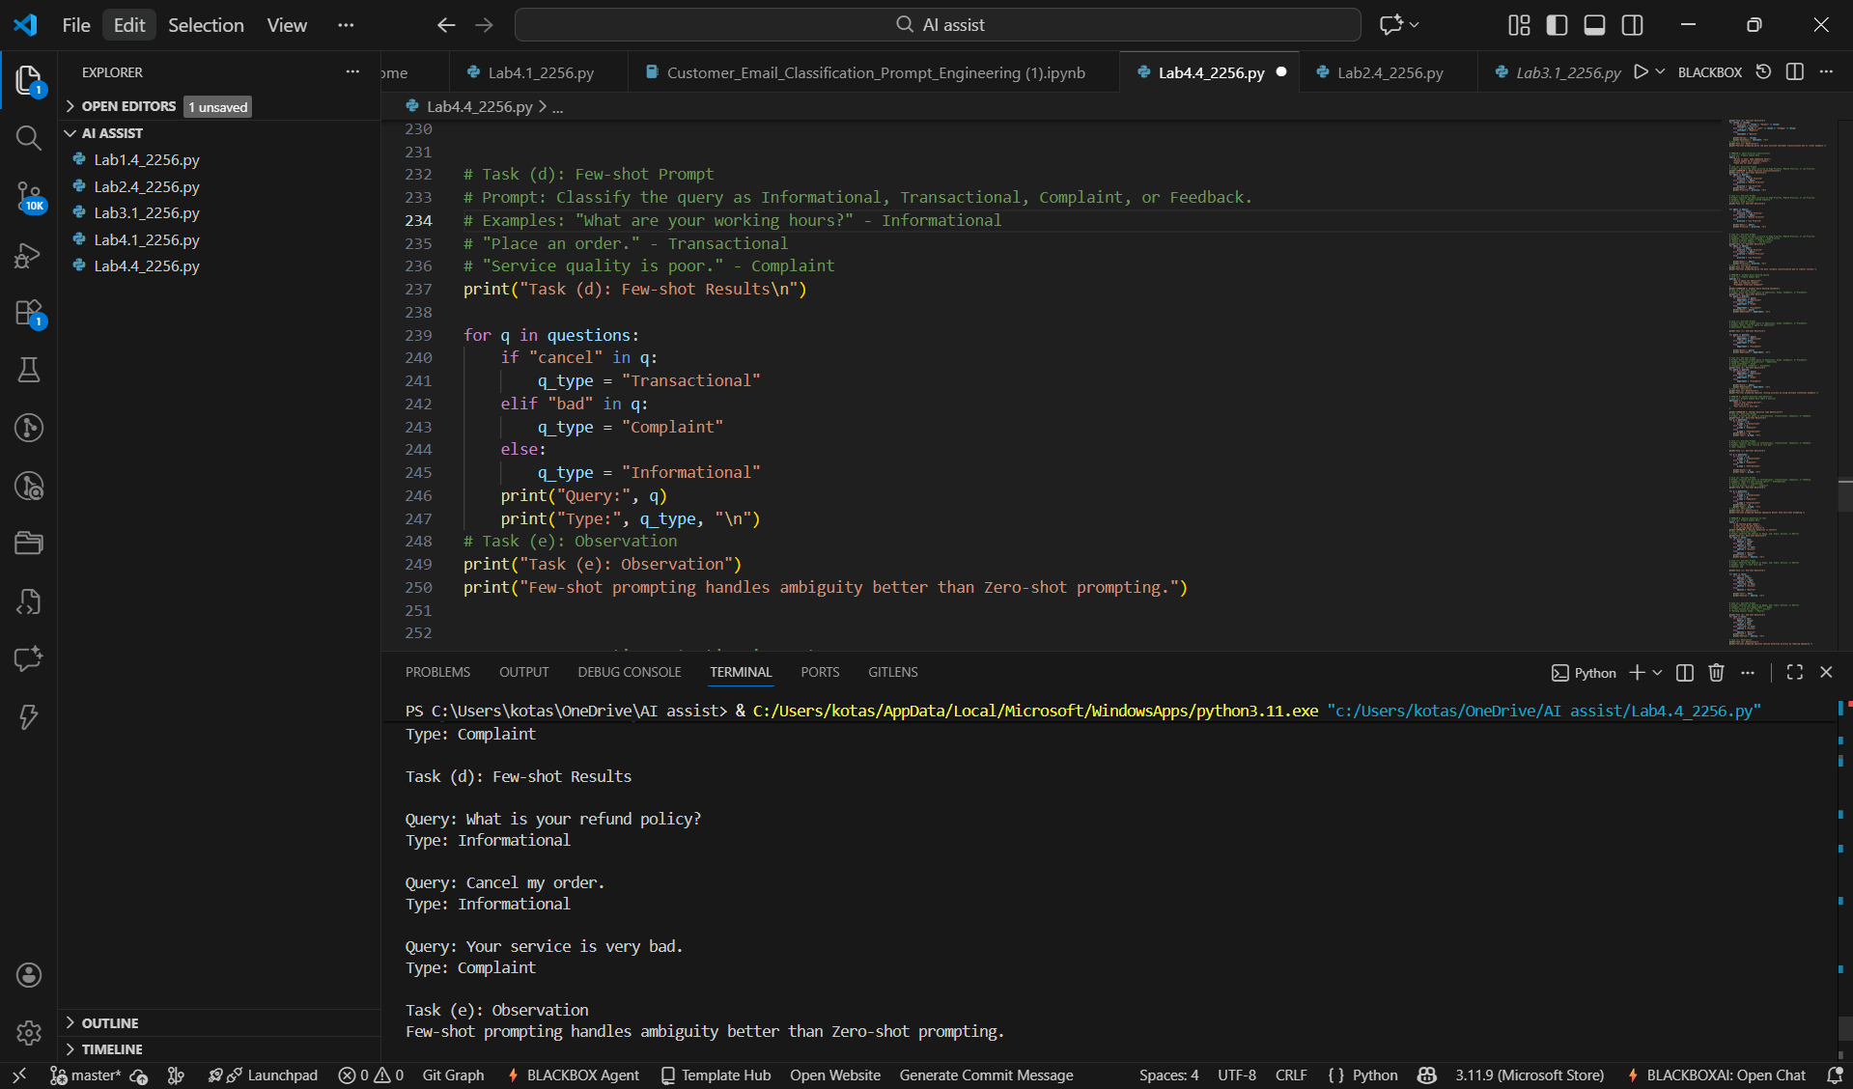

PROBLEM 5: Emotion Detection in Text
5.1 Task (a & b):
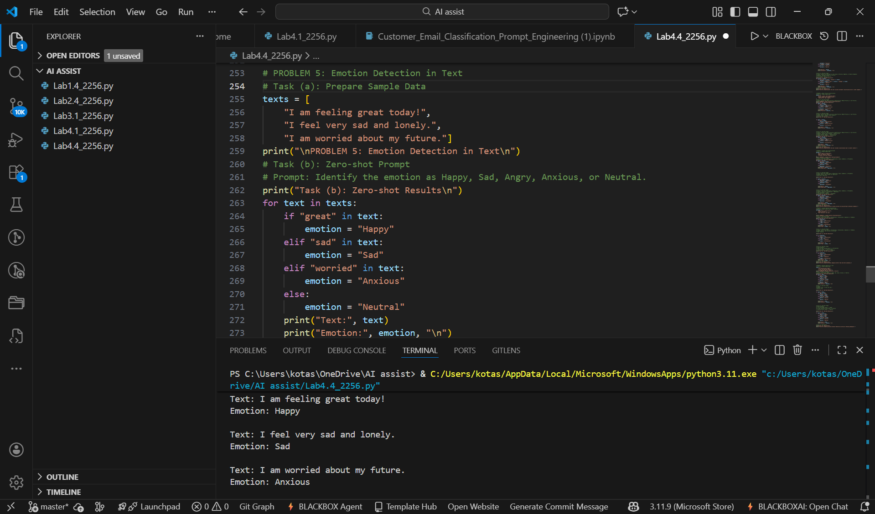

5.2 Task c:
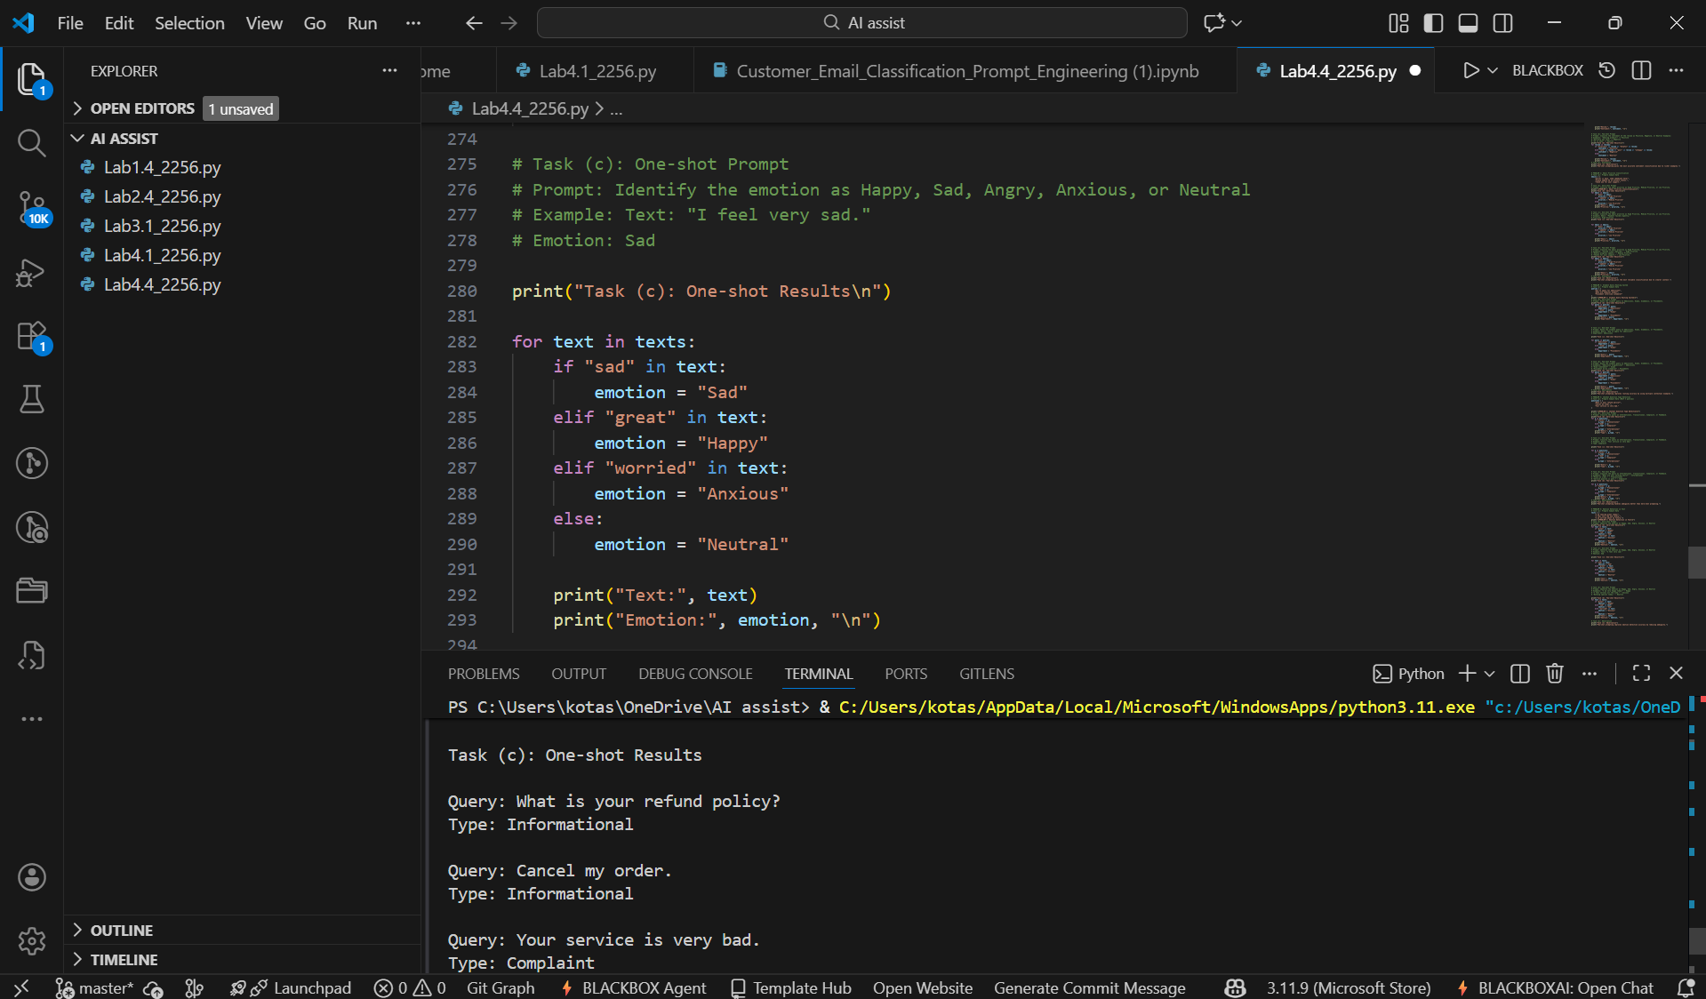

5.3 Task (d & e):
