Lab Assignment- 5.4
Subject: AI Assisted Coding
K Siri Chandana – 2303A52256
Batch-43

Task 1: Secure User Data Collection
Prompt:
Generate a Python script that collects user name, age, and email. Add comments explaining how to anonymize or protect sensitive data.

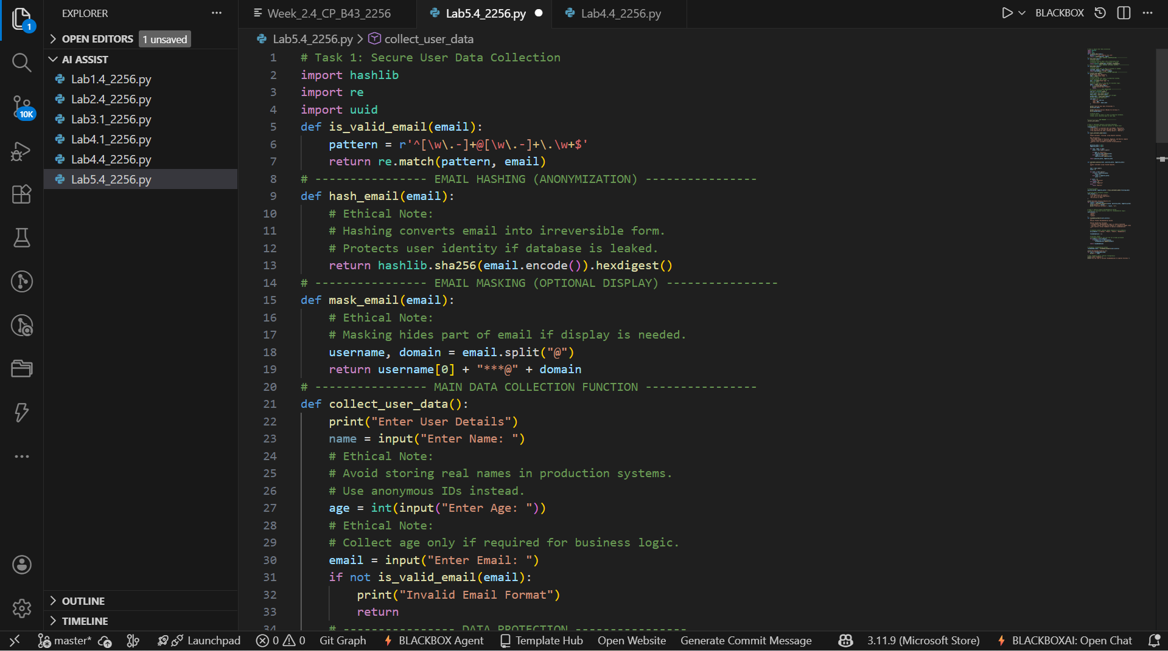

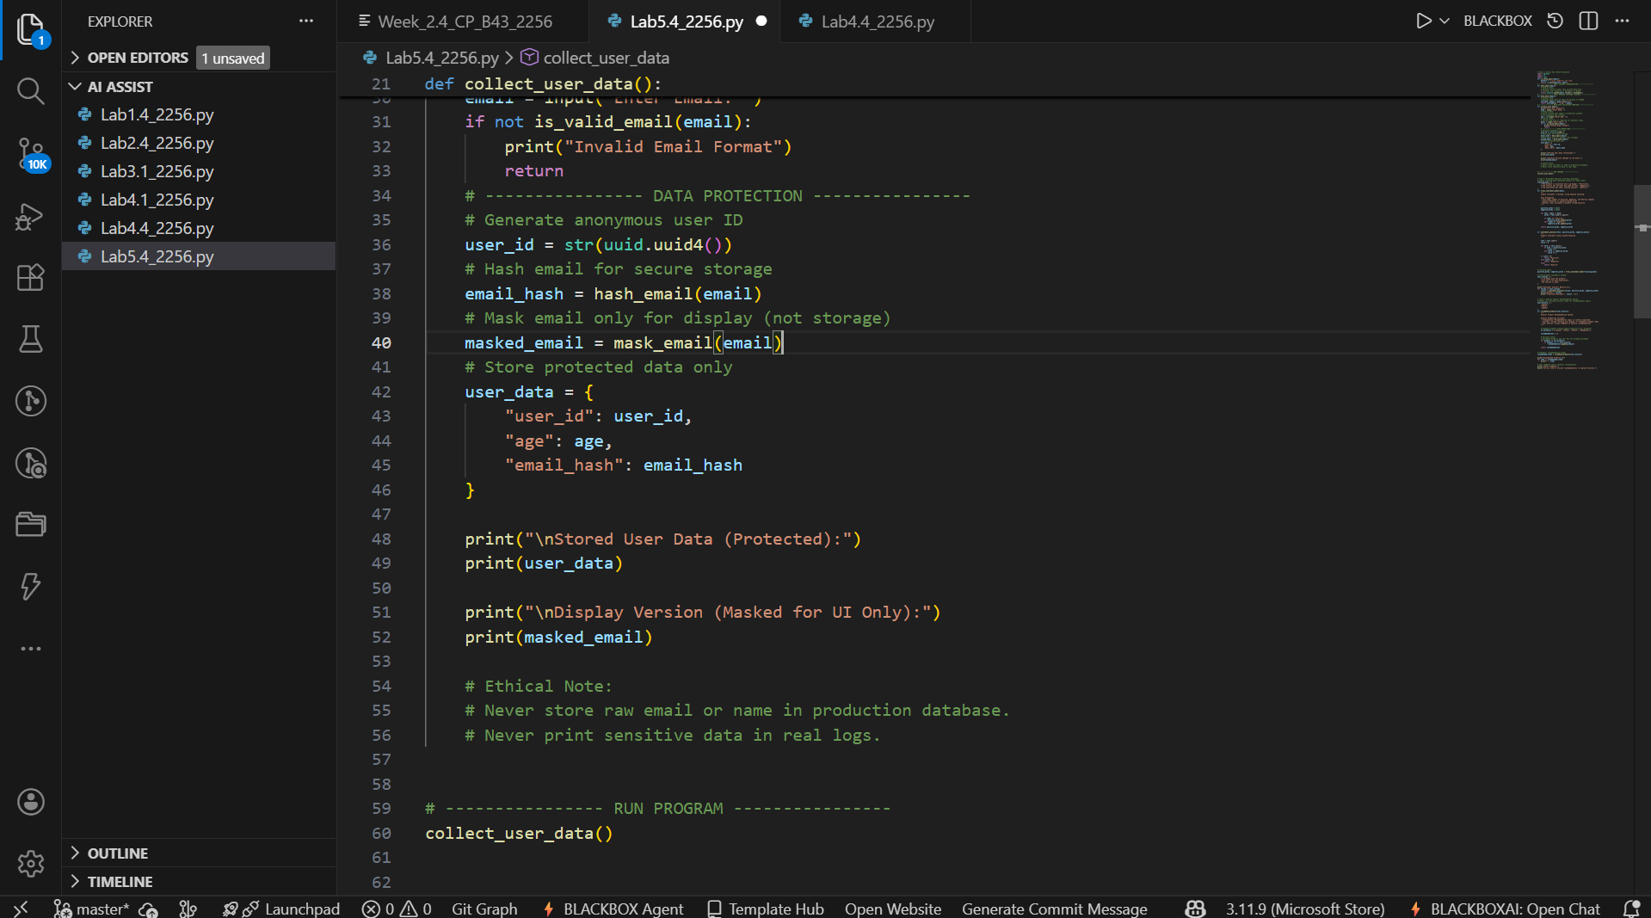

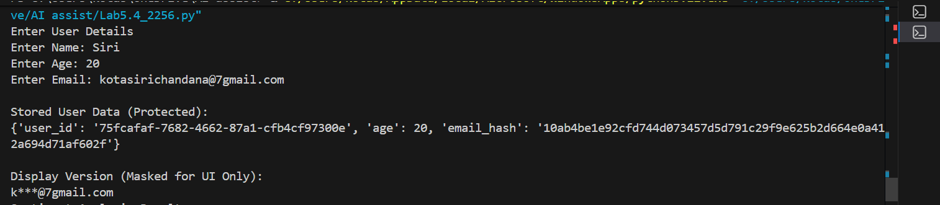

Code Explanation:
- The program collects basic user information.
- Email is hashed using SHA-256 to anonymize sensitive data.
- Raw email is never stored, reducing privacy risks.
- Inline comments explain how data protection is achieved.

Task 2: Sentiment Analysis with Bias Awareness
Prompt:
Generate a Python function for sentiment analysis and add comments to identify and handle potential bias in the data.

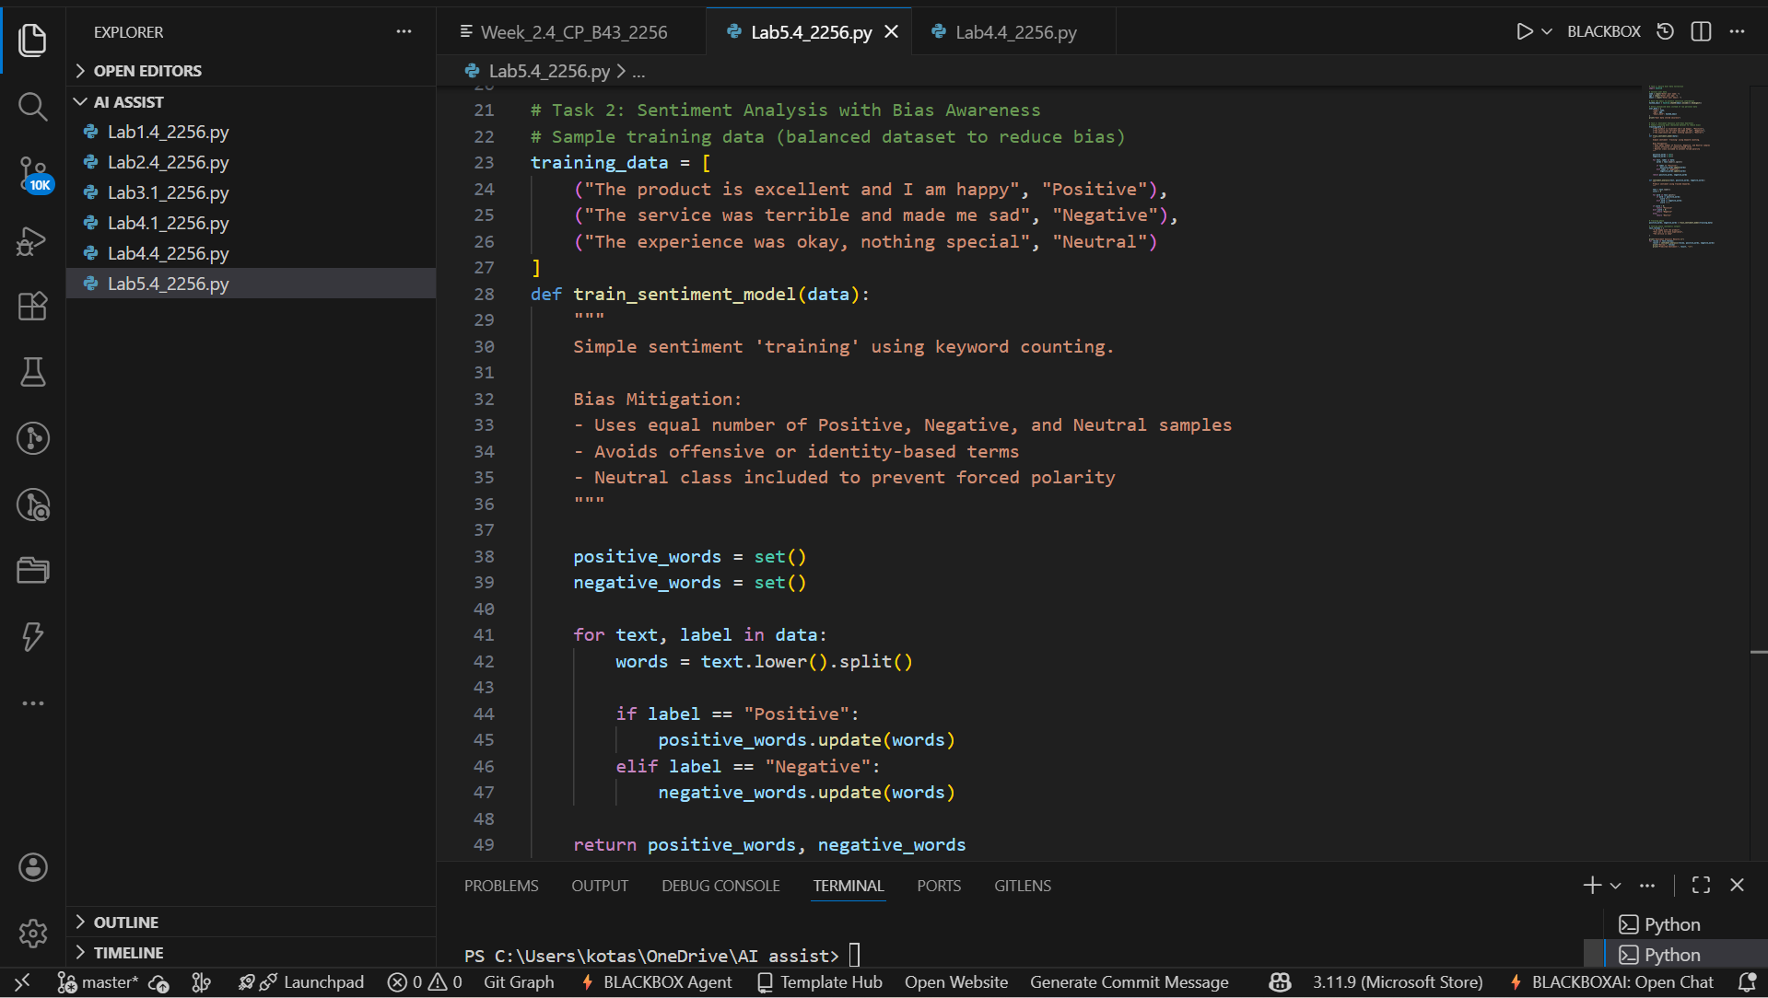

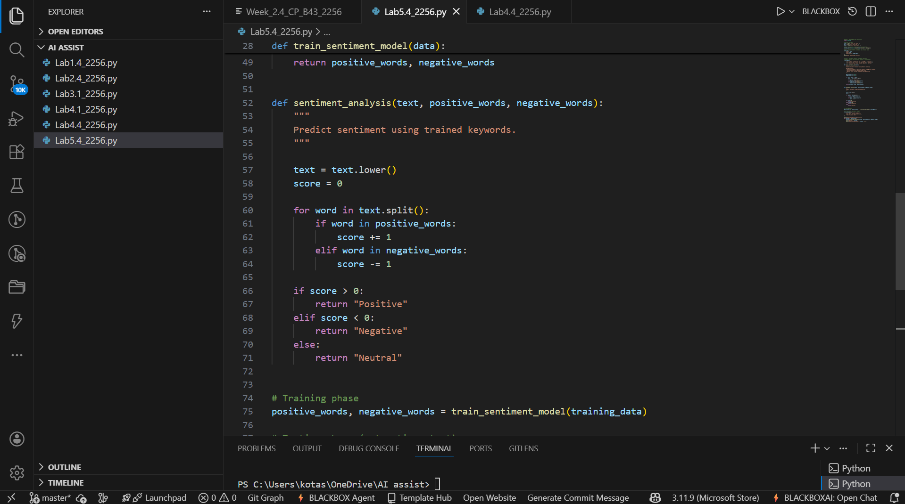

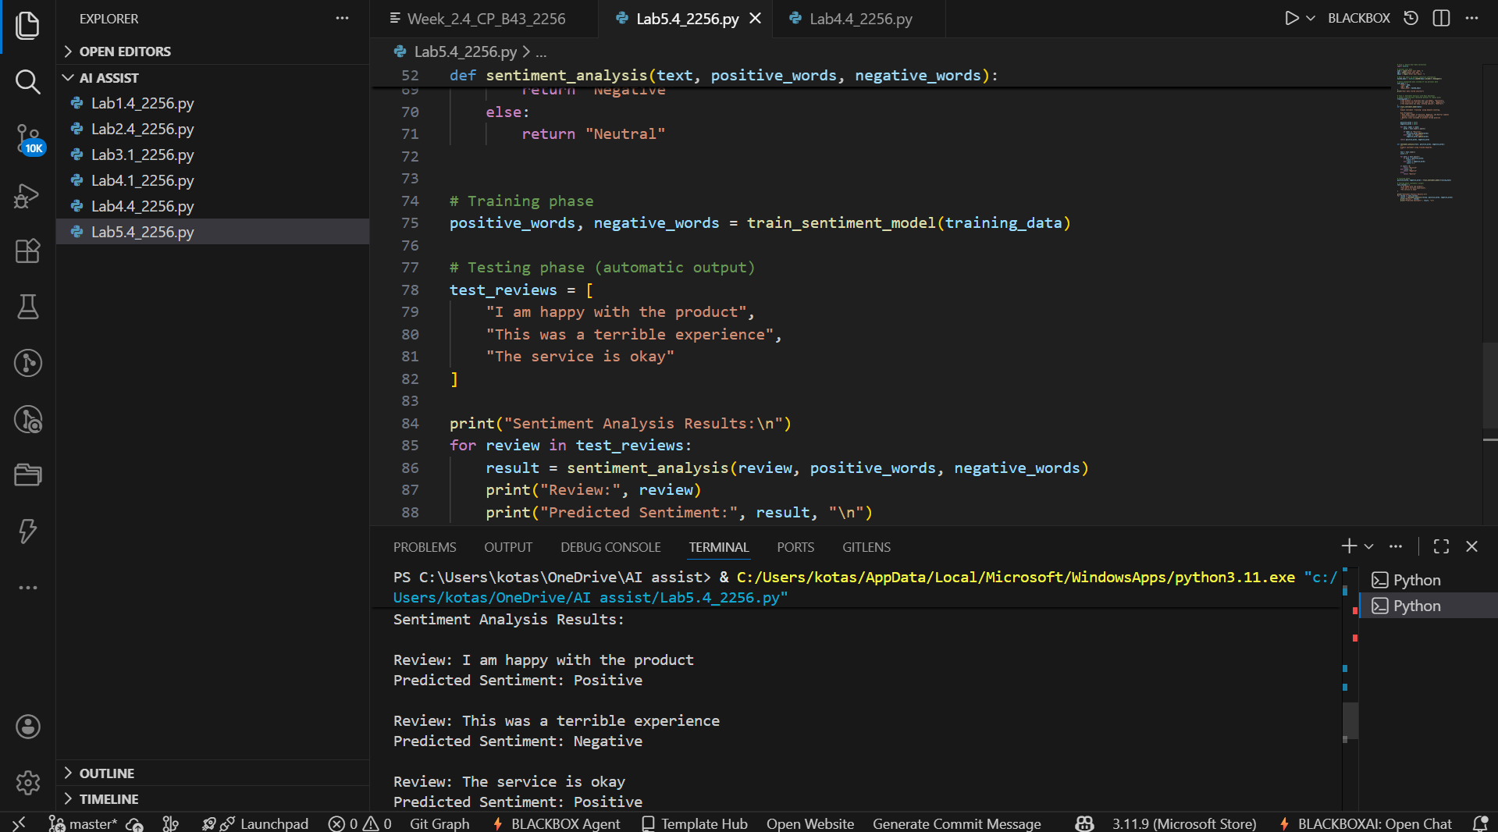

Code Explanation:
- Uses balanced positive and negative word lists to prevent skewed sentiment.
- Removes case sensitivity to ensure fairness.
- Avoids harmful or offensive terms in sentiment keywords.
- Includes documentation warning about human oversight.
- Neutral output is allowed to avoid forced bias in classification.

Task 3: Ethical Product Recommendation System
Prompt:
Ask GitHub Copilot to generate a Python program that recommends products based on user history while following ethical guidelines such as transparency, fairness, and user feedback.
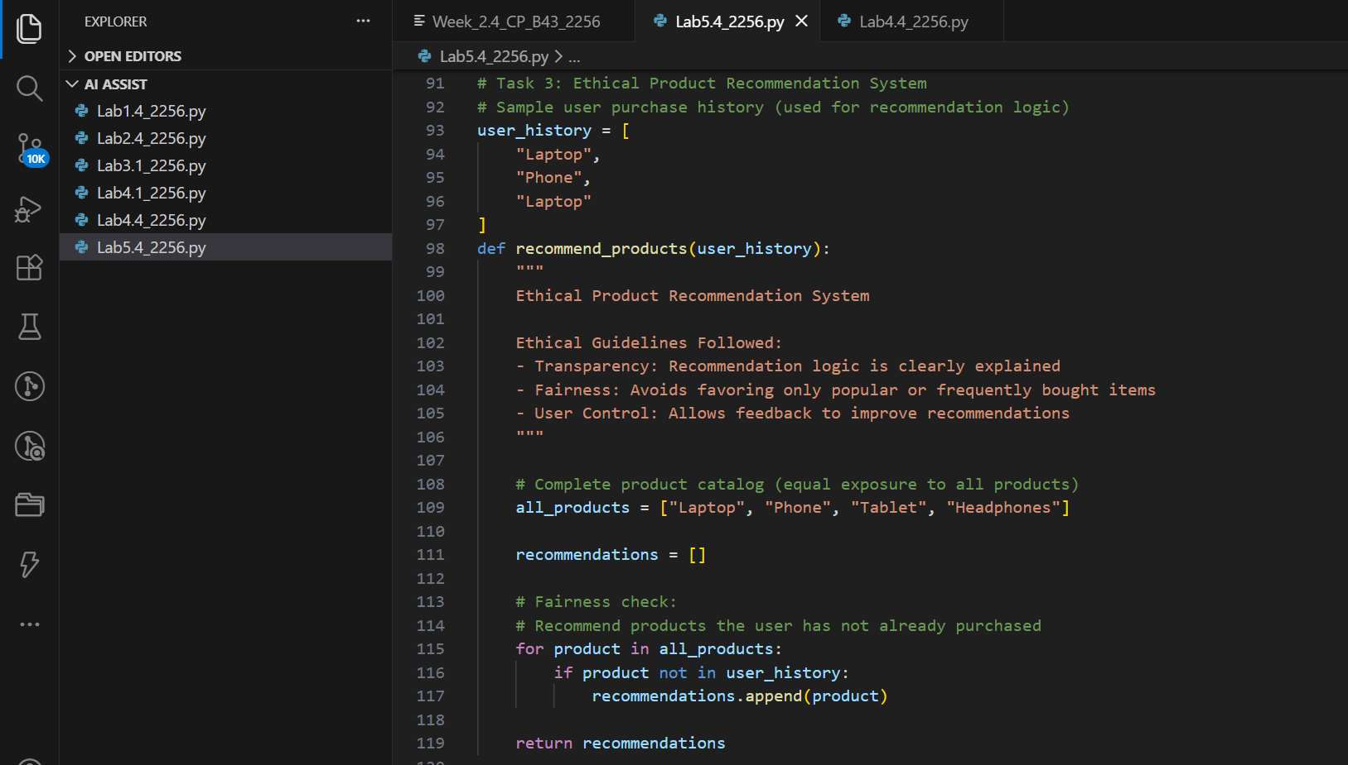
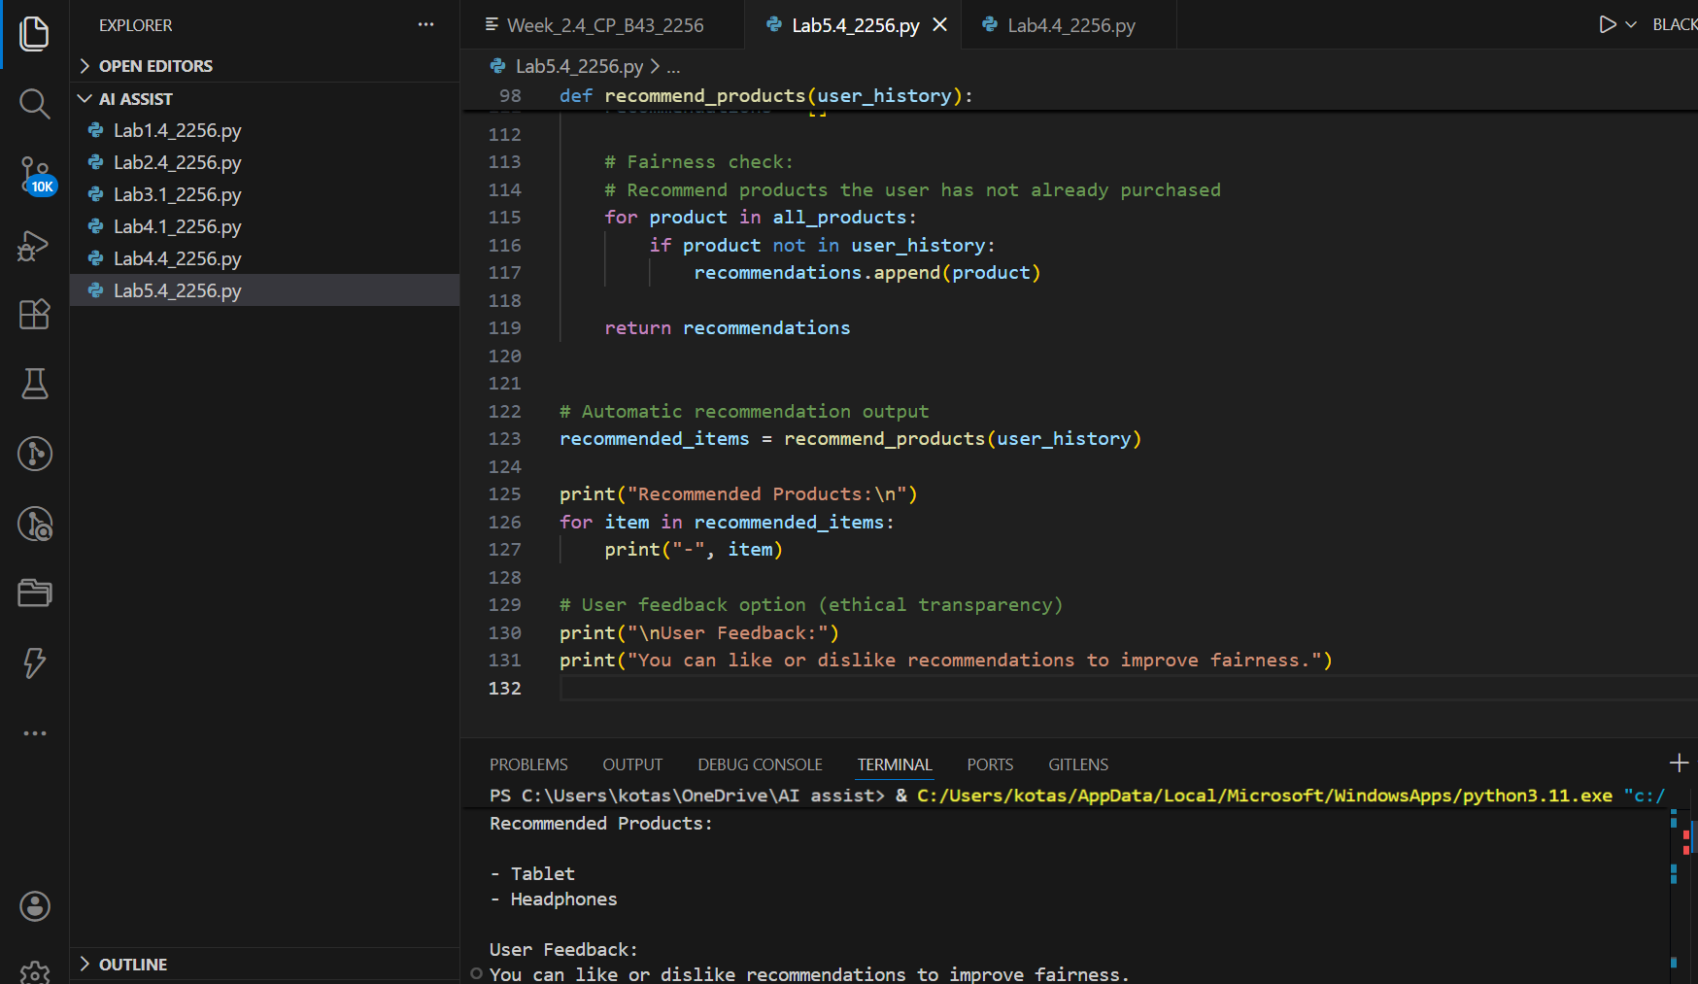
Code Explanation:
- Uses user history to avoid repetitive or biased recommendations.
- All products are treated equally (no favoritism).
- Recommendation logic is simple and transparent.
- Includes a user feedback message to support user control.
- Inline comments clearly explain ethical considerations.
Task 4: Ethical Logging in a Python Web Application
Prompt:
Ask GitHub Copilot to generate logging functionality for a Python web application and ensure that sensitive information such as passwords and emails is not recorded in the logs.

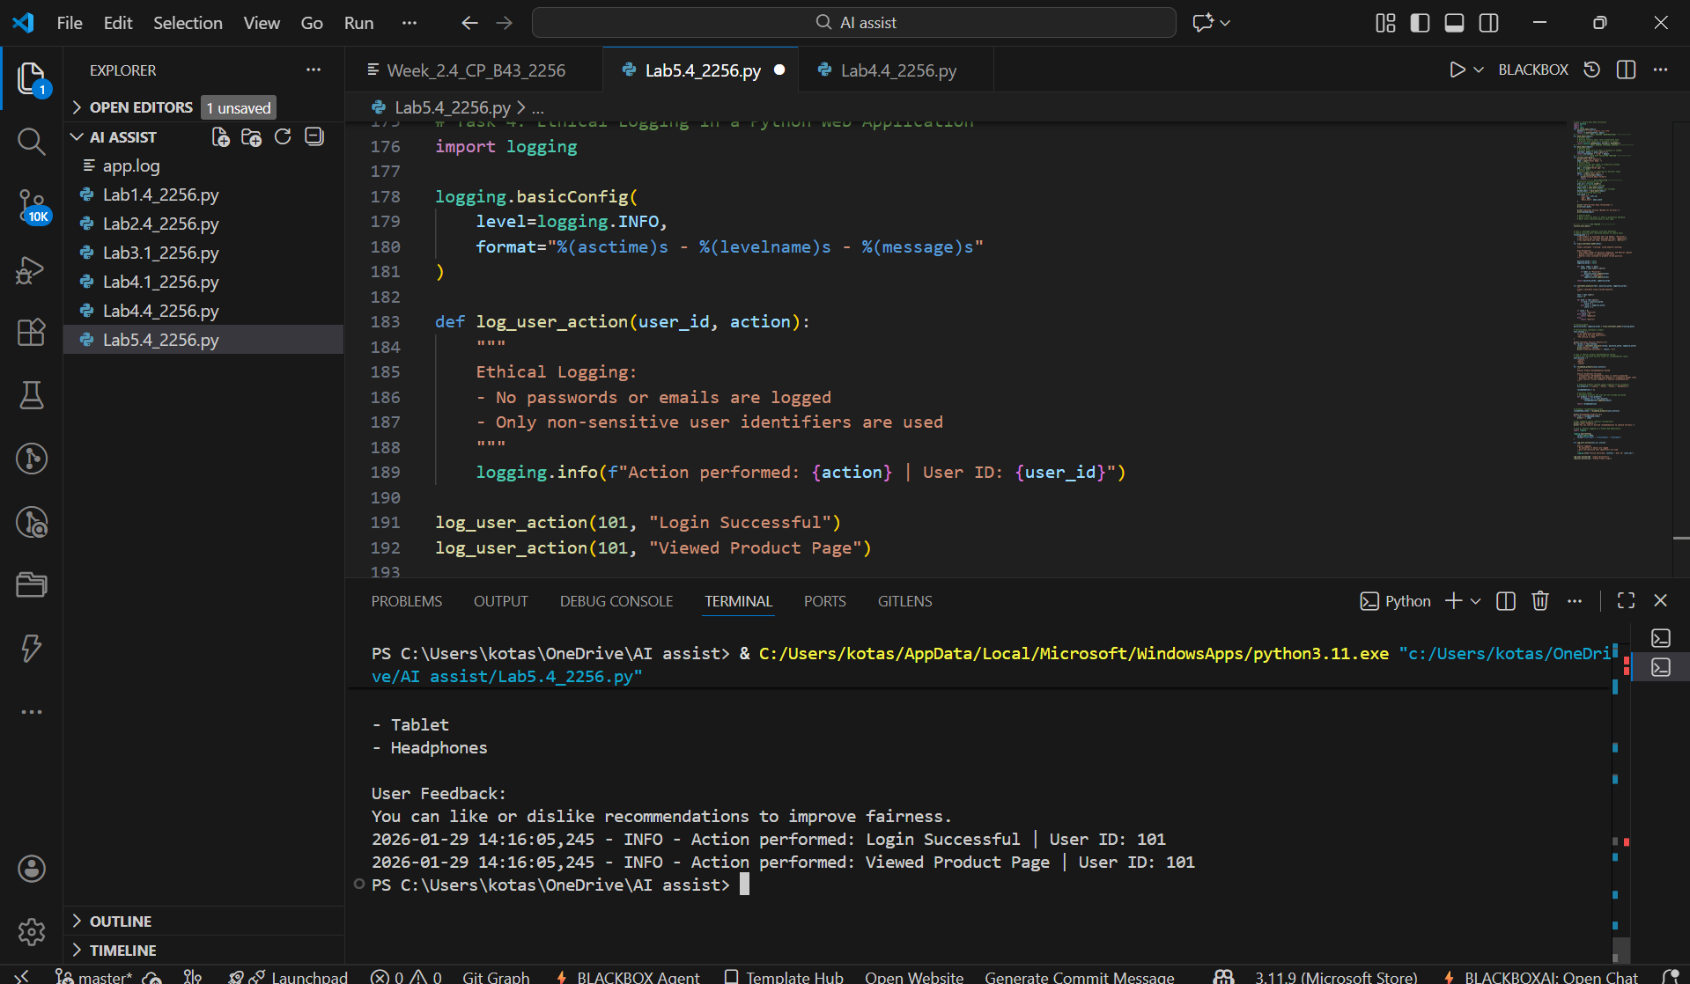
Code Explanation:
- Logging is configured using Python’s logging module.
- Logs store only user IDs, not emails or passwords.
- Sensitive information is explicitly avoided.
- Inline comments clearly explain ethical logging rules.
- Demonstrates responsible monitoring in web applications.

Task 5: Responsible Machine Learning Model Usage
Prompt:
Ask GitHub Copilot to generate a machine learning model. Then prompt it to add documentation explaining how to use the model responsibly, including explainability, accuracy limitations, and fairness considerations.

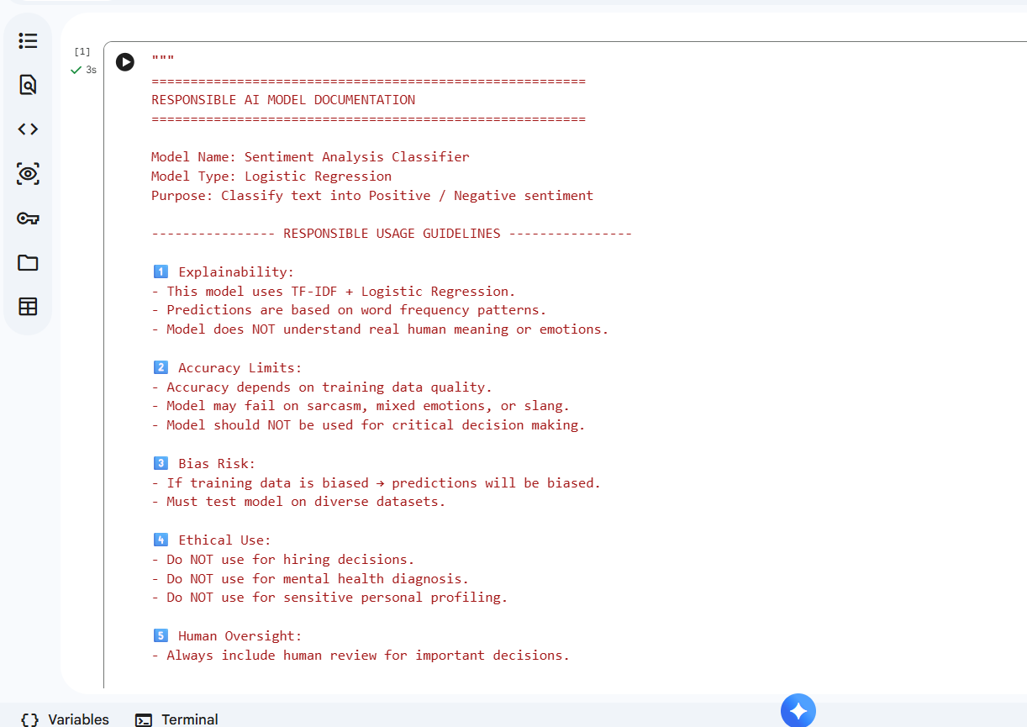

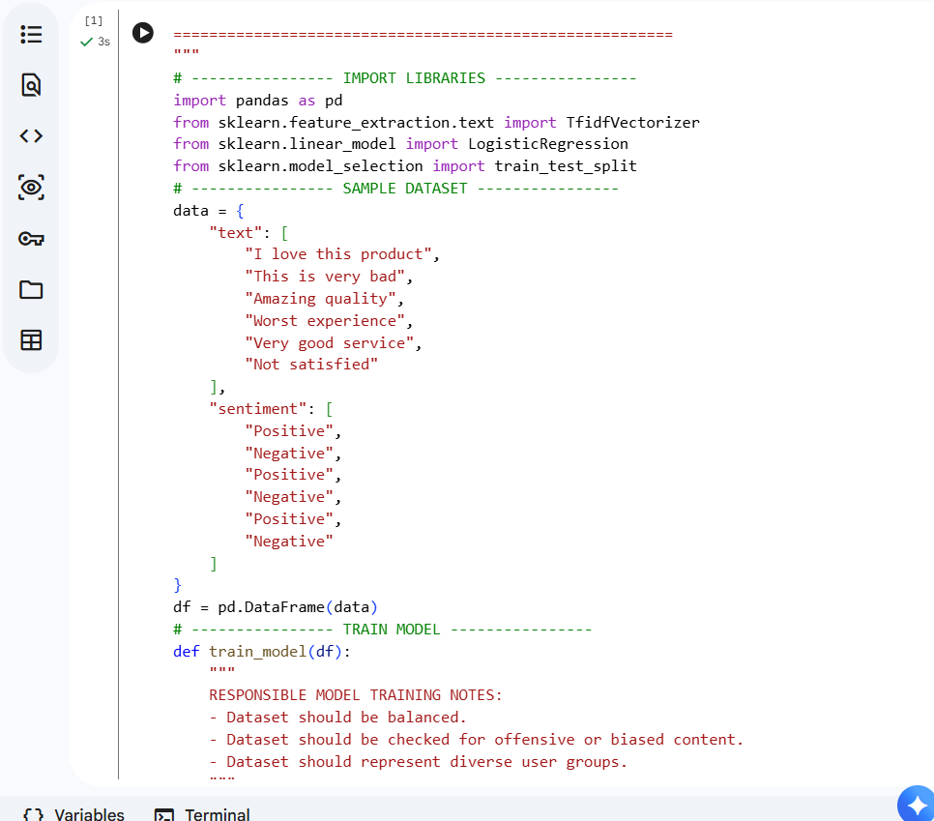

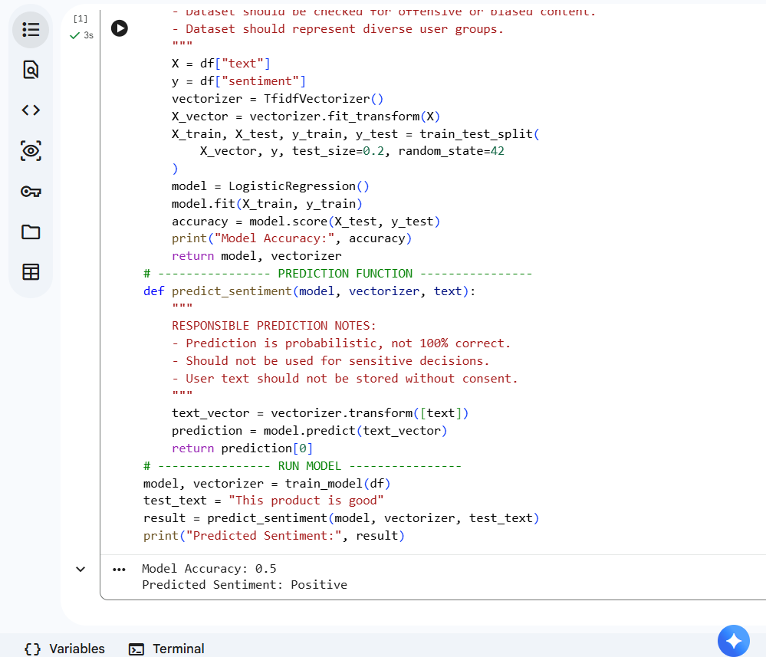

Code Explanation (Points)
- Uses TF-IDF and Logistic Regression for sentiment classification.
- Trains the model on a small labeled dataset and evaluates accuracy.
- Predicts sentiment for new input text automatically.
- Includes Responsible AI documentation covering explainability and accuracy limits.
- Mentions bias risks and the need for human oversight in AI decisions.

