Assignment 21.5 Name: K Siri Chandana
Batch:43
H. No:2303A52256

Task A – AI-Based Initial Program Development

Prompt:
Generate a Python program for a Student Grade Calculator that takes marks of 3 subjects as input and calculates the average and grade.

Then enhance the program by adding:
- Input validation (marks between 0–100)
- Exception handling for invalid inputs
- Correct average calculation
- Total marks display
- Pass/Fail status based on individual subject marks
- User-friendly output

Code:

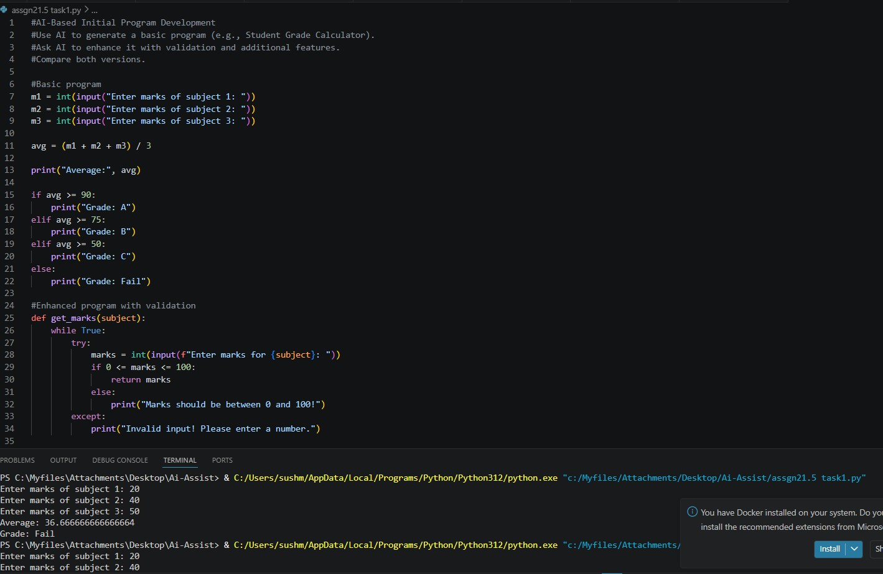

Observation:
The initial AI program was simple and worked only for valid inputs but lacked validation and error handling. After refining the prompt, the improved version became more reliable, user-friendly, and

included real-world features. This shows that better prompts lead to better AI-generated code.

Task B – AI-Assisted Application Improvement

Prompt:
Generate a simple Python program for a Library Management system to add and display books.
Then enhance the program by adding:
- Search functionality
- Book issue and return system
- Input validation
- Better structured code using functions

Code:

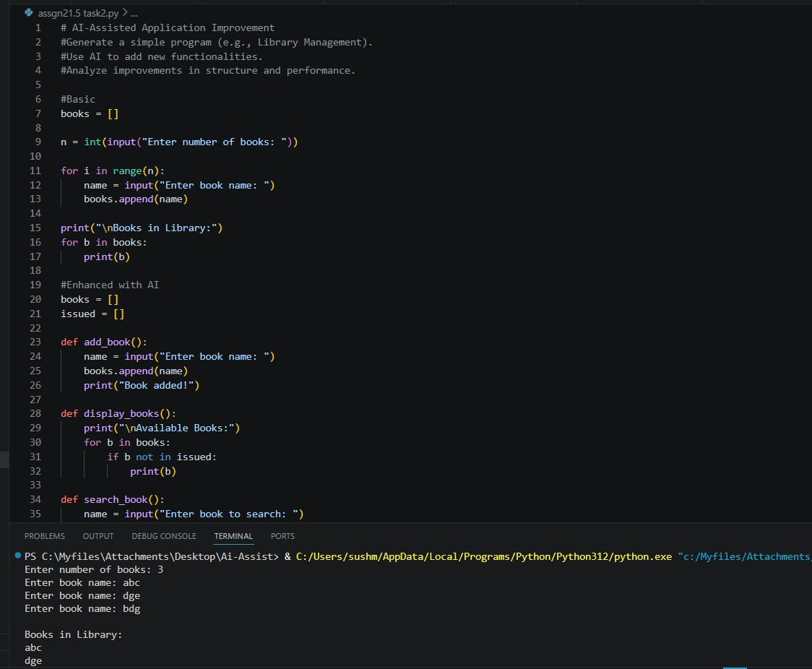
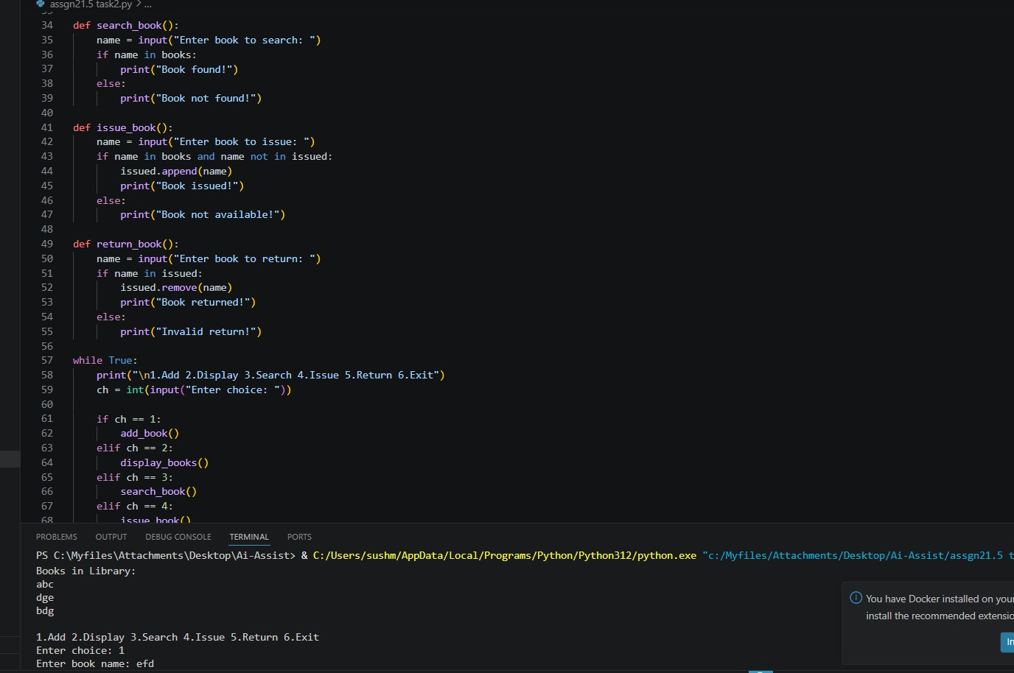

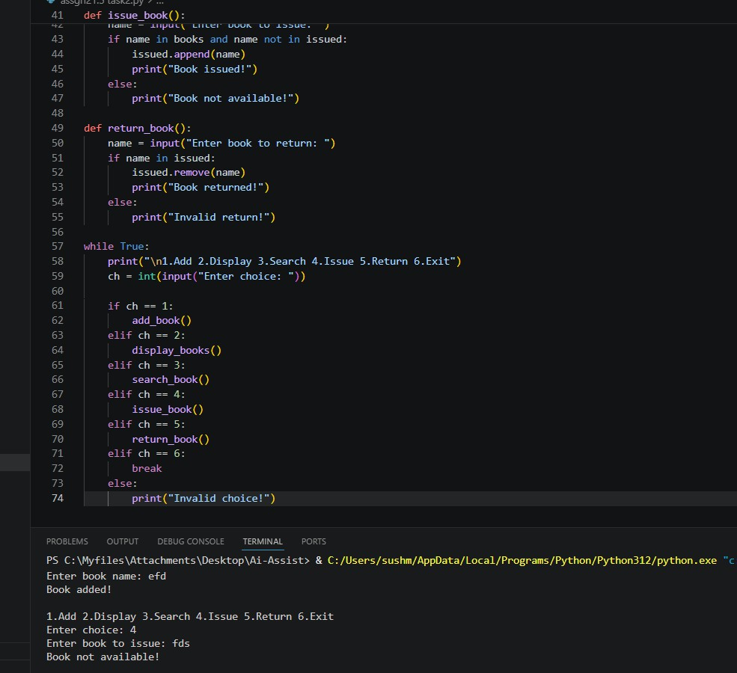
Observation:
  - Basic program was simple and limited
  - Enhanced version added search, issue, return features
  - Code structure improved using functions
  - Program became more interactive and user-friendly
  - Shows that AI can improve both functionality and structure

Task C – Git Workflow Practice

Prompt:

Generate a clear and concise Git commit message for the following changes:
- Added search functionality
- Implemented input validation
- Improved code structure using functions

Code:
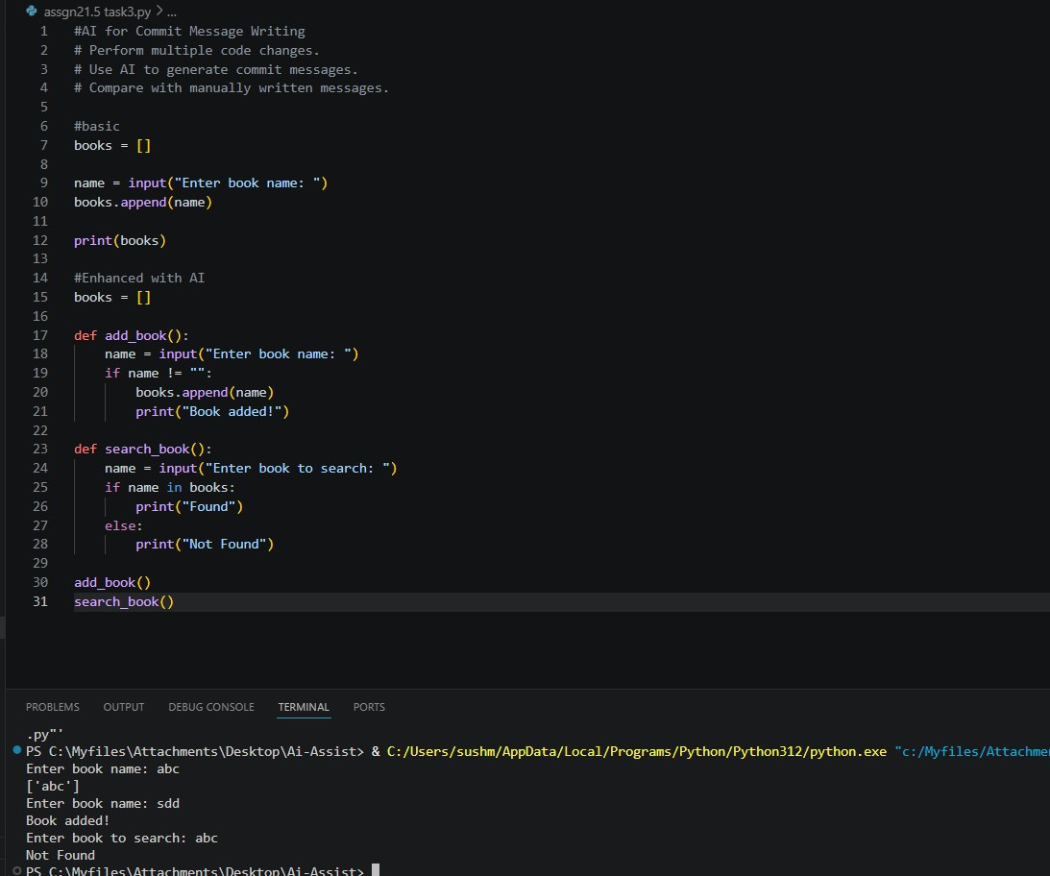
Observation:
AI-generated commit messages are more clear, specific, and
structured compared to manually written messages. They describe the exact changes made in the code, which improves readability and project tracking. Manual messages are quicker to write but may be

vague or inconsistent. This shows that AI helps in generating better quality commit messages and saves time.

Task D – Pair Programming with AI Assistance
Prompt:
Improve the given Python library management code by adding:
- Input validation
- Search functionality
- Issue and return system
- Better structure using functions
- User-friendly interaction

Code:

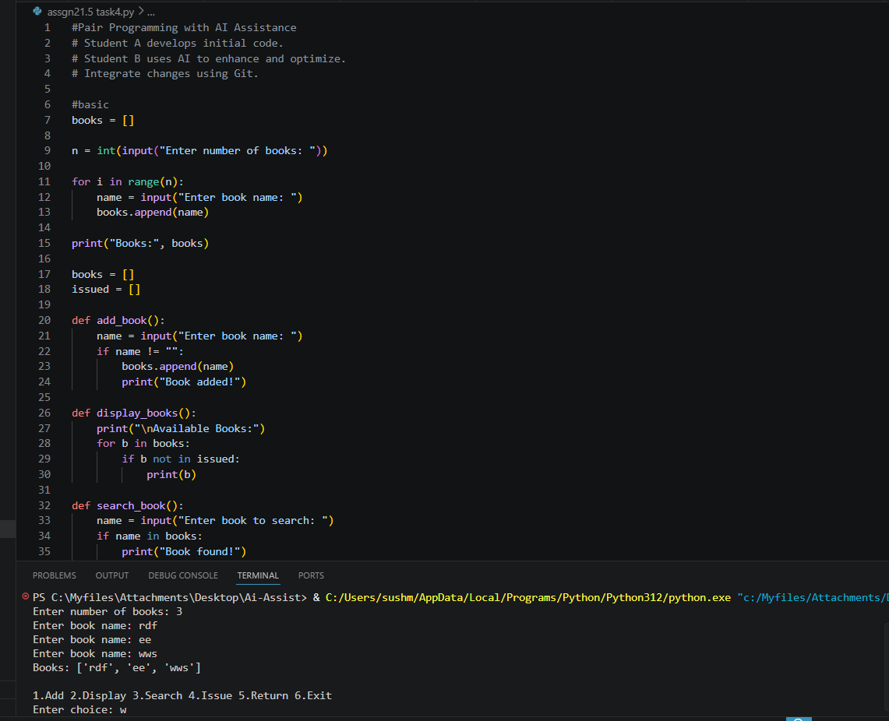
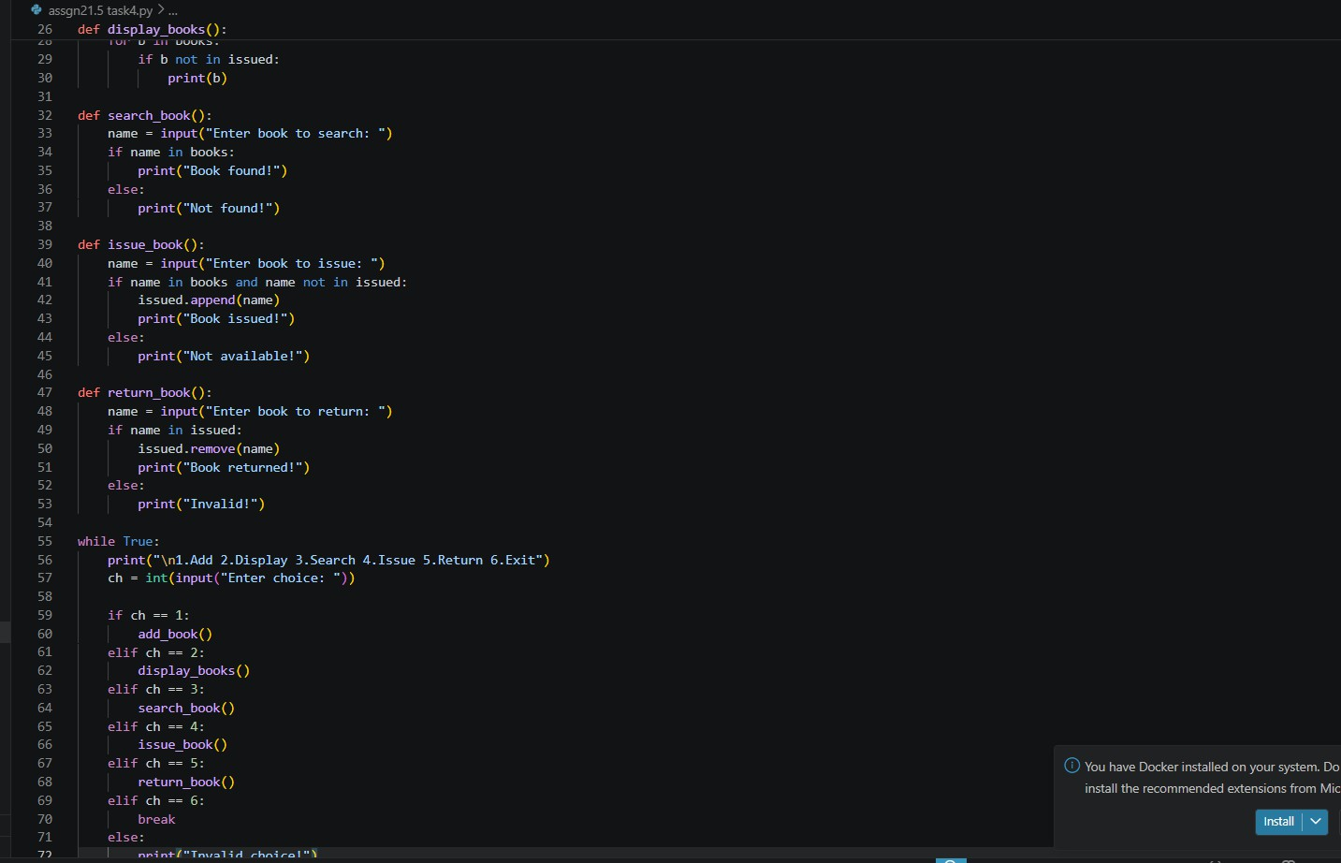
Observation:

Pair programming with AI improved both code quality and development speed. Student A created a basic version, while Student B used AI to enhance it with better features and structure. The final program became more efficient, user-friendly, and maintainable. Git helped in managing and merging contributions smoothly without affecting the original code.

Task E – Collaborative Development using Branches

Prompt:
Generate Python functions for a library system including:
- Search book feature
- Issue and return book functionality
- Input validation
- Menu-driven interaction

Code:

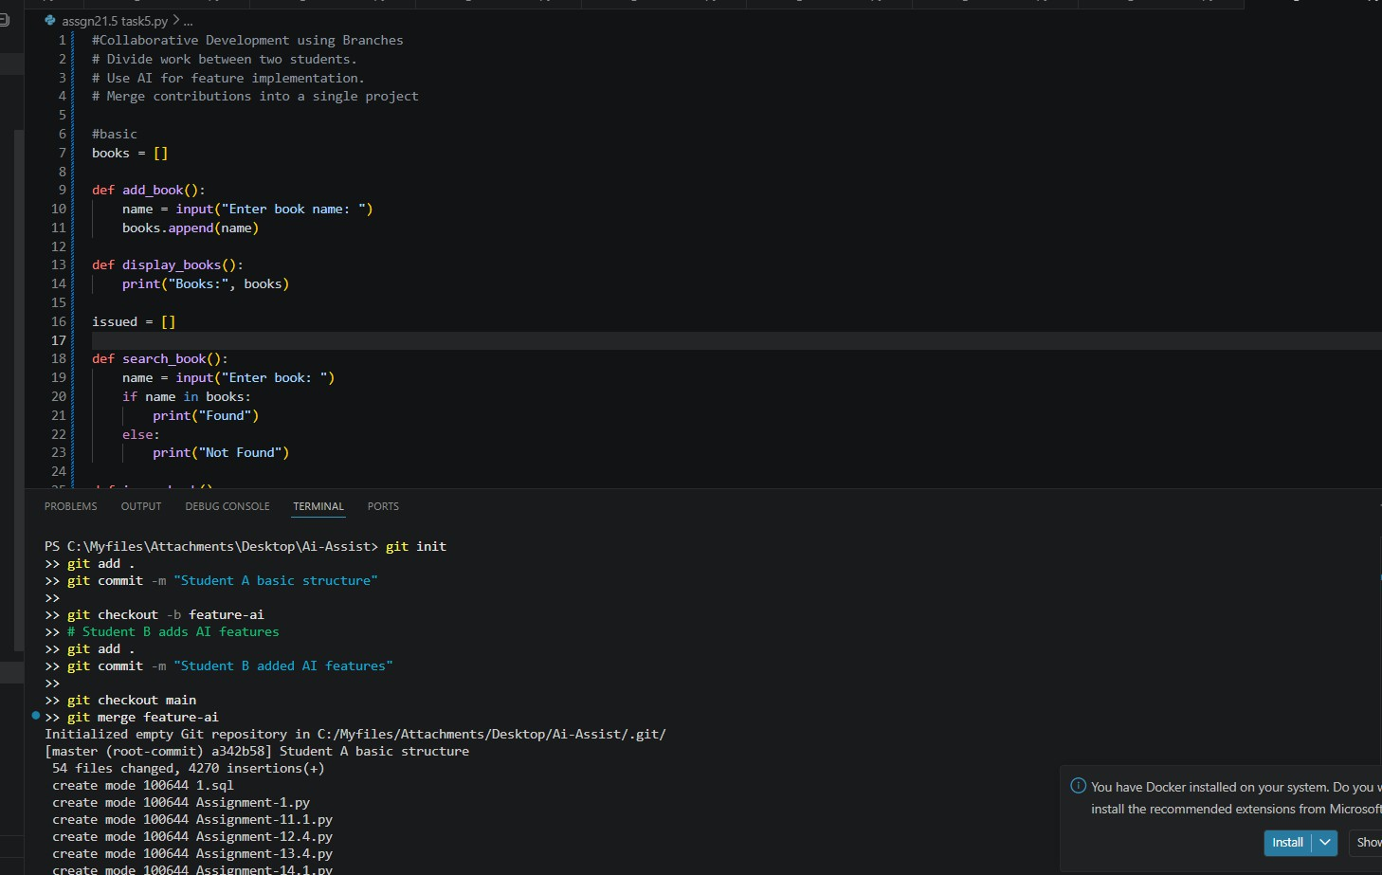
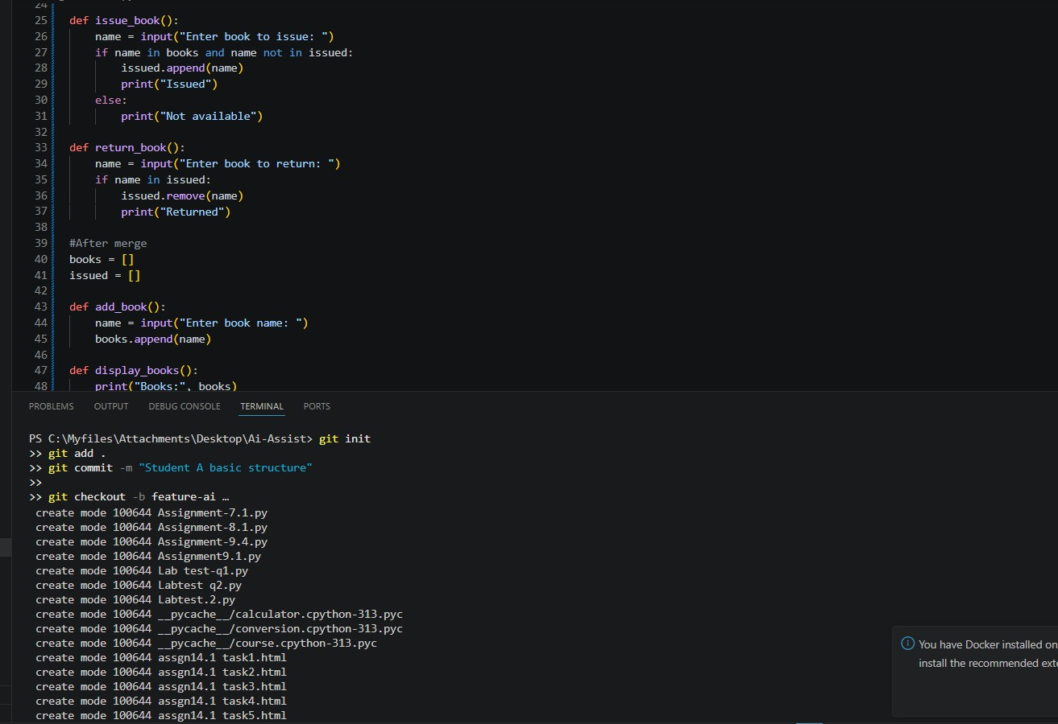

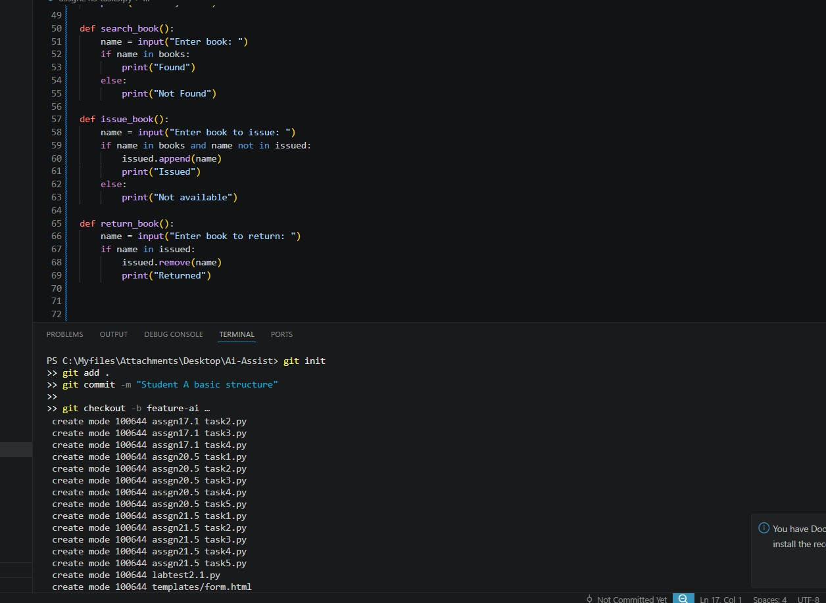
Observation:
Collaborative development using branches allows multiple students to work independently without conflicts. Student A created the base
structure, while Student B added AI-based features in a separate branch. After merging, the final project combined all functionalities efficiently. This approach improves teamwork, code organization, and development speed.

