Lab Assignment – 2.4
AI Assisted Coding
K Siri Chandana – 2303A52256
Batch-43

Task 1: Book Class Generation
Prompt: Generate a Python class named Book with attributes title and author and a summary() method.
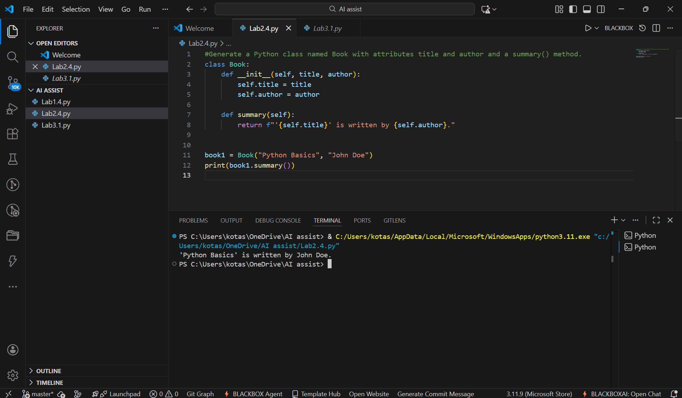
Code Explanation
- The Book class contains two attributes: title and author
- Constructor initializes the attributes
- summary() method returns formatted book information
- The code generated by Cursor AI is clean, readable, and follows object-oriented programming principles.

Task 2: Sorting Dictionaries with AI
Prompt: Write Python code to sort a list of dictionaries by age.
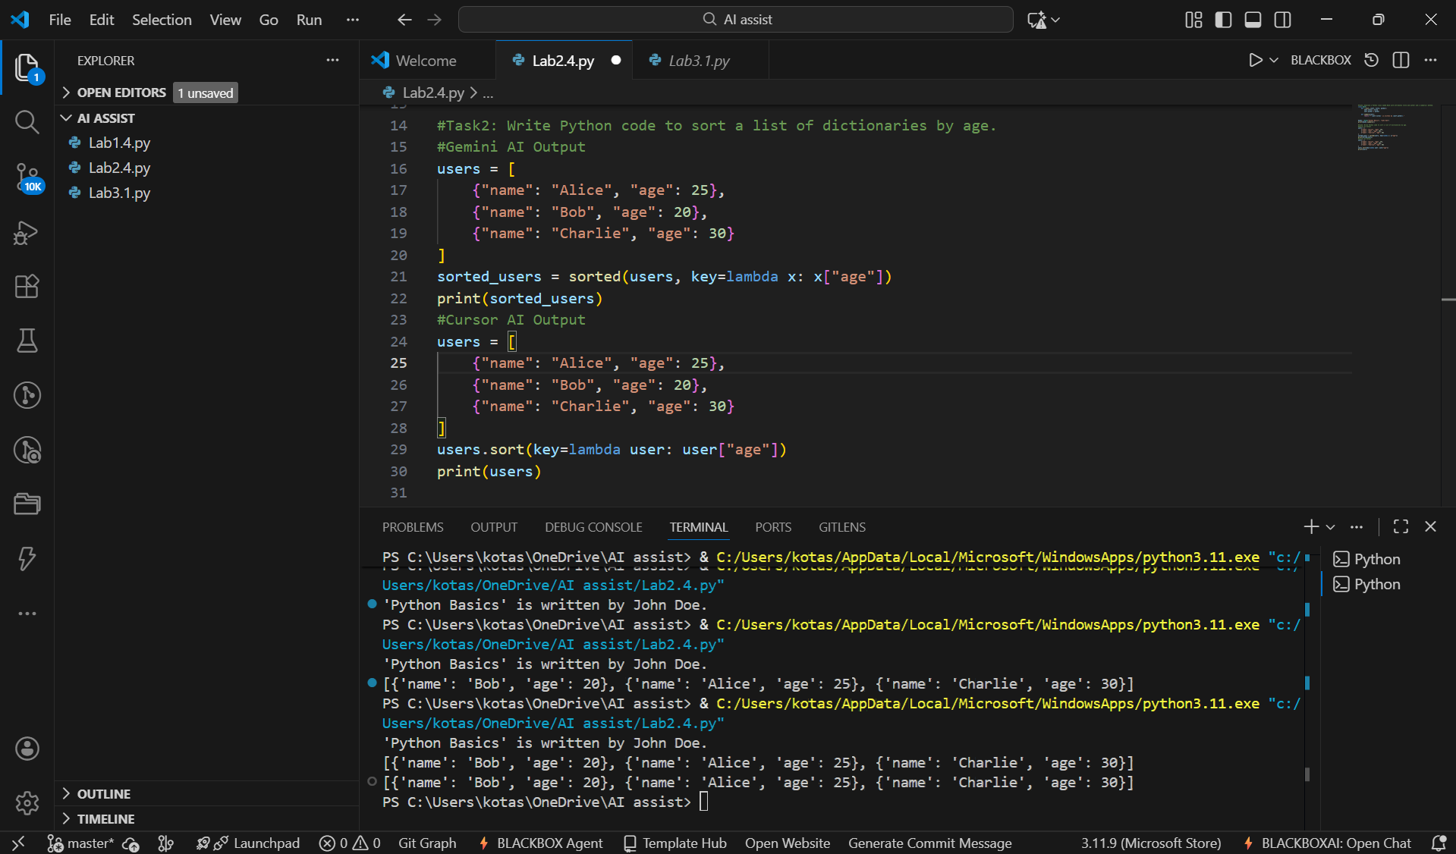

Gemini AI Code Explanation
- A list of dictionaries named users is defined, each containing name and age.
- The sorted() function is used to sort the list based on the age key.
- A lambda function extracts the age value for comparison.
- The sorted list is stored in a new variable and printed.
Cursor AI Code Explanation
- A list of dictionaries is created to store user data.
- The sort() method is applied directly to the list.
- A lambda function specifies that sorting should be done using the age key.
- The original list is modified and displayed in sorted order.

Comparison
Aspect | Gemini | Cursor AI
Readability | Good | Very clear
Performance | Same | Same
Style | Functional | In-place sorting
- Both tools generate efficient code; Cursor AI’s version is slightly more concise for in-place operations.

Task 3: Calculator Using Functions
Prompt: Create a simple calculator in Python using functions and explain how it works.

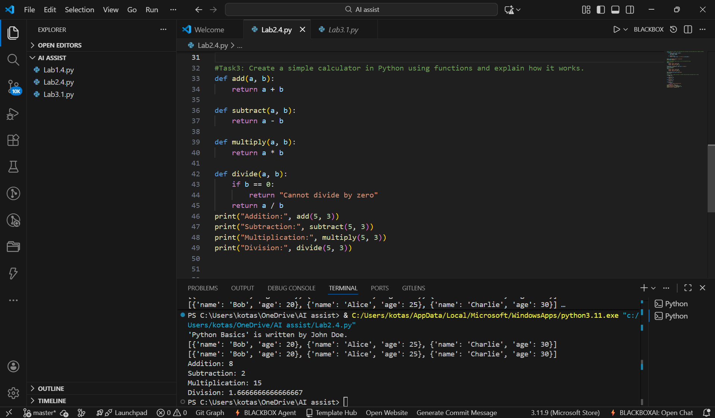

Code Explanation
- Separate functions are created for addition, subtraction, multiplication, and division.
- Each function takes two parameters and returns the calculated result.
- The division function includes a condition to handle division by zero.
- The functions are called with sample values and the results are printed.

AI Explanation (Gemini)
- Each arithmetic operation is implemented as a separate function
- Functions improve modularity and reusability
- Division function includes error handling
- Gemini provides both functional code and a clear explanation, making it suitable for learning purposes.

Task 4: Armstrong Number Optimization
Prompt (Gemini): Write a Python program to check whether a number is an Armstrong number.

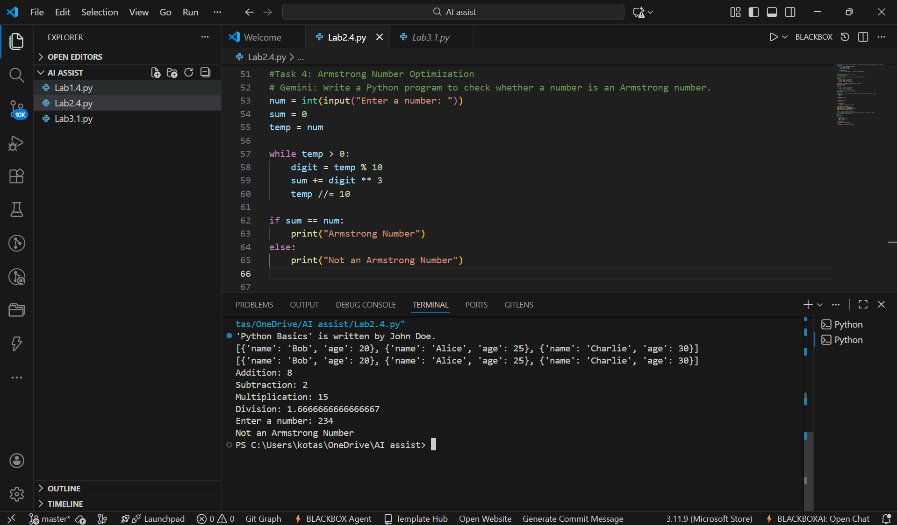

Code Explanation
- The user enters a number using input.
- A temporary variable is used to store the number for processing.
- Each digit is extracted using modulus (%) and raised to power 3.
- The sum of cubes of digits is compared with the original number.
- The program prints whether the number is Armstrong or not.

Prompt (Cursor AI): Optimize this Armstrong number program and improve readability.

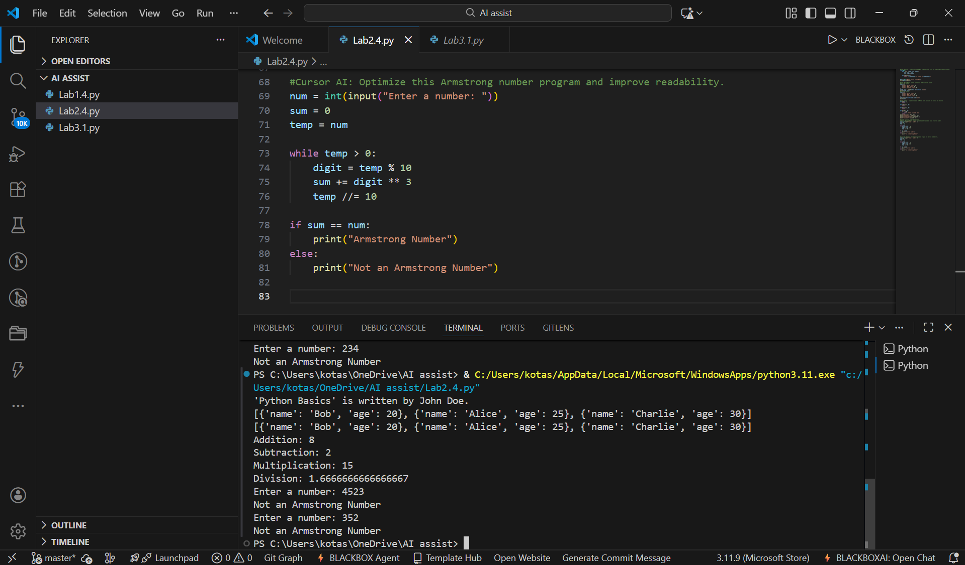

Code Explanation
- A function is_armstrong() is defined for reusability.
- The number is converted into a string to easily access digits.
- The length of the number is used as the power value.
- A generator expression calculates the sum of powered digits.
- The function returns True or False based on the comparison result.

Summary of Improvements
- Reduced lines of code
- Removed manual loops
- Improved readability and efficiency
- Function-based reusable logic
- Cursor AI significantly improves code quality by refactoring logic into a concise and reusable function.

