Assignment 13.4
K Siri Chandana
2303A52256
Batch-43

Task 1: Refactoring Data Transformation Logic
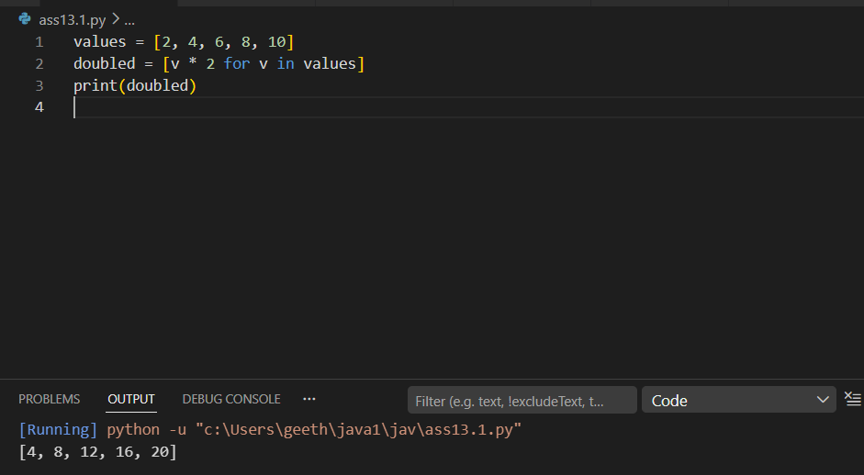

Task 2: Improving Text Processing Code Readability
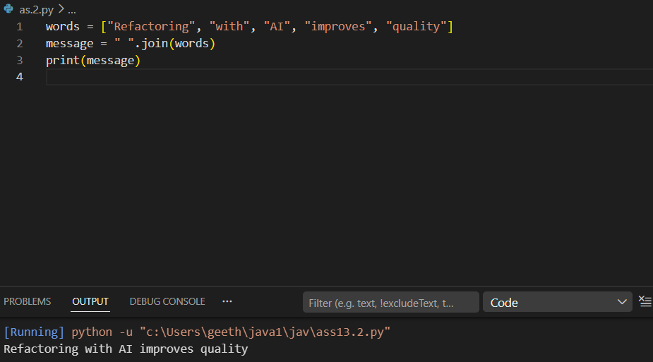

Task 3: Safer Access to Configuration Data
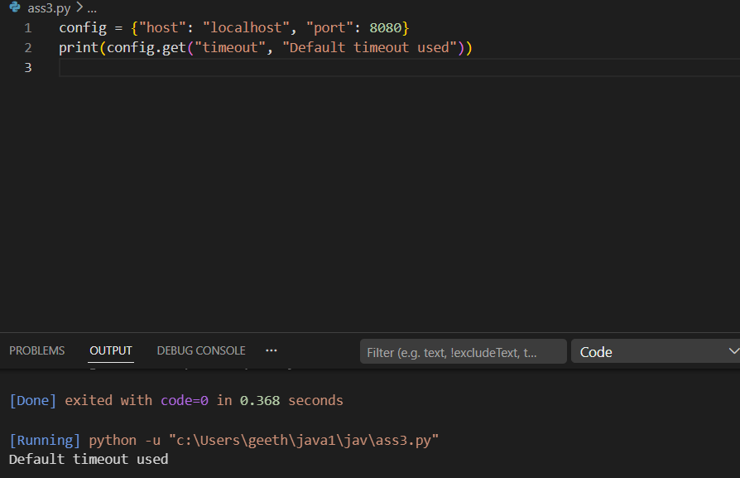

Task 4: Refactoring Conditional Logic for Scalability
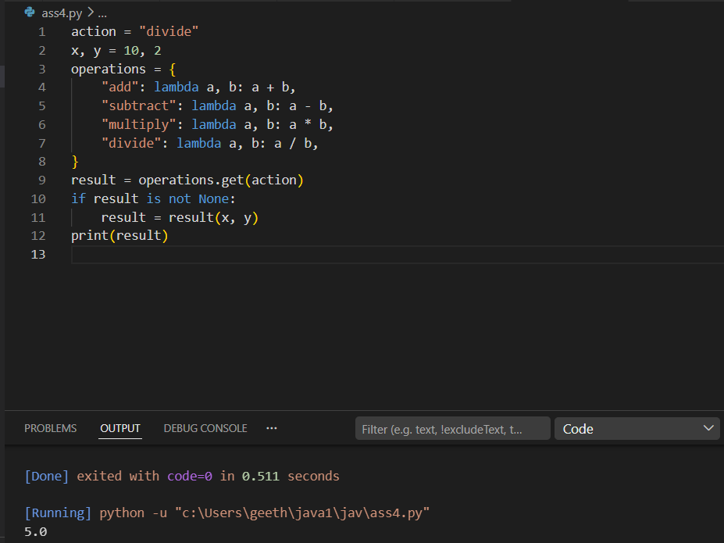

Task 5: Simplifying Search Logic in Collections
