Lab Assignment- 7.1
Subject: AI Assisted Coding
K Siri Chandana – 2303A52256
Batch-43

Task #1 – Syntax Error (Missing Parentheses in print)
Prompt: Use AI to detect the syntax error caused by missing parentheses in the print statement, correct it, and validate the fix using at least 3 assert test cases.

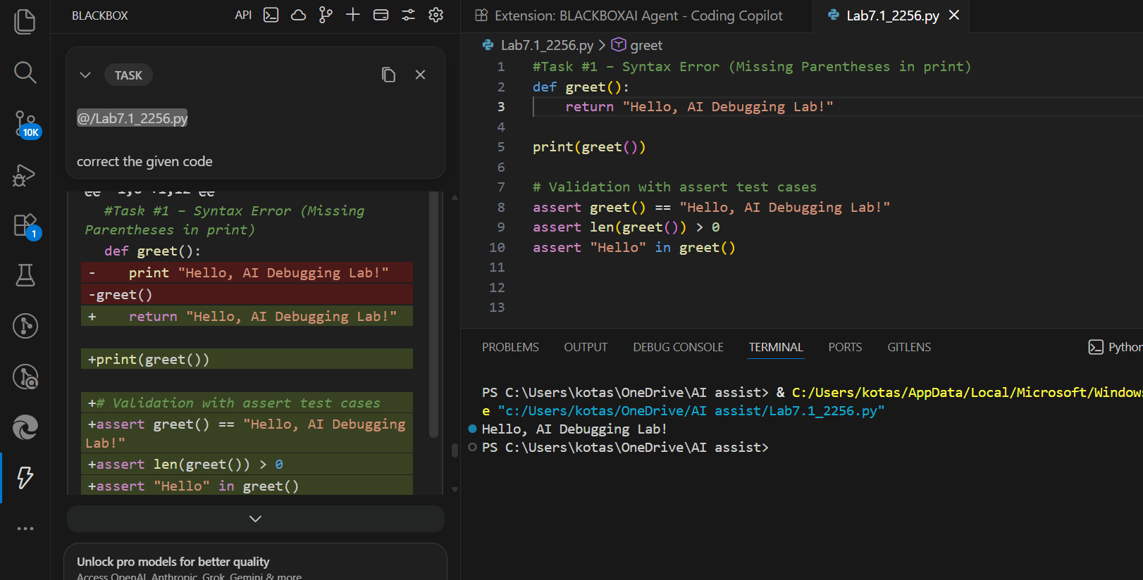

AI Explanation
Python 3 requires parentheses in print(). Without them, it raises a SyntaxError.
Code Explanation
The syntax was corrected by adding parentheses to the print function.

Task #2 – Incorrect If Condition (= vs ==)
Prompt
Ask AI to explain why using = instead of == causes a bug, correct the code, and verify the fix using 3 assert test cases.

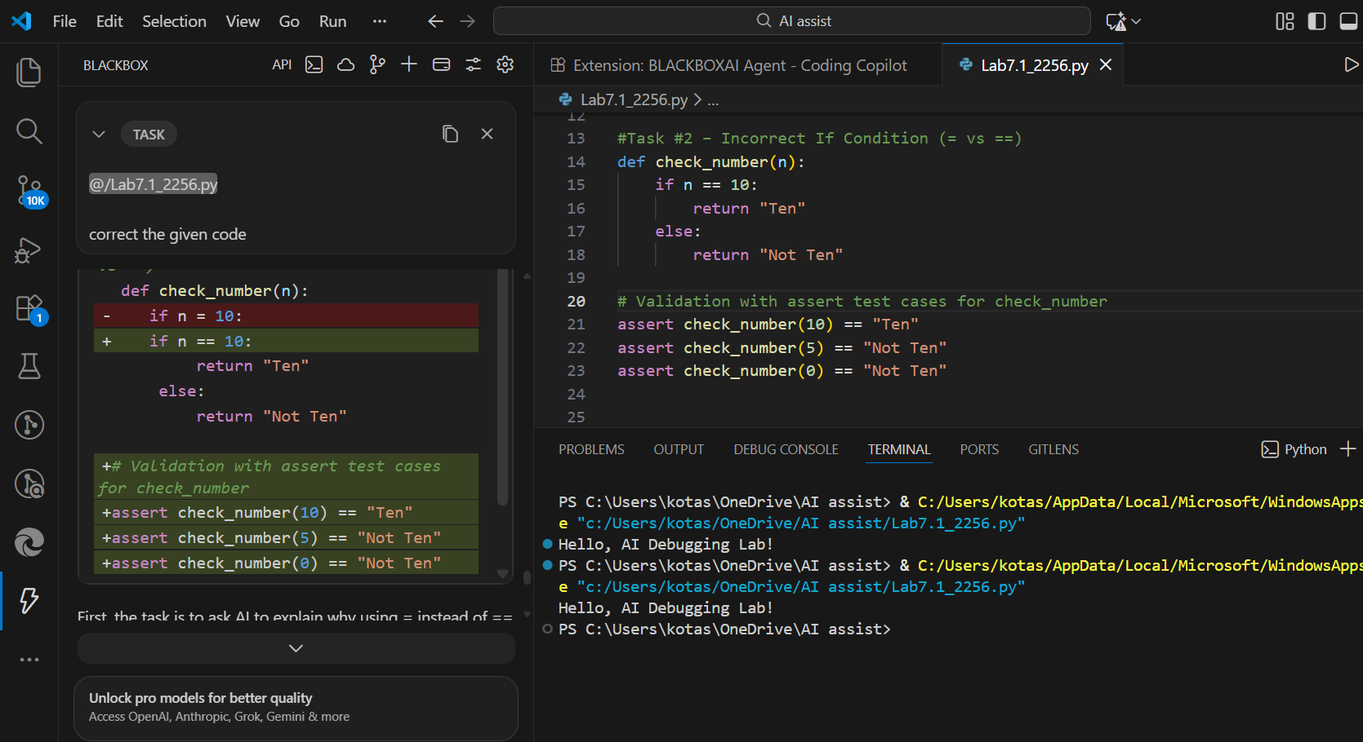
AI Explanation
= is an assignment operator, not comparison. Conditions require ==.
Code Explanation
Using == ensures proper comparison instead of assignment.

Task #3 – Runtime Error (File Not Found)
Prompt
Use AI to add safe error handling using try-except, provide a user-friendly message, and validate with 3 test scenarios and assert checks.
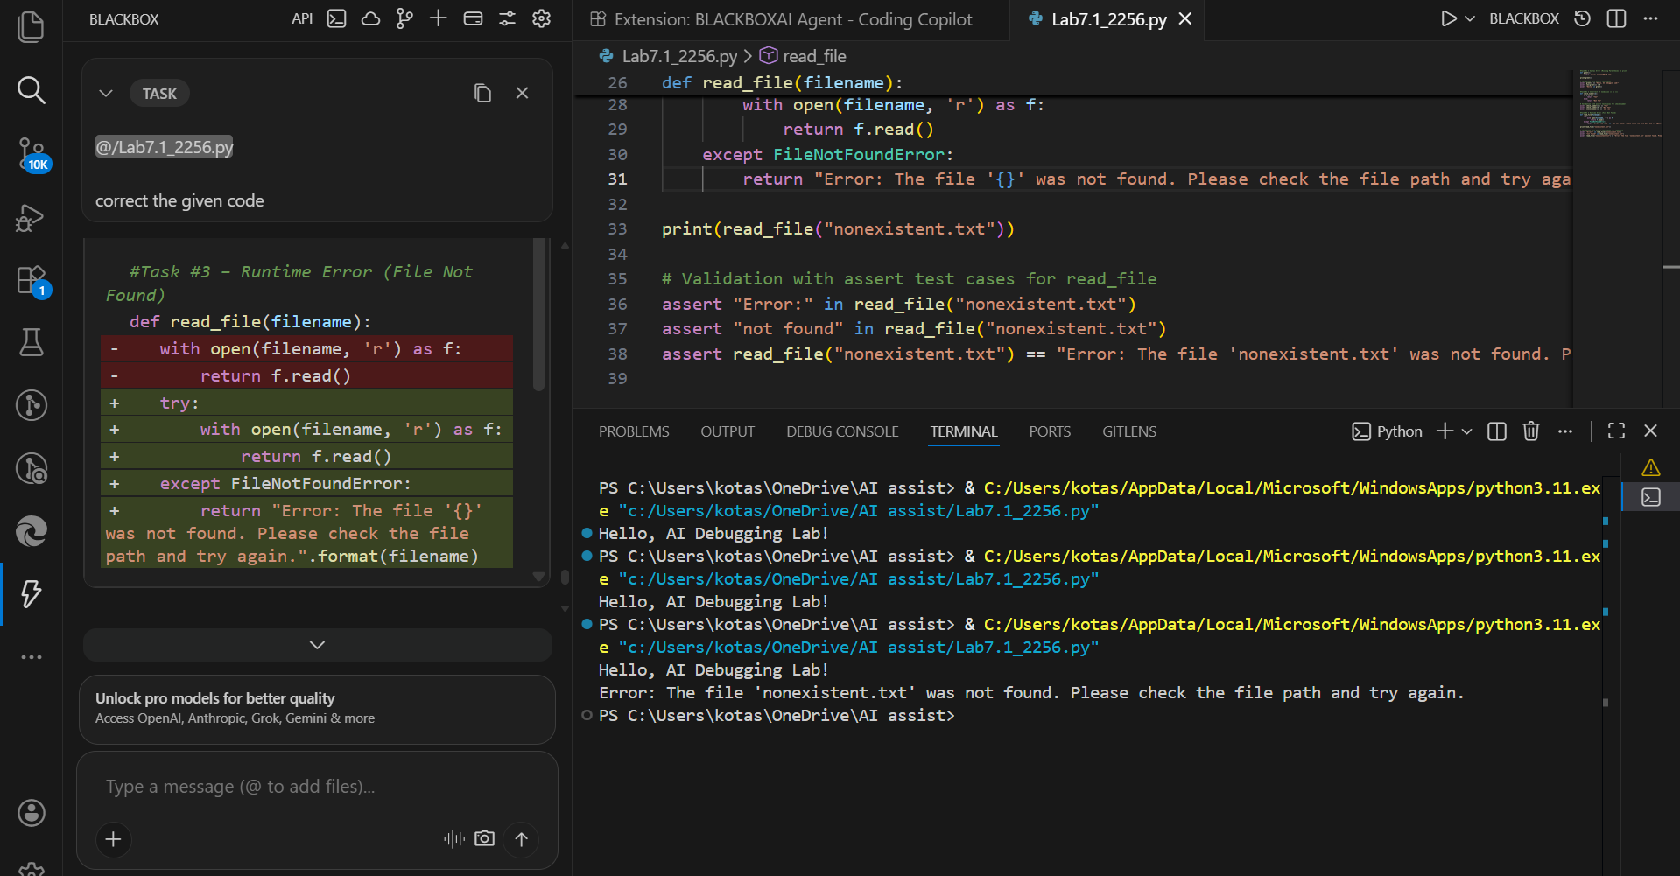

AI Explanation
The error occurs because the program tries to open a non-existent file, so AI suggests using a try–except block to handle the exception safely.
Code Explanation
try-except prevents crashes and handles runtime errors gracefully.

Task #4 – Calling a Non-Existent Method
Prompt
Use AI to analyze the bug, either define the missing method or correct the method call, and validate using 3 assert tests.

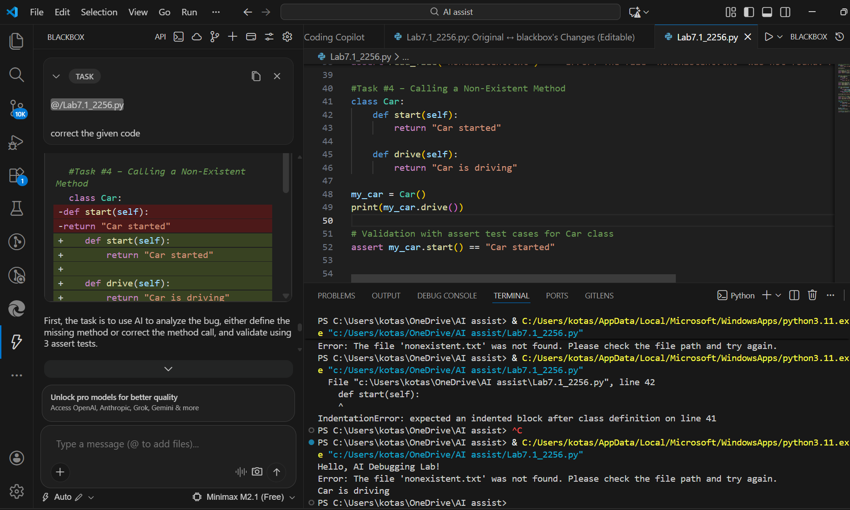

AI Explanation
drive() does not exist, causing AttributeError.
Code Explanation
The missing method was defined to eliminate the AttributeError.

Task Description #5 (TypeError – Mixing Strings and Integers in Addition)
Prompt
Ask AI for two solutions (type casting and string concatenation), fix the bug, and validate using 3 assert test cases.

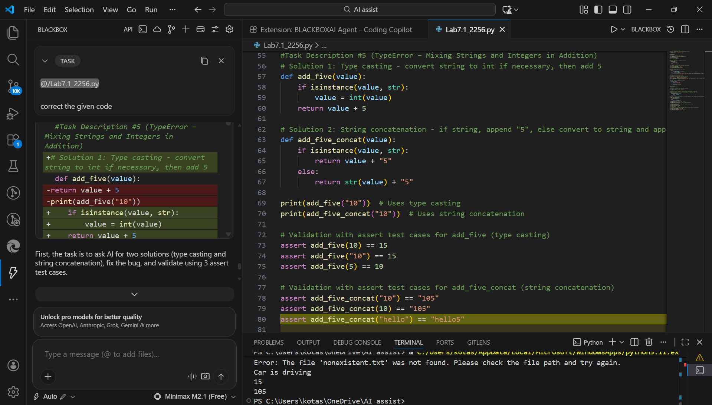

AI Explanation
The error happens due to adding incompatible data types, so AI suggests type casting or string concatenation to fix it.
Code Explanation
The error occurred due to mixing data types. Fixes include converting to integer or concatenating strings.

