LAB ASSIGNMENT 6.4

Subject: AI ASST CODING
K Siri Chandana
2303A52256
Batch-43
Task 1: Student Performance Evaluation System

PROMPT:
Create a method to display student details.
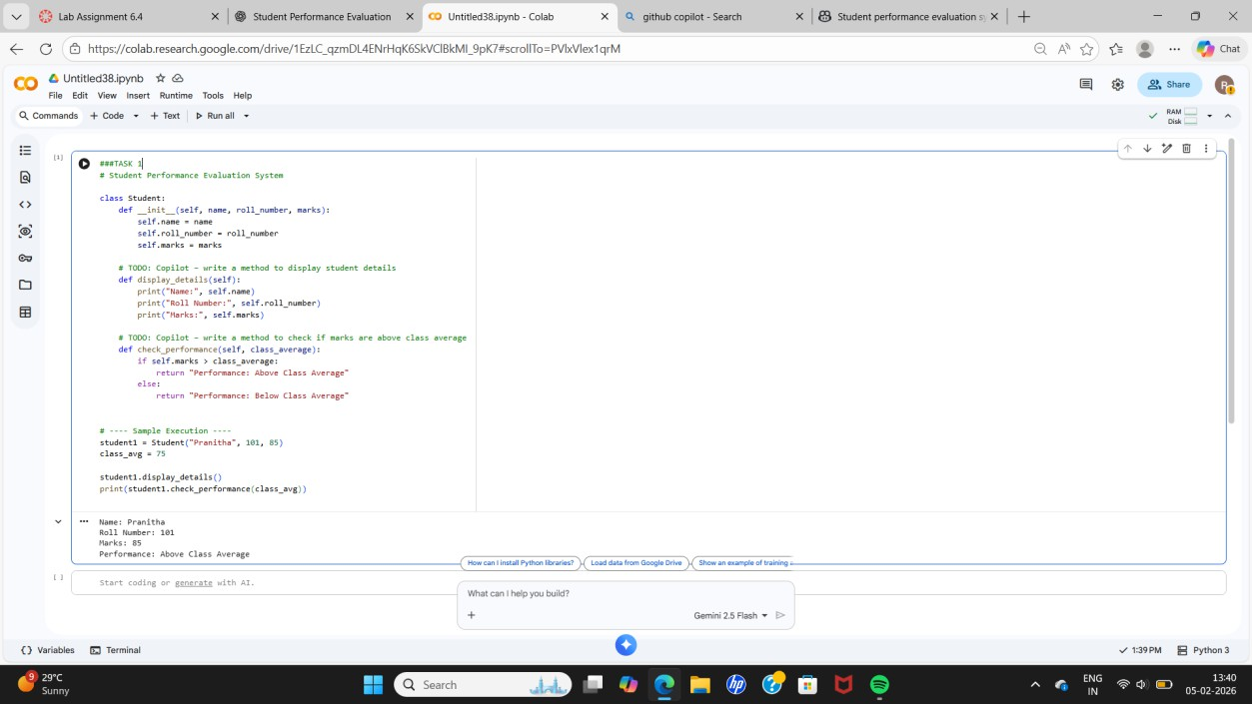
Create another method to check if student marks are above class average using if-else and return a message.
Code Explanation:
- A Student class is created with attributes name, roll_number, and marks.
- display_details() prints student information.
- check_performance() compares student marks with class average using if- else.
- If marks are greater than average, it returns Above Class Average, else
Below Class Average.

Task 2: Data Processing in a Monitoring System

PROMPT:
Iterate through the list.
Check if the number is even.
Calculate the square of even numbers. Print the result in a readable format.

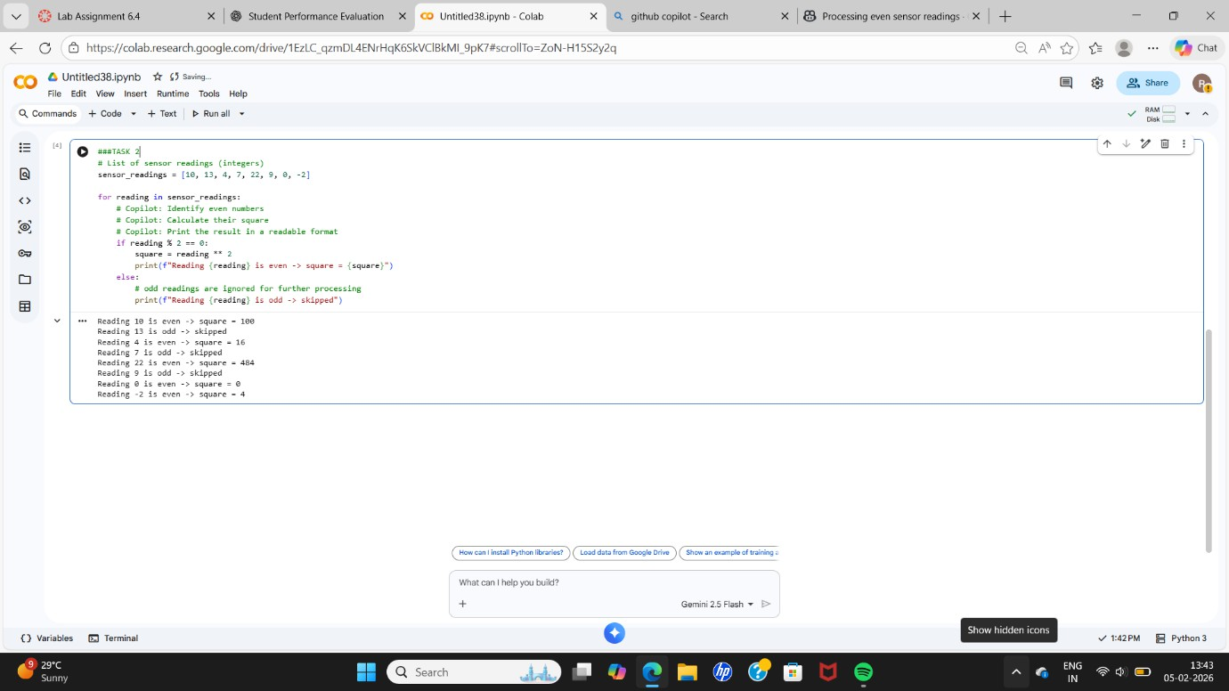
Code Explanation:
- A list of sensor readings is iterated using a for loop.
- The modulus operator % checks for even numbers.
- Squares of even numbers are calculated using **.
- Output is printed in a readable format.

Task 3: Banking Transaction Simulation

PROMPT:
Write methods to deposit money. Write a withdrawal method.
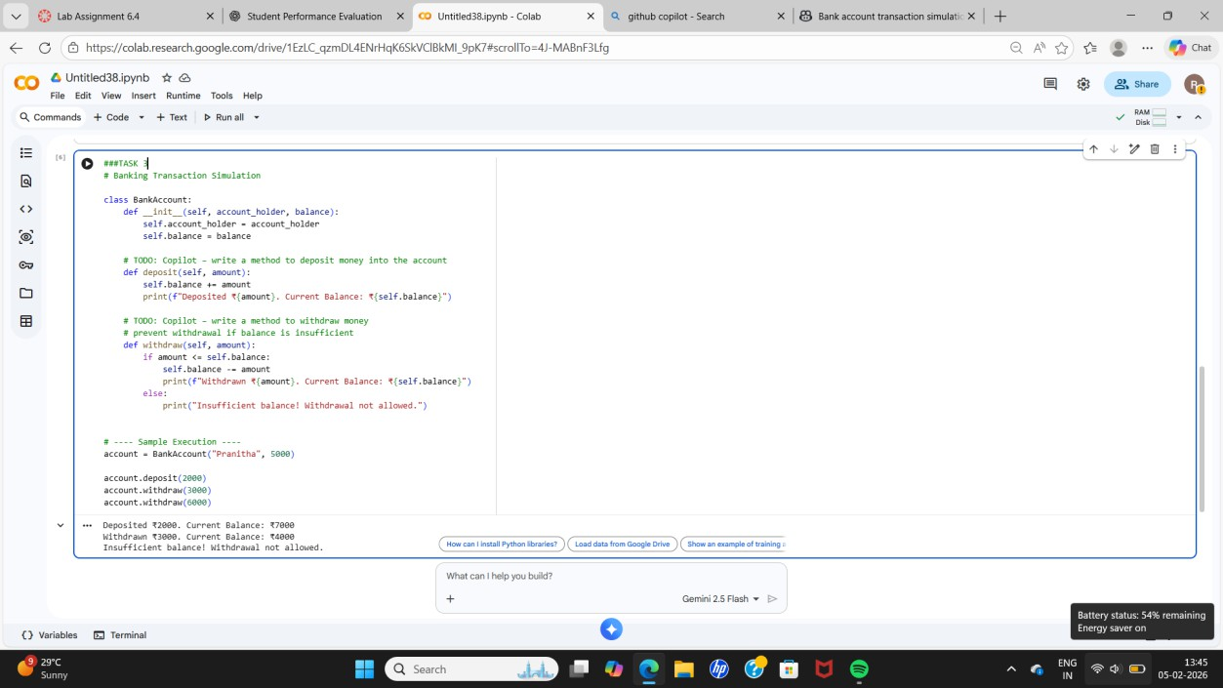
Prevent withdrawal if balance is insufficient. Display user-friendly messages.
Code Explanation:
- BankAccount class stores account holder name and balance.
- deposit() adds money to balance.
- withdraw() uses if-else to check balance before withdrawing.
- Prevents invalid withdrawals and shows clear messages.

Task 4: Student Scholarship Eligibility Check

PROMPT:
Use a while loop to iterate through students list. Check score greater than 75.
Print eligible student names.
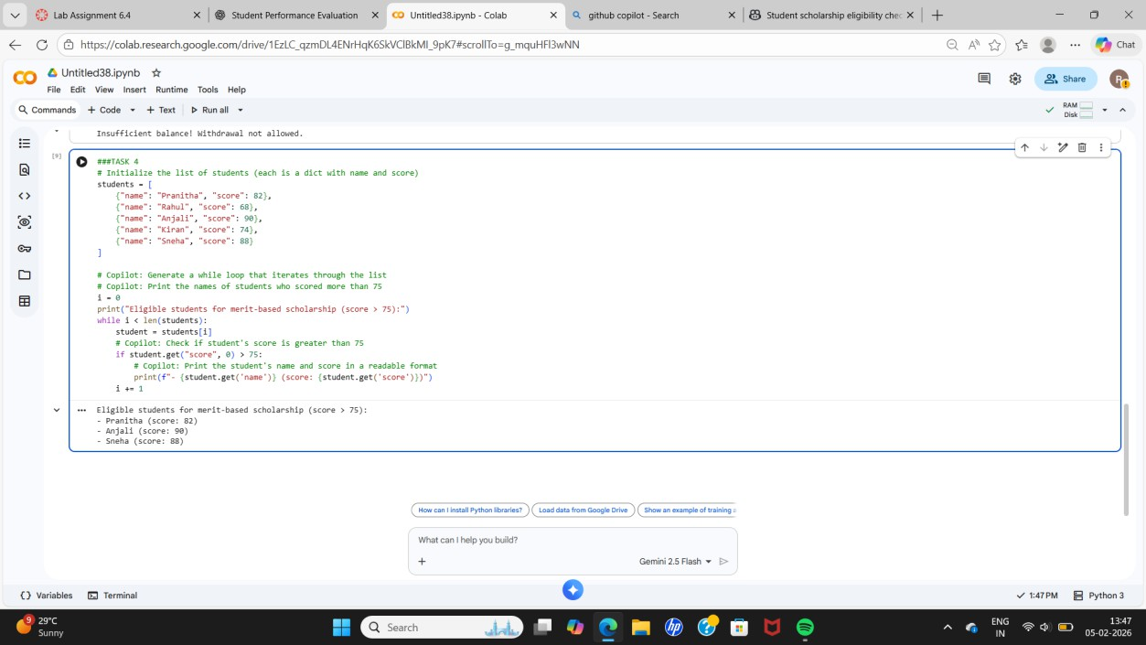

Code Explanation:
- A list of dictionaries stores student data.
- A while loop iterates using an index.
- if condition checks scholarship eligibility.
- Names of eligible students are printed.

Task 5: Online Shopping Cart Module

PROMPT:
Create methods to add items. Remove items from cart.
Calculate total using a loop.
Apply discount if total exceeds limit.
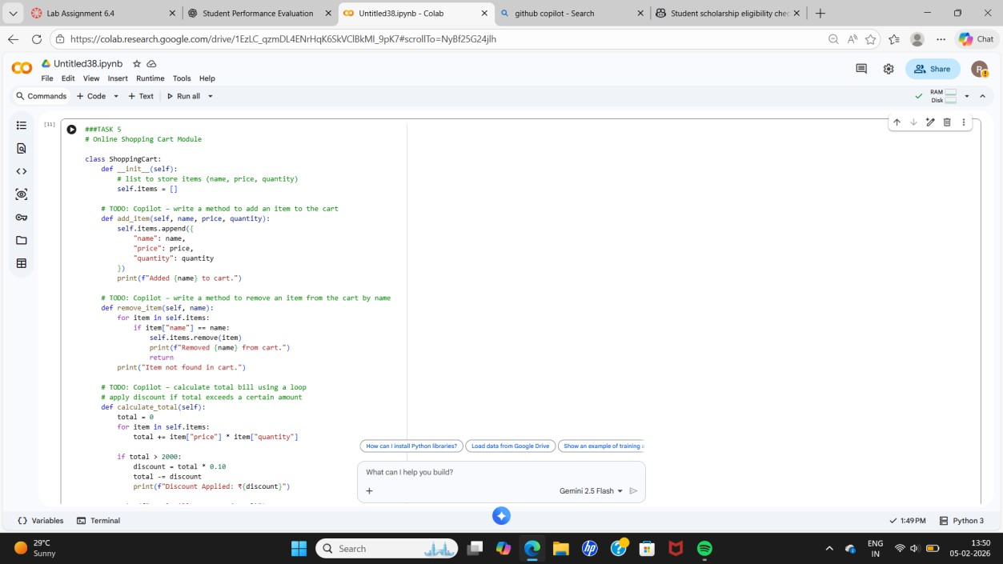

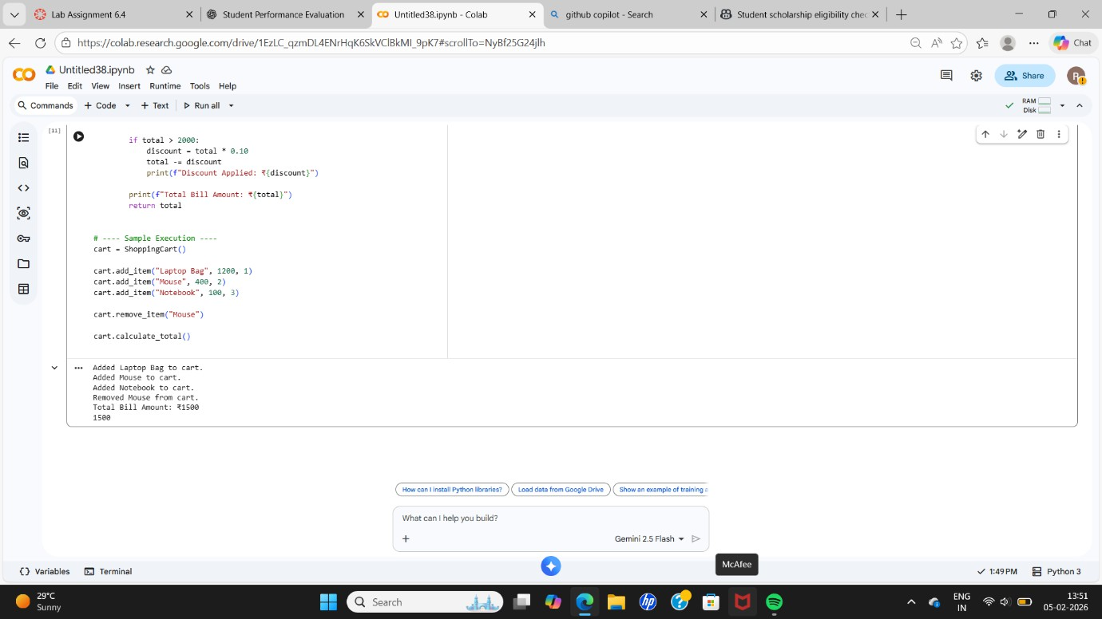
Code Explanation:
- Shopping Cart class stores items in a list.
- Each item includes name, price, and quantity.
- add_item() adds products to the cart.
- remove_item() removes products by name.
- calculate_total() computes bill using a loop and applies discount using if

