Assignment-17.1 Name: K Siri Chandana
Batch:43
H. No:2303A52256

Task 1 – Customer Data Cleaning
Use AI to generate a Python script for cleaning a customer dataset

Prompt:
Perform data preprocessing on the shopping trends dataset by handling missing values, removing duplicates, standardizing text (Location), and encoding categorical variables (Gender, Location).

Code:

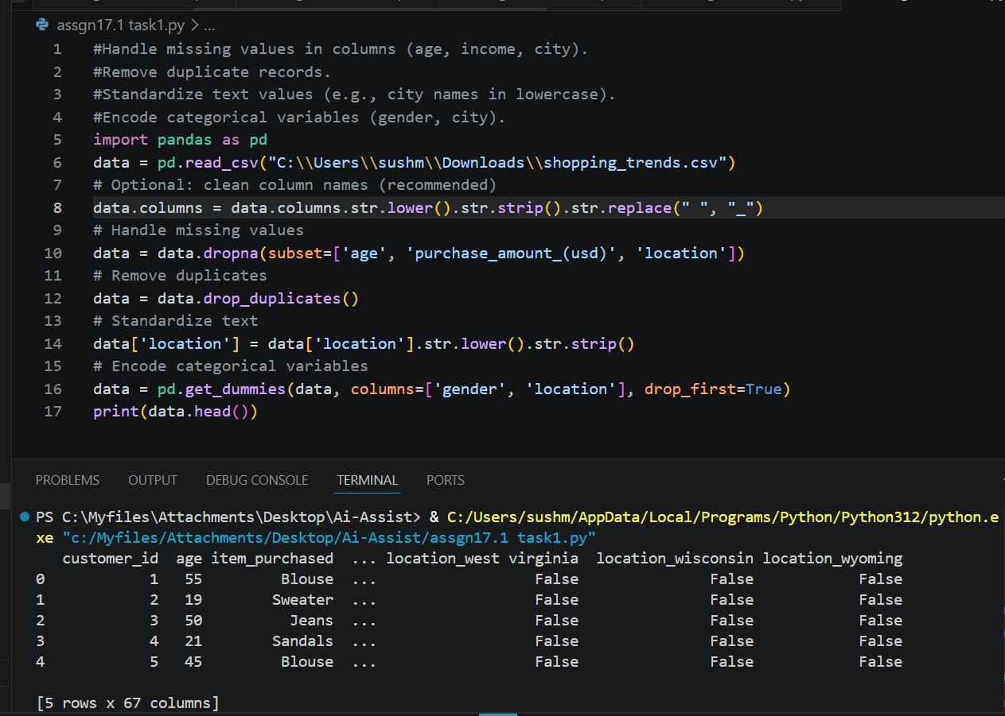
Observation:
- Missing values in key columns were removed to improve data quality and avoid errors during analysis.
- Duplicate records were identified and deleted, ensuring no repeated entries affect results.
- The Location column was standardized to lowercase and trimmed, maintaining consistency in text data.
- Categorical variables like Gender and Location were converted into numerical format using one-hot encoding.
- After preprocessing, the dataset became clean, consistent, and suitable for machine learning models and further analysis.

Task 2 – Sales Data Preprocessing
Preprocess sales transaction data using AI assistance.

Prompt:
Perform data preprocessing on the sales dataset by converting the date column into datetime format, extracting new features (month, year, day of week), normalizing the sales amount, and detecting and removing outliers.

Code:

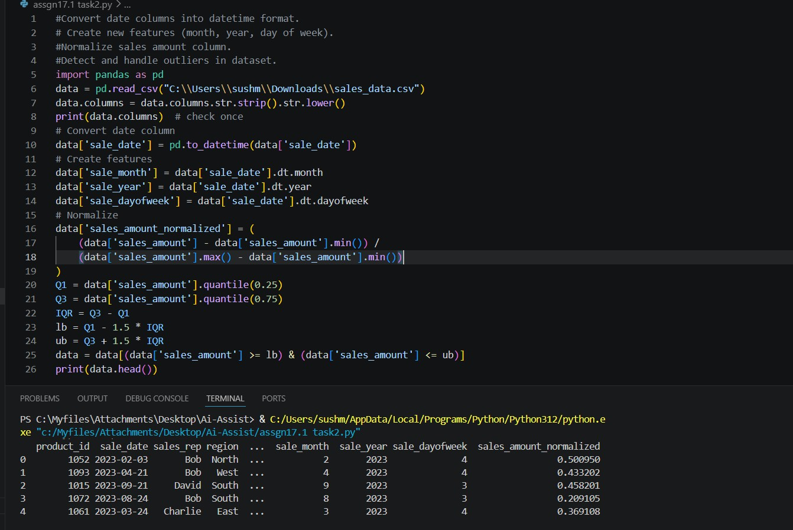
Observation:
- The sale_date column was successfully converted into datetime format, enabling time-based analysis.
- New features such as month, year, and day of week were extracted, enhancing the dataset with useful temporal information.
- The sales_amount column was normalized to a range between 0 and 1, making it suitable for machine learning models.

- Outliers in the sales data were detected using the IQR method
and removed to improve data consistency.
- After preprocessing, the dataset became structured, clean, and more suitable for analysis and predictive modeling.

Task 3 – Healthcare Data Preparation
Clean and preprocess a healthcare dataset using AI scripts.

Prompt:
Perform preprocessing on health dataset including handling missing values, encoding categorical features, scaling numerical features, and splitting into train and test sets.

Code:
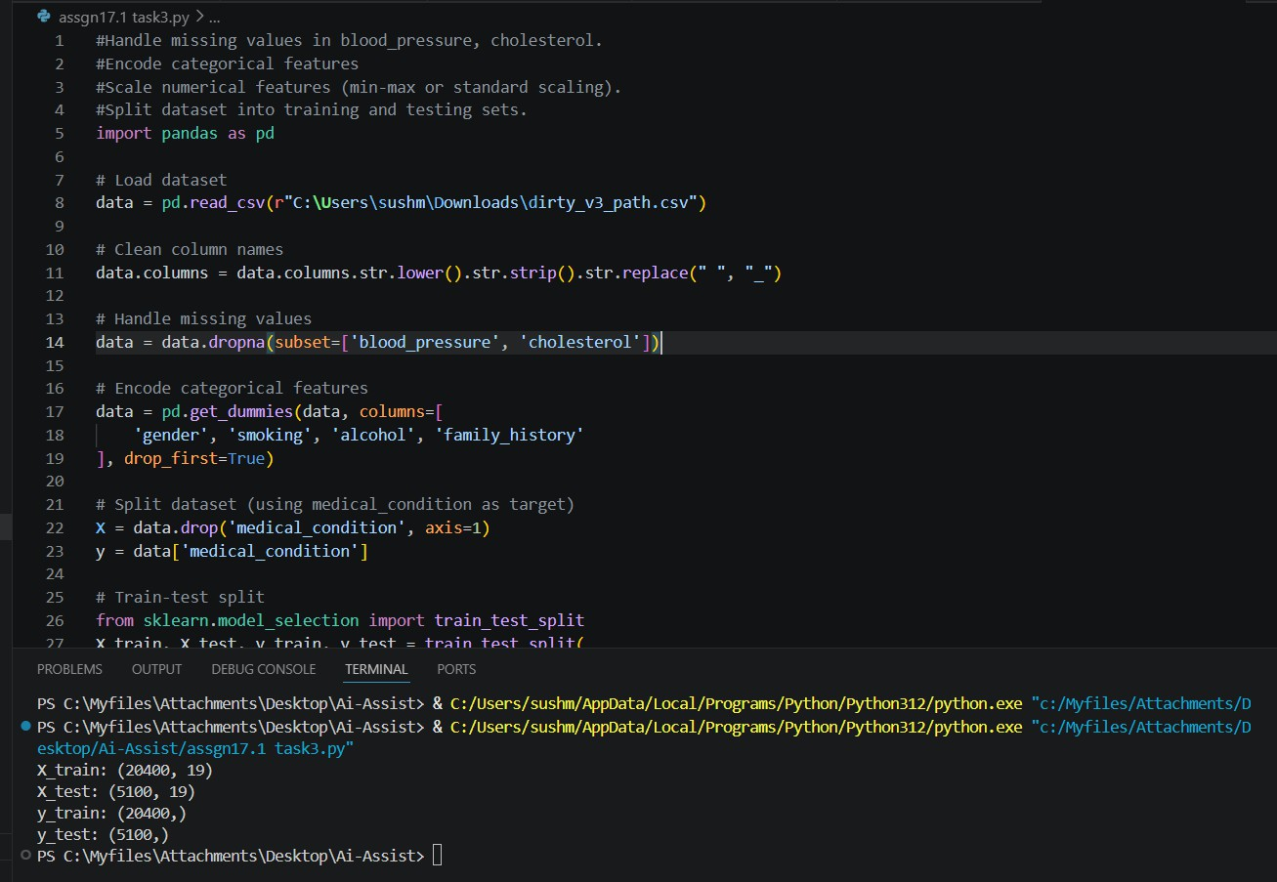

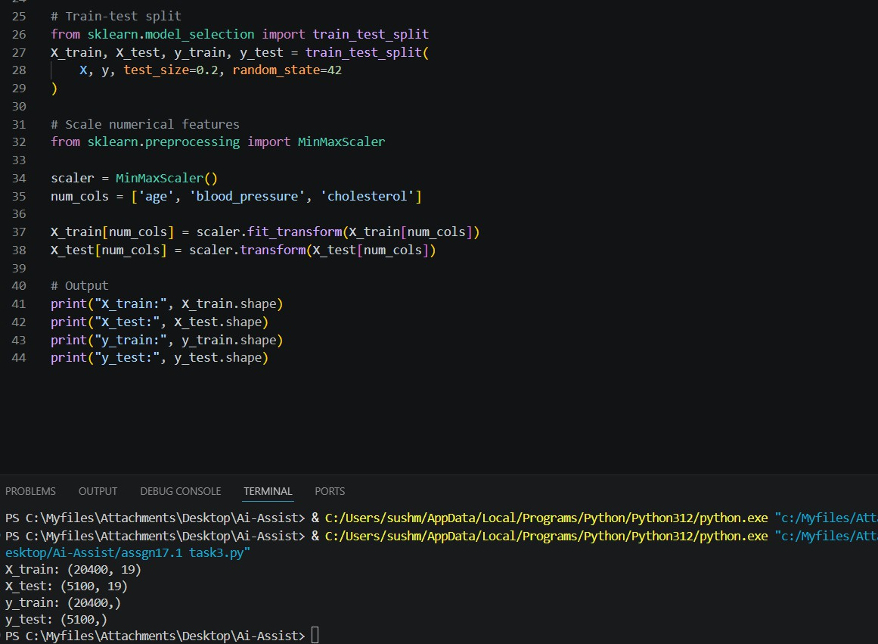
Observation:
Missing values were removed, categorical features were encoded, numerical features were scaled, and the dataset was split into training and testing sets for model building.

Task 4 – Employee Salary Data Preprocessing
Clean and preprocess an employee salary dataset using AI scripts.

Prompt:
Perform data preprocessing on the employee salary dataset by handling missing values, detecting and removing salary outliers, standardizing gender values, and encoding categorical features.

Code:

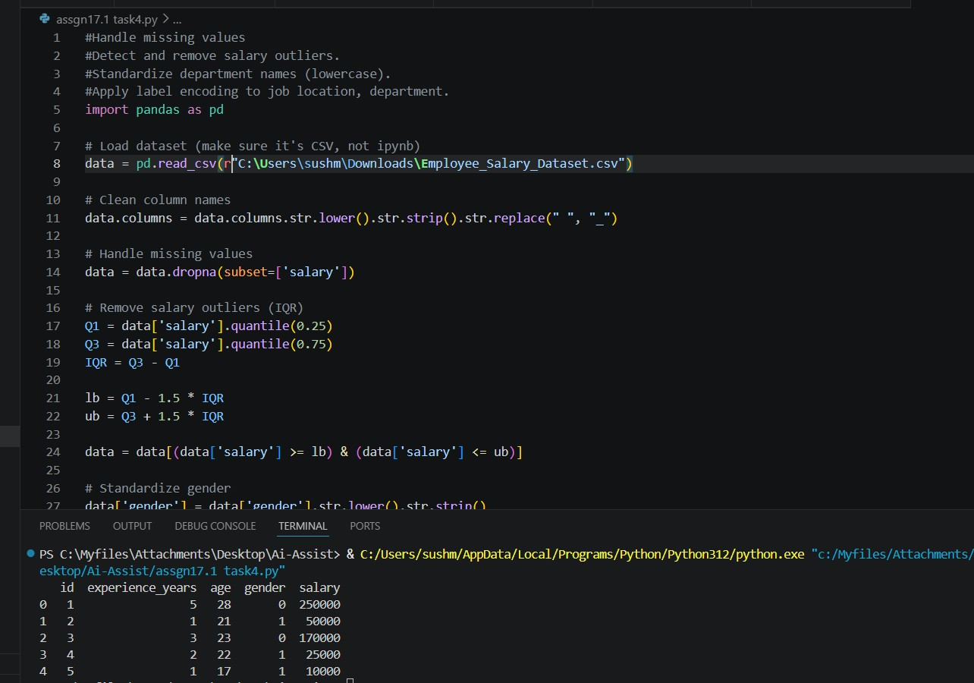

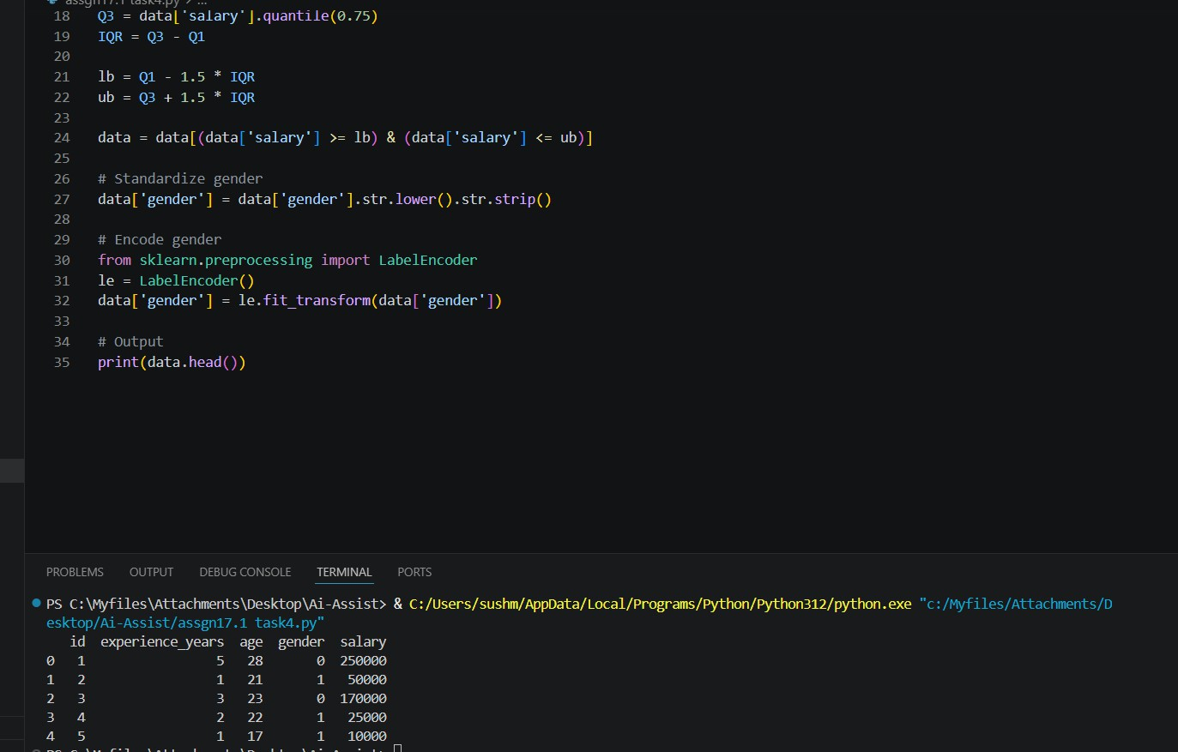
Observation:

- Missing values in the salary column were removed to ensure data quality.
- Outliers in salary were detected using the IQR method and eliminated to avoid skewed analysis.
- The gender column was standardized to lowercase for consistency.
- Categorical data (gender) was encoded into numerical format using label encoding.
- The dataset is now clean, consistent, and ready for further analysis or machine learning tasks.

