Lab Assignment- 3.1
AI Assisted Coding
K Siri Chandana – 2303A52256

Question1: Zero-Shot Prompting (Palindrome Number Program)
Prompt: generate a Python code, function that checks whether a given number is a palindrome. And input is given by the user

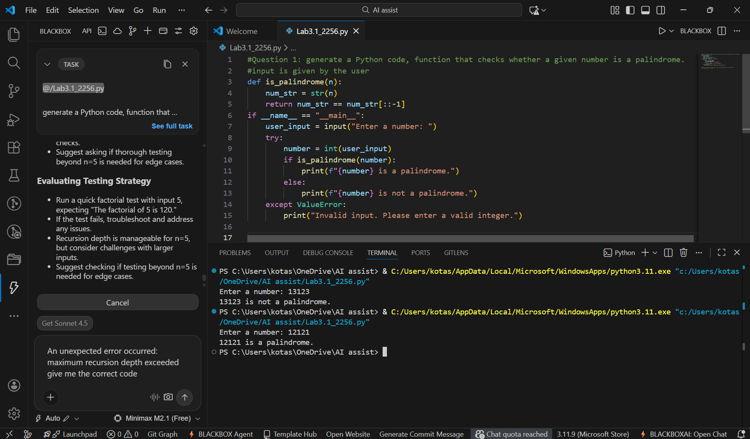
- It generates correct logic but does not handle negative numbers explicitly.\

Question 2: One-Shot Prompting (Factorial Calculation)
Prompt: generate a python code, to get the factorial number of a given number.
for example, i/p: 5, o/p:120

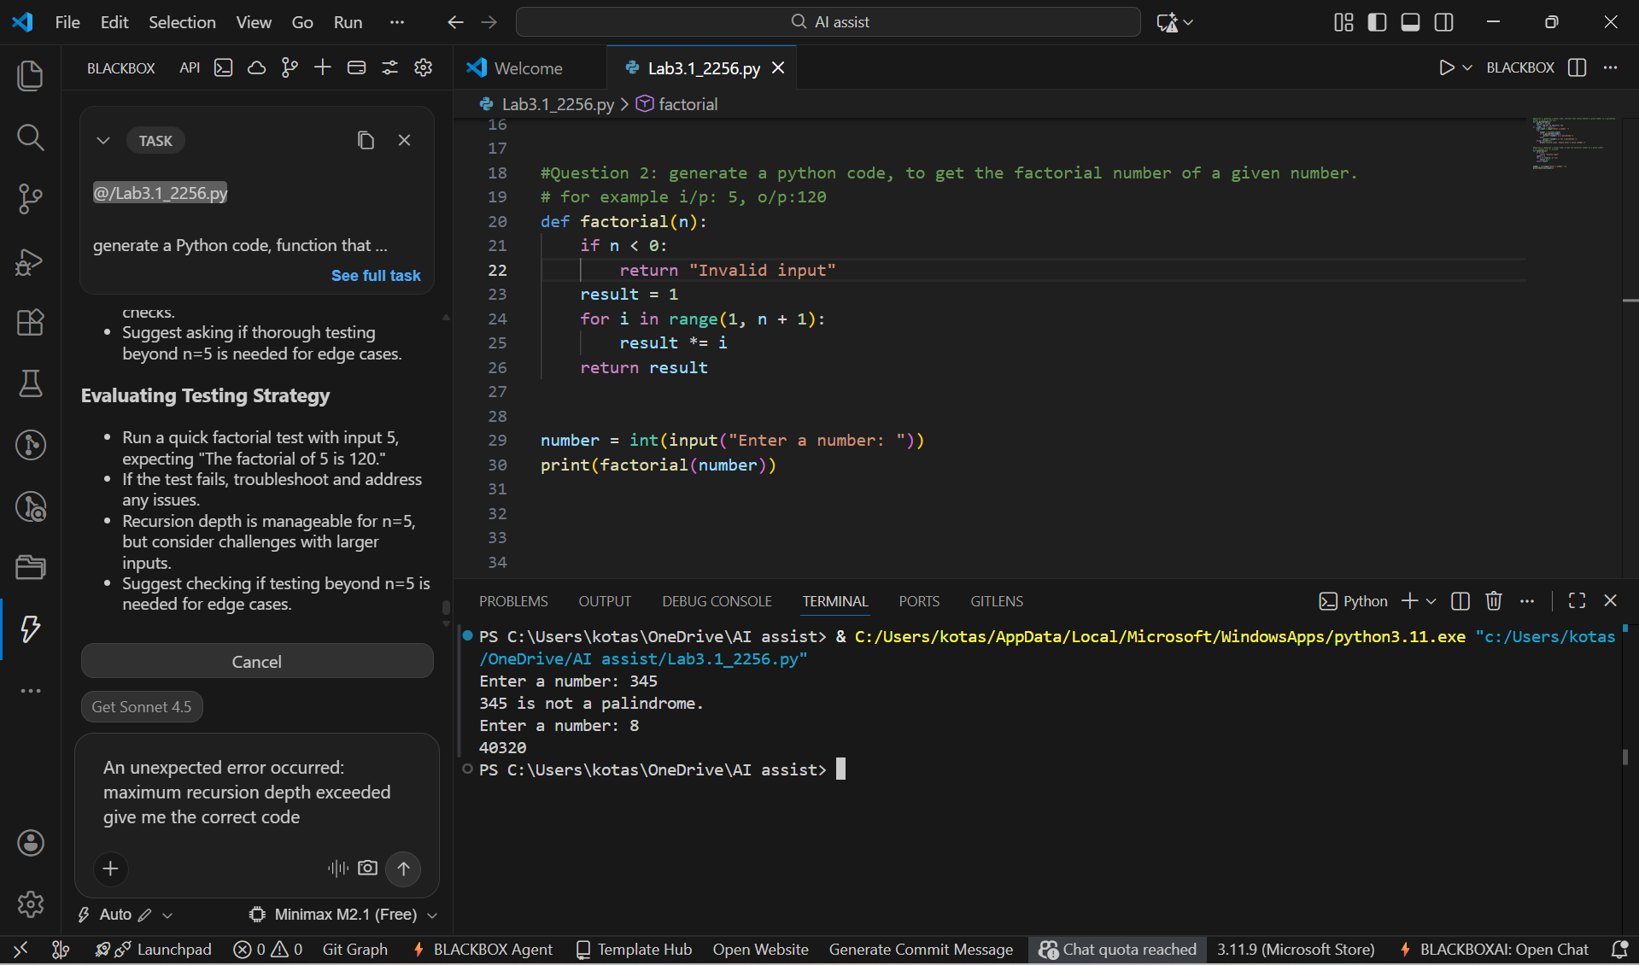
- When compared to zero- short prompting this prompt improves correctness and handles edge cases like zero and negative values.

Question 3: Few-Shot Prompting (Armstrong Number Check)
Prompt: Generate a Python code to check whether a number is an Armstrong number.
Examples: i/p: 153, o/p: Armstrong Number
i/p: 370, o/p: Armstrong Number
i/p: 123 , o/p: Not an Armstrong Number

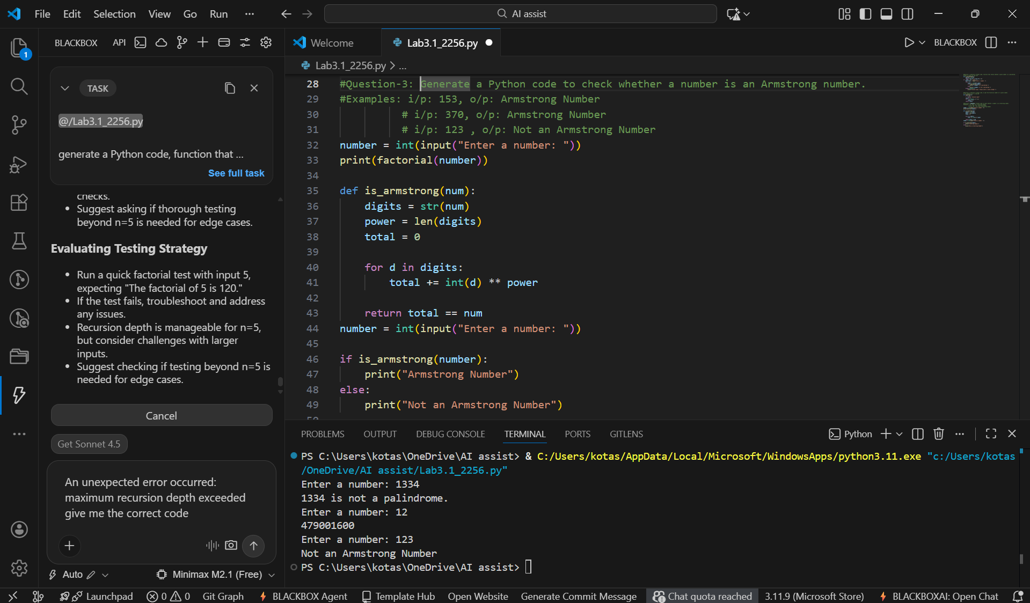

- Few-shot prompting improves structural accuracy and produces organized logic.

Question 4: Context-Managed Prompting (Optimized Number Classification)
Prompt: Write an optimized Python program to classify a number as prime, composite, or neither. Ensure input validation and efficient logic.

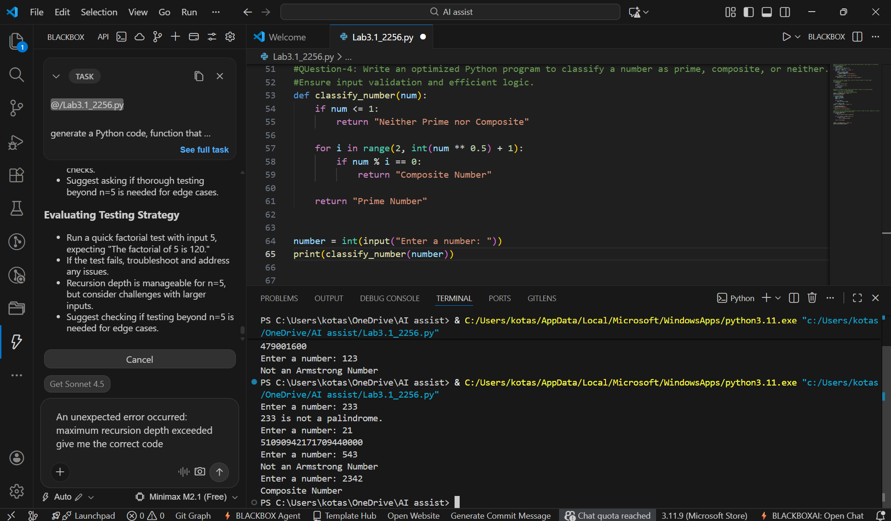

- Context-managed prompts produce optimized and validation-aware solutions suitable for real-world applications.

Question 5: Zero-Shot Prompting (Perfect Number Check)
Prompt: Generate a Python function to check whether a given number is a perfect number.

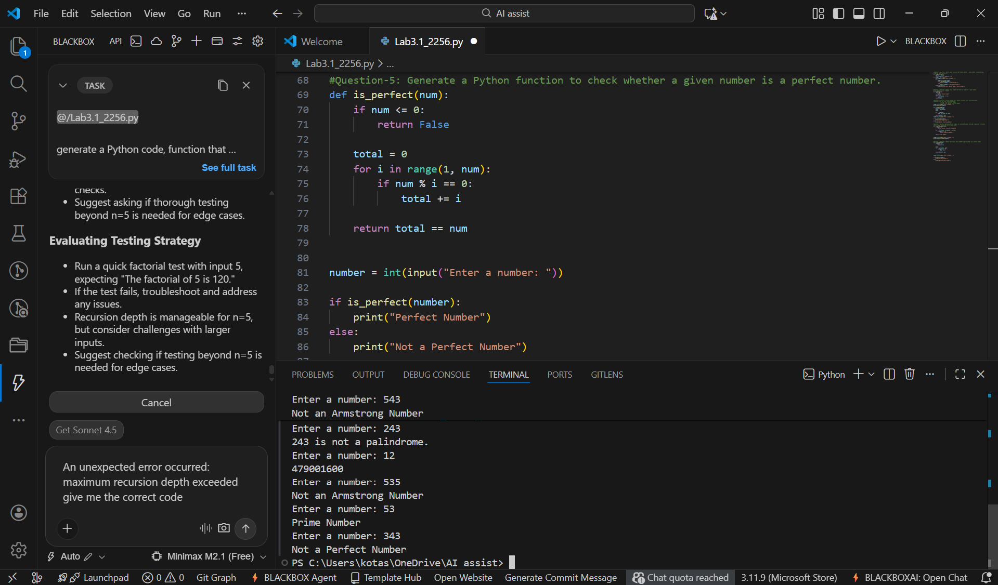

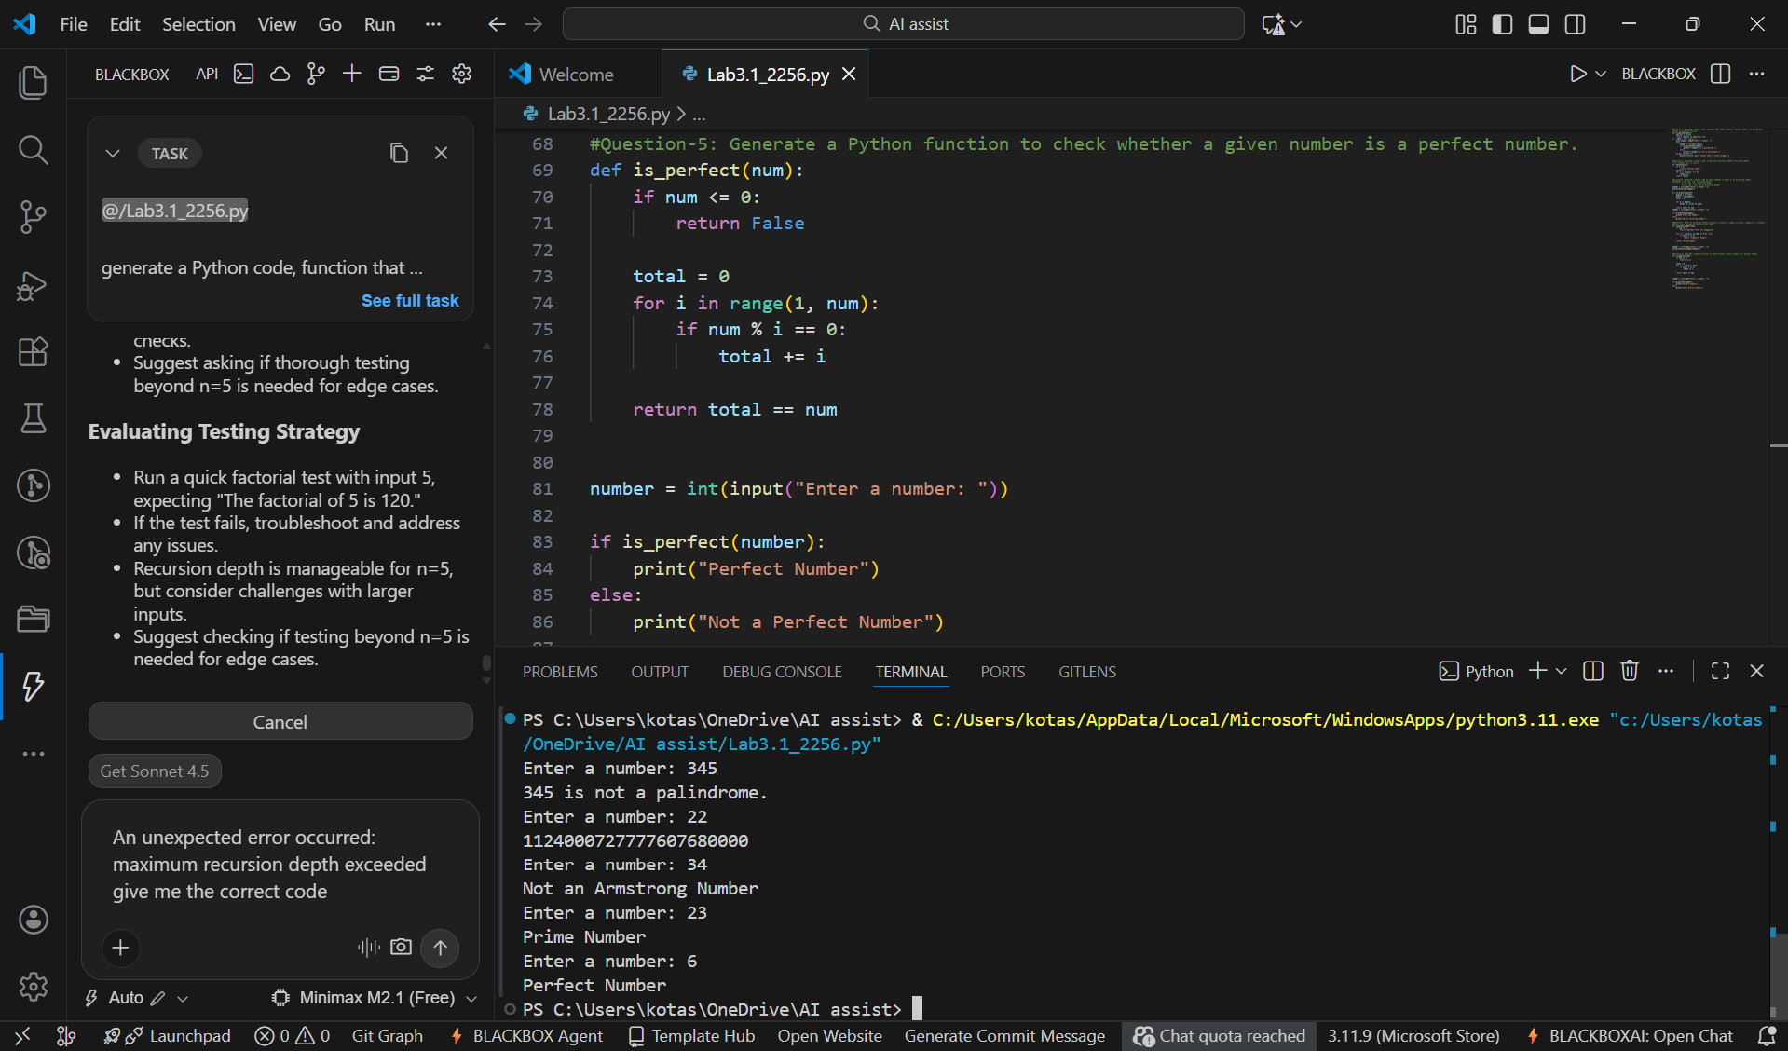

- Zero-shot prompting works but is less optimized due to unnecessary full-range iteration.

Question 6: Few-Shot Prompting (Even or Odd Classification with
Validation)
Prompt: Generate a Python program to check whether a number is even or odd with input validation.
Examples:
I/p: 8, O/p: Even
I/p: 15, O/p: Odd
I/p: 0, O/p: Even
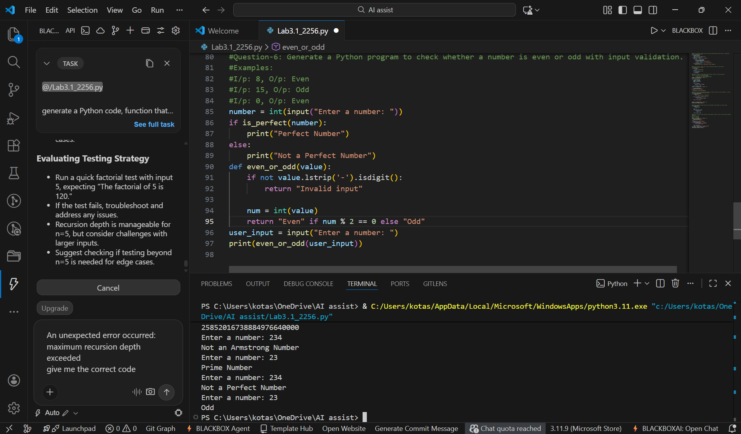

- Few-shot prompting significantly improves the quality of AI-generated code by providing clear input–output examples.
- The generated program handles input validation effectively, correctly classifies even and odd numbers, and manages negative and non-integer inputs more reliably compared to zero-shot prompting.

