**Cognizant Digital Nurture 4.0**

**Name: Siri Chandana Chittipolu**

**Email:** [**sirichittipolu11@gmail.com**](mailto:sirichittipolu11@gmail.com)

**Superset ID: 6386277**

**Mandatory Hands-On Exercises**

**Data structures and Algorithms :**

**Exercise 2: E-commerce Platform Search Function:**

Solution:

**Step 1:**

What is Big O Notation?

* Big O Notation describes the time or space complexity of an algorithm in terms of input size n.
* It tells us how the performance of an algorithm scales as the input size grows.

| **Case** | **Linear Search** | **Binary Search** |
| --- | --- | --- |
| **Best** | O(1) (first element) | O(1) (middle element) |
| **Average** | O(n/2) → O(n) | O(log n) |
| **Worst** | O(n) | O(log n) |

Big O for Search Algorithms:

**Step 2:**

Product.java :

public class Product {

int productId;

String productName;

String category;

public Product(int productId, String productName, String category) {

this.productId = productId;

this.productName = productName;

this.category = category;

}

@Override

public String toString() {

return productId + " - " + productName + " (" + category + ")";

}

}

**Step 3:**

SearchUtil.java :

public class SearchUtil {

public static Product linearSearch(Product[] products, String targetName) {

for (Product product : products) {

if (product.productName.equalsIgnoreCase(targetName)) {

return product;

}

}

return null;

}

public static Product binarySearch(Product[] products, String targetName) {

int low = 0;

int high = products.length - 1;

while (low <= high) {

int mid = (low + high) / 2;

int cmp = products[mid].productName.compareToIgnoreCase(targetName);

if (cmp == 0) {

return products[mid];

} else if (cmp < 0) {

low = mid + 1;

} else {

high = mid - 1;

}

}

return null;

}

}

**Step 4:**

Compare the Time Complexity of Linear and Binary Search Algorithms

| Feature | Linear Search | Binary Search |
| --- | --- | --- |
| Time Complexity | O(n) | O(log n) |
| Best Case | O(1) (target at beginning) | O(1) (target at middle) |
| Average Case | O(n/2) → O(n) | O(log n) |
| Worst Case | O(n) (target not found or last) | O(log n) (search space halves each step) |
|  |  |  |

Binary Search is more suitable, because:

1. Performance:  
Binary search is significantly faster (O(log n)) than linear search (O(n)) as the product catalog grows.

2. Scalability:  
E-commerce platforms typically handle thousands to millions of products — log-based performance is essential for responsiveness.

3. Search Optimization:  
Product data can be indexed or pre-sorted (e.g., by product name), which makes binary search practical and efficient.

Output :

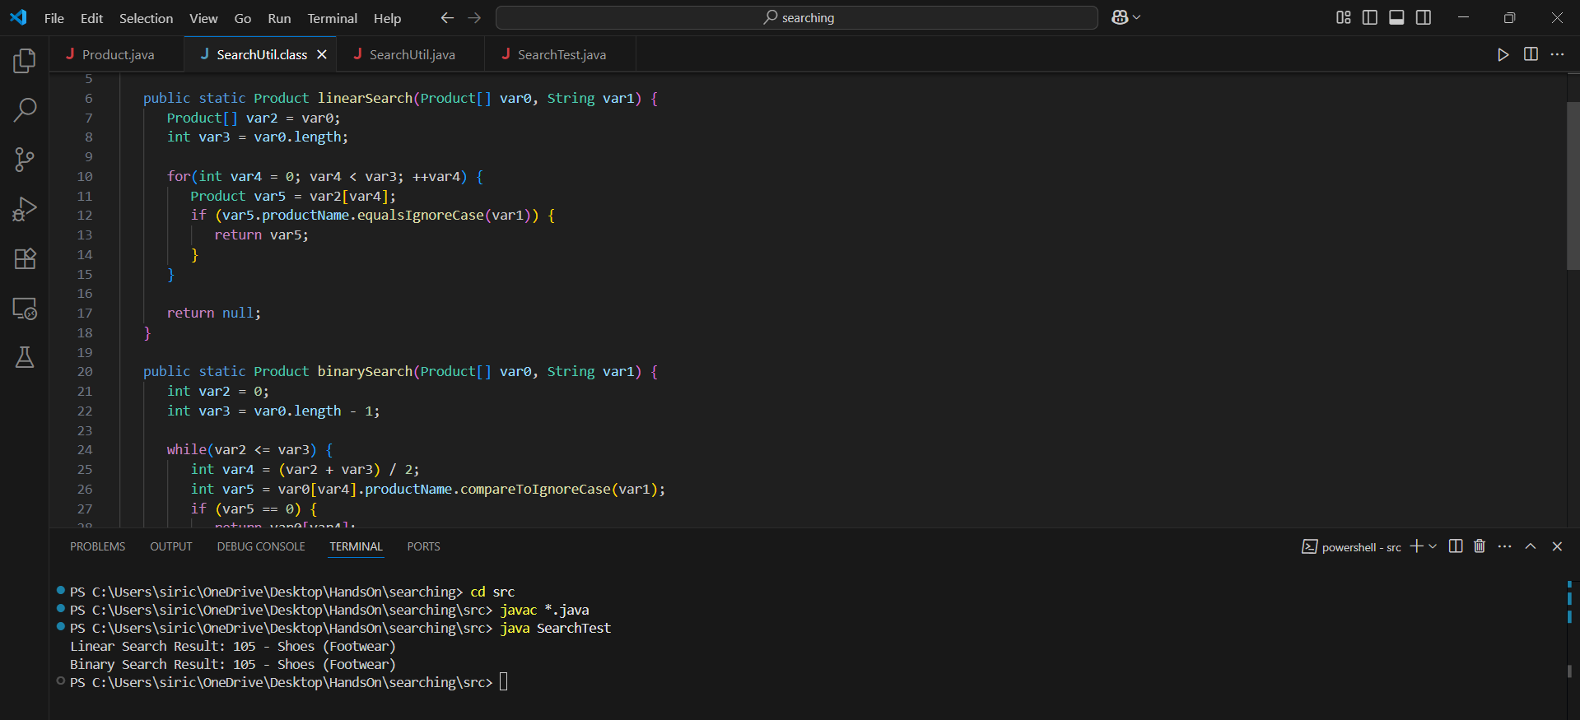

**Exercise 7: Financial Forecasting :**

Solution:

**Step 1:**

Recursion:

* Recursion is a programming technique where a method calls itself directly or indirectly to solve a problem.
* Simplifies complex problems like tree traversal, mathematical series, and forecasting.
* Good fit when the current output depends on previous results, like forecasting based on prior growth.

**Step 2:**

Future Value Method:

Let’s assume:

* futureValue(years) = currentValue * (1 + growthRate)^years
* We’ll write this using recursion.

**Step 3 :**

FinancialForecast.java :

public class FinancialForecast {

    public static double forecast(double currentValue, double growthRate, int years) {

        if (years == 0) {

            return currentValue;

        }

        return forecast(currentValue, growthRate, years - 1) * (1 + growthRate);

    }

    public static void main(String[] args) {

        double currentValue = 10000;

        double growthRate = 0.05;

        int years = 5;

        double predictedValue = forecast(currentValue, growthRate, years);

        System.out.printf("Predicted value after %d years: %.2f\n", years, predictedValue);

    }

}

Output :

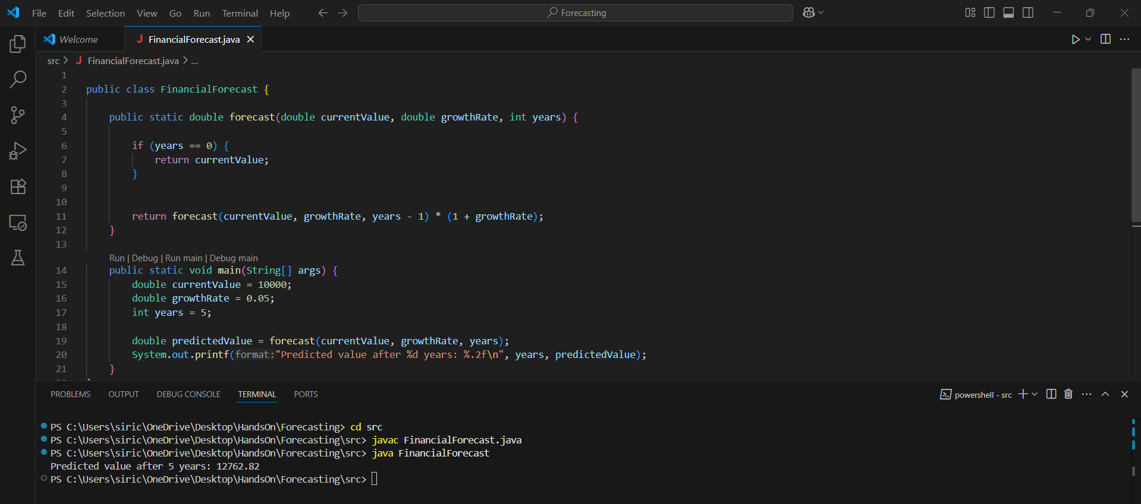

**Step 4 :**

Time Complexity of the Recursive Algorithm

Recursive Formula Used:

futureValue(currentValue, growthRate, years) =

futureValue(currentValue, growthRate, years - 1) * (1 + growthRate)

Time Complexity:

* The recursion makes one call per year, reducing years by 1 each time.
* So, for n years, it makes n recursive calls.

Therefore:

* Time Complexity: O(n)
* Space Complexity: O(n) (due to the recursive call stack)

Problem in the Recursive Solution :

* Recursive calls add stack overhead.
* In large input cases, this may lead to stack overflow or performance issues.

Use Iteration Instead of Recursion :

Replace recursion with a loop for constant space.

public static double forecastIterative(double currentValue, double growthRate, int years) {

for (int i = 0; i < years; i++) {

currentValue *= (1 + growthRate);

}

return currentValue;

}

* Time Complexity: O(n)
* Space Complexity: O(1)