**Cognizant Digital Nurture 4.0**

**Name: Siri Chandana Chittipolu**

**Email:** [**sirichittipolu11@gmail.com**](mailto:sirichittipolu11@gmail.com)

**Superset ID: 6386277**

**Mandatory Hands-On Exercises**

**Design principles & Patterns**

Exercise 1: Implementing the Singleton Pattern

Solution:

Logger.java:

public class Logger {

   private static Logger instance;

    private Logger() {

        System.out.println("Logger Initialized");

    }

    public static Logger getInstance() {

        if (instance == null) {

            instance = new Logger();

        }

        return instance;

    }

    public void log(String message) {

        System.out.println("LOG: " + message);

    }

}

SingletonTest.java :

public class SingletonTest {

    public static void main(String[] args) {

        Logger logger1 = Logger.getInstance();

        logger1.log("This is the first log message.");

        Logger logger2 = Logger.getInstance();

        logger2.log("This is the second log message.");

        if (logger1 == logger2) {

            System.out.println("Both logger1 and logger2 refer to the same instance.");

        } else {

            System.out.println("Different instances detected!");

        }

    }

}

Output:

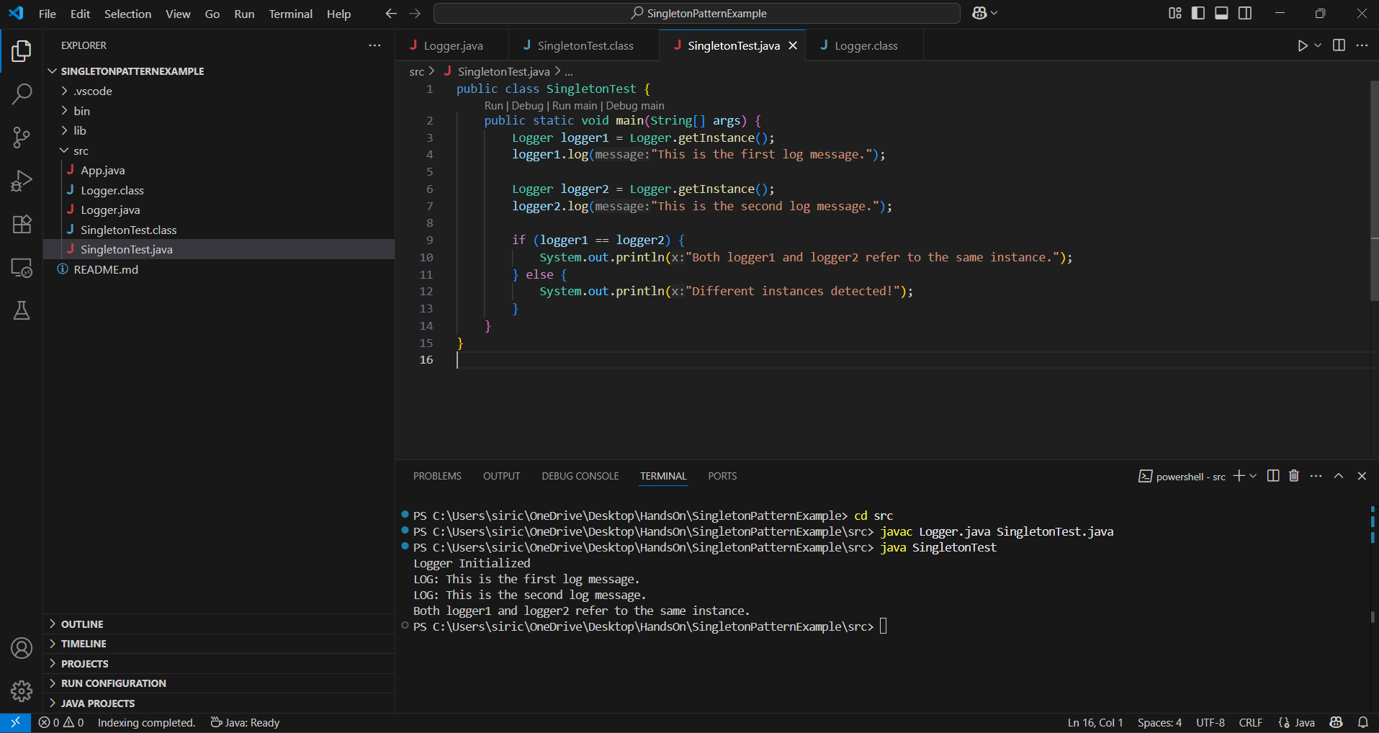

Exercise 2: Implementing the Factory Method Pattern:

Solution:

Document.java :

public interface Document {

    void open();

}

WordDocument.java :

public class WordDocument implements Document {

    public void open() {

        System.out.println("Opening a Word document.");

    }

}

PdfDocument.java :

public class PdfDocument implements Document {

    public void open() {

        System.out.println("Opening a PDF document.");

    }

}

ExcelDocument.java :

public class ExcelDocument implements Document {

    public void open() {

        System.out.println("Opening an Excel document.");

    }

}

WordDocumentFactory.java :

public class WordDocumentFactory extends DocumentFactory {

    public Document createDocument() {

        return new WordDocument();

    }

}

PdfDocumentFactory.java :

public class PdfDocumentFactory extends DocumentFactory {

    public Document createDocument() {

        return new PdfDocument();

    }

}

ExceldocumentFactory.java :

public class ExcelDocumentFactory extends DocumentFactory {

    public Document createDocument() {

        return new ExcelDocument();

    }

}

TestFactoryMethod.java :

public class TestFactoryMethod {

    public static void main(String[] args) {

        DocumentFactory wordFactory = new WordDocumentFactory();

        Document wordDoc = wordFactory.createDocument();

        wordDoc.open();

        DocumentFactory pdfFactory = new PdfDocumentFactory();

        Document pdfDoc = pdfFactory.createDocument();

        pdfDoc.open();

        DocumentFactory excelFactory = new ExcelDocumentFactory();

        Document excelDoc = excelFactory.createDocument();

        excelDoc.open();

    }

}

Output:

