**Cognizant Digital Nurture 4.0**

**Name: Siri Chandana Chittipolu**

**Email:** [**sirichittipolu11@gmail.com**](mailto:sirichittipolu11@gmail.com)

**Superset ID: 6386277**

**Mandatory Hands-On Exercises**

**Spring Core and Maven**

**Exercise 1: Configuring a Basic Spring Application**

**Scenario:** Your company is developing a web application for managing a library. You need to use the Spring Framework to handle the backend operations.

**Solution:**

**Step 1: Setting Up a Maven Project:**

Opening Eclipse and creating a new Maven project named LibraryManagement using the maven-archetype-quickstart archetype.

**Step 2: applicationContext.xml:**

<?xml version="1.0" encoding="UTF-8"?>

<beans xmlns="http://www.springframework.org/schema/beans"

xmlns:xsi="http://www.w3.org/2001/XMLSchema-instance"

xsi:schemaLocation="

http://www.springframework.org/schema/beans

http://www.springframework.org/schema/beans/spring-beans.xsd">

<bean id="bookRepository" class="com.library.repository.BookRepository" />

<bean id="bookService" class="com.library.service.BookService">

<property name="bookRepository" ref="bookRepository" />

</bean>

</beans>

**Step 3:** **BookService.java:**

package com.library.service;

import com.library.repository.BookRepository;

public class BookService {

private BookRepository bookRepository;

public void setBookRepository(BookRepository bookRepository) {

this.bookRepository = bookRepository;

}

public void addBook(String bookName) {

System.*out*.println("Adding book: " + bookName);

bookRepository.save(bookName);

}

}

**BookRepository.java:**

package com.library.repository;

public class BookRepository {

public void save(String bookName) {

System.*out*.println("Saving book: " + bookName);

}

}

**Step 4: MainApp.java:**

package com.example.LibraryManagement;

import com.library.service.BookService;

import org.springframework.context.ApplicationContext;

import org.springframework.context.support.ClassPathXmlApplicationContext;

public class MainApp {

public static void main(String[] args) {

ApplicationContext context = new ClassPathXmlApplicationContext("applicationContext.xml");

BookService bookService = (BookService) context.getBean("bookService");

bookService.addBook("Spring in Action");

}

}

**Output:**

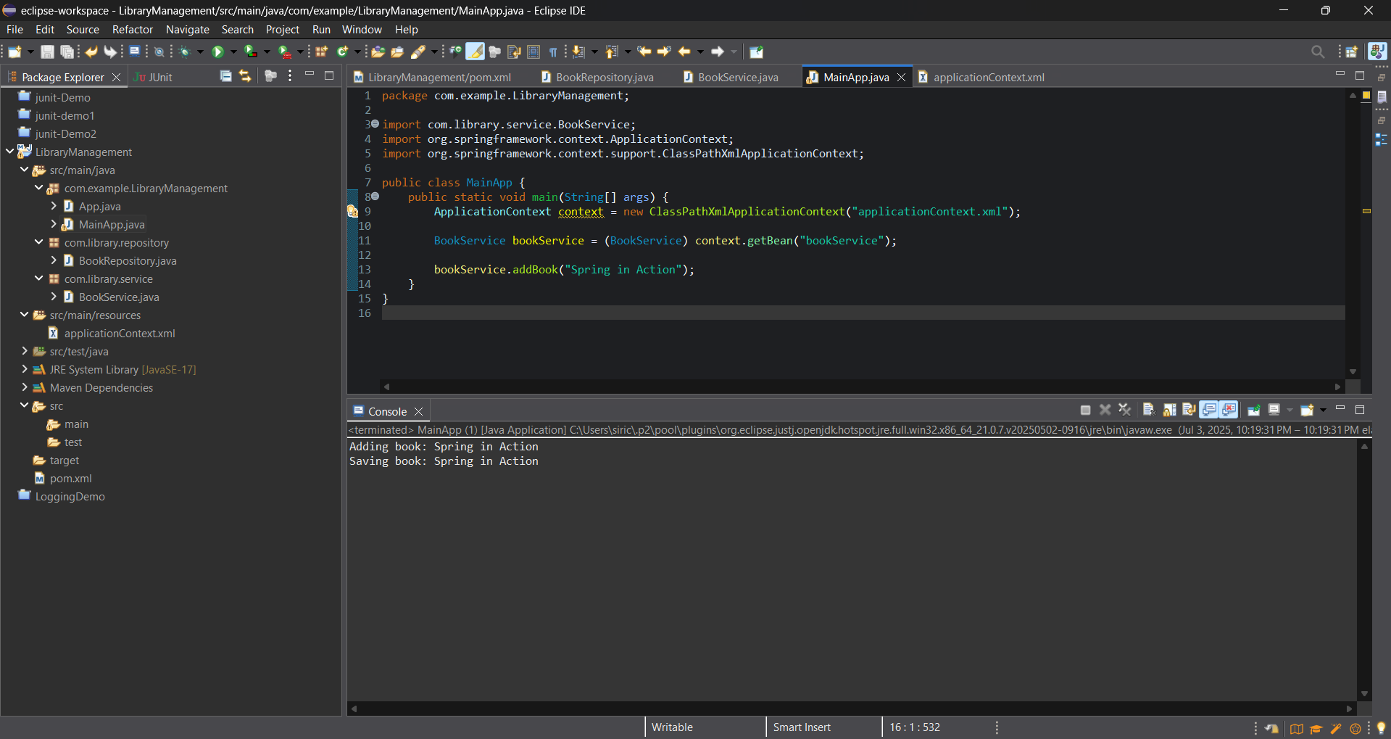

**Exercise 2: Implementing Dependency Injection**

**Scenario:** In the library management application, you need to manage the dependencies between the BookService and BookRepository classes using Spring's IoC and DI.

**Solution:**

**Step 1: Modifying the xml configuration**

**applicationContext.xml**

<?xml version="1.0" encoding="UTF-8"?>

<beans xmlns="http://www.springframework.org/schema/beans"

xmlns:xsi="http://www.w3.org/2001/XMLSchema-instance"

xsi:schemaLocation="

http://www.springframework.org/schema/beans

http://www.springframework.org/schema/beans/spring-beans.xsd">

<bean id="bookRepository" class="com.library.repository.BookRepository" />

<bean id="bookService" class="com.library.service.BookService">

<property name="bookRepository" ref="bookRepository" />

</bean>

</beans>

**Step 2: Updating the BookService class**

**BookService.java:**

package com.library.service;

import com.library.repository.BookRepository;

public class BookService {

private BookRepository bookRepository;

public void setBookRepository(BookRepository bookRepository) {

this.bookRepository = bookRepository;

}

public void addBook(String bookName) {

System.***out***.println("Adding book: " + bookName);

bookRepository.save(bookName);

}

}

**Step 3: MainApp.java**

package com.library;

import com.library.service.BookService;

import org.springframework.context.ApplicationContext;

import org.springframework.context.support.ClassPathXmlApplicationContext;

public class MainApp {

public static void main(String[] args) {

ApplicationContext context = new ClassPathXmlApplicationContext("applicationContext.xml");

BookService bookService = (BookService) context.getBean("bookService");

bookService.addBook("Spring in Action");

}

}

**Output :**

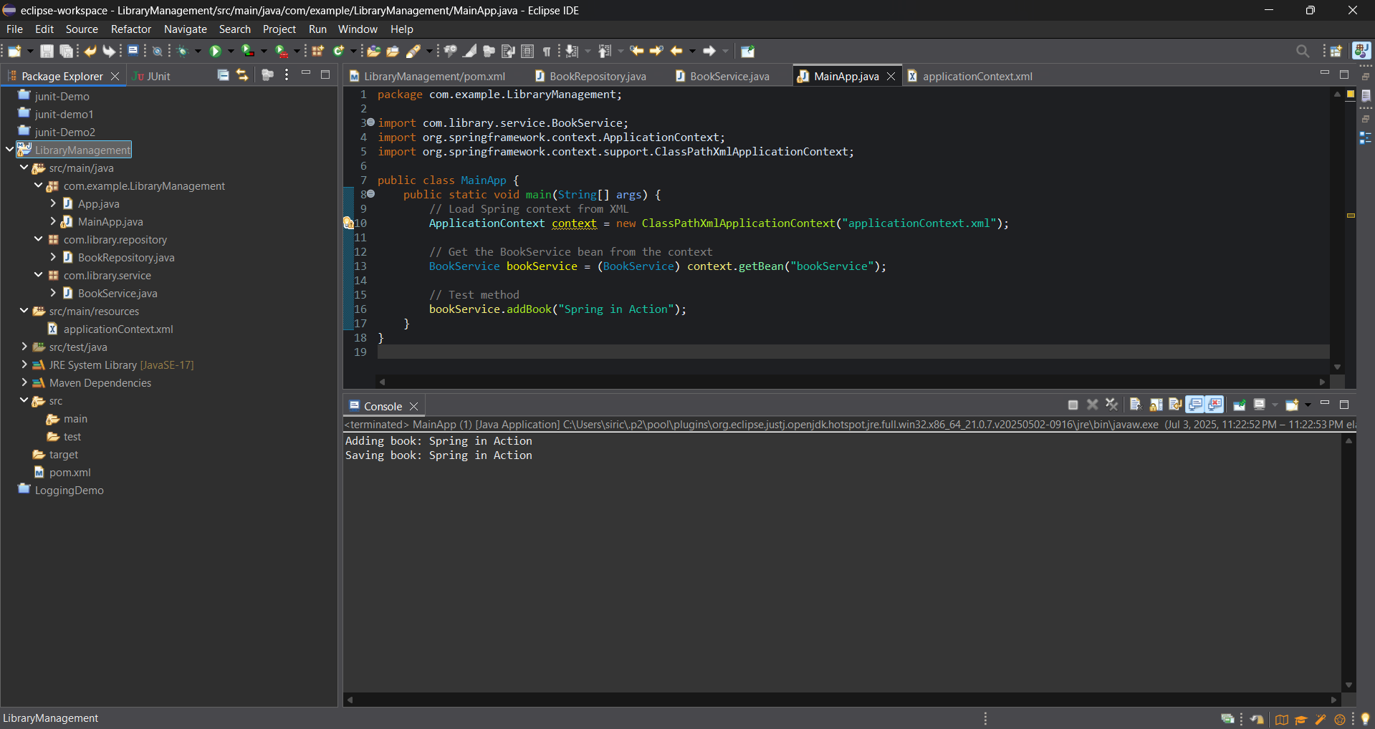

**Exercise 4: Creating and Configuring a Maven Project**

**Scenario:** You need to set up a new Maven project for the library management application and add Spring dependencies.

**Solution:**

**Step 1: Creating a new project**

Opening Eclipse and creating a new Maven project named LibraryManagement using the maven-archetype-quickstart archetype.

**Step 2: Adding Spring dependencies to pom.xml**

<dependencies>

<dependency>

<groupId>org.springframework</groupId>

<artifactId>spring-context</artifactId>

<version>5.3.32</version>

</dependency>

<dependency>

<groupId>org.springframework</groupId>

<artifactId>spring-aop</artifactId>

<version>5.3.32</version>

</dependency>

<dependency>

<groupId>org.springframework</groupId>

<artifactId>spring-webmvc</artifactId>

<version>5.3.32</version>

</dependency>

</dependencies>

**Step 3: Configure Maven Compiler Plugin**

<build>

<plugins>

<plugin>

<groupId>org.apache.maven.plugins</groupId>

<artifactId>maven-compiler-plugin</artifactId>

<version>3.8.1</version>

<configuration>

<source>1.8</source>

<target>1.8</target>

</configuration>

</plugin>

</plugins>

</build>

**Output:**

