**Cognizant Digital Nurture 4.0**

**Name: Siri Chandana Chittipolu**

**Email:** [**sirichittipolu11@gmail.com**](mailto:sirichittipolu11@gmail.com)

**Superset ID: 6386277**

**Mandatory Hands-On Exercises**

**Microservices with API gateway**

**Task : Creating Microservices for account and loan**

**Solution :**

**Account Microservice:**

1. Go to <https://start.spring.io/>
   * Group: com.cognizant
   * Artifact: account
   * Add: Spring Web, Spring Boot DevTools
   * Generate & download zip
2. Import this project into Eclipse.
3. Create AccountController:

package com.cognizant.account;

import org.springframework.web.bind.annotation.GetMapping;

import org.springframework.web.bind.annotation.PathVariable;

import org.springframework.web.bind.annotation.RestController;

import java.util.Map;

@RestController

public class AccountController {

@GetMapping("/accounts/{number}")

public Map<String, Object> getAccount(@PathVariable String number) {

return Map.of("number", number, "type", "savings", "balance", 234343); } }

1. Run app and then test in browser:

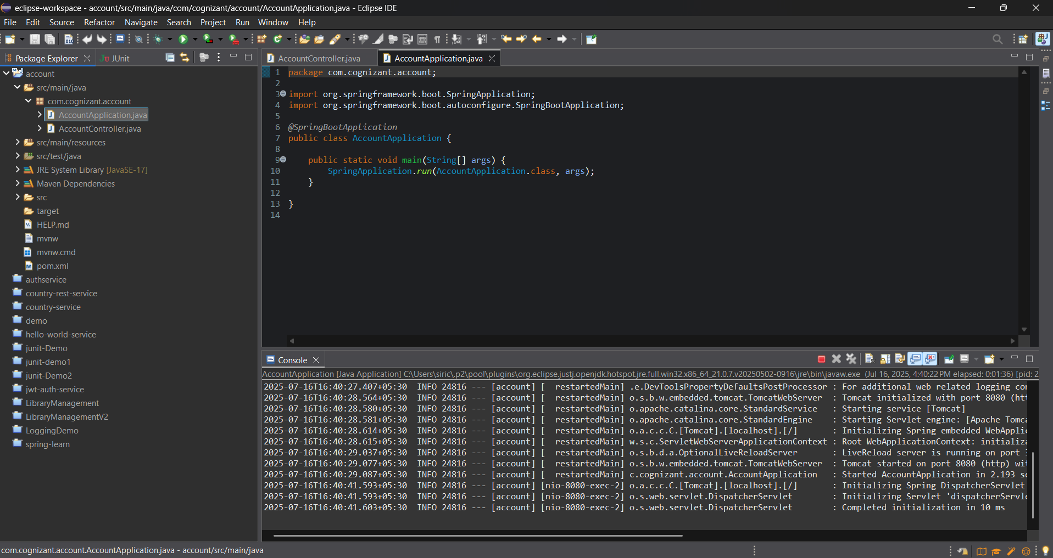

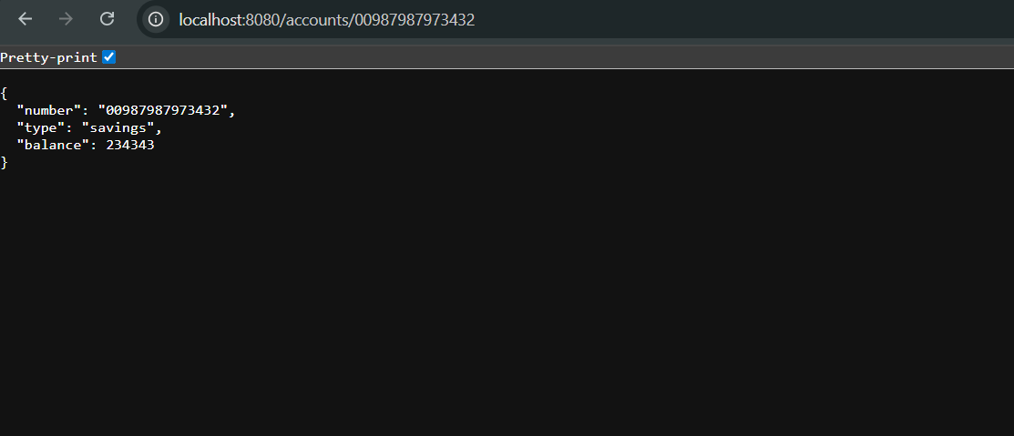

**Loan Microservice:**

1. Go to <https://start.spring.io/>
   * Group: com.cognizant
   * Artifact: loan
   * Add: Spring Web, Spring Boot DevTools
   * Generate & download zip
2. Import this project into Eclipse.
3. Create LoanController:

package com.cognizant.loan;

import org.springframework.boot.SpringApplication;

import org.springframework.boot.autoconfigure.SpringBootApplication;

@RestController

public class LoanController {

@GetMapping("/loans/{number}")

public Map<String, Object> getLoan(@PathVariable String number) {

return Map.of("number", number, "type", "car", "loan", 400000, "emi", 3258, "tenure", 18);

}

}

1. Run app and then test in browser:

