

## VISVESVARAYATECHNOLOGICALUNIVERSITY

“JnanaSangama”,Belagavi,karnataka–590018

**A MINIPROJECT REPORT ON**

**“MEDICAL SUPPLY MANAGEMENT”**

Submitted in partial fulfillment to the requirements for the DBMS LABORATORY WITH MINI PROJECT

Bachelor of Engineering

In

Information Science & Engineering

### Submitted by

|  |  |
| --- | --- |
| **Priyanka .K.S** | **4MH21IS064** |
| **Siri Sinchana .N**  **Tanya .M** | **4MH21IS092**  **4MH21IS104** |

**The Foundation of Success 2023-2024**

DEPARTMENTOFINFORMATIONSCIENCE&ENGINEERING

MAHARAJA INSTITUTE OF TECHNOLOGY MYSORE BELAVADI ,S.R.PATNA TALUK ,MANDYA DIST-571438.



### DEPARTMENTOFINFORMATIONSCIENCE&ENGINEERING MAHARAJA INSTITUTE OF TECHNOLOGY MYSORE MANDYA–571438.

**CERTIFICATE**

Certified that the project work entitled “**MEDICAL SUPPLY MANAGEMENT**” has been successfully carried out by **PRIYANKA K.S** [**4MH21IS064**],**SIRI SINCHANA.N[4MH21IS096] & TANYA .M[4MH21IS104]** students of **Maharaja Institute of Technology** in partial fulfilment of the requirements of **DBMS LABORATORY WITH MINI PROJECT** in **Information Science and Engineering of Visvesvaraya Technological University, Belgaum** during the academic year 2023- 2024. It is certified that all corrections/suggestions indicated for the Internal Assessment have been in corporate in the report deposited in the department library. The project report has been approved as it satisfies the academic requirements with respect to the project work prescribed for Bachelor of Engineering degree.

|  |  |  |
| --- | --- | --- |
| Signature of Guide (**Dharmaraj KB**)  Assistant Professor Dept. of  ISE MIT Mysore. |  | Signature of HOD  (**Dr. Sharath Kumar YH**) Professor & Head, Dept. of  ISE MIT Mysore. |

|  |  |  |
| --- | --- | --- |
| **Name of the Examiners** | **External Viva** | **Signature with date** |
| **1.** |  |  |
| **2.** |  |  |

**ACKNOWLEDGEMENT**

We sincerely owe our gratitude to all the people who helped and guided us in completing this mini project

We are thankful to **Dr. B. G. Naresh Kumar, Principal, Maharaja Institute of Technology Mysore**, for having supported us in our academic endeavours.

We are extremely thankful to **Dr. Sharath Kumar Y H, Professor &Head, Department of Information Science and Engineering,** for his valuable support and his timely inquiries into the progress of the work.

We are obliged to all **teaching and non-teaching staff members** of the **Department of Information Science and Engineering** for the valuable information provided by them in their respective field’s. We are grateful for their co-operation during the period of our mini project.

**PRIYANKA .K.S [4MH21IS064] SIRI SINCHANA .N [4MH21IS092] TANYA .M [4MH21IS104]**

**ABSTRACT**

The purpose of Medical Supply Management System is to automate the existing manual system by the help of computerized equipment’s and full-fledged computer software , fulfilling their requirements, so that their valuable data/information can be stored for a longer period with easy accessing and manipulation of the same.

The required software and hardware are easily available and easy to work with. Medical Management System, as described above, can lead to error free , secure ,reliable and fast management system .It can assist the user to concentrate on their other activities rather to concentrate on the record keeping.

Thus , it will help organization in better utilization of resources. The organization can maintain computerized records without redundant entries. That means that one need not be distracted by information that is not relevant, while being able to reach the information.

The aim is to automate its existing manual system by the help of computerized equipment’s and full-fledged computer software, fulfilling their requirements, so that their valuable data/information can be stored for a longer period with easy accessing and manipulation of the same. Basically, the project describes how to manage for good performance and better services for the clients.

**TABLE OF CONTENTS**

### Chapter1: INTRODUCTION

* 1. Aim of the project 01
  2. Overview of the project 02
  3. Outcome of the project 02
  4. Benefits 02

### Chapter2:SOFTWAREREQUIREMENT

* 1. Software used
  2. Software description
     1. XAMPP 03
     2. TheSQL Language 04
     3. HTML 05
     4. CSS 06

### Chapter3:DESIGN

* 1. Schema diagram… 07
  2. ER diagram 08

### Chapter4:RESULTANALYSIS

* 1. Testing 09
  2. Normalization… 10-11
  3. Triggers 12

### Chapter5 : IMPLEMENTATION

Description of Tables… 13-15

Snapshot 16-18

### Chapter6 : CONCLUSION AND FUTUREWORK

Conclusion 19

Future Enhancement 19

### Chapter7 : REFERENCES 20

# Aim of the project

**CHAPTER 1 INTRODUCTION**



* + - The main objective of the project is to design and develop a user friendly system
    - Easy to use and an efficient computerized system
    - To develop an accurate and flexible system , it will eliminate data redundancy
    - To study the functioning of medical supply management System
    - To make a software fast in processing ,with good user interface
    - To make software with good interfaces so that user can change it and it should be used for long time without error and maintenance
    - To provide better Graphical user interface (GUI)
    - To provide synchronized and centralized farmer and seller database
    - Computerization can be helpful as a means of saving time and money
    - Less chances of information leakage
    - Provide Security to the data by using login and password method
    - To provide immediate storage and retrieval of data and information
    - Improving arrangements for medicines coordination
    - Reducing paperwork



# Overview of the project

The medical supply management project aims to streamline the procurement, storage, and distribution of medications within healthcare facilities. It involves optimizing inventory levels, implementing efficient procurement processes, and enhancing supply chain logistics. Utilizing technology and data analysis, the project aims to forecast demand accurately and reduce wastage. Emphasis is placed on ensuring medication quality, compliance with regulations, and cost-effective practices. Through staff training and continuous improvement initiatives, the project aims to enhance efficiency, patient safety, and overall pharmacy operations.

# Outcome of the project

It is difficult to note down all the problems manually .Instead it is decided to develop an

**“MEDICAL SUPPLY MANAGEMENT”** to ease the operation.

A system is required which is being capable of elimination all the problems and become useful to users and thus the new system is derived. Here we get a different view from different users. The medical supply management project delivers enhanced efficiency, cost savings, and patient safety. It optimizes procurement, storage, and distribution of medications, reducing waste and ensuring timely access to drugs. Improved inventory management minimizes stock outs and overstocking, enhancing overall supply chain resilience. Adherence to quality control measures and regulatory compliance safeguards patient well-being. Utilizing data analytics provides valuable insights for informed decision-making and strategic planning. Stakeholders benefit from increased satisfaction due to streamlined processes and improved medication availability. Ultimately, the project fosters sustainable healthcare operations, promoting better resource utilization and long-term viability.

# BENEFITS

1. Improved Efficiency
2. Cost Control
3. Enhanced Patient Safety



**CHAPTER 2 SOFTWARE REQUIREMENT**

* 1. **Software Used:**
     + Operating system : Windows 10
     + XAMPP(VERSION 3.7)
     + Python main editor (user interface) : PyCharm Community
  2. **Software Description**:

### XAMPP

Php My Admin can manage a whole MySQL server as well as a single database. To accomplish the latter you'll need a properly set up MySQL user who can read/write only the desired database. It's up to you to look up the appropriate part in the MySQL manual.

* + - * Xampp browses and drop databases, tables, views, columns and indexes and create, copy, drop, rename and alter databases, tables, columns and indexes.
      * It maintenance server, databases and tables, with proposals on server configuration and execute, edit and bookmark any SQL-statement, even batch-queries.
      * It loads text files into tables, create and read dumps of tables and export data to various format of some where : CSV, XML, PDF, 150/IEC 26300



* + - * Open Document Text and Spreadsheet, Word, and LTX formats and import data and MySQL structures from Open Document spreadsheets, as well as XML, CSV and SQL files administer multiple servers manage MySQL users
      * Privileges and check referential integrity in MySQL tables and using Query- by example (QBE), create complex queries automatically connecting required tables and create PDF graphics of your Database layout.
      * Create, edit, export and drop events and triggers communicate in synchronize two databases residing on the same as well as remote servers.
    1. **The SQL Language:**

SQL is a language for relational database. SQL is a non-procedural i.e. when we use SQL we specify what we want to be done not how to do it .

Features of SQL

* + - * SQL is an interactive query language.
      * SQL is a database administration language.
      * SQL is a data base programming language.
      * SQL is a client/server language ➢SQL is a distributed data base language.
      * SQL is a database gateway language.

### Basic SQL Commands

* + - * Data Definition Language commands(DDL)
      * Data Manipulation Language commands (DML)
      * Data Manipulation Language commands (DML)
      * Transaction Control Language commands(TCL)
      * Data control Language commands(DCL)



* + 1. **HTML:**

To publish information for global distribution, one needs a university-understood language, a kind of publishing mother tongue that all computers may potentially understand. The publishing language used by the World Wide Web HTML(Hyper Text Markup Language)

* + - * Publish online documents with headings, text , tables, list, photos etc.
      * Retrieve online information via hyper text links, at the click of a button
      * Design forms for conducting transactions with remote services, for use in searching information, making reservation, ordering products etc.
      * Includes spread sheets , video clips, sound clips, and other applications directly in the documents.

### CSS :

CSS (Cascading Style Sheets) is a fundamental component of web development, used to control the visual presentation of HTML elements. It allows developers to define styles such as colors, fonts, spacing, and layout, thereby enhancing the appearance and usability of web pages.

CSS operates on a selector-based model, where selectors target specific HTML elements to apply styling rules. Properties within these rules dictate how the selected elements should appear. CSS supports various units for measurements, including pixels, percentages, ems, and rems, enabling flexible and responsive design.

Selectors in CSS can target elements based on their tag names, classes, IDs, attributes, or relationships to other elements, providing granular control over styling. Additionally, CSS supports inheritance and cascading, allowing styles to be applied hierarchically and overridden as needed.

**CHAPTER 3 DESIGN**

**SCHEMA DIAGRAM**

Posts

|  |  |  |  |  |  |
| --- | --- | --- | --- | --- | --- |
| MID | | MEDICAL_NAME | OWNER_NAME | PHONE_NO | ADDRESS |
|  |  | | | | |

Medicine

MID

NAME

MEDICINES

PRODUCTS EMAIL AMOUNT



Logs

|  |  |  |  |  |
| --- | --- | --- | --- | --- |
|  |  | | | |
|  | |  | | |
| ID | MID | | ACTION | DATE |

ADDMD

MEDICINES

SNO

ADDPD

PRODUCTS

SNO

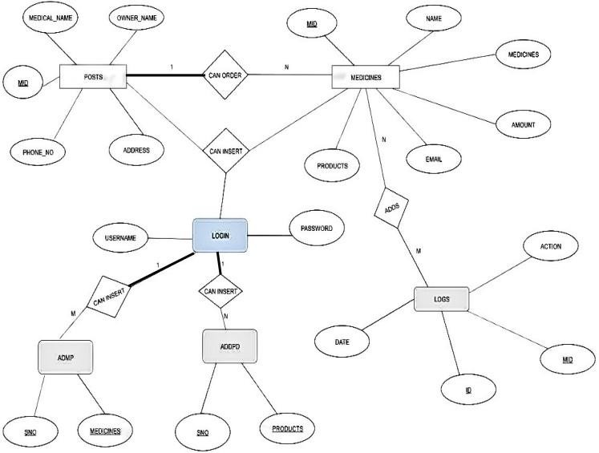

**ER diagram**

* 1. **Testing**

**CHAPTER 4 RESULT ANALYSIS**



|  |  |  |  |  |  |
| --- | --- | --- | --- | --- | --- |
| TESTCASE ID | TEST CASES | CASE TYPE | EXCEPTED OUTPUT | ACTUAL OUTPUT | SATUS |
| TC1 | Login with  wrong user name and  wrong password | 1.Invalid user name and password | The system will not accept the  invalid user name or password | As excepted | Fail |
| TC2 | Login with  correct user  name and wrong password | 2.Invalid Password | The system will not accept the  invalid password | As excepted | Fail |
| TC3 | Login with  wrong user  name and correct password | 3.Invalid username | The system will not accept the  invalid username | As excepted | Fail |
| TC4 | Login with  correct user  name and correct password | 1.Require field validation | Field should not be empty | Users have to enter the value | Pass |



* 1. **Normalization**

The complete tables of the data base in the project is normalized, obeying all the rules of normalization

## 1NF:

1NF disallows relations within relations or relations as attribute values within tuples. The only attribute values permitted by 1NF are single **atomic values**.

## 2NF:

A functional dependency XY is a **full functional dependency** if removal of any attribute A from X means that the dependency does not hold any more; that is, for any attribute A epsilon X, (X-{A}) does not functionally determine Y.

## 3NF:

### Transitive functional dependency

A functional dependency XY in a relation schema R is a **transitive dependency** if there exists a set of attribute Z. that are neither a primary nor a subset of any key of R(candidate key) and both XZ and YZ holds

## 2NF:

|  |  |  |
| --- | --- | --- |
| SNO | MEDCINES | PRODUCTS |
| 111 | Dolo650 | Alovera gel |
| 222 | Rantac | Nivea face wash |
| 333 | Chesthon cold | Lip balm |

ADDMEDICINES

|  |  |
| --- | --- |
| SNO | MEDICINES |
| 111 | DOLO650 |
| 222 | RANTAC |



## ADDPRODUCT

|  |  |
| --- | --- |
| SNO | PRODUCTS |
| 111 | ALOVERA GEL |
| 222 | LIPBALM |

3NF:

|  |  |  |
| --- | --- | --- |
| SNO | MEDICINES | PRODUCTS |
| 111 | Dolo650 | Alovera gel |
| 222 | Rantac | Nivea face  wash |
| 333 | Chesthon cold | Lip balm |

1NF:

|  |  |  |
| --- | --- | --- |
| **Mid** | **Name** | **medicines** |
| 1001 | Shiva | Dolo650,Rantac |
| 1002 | Sagar | Cheston cold ,omzee |

|  |  |  |
| --- | --- | --- |
| **Mid** | **Name** | **medicines** |
| 1001 | Shiva | Dolo650 |
| 1001 | Shiva | Rantac |
| 1002 | Sagar | Chesthon cold |
| 1002 | Sagar | Omzee |

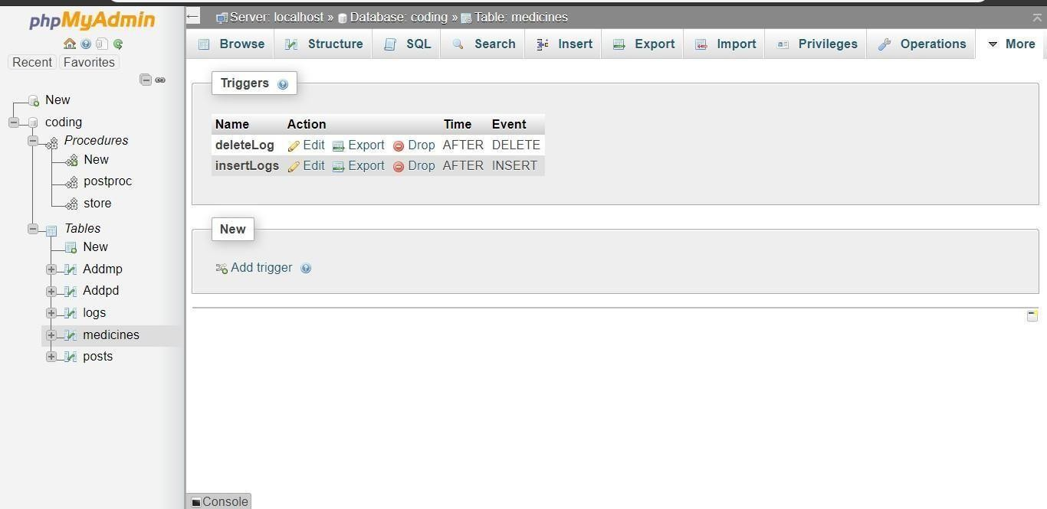

* 1. **TRIGGER:**
     + There is a basic triggers in this project.
     + If we make an inserted, then the TRIGGER updates the status value insertion after the event has occurred.

**CHAPTER 5 IMPLEMENTATION**

* 1. **DESCRIPTION OF THE TABLES**

### addmp

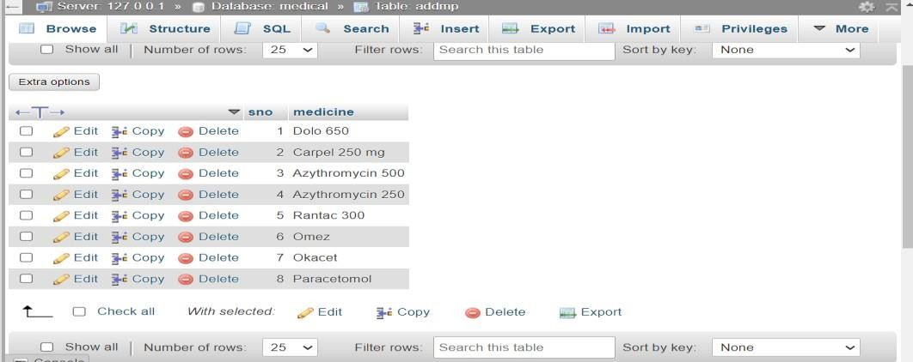

### Addpd

Fig 5.1.1

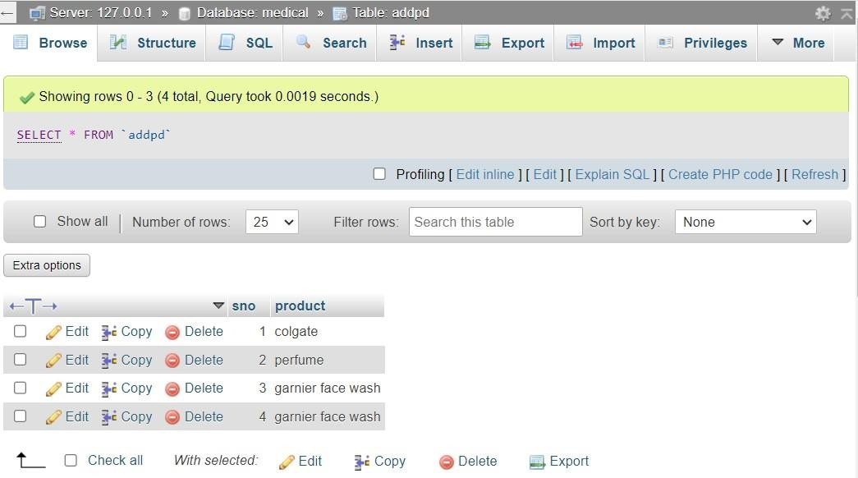Fig 5.1.2

### logs

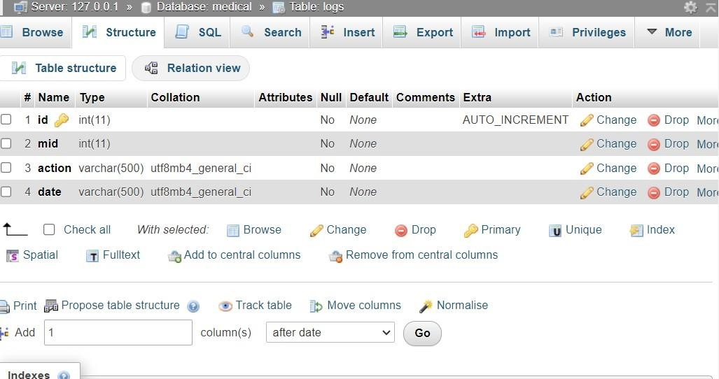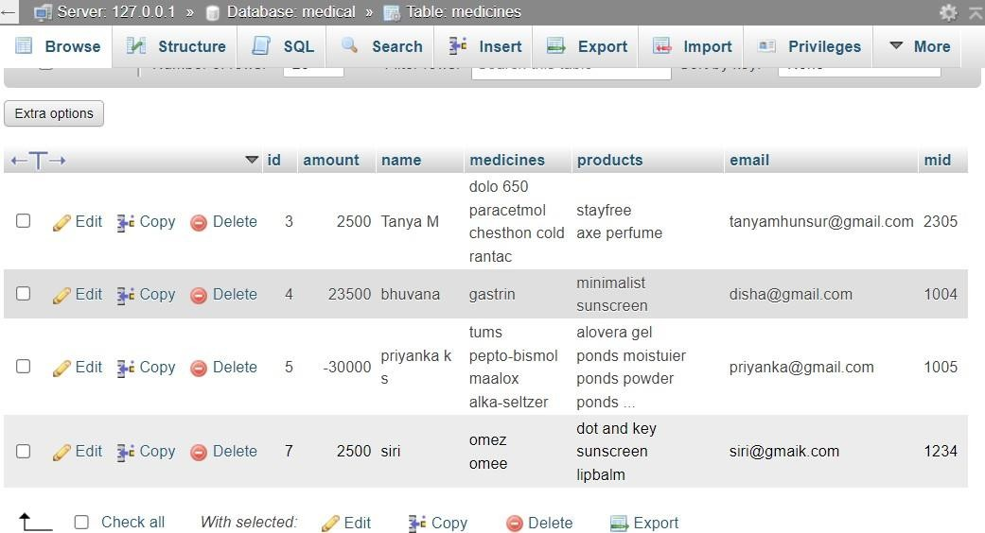

Fig 5.1.3

### medicines

Fig 5.1.4

### posts

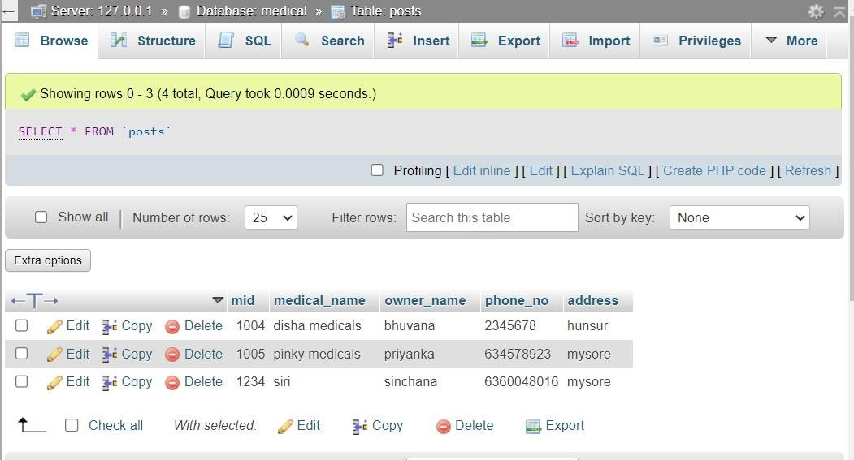

Fig 5.1.5

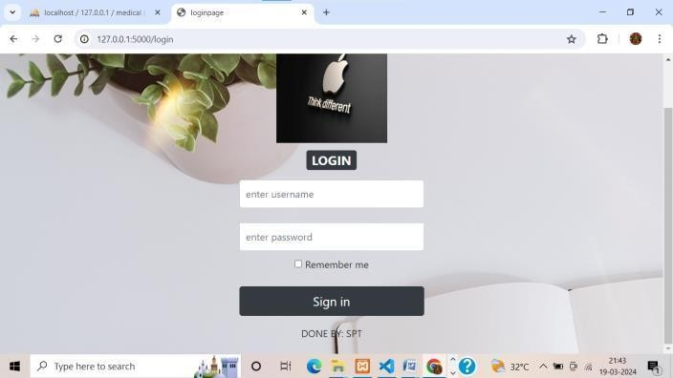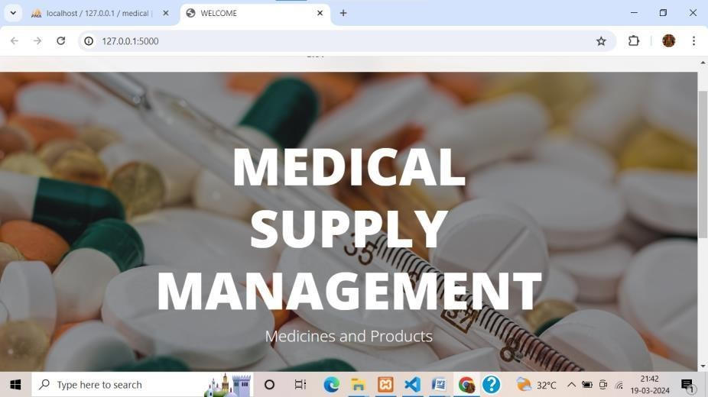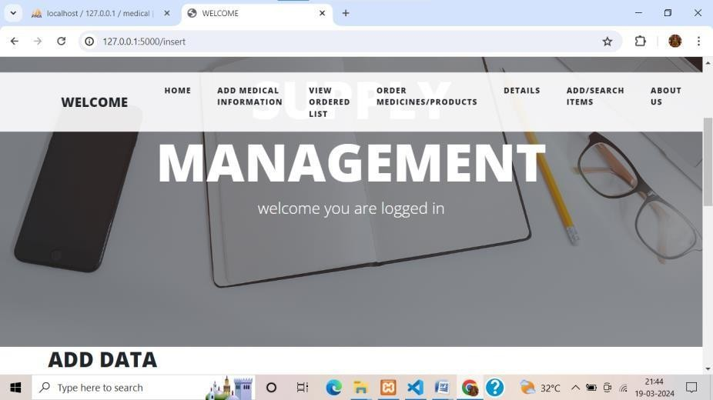

* 1. **SNAPSHOTS**

## LOGIN PAGE

### 5.2.1 ADD MEDICAL INFORMATION

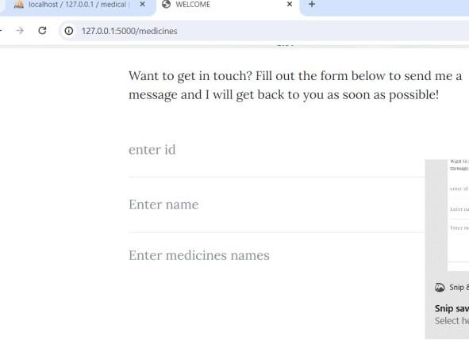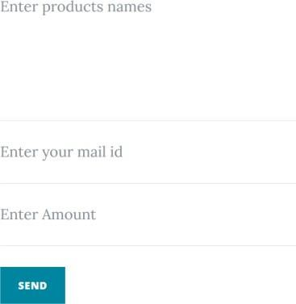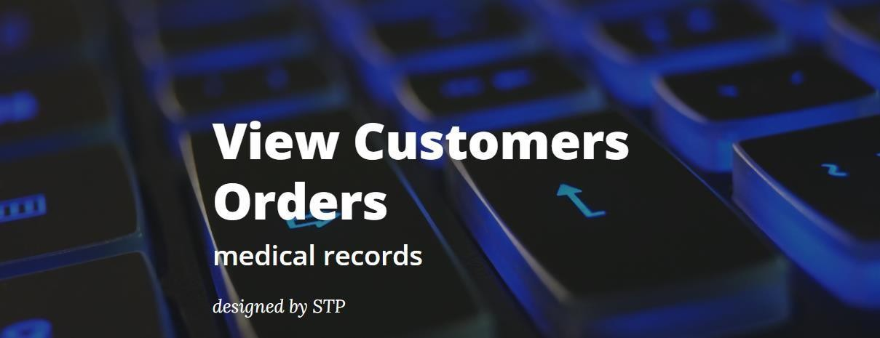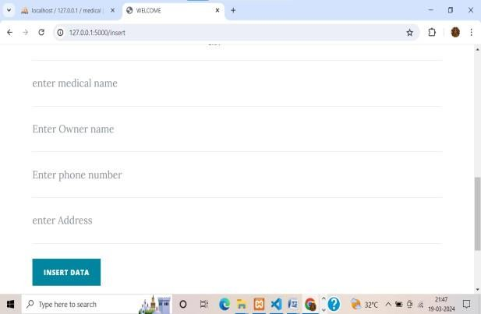

* + 1. VIEW CUSTOMERS ORDER

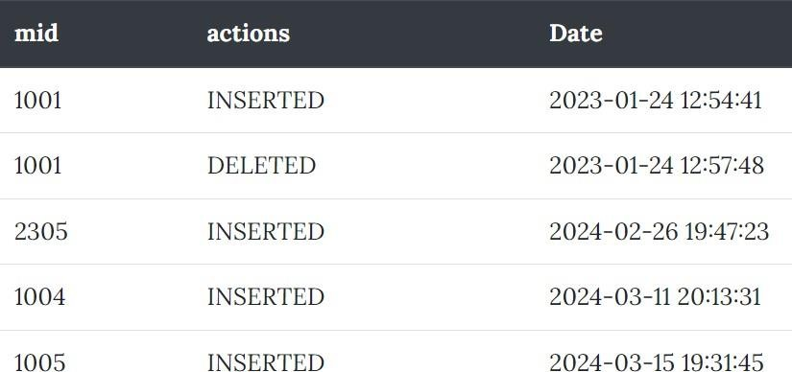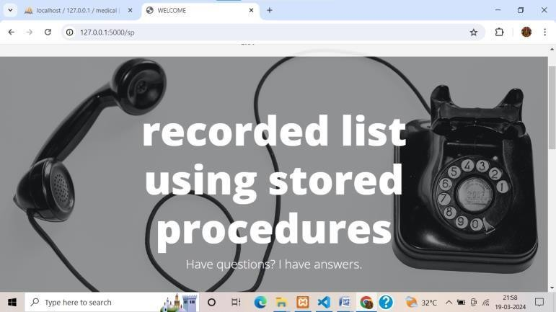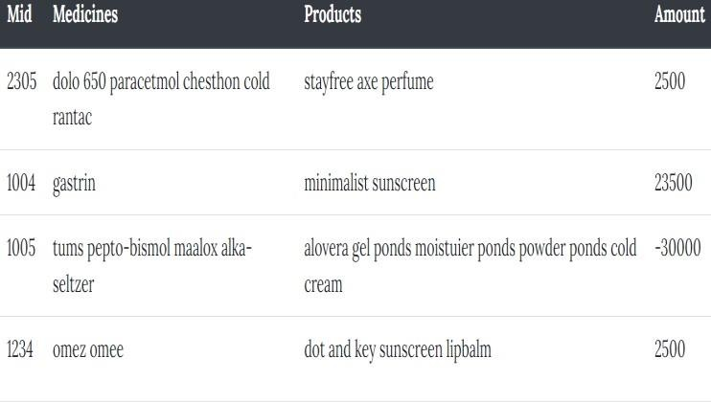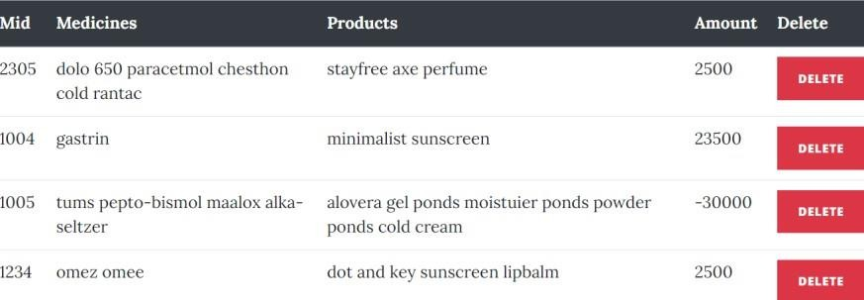

* + 1. VIEW Details of medical records
    2. Stored details



**CHAPTER 6**

**CONCLUSION AND FUTURE ENCHANCEMENT**

PHARMACY MANAGEMENT SYSTEM successfully implemented offline medicines supply mchanagement database which helps us in administrating the data user for managing the tasks performed in medicines supply .The project successfully used various functionalities of Xampps and python flask and also create the fully functional database management system for offline pharmacy**.**

With the theoretical inclination of our syllabus it becomes very essential to take the at most advantage of any opportunity of gaining practical experience that comes along. The building blocks of this Major Project “Pharmacy Supply Management System” was one of these opportunities. It gave us the requisite practical knowledge to supplement the already taught theoretical concepts thus making us more competent as a computer engineer. The project from a personal point of view also helped us in understanding the following aspects of project development:

* + - * The planning that goes into implementing a project.
* The importance of proper planning and an organized methodology.
* The key element of team spirit and co-ordination in a successful project.

### FUTURE ENHANCEMENT

* Enhanced data base storage facility
* Enhanced user friendly GUI
* More advanced transportation of medicines
* Online Bill payments



**CHAPTER 7 REFERENCES**

## Fundamentals of Database System, 7th Edition - By Elmasri Ramez and Navathe Shamkanth

## PHP and MySQL Web Development - By Luke Welling and Laura Thompson

## HTML & CSS: Design and Build Web Sites - By John Duckett

## HTML Tutorial - <http://www.w3schools.com/html>

## CSS Tutorial - <https://www.w3schools.com/Css> 6.SQLTutorial <http://www.w3schools.com/sql> 7.javascript Tutorial- <https://www.w3schools.com/js>