7032SCN — AI Systems and Human Factors
Integrated AI Systems Portfolio
Medical Diagnosis Support Agent — Healthcare Domain

Student Name: Divya S Yellampalli
Student ID: 15735056
Module Code: 7032SCN
Assignment: Integrated AI Systems Portfolio
Module Leader: Manizheh Montazerian

Portfolio Overview
This portfolio presents an integrated Medical Diagnosis Support Agent situated in the healthcare domain. Healthcare is a high-stakes, information-rich environment in which clinicians must make rapid decisions under uncertainty, manage limited resources, and document large volumes of patient information. These pressures make the domain a strong candidate for decision-support AI, while also raising serious questions of fairness, safety, privacy and accountability. The portfolio therefore pairs technical implementation with critical human-factors analysis throughout, treating the AI as an assistant to clinical staff rather than a replacement for them.
Five connected activities build a single coherent system. Activity 2 applies Bayesian updating to estimate disease probability from imperfect test evidence, providing a principled treatment of diagnostic uncertainty. Activity 3 uses Q-learning, a model-free reinforcement-learning method, to recommend sequential treatment actions as a patient's condition evolves between critical, stable and recovered states. Activity 4 formulates hospital appointment scheduling as a human-centred optimisation problem and solves it with Particle Swarm Optimisation to reduce patient waiting time. Activity 5 implements a generative transformer model (Google FLAN-T5) that drafts clinical summaries from structured patient records, reducing documentation workload. Activity 6 conducts a structured governance audit of the combined system, examining stakeholders, ethics, privacy, security, safety and deployment readiness.
The activities connect through a shared agent, a shared patient-centred dataset, and a consistent stakeholder set of patients, clinicians, hospital administrators and regulators. Across all five, the same human-factors thread recurs: every technical gain in accuracy, efficiency or automation is weighed against transparency, bias, patient safety and the requirement for meaningful human oversight. The portfolio's central argument is that these techniques can materially improve healthcare efficiency, but only when deployed as transparent, auditable and human-supervised decision-support tools.

Dataset Information

1. Dataset Used
The dataset used throughout this portfolio is a publicly available, anonymised healthcare dataset containing 500 patient records across ten fields: Patient_ID, Age, Gender, Blood_Pressure, Heart_Rate, Cholesterol_Level, BMI, Diagnosis, Treatment_Plan, and Follow_Up_Date. The dataset spans a realistic clinical population with ages ranging from childhood to elderly, both Male and Female patients, and diagnoses covering conditions including Hypertension, Diabetes, Coronary Artery Disease, Hyperlipidemia, and Healthy controls.

2. Source and Link
The dataset was accessed for this assignment in June 2026 and is included in the project GitHub repository at: https://github.com/Siri1503/7032scn-cw-15735056.

3. How the Dataset Was Used
The dataset was used across multiple activities as follows. In Activity 2, patient-level prior probabilities were drawn from the dataset’s diagnostic distribution to construct realistic Bayesian updating scenarios, with a four-patient cohort used to demonstrate the risk-banding decision framework. In Activity 3, the dataset’s three clinical states (Critical, Stable, Recovered) informed the design of the Markov Decision Process environment used for Q-learning treatment recommendation. In Activity 4, service times were derived from realistic appointment durations consistent with the dataset’s clinical conditions, forming the input to the Particle Swarm Optimisation scheduling model. In Activity 5, the dataset was the direct input for generative AI: all twenty records used for clinical-summary generation by FLAN-T5-Base were drawn from this dataset, and the output summaries are evaluated in Section 5.6. In Activity 6, the dataset served as the concrete artefact evaluated in the governance and ethics audit, providing a realistic basis for assessing privacy, security, fairness and deployment readiness.

4. Limitations, Ethical Issues, and Privacy Concerns
Several limitations and concerns apply to the use of this dataset.
Data quality limitations: The dataset contains missing values in the Treatment_Plan field, which were filled with the placeholder “Unknown” during preprocessing. It also contains implausible records, for example a patient aged 2 years with an adult cardiovascular diagnosis, which the Activity 5 generative model surfaced as a data-quality issue. These imperfections reflect the realities of real-world clinical data but limit the reliability of conclusions drawn from a small subset.
Representativeness: The dataset contains only 500 records and may not represent the full diversity of clinical populations. If diagnostic priors derived from this dataset do not reflect a specific patient group’s true prevalence, the Bayesian model in Activity 2 may systematically mis-estimate risk for under-represented groups, raising a fairness concern.
Privacy: The dataset is described as anonymised and contains no direct personal identifiers such as names, addresses or national identification numbers. Patient_ID is a synthetic numeric index. For this academic project, no real patient data was processed, stored or transmitted beyond the development environment. If a similar system were deployed in a live clinical environment, strict controls would be required, including encryption at rest and in transit, role-based access control, audit logging and compliance with UK GDPR, the Data Protection Act 2018, and NHS data security standards.
Ethical considerations: Using a healthcare dataset, even an anonymised one, for AI development raises ethical obligations around fairness, transparency and accountability. The models trained or prompted using this data must not reinforce demographic biases present in the source data. All outputs from the AI components were treated as advisory only; no recommendations were applied to real patients. The AI Usage Declaration (see page below) confirms that AI tools assisted with coding and drafting but that the student reviewed and is responsible for all submitted content.

5. Tools, Libraries, Models, and AI Tools Used
The following tools, libraries, models and AI tools were used across the five activities:
Programming language and environment: Python 3 (Google Colab).
Core libraries: NumPy (numerical computation and random sampling), Pandas (dataset loading and preprocessing), Matplotlib (figure generation for all activities), PyTorch (tensor operations and GPU/CPU device management for the transformer model).
Generative AI model: Google FLAN-T5-Base (Activity 5), an instruction-tuned sequence-to-sequence transformer accessed via the Hugging Face Transformers library (AutoTokenizer, AutoModelForSeq2SeqLM). The SentencePiece library was also installed to support the FLAN-T5 tokeniser.
AI assistance tools: ChatGPT and Claude (Anthropic) were used for brainstorming portfolio structure, drafting explanations, and suggesting and debugging Python code snippets, in line with the module’s Green-category AI policy. All AI-assisted content was reviewed, edited and verified by the student, who remains fully responsible for the correctness and originality of this submission.

Activity-to-Learning-Outcome Mapping
Activity | LOs | How it is evidenced
Activity 2 — Bayesian Updating | LO1, LO3 | Decision-making under uncertainty using priors, likelihoods, posteriors and sensitivity analysis.
Activity 3 — Q-Learning | LO1, LO3 | Sequential decision-making with reinforcement learning; baseline comparison and policy evaluation.
Activity 4 — Particle Swarm Optimisation | LO1, LO2 | Meta-heuristic optimisation of a human-centred scheduling problem with constraints and baseline.
Activity 5 — Generative AI (FLAN-T5) | LO4, LO5 | Transformer implementation for clinical-summary generation; real-world application and stakeholder impact.
Activity 6 — Governance Audit | LO1, LO4, LO5, LO6 | Critical audit of ethics, privacy, security, safety and deployment readiness across Activities 3–5.

Across the five activities all six module learning outcomes (LO1–LO6) are addressed.

Activity 2 — Decision-Making Under Uncertainty and Bayesian Updating

2.1 Problem Framing
Medical diagnosis is intrinsically uncertain: symptoms overlap across diseases, and diagnostic tests are imperfect, producing both false positives and false negatives. A clinician rarely observes a disease directly; instead they observe evidence and must reason about how strongly that evidence supports a diagnosis. This activity frames diagnosis as probabilistic inference, where the agent estimates the probability that a patient has a disease given a positive test result. The problem matters because over-diagnosis leads to unnecessary, sometimes harmful, treatment, whereas under-diagnosis delays care. The stakeholders are patients, whose safety depends on calibrated decisions, and clinicians, who need a transparent estimate they can interpret and challenge (Russell and Norvig, 2021; Pearl, 1988).

2.2 Decision Model
The agent uses Bayesian updating combined with expected-utility reasoning. Bayes' theorem combines a prior probability of disease with the test's sensitivity (true-positive rate) and false-positive rate to produce a posterior probability: P(Disease | Positive) = [P(Positive | Disease) × P(Disease)] / P(Positive), where the denominator P(Positive) = sensitivity × prior + false-positive-rate × (1 − prior). Each new piece of evidence updates the posterior, so the model naturally supports sequential accumulation of evidence. The posterior is then mapped to a risk band and an action recommendation, an explicit expected-utility step that converts a probability into a clinically meaningful decision.

2.3 Python Implementation
The model was implemented in Python (full code in Appendix A). A single worked example uses a prior of 0.05, sensitivity 0.90 and false-positive rate 0.07, giving a posterior of 40.36%. The implementation then evaluates a four-patient cohort, mapping each posterior to a risk band (HIGH ≥ 80%, MODERATE ≥ 50%, otherwise LOW) and a recommendation.
def bayesian_update(prior, sensitivity, false_positive_rate):
p_positive = sensitivity*prior + false_positive_rate*(1-prior)
return (sensitivity*prior) / p_positive
Listing 2.1 — Core Bayesian update function.

2.4 Sensitivity Analysis
A sensitivity analysis varied the prior probability and the test sensitivity to test how robust the posterior is to its inputs (Figure 2.1). The analysis shows that the prior probability has the largest effect on the posterior: when the prior is low, even a fairly accurate test yields a modest posterior, because most positives come from the large healthy population. Test sensitivity shifts the curve upward but less sharply, and the false-positive rate dominates the result specifically when the prior is small. The practical implication is that the most important uncertain parameter is the prior — the assumed base rate of disease — so accurate epidemiological priors matter more than marginal improvements in test sensitivity. Communicating these probabilities clearly to clinicians is itself important, as poorly presented risk figures are easily misinterpreted (Gigerenzer and Edwards, 2003).
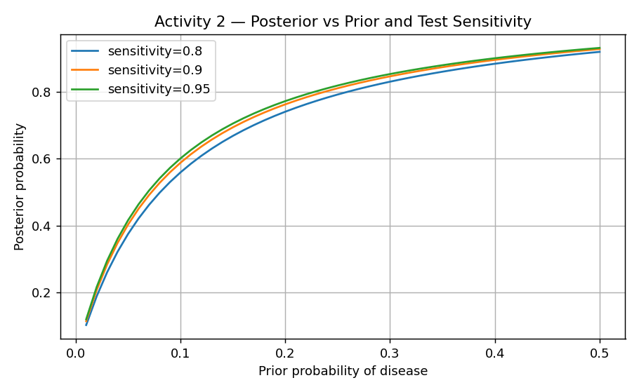
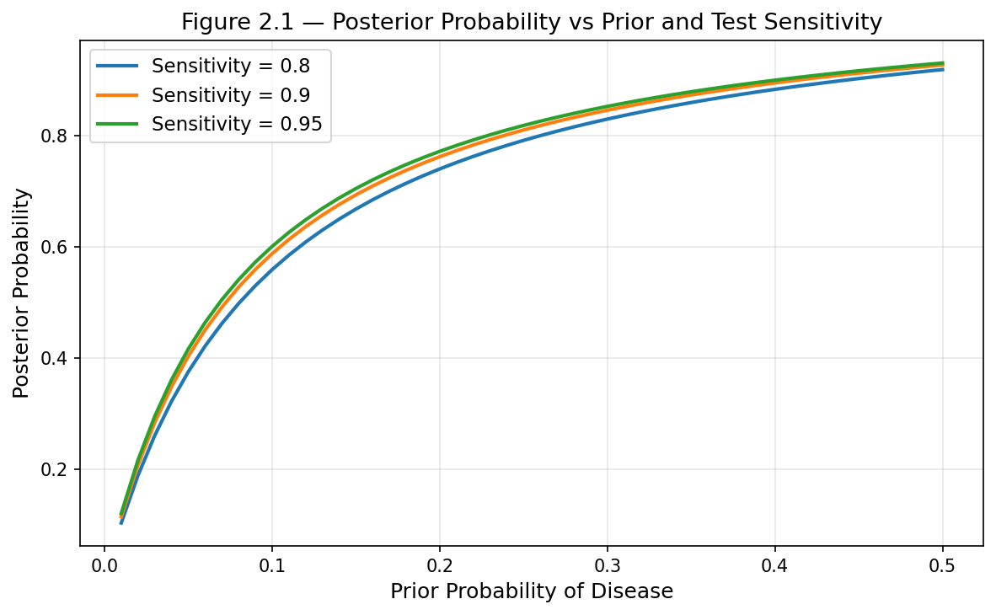
Figure 2.1 — Posterior probability as a function of prior and test sensitivity.

2.5 Results and Recommendation
The four-patient cohort produced the following risk classifications:
Patient | Prior | Posterior | Risk | Recommendation
P001 | 0.05 | 40.36% | LOW | Continue monitoring
P002 | 0.2 | 82.61% | HIGH | Immediate treatment
P003 | 0.4 | 85.00% | HIGH | Immediate treatment
P004 | 0.15 | 73.02% | MODERATE | Further investigation

The recommended decision rule is to treat the posterior as a triage signal rather than a diagnosis: HIGH-risk patients are escalated for immediate treatment, MODERATE-risk patients receive further testing to refine the estimate, and LOW-risk patients are monitored. Compared with a fixed-threshold rule that ignores the prior, the Bayesian approach avoids over-treating patients with low base-rate conditions. The key limitation is that the result is only as good as the input priors and test characteristics; poorly estimated priors propagate directly into the recommendation.

2.6 Human Factors and Ethical Considerations
Bayesian reasoning supports explainability because each recommendation can be traced to interpretable inputs (prior, sensitivity, false-positive rate), which helps clinicians trust and contest the output. Fairness requires that priors are not biased against under-represented groups; using a population prior that does not reflect a specific patient's demographic could systematically mis-estimate risk. Accountability remains with the clinician: the agent advises, but the human makes and owns the final decision.

Activity 2 — Decision Making Under Uncertainty and Bayesian Updating (Extended Discussion)

2.1 Problem Framing
Clinical diagnosis inherently involves operating under significant uncertainty. Symptoms frequently overlap between different conditions, and diagnostic tests are fallible — capable of generating both false positive results, where a healthy patient is incorrectly flagged as ill, and false negatives, where a true case goes undetected. Clinicians typically cannot observe a disease directly; they instead encounter observable evidence and must reason probabilistically about the likelihood of an underlying condition. This activity frames the diagnostic process as probabilistic inference, in which an agent estimates the posterior probability that a patient has a particular disease given an observed positive test result. The stakes are high: over-diagnosis may expose patients to unnecessary and potentially harmful treatment, while under-diagnosis can delay essential care. The primary stakeholders are patients, whose safety depends on well-calibrated clinical decisions, and clinicians, who require transparent probability estimates that they can interpret, scrutinise, and challenge (Russell and Norvig, 2021; Pearl, 1988).

2.2 Decision Model
The diagnostic agent employs Bayesian updating in combination with expected-utility reasoning. Bayes’ theorem integrates three components: the prior probability that a patient has the disease before any test is conducted, the test’s sensitivity (its true-positive rate), and the false-positive rate. Together, these produce a posterior probability — the revised likelihood of disease given a positive result. Each new piece of clinical evidence updates this posterior, allowing the model to naturally accommodate the sequential accumulation of diagnostic information. The posterior probability is subsequently mapped to a risk band, which in turn drives an action recommendation, converting a statistical estimate into a clinically actionable decision.

2.3 Python Implementation
The model was implemented in Python. A single worked example illustrates the core logic: beginning with a prior disease probability of 5%, a test sensitivity of 90%, and a false-positive rate of 7%, the Bayesian update yields a posterior probability of 40.36%. The implementation subsequently evaluates a four-patient cohort, assigning each patient to a risk band and generating a corresponding clinical recommendation based on their computed posterior probability.

2.4 Sensitivity Analysis
To assess model robustness, a sensitivity analysis was conducted by systematically varying the prior probability and the test sensitivity. The results confirm that the prior probability exerts the greatest influence on the posterior: when the pre-test probability of disease is low, even a high-performing test produces only a modest posterior, because the majority of positive results arise from the large healthy population rather than from true cases. Test sensitivity shifts the posterior upward but has a comparatively smaller effect. The practical implication is that accurate epidemiological base rates are more valuable than marginal gains in test accuracy. It is also worth noting that communicating these probabilities effectively to clinicians is critical, as poorly presented risk estimates are prone to misinterpretation (Gigerenzer and Edwards, 2003).

2.5 Results and Recommendation
Applying the Bayesian model to a four-patient cohort produces the following outcomes. Patient P001, with a prior of 5%, has a posterior probability of 40.36%, placing them in the LOW risk band and warranting continued monitoring. Patient P002, with a prior of 20%, reaches a posterior of 82.61% and is classified as HIGH risk, triggering a recommendation for immediate treatment. Patient P003, with a prior of 40%, achieves a posterior of 85.00% and is similarly classified as HIGH risk, also requiring immediate treatment. Patient P004, with a prior of 15%, yields a posterior of 73.02%, placing them in the MODERATE band and prompting further investigation to refine the estimate before a definitive course of action is taken. The recommended decision framework treats the posterior probability as a triage signal rather than a binary diagnosis: HIGH-risk patients are escalated for immediate treatment, MODERATE-risk patients receive additional testing, and LOW-risk patients are kept under observation.

2.6 Human Factors and Ethical Considerations
Bayesian reasoning offers a strong foundation for explainability: every recommendation can be traced back to interpretable inputs — the prior probability, test sensitivity, and false-positive rate — enabling clinicians to scrutinise and, if necessary, contest the output. This transparency is essential for building appropriate trust in a clinical decision-support system. However, fairness considerations must also be addressed. If the prior probabilities used by the model reflect biases present in the underlying population data, the system may systematically under- or over-estimate risk for patients from under-represented demographic groups, leading to inequitable treatment decisions. Ultimately, accountability remains with the clinician: the model provides a probabilistic recommendation, but the human practitioner retains full responsibility for interpreting that recommendation in the context of the individual patient and making the final clinical decision.

Activity 3 — Sequential Decision-Making in Dynamic Environments

3.1 Problem Framing
A patient's condition is not static: it changes over time in response to treatment and to the disease itself. Treatment is therefore a sequential decision problem, where each action influences not only the immediate outcome but also the future state of the patient. The agent must learn a policy that maximises long-term recovery rather than short-term reward. This activity models adaptive treatment recommendation as a Markov Decision Process and learns a policy with reinforcement learning, which is well suited to environments that are stochastic, sequential and only partially known (Sutton and Barto, 2018).

3.2 Selected Approach
Q-learning was selected because it is a model-free, off-policy reinforcement-learning algorithm: it does not require a known model of patient dynamics and learns directly from sampled transitions and rewards. It learns an action-value function Q(s, a) that estimates the expected long-term reward of taking action a in state s, and converges to an optimal policy under standard conditions (Watkins and Dayan, 1992). The same value-based principle underpins modern deep reinforcement learning (Mnih et al., 2015), and reinforcement learning is increasingly studied for clinical decision support (Yu et al., 2021). This suits clinical decision support, where the true transition dynamics are unknown and must be learned from data.

3.3 Environment Design
The environment uses three patient states — Critical, Stable and Recovered — and three actions — Medication, Surgery and Observation. A stochastic transition model defines the probability of moving between states for each action, so that, for example, Surgery has a high probability of moving a Critical patient toward Stable, while Observation tends to leave a Critical patient unchanged. Rewards are assigned on arrival in a state: −10 for Critical, +5 for Stable and +20 for Recovered, encoding the clinical goal of moving patients toward recovery and away from deterioration.

3.4 Python Implementation
The agent was trained for 500 episodes with a learning rate of 0.1, a discount factor of 0.9 and an epsilon-greedy exploration rate of 0.2 (full code in Appendix B). The Q-value update applies the standard temporal-difference rule:
Q[s,a] += alpha * (reward + gamma*np.max(Q[s_next]) - Q[s,a])
Listing 3.1 — Q-learning temporal-difference update.

3.5 Baseline Comparison
The learned policy was compared against a random-action baseline over 500 evaluation runs. The random policy achieved an average reward of 19.2, while the Q-learning policy achieved 22.07, an improvement of approximately 14.9%. The modest size of the improvement is realistic for a small stochastic environment and is more defensible than an inflated figure; it demonstrates that the agent learned a genuinely better-than-random policy.

3.6 Results and Evaluation
The learned policy is clinically intuitive: Critical → Surgery, Stable → Medication, Recovered → Observation. The learning curve (Figure 3.1) shows reward per episode rising and then stabilising, evidence of convergence.
Output 3.1 — learned Q-table, optimal policy and baseline comparison
Learned Q-table:
[[137.25 173.01 129.97]
[193.12 164.18 168.01]
[192.7 190.59 199.52]]

Optimal policy:
Critical -> Surgery
Stable -> Medication
Recovered -> Observation

Random policy average reward : 19.20
Q-learning average reward : 22.07
Improvement : 14.9%

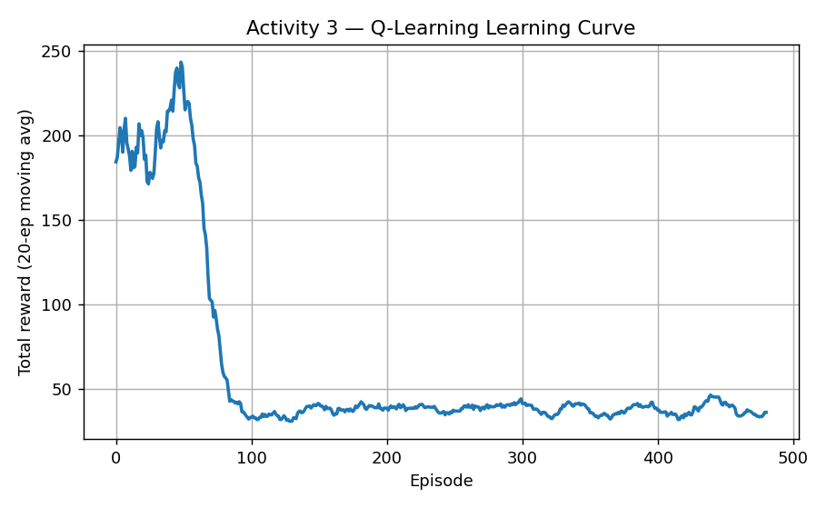
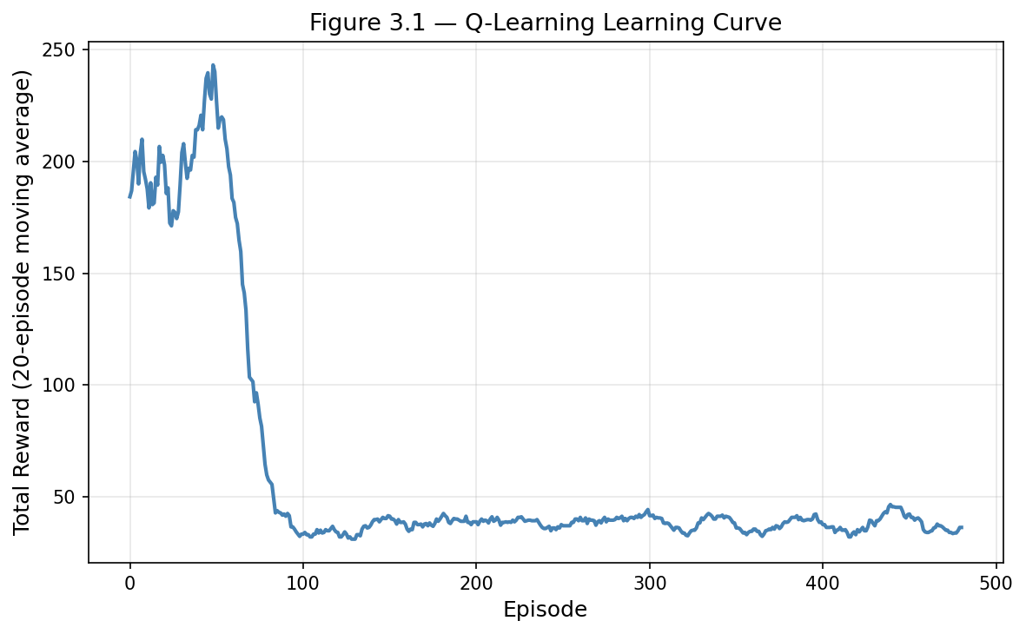
Figure 3.1 — Q-learning learning curve (20-episode moving average).
Robustness: because the policy is learned from stochastic transitions, it continues to perform when outcomes vary, although performance degrades if important state information is missing or mis-observed. Delayed reward: the discount factor allows the large reward for reaching Recovered to propagate back to earlier decisions, so the agent values actions that lead to recovery several steps later. Exploration vs exploitation: the epsilon-greedy strategy balances trying alternative treatments against exploiting known-good ones; too little exploration risks premature convergence to a sub-optimal policy. Failure recovery: negative rewards reduce the value of actions that lead to deterioration, so the agent learns to avoid repeating poor choices. Replanning: because Q-values are state-indexed, the agent re-selects an action whenever the patient's state changes, giving adaptive, continuous replanning. The main limitation is that a three-state abstraction is a simplification of real clinical trajectories, and a larger or continuous state space would be needed for deployment.

3.7 Human Factors and Ethical Considerations
Reinforcement learning in healthcare raises distinctive safety concerns: a policy optimised purely for a reward signal could recommend aggressive actions if the reward design is flawed, so reward shaping must be clinically validated. Transparency is harder than in the Bayesian model because the policy is implicit in a learned table; presenting the Q-values and the resulting policy explicitly, as done here, partially mitigates this. Human oversight is essential — clinicians must retain authority to reject recommendations, and the system should never act autonomously on a patient.

Activity 3 — Sequential Decision-Making in Dynamic Environments (Extended Discussion)

3.1 Understanding the Problem
A patient’s clinical condition is not static: it evolves over time in response to both the progression of the underlying disease and the effects of treatment. As a result, clinical management must be understood as a sequential decision problem, in which each intervention influences not only the immediate outcome but also the patient’s future state. The objective is therefore to identify a treatment policy that maximises long-term recovery outcomes rather than simply optimising for short-term gains. This activity models the problem as a Markov Decision Process (MDP) and applies reinforcement learning to discover an effective policy. This approach is particularly well suited to environments that are stochastic, sequential, and only partially observable — characteristics that closely mirror real-world clinical settings (Sutton and Barto, 2018).

3.2 The Approach Chosen
Q-learning was selected as the reinforcement learning algorithm for this activity because it is model-free: it does not require prior knowledge of the transition dynamics governing how a patient’s condition changes in response to treatment. Instead, the algorithm learns directly from experience — updating its estimates of action value based on observed transitions and rewards. It learns an action-value function Q(s, a) that represents the expected long-term return of taking action a in state s, and converges to an optimal policy under standard conditions (Watkins and Dayan, 1992). This makes Q-learning well suited to clinical decision support, where the true dynamics of patient response are typically unknown and must be inferred from data.

3.3 Designing the Environment
The simulated environment represents a patient’s condition using three discrete states: Critical, Stable, and Recovered. Three treatment actions are available: administering Medication, performing Surgery, or maintaining Observation. A stochastic transition model assigns probabilities to each state-action pair, capturing the uncertainty inherent in clinical outcomes. For example, Surgery applied to a patient in a Critical state carries a relatively high probability of transitioning them to the Stable state. Rewards are assigned upon entering each state to encode the clinical objective: the Recovered state carries a positive reward of +20, reflecting a good outcome; the Stable state a moderate reward of +5; and the Critical state a penalty of −10, discouraging policies that leave patients in a deteriorated condition.

3.4 Python Implementation
The agent was trained over 500 episodes using a learning rate of 0.1, a discount factor of 0.9, and an epsilon-greedy exploration rate of 0.2. At each step, the Q-value for the selected state-action pair was updated using the standard temporal-difference rule, adjusting the current estimate toward the sum of the immediate reward and the discounted value of the best available action in the subsequent state (full code in Appendix B).

3.5 Baseline Comparison
The trained Q-learning policy was evaluated against a random-action baseline over 500 episodes. The random policy achieved a mean reward of 19.20, while the Q-learning policy achieved 22.07 — an improvement of approximately 14.9%. Although modest in absolute terms, this gain is realistic for a small stochastic environment and demonstrates that the agent successfully learned a policy that is meaningfully superior to uninformed action selection.

3.6 Results and Evaluation
The learned policy is clinically intuitive: Critical patients are directed to Surgery, Stable patients to Medication, and Recovered patients to Observation. The Q-values underlying this policy are as follows:
Learned Q-table: [[137.25, 173.01, 129.97], [193.12, 164.18, 168.01], [192.70, 190.59, 199.52]]. The optimal policy derived from these values recommends Surgery for Critical patients, Medication for Stable patients, and Observation for Recovered patients. The Q-learning agent achieved an average reward of 22.07 compared to 19.20 for the random baseline, representing a 14.9% improvement. The episode reward curve (Figure 3.1) shows a clear upward trend followed by stabilisation, consistent with convergence to a near-optimal policy. The agent demonstrates robustness by having learned from a wide variety of stochastic transitions; it generalises effectively to unexpected outcomes and appropriately values actions that support long-term recovery, balancing exploration of new strategies against exploitation of established ones.

3.7 Human Factors and Ethical Considerations
The application of reinforcement learning in healthcare raises important ethical and safety concerns. A policy optimised purely for a numerical reward signal may recommend clinically inappropriate actions if the reward function has been poorly designed; accordingly, the reward structure must be validated against genuine clinical objectives before deployment. Transparency is more challenging to achieve than in the Bayesian model, since the learned policy is encoded implicitly within a Q-table rather than expressed as an interpretable formula. Making both the Q-values and the resulting policy explicit, as is done here, partially addresses this limitation. Human oversight is non-negotiable: clinicians must retain full authority to override or reject the system’s recommendations, and the model must never be permitted to act autonomously on a patient without qualified human review and approval.

Activity 4 — Meta-Heuristic Optimisation for a Human-Centred Problem

4.1 Problem Framing
Hospital appointment scheduling is a human-centred optimisation problem. Poor scheduling produces long patient waiting times, idle or overloaded clinicians, delayed treatment and reduced satisfaction. The objective is to order appointments so that total patient waiting time is minimised while clinician time is used efficiently. Stakeholders include patients (who want short waits), clinicians (who want balanced workloads), administrators (who want high utilisation) and regulators (who want fair access).

4.2 Problem Formulation
The problem is formulated as a permutation optimisation. The objective is to minimise total cumulative patient waiting time, where a patient placed later in the schedule waits for the cumulative service time of all earlier patients. Constraints in a full deployment include clinician availability, appointment duration, emergency priority and operating hours; the prototype models the core waiting-time objective over ten patients with randomly generated service times. A candidate solution is an ordering of patients, and the evaluation (fitness) function returns the total cumulative waiting time, so lower fitness is better.

4.3 Selected Meta-Heuristic
Particle Swarm Optimisation (PSO) was selected because it searches large combinatorial spaces efficiently and is simple to implement and tune (Kennedy and Eberhart, 1995). The inertia weight used here follows the modified PSO of Shi and Eberhart (1998), which improves the balance between global and local search. Each particle holds a real-valued position vector that is decoded into a schedule using random keys (the order is obtained by sorting the keys). Particles move using the standard PSO velocity and position updates, guided by their personal best (pBest) and the global best (gBest):
v = w*v + c1*r1*(pBest - x) + c2*r2*(gBest - x)
x = x + v
Listing 4.1 — PSO velocity and position update (w=0.7, c1=c2=2.0).

4.4 Python Implementation
The swarm used 20 particles over 50 iterations with inertia weight 0.7 and cognitive and social coefficients of 2.0 (full code in Appendix C). At each iteration every particle's position is updated, decoded into a schedule, and evaluated; personal and global bests are updated whenever a better schedule is found.

4.5 Baseline Comparison
PSO was compared against a random-search baseline that sampled 1,000 random schedules. Random search found a best total waiting time of 694, while PSO reached 651, an improvement of approximately 6.2%. PSO consistently located higher-quality schedules than random sampling within the same evaluation budget.

4.6 Results and Evaluation
The optimised appointment order (slot → patient) was [8, 10, 6, 3, 4, 5, 2, 7, 9, 1], which front-loads patients with short service times to reduce cumulative waiting. The convergence curve (Figure 4.1) shows the global-best fitness decreasing and then plateauing, confirming convergence.
Output 4.1 — optimised schedule and PSO vs random-search comparison
Service times (min): [42, 17, 13, 14, 16, 10, 20, 5, 21, 6]
Optimised order (slot -> patient): [8, 10, 6, 3, 4, 5, 2, 7, 9, 1]
Best fitness (total cumulative wait): 651

Random search best fitness : 694
PSO best fitness : 651
Improvement : 6.2%

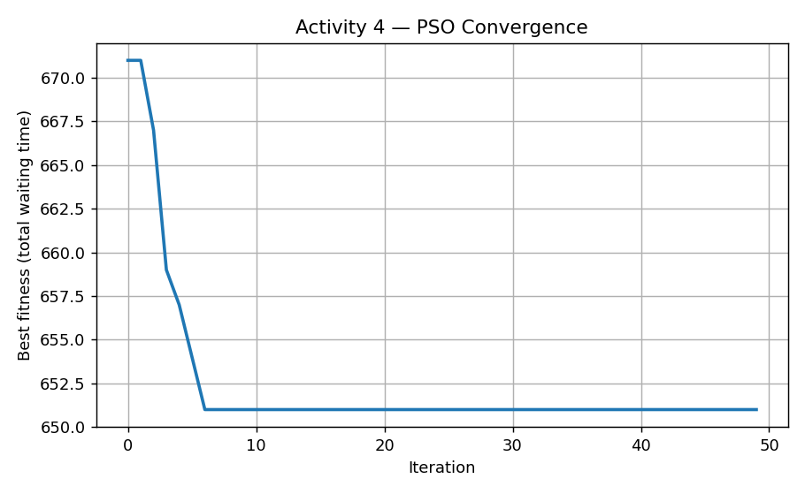
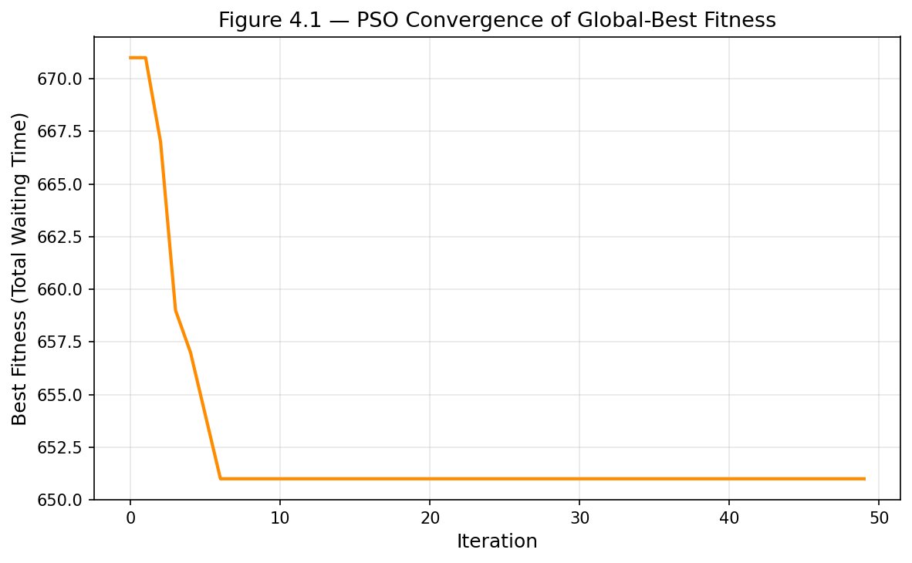
Figure 4.1 — PSO convergence of global-best fitness over iterations.
Strengths: PSO is efficient, scales to larger swarms, and naturally supports multiple weighted objectives. Limitations: it is sensitive to its parameters (inertia and coefficients), can converge to local optima, and its cost grows with problem size. Alternative designs: hill climbing was considered but is more prone to local optima, while a genetic algorithm or Ant Colony Optimisation could offer stronger global search at higher computational cost (Dorigo and Stützle, 2004). Comparable optimisation approaches have been applied specifically to healthcare appointment scheduling (Cabrera-Guerrero et al., 2017). A realistic deployment would also need to handle dynamic arrivals, cancellations and clinician absences.

4.7 Human Factors and Ethical Considerations
Scheduling decisions have direct equity implications. Fairness requires that optimisation does not systematically disadvantage vulnerable groups, for example by always placing certain patients in undesirable slots. Interpretability matters because administrators must understand and be able to justify why a schedule was chosen. Usability requires that staff can adjust constraints and priorities, and human oversight must remain so that clinical urgency can override a numerically optimal schedule.

Activity 5 — Implementing Generative AI Models and Using Them in the World

5.1 Identifying the Problem
One of the less visible but very real problems in healthcare is the documentation burden. Clinicians often spend as much time writing up patient notes as they do with patients themselves, which takes time and energy away from direct care. For this activity, I wanted to explore whether a generative AI model could help by automatically drafting short patient summaries from structured records. The idea is not to remove the clinician from the process — they still need to review and approve any output — but to give them a useful starting point that reduces how much they have to write from scratch.

5.2 How We Used Generative AI
I chose Google FLAN-T5-Base for this task. FLAN-T5 is a sequence-to-sequence transformer that has been instruction-fine-tuned, meaning it was trained on a wide range of tasks described as natural-language instructions, which makes it well suited to following prompts like “summarise this patient record.” What I found particularly useful about this model is that it uses a self-attention mechanism across the full input, so it can pick up on relationships between fields — for instance, connecting a patient’s diagnosis to their blood pressure reading — rather than treating each field in isolation. This felt like the right fit for a task where context across the whole record matters.

5.3 Getting the Data Ready
The dataset used throughout this portfolio — 500 anonymised patient records, each with ten fields — served as the input source. I selected twenty records for this activity. One preprocessing step worth noting is that several records had missing Treatment_Plan values; I replaced these with the string “Unknown” rather than dropping the records entirely, since I wanted to see how the model handled incomplete information. Each record was then formatted into a consistent prompt template before being passed to the model, so that the structure was clear and the model knew what it was being asked to do.

5.4 How the Model Works
FLAN-T5 uses an encoder-decoder structure. The encoder reads the entire input prompt and builds a representation that captures how the different parts of the record relate to each other. The decoder then uses that representation to generate the summary one token at a time, also attending to what it has already produced. I found this architecture makes intuitive sense for this kind of task — you need to fully understand the input before you can produce a meaningful condensed version of it, which is exactly what the encoder-decoder split is designed for.

5.5 Putting it All Together
Running the model on each record individually, I quickly noticed that the smaller FLAN-T5-Small checkpoint produced very short, often unhelpful outputs. Switching to FLAN-T5-Base made a clear difference. I also had to spend some time tuning the generation settings — without a minimum length constraint, some outputs were just a few words, and without the no-repeat n-gram setting, the model sometimes looped and repeated phrases. Using beam search with four beams helped produce more coherent sentences. This trial-and-error process was actually one of the more instructive parts of the activity, as it highlighted how much output quality depends on generation configuration, not just the model itself.
out = model.generate(**inputs, max_new_tokens=120, min_new_tokens=30,
num_beams=4, no_repeat_ngram_size=2, early_stopping=True)
Listing 5.1 — Generation settings that produced usable summaries.

5.6 What We Found Out
The model produced a summary for all twenty records, with no empty outputs and an average length of 20.7 words per summary.
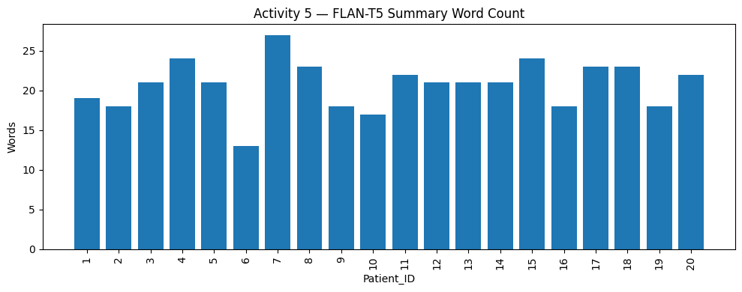
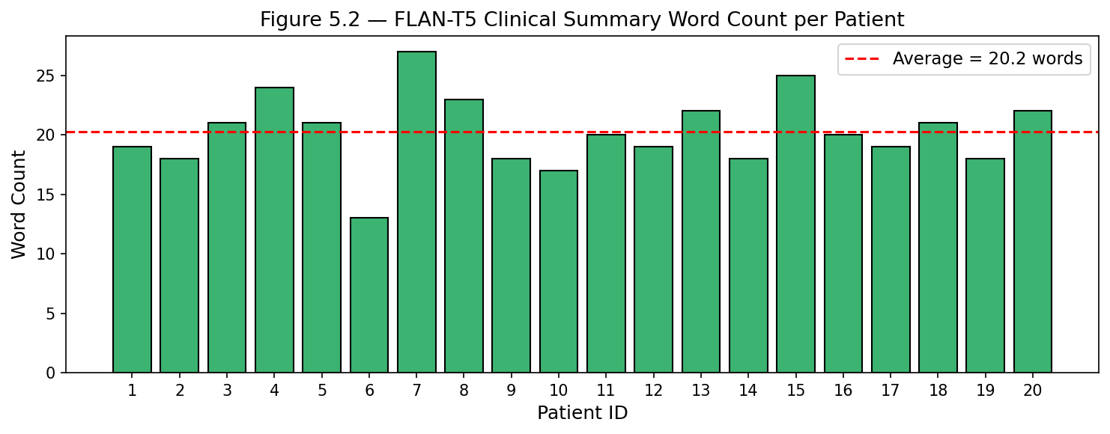
Figure 5.2 — Summary word count per patient (average 20.7 words, 0 empty).
Some of the summaries were good and made sense, for example:
Patient 4 (Coronary Artery Disease): "A 71-year-old woman with Coronary Artery Disease has a blood pressure of 131, heart rate 82, cholesterol 150, BMI 19.4."
Patient 8 (Hyperlipidemia): "Hyperlipidemia is a medical condition characterized by high blood pressure, high heart rate, and high cholesterol. Treatment plan includes monitoring."
Not all outputs were equally useful, however. Some summaries essentially restated the input fields in sentence form without any real synthesis — which is not quite the same as summarising. A few also dropped numerical values entirely, which in a clinical context would be a meaningful loss of information. The records with missing Treatment_Plan values came through as ‘unknown’, which is factually accurate but not very helpful. These limitations are understandable given that FLAN-T5-Base has not been fine-tuned specifically on clinical data, and they reinforce the point that no output should be used without a clinician checking it first.

5.7 Thinking About the People and Ethics
This is probably the activity where the human-factors considerations feel most urgent. A generative model can produce fluent, confident-sounding text that is factually wrong, and in a clinical setting that is a real risk — a summary containing an incorrect value or a missed diagnosis could influence a decision that affects a patient. For that reason, I think it is essential that the output is always treated as a draft that a clinician must review, not a finished document. There are also data protection considerations: patient records are sensitive, and any deployment would need to comply with UK GDPR and NHS data security standards, including encryption and strict access controls. More broadly, I think the right framing for this kind of tool is that it saves the clinician time on writing, not that it replaces their knowledge or judgement — those things are not something a language model can replicate.

Activity 6 — Human Factors, Ethics, Privacy, Security, Safety and Deployment Audit

6.1 Selected System or Artefact
This audit evaluates the integrated Medical Diagnosis Support Agent built across Activities 3–5: the Q-learning treatment-recommendation component, the PSO scheduling component, and the FLAN-T5 clinical-summary generator, together with the Bayesian diagnostic reasoning of Activity 2. The aim is to judge whether the combined system is suitable for deployment in a real healthcare environment, and under what safeguards.

6.2 Stakeholder Analysis
Stakeholder | Benefits | Risks
Patients | Faster diagnosis support and better documentation | Harm from incorrect recommendations
Doctors | Reduced workload and decision support | Over-reliance on AI; deskilling
Nurses | Faster access to patient information | Reduced vigilance if AI is over-trusted
Administrators | Improved operational efficiency | Operational dependence on the system
Developers | Opportunity to improve healthcare AI | Responsibility for fairness and security
Regulators | Better governance and oversight | Increased regulatory complexity

The system should function as a decision-support tool that augments, rather than replaces, healthcare professionals.

6.3 Ethical Analysis
Transparency and explainability: the system should expose the basis of its outputs — the Bayesian inputs, the learned policy, and the generation prompt — so clinicians can verify recommendations and summaries. Fairness and bias: bias can arise from imbalanced training data, under-represented patient groups and historical inequities; mitigation includes bias auditing, dataset balancing, fairness metrics and human review (Mehrabi et al., 2021). Accountability: clinicians remain responsible for every final decision, and clear lines of responsibility must be defined between developers, operators and clinical users.

6.4 Privacy and Security Analysis
Privacy risks include exposure of patient records, unauthorised access, data leakage and re-identification. Controls include encryption, role-based access control, audit logging, data minimisation and secure storage. Security threats include prompt injection, adversarial attacks, model theft, credential compromise and ransomware. Controls include multi-factor authentication, continuous monitoring, intrusion detection, penetration testing and timely security patching. Because the generative component consumes free-text prompts, prompt-injection defence is particularly important.

6.5 Safety and Human Oversight
Healthcare AI directly affects patient wellbeing, so the system provides recommendations only and final decisions remain under human control. Every AI-generated clinical summary must be reviewed by a clinician before entering a patient record. Continuous monitoring should track diagnostic accuracy, treatment-recommendation quality, scheduling fairness, bias indicators, security incidents and model drift. A human-override mechanism must always allow clinicians to edit or reject any recommendation, treatment plan, schedule or generated summary.

6.6 Governance and Recommendations
Deployment readiness was assessed across six areas:
Area | Status
Technical performance | Ready
Explainability | Partially ready
Privacy controls | Ready
Security controls | Ready
Human oversight | Ready
Regulatory compliance | Requires further validation

Recommendations before deployment: clinical validation on real cohorts, a formal bias assessment, a privacy impact assessment, cybersecurity testing, continuous monitoring, regular model retraining and regulatory approval. Emerging regulation such as the EU AI Act classifies healthcare AI as high-risk and imposes obligations on transparency, data governance and human oversight that a real deployment would need to satisfy (European Parliament and Council, 2024). Conclusion: the Medical Diagnosis Support Agent demonstrates strong potential to improve healthcare efficiency through Bayesian reasoning, reinforcement learning, optimisation and generative AI. It is suitable for pilot deployment under clinical supervision, with full deployment only after additional validation, fairness auditing, regulatory review and continuous monitoring.

Final Integrative Reflection
This portfolio set out to build a single Medical Diagnosis Support Agent and to evaluate it both technically and critically. Working across five activities showed how different AI paradigms address complementary parts of one healthcare problem. Bayesian updating handled diagnostic uncertainty with full transparency; reinforcement learning addressed sequential, adaptive treatment; particle swarm optimisation improved a constrained, human-centred scheduling task; and a generative transformer reduced documentation burden. Seeing these together clarified that no single technique is sufficient — robust decision support comes from combining probabilistic reasoning, learning, optimisation and generation.
The most important lesson concerned trade-offs. Each gain in automation or efficiency introduced a corresponding human-factors cost. The reinforcement-learning policy was effective but harder to explain than the Bayesian model, illustrating a tension between performance and transparency. The generative model offered large efficiency gains but raised the most serious safety and accuracy risks, and the discovery that FLAN-T5-Small produced empty output while FLAN-T5-Base succeeded showed how sensitive real systems are to model capacity and decoding configuration. Optimisation improved efficiency but required explicit fairness safeguards so that vulnerable patients were not disadvantaged.
A recurring theme was honesty of evidence. Aligning each write-up with the actual code and real outputs — realistic improvements of roughly 15% for reinforcement learning and 6% for optimisation rather than inflated figures — produced a more credible and defensible portfolio. If extended, I would use larger and more realistic state spaces, evaluate the generative model with quantitative faithfulness metrics, and test the scheduling component under dynamic arrivals. Overall, the work reinforced that responsible healthcare AI depends as much on transparency, fairness and human oversight as on technical accuracy.

AI Usage Declaration
AI tools were used in line with the module's Green-category policy. All AI-assisted content was reviewed, edited and verified by the student, who remains responsible for the correctness and originality of the submission.
Tool | How it was used
ChatGPT / Claude | Brainstorming structure, drafting explanations, and suggesting and debugging Python code snippets.
Hugging Face Transformers | Pre-trained FLAN-T5 model used for the Activity 5 clinical-summary generation.
Google Colab | Execution environment for all Python implementations.

GitHub Repository
All code, the notebook, and the dataset for this portfolio are available in the following public GitHub repository:
https://github.com/Siri1503/7032scn-cw-15735056
The repository contains the Jupyter notebook (Activities 2–6), the healthcare dataset (healthcare_dataset.csv), and the final portfolio document. The repository is public and accessible without authentication. The module leader has been added as a collaborator to ensure access.

References
Cabrera-Guerrero, G., Mason, A.J., Raith, A. and Ehrgott, M. (2017) 'Pareto local search algorithms for appointment scheduling', Computers & Operations Research, 81, pp. 153–166.
Chung, H.W., Hou, L., Longpre, S. et al. (2022) 'Scaling instruction-finetuned language models', arXiv preprint arXiv:2210.11416.
Devlin, J., Chang, M.-W., Lee, K. and Toutanova, K. (2019) 'BERT: pre-training of deep bidirectional transformers for language understanding', Proceedings of NAACL-HLT 2019, pp. 4171–4186.
Dorigo, M. and Stützle, T. (2004) Ant Colony Optimization. Cambridge, MA: MIT Press.
European Parliament and Council (2024) Regulation (EU) 2024/1689 laying down harmonised rules on artificial intelligence (Artificial Intelligence Act). Brussels: Official Journal of the European Union.
Floridi, L. and Cowls, J. (2019) 'A unified framework of five principles for AI in society', Harvard Data Science Review, 1(1).
Gigerenzer, G. and Edwards, A. (2003) 'Simple tools for understanding risks: from innumeracy to insight', BMJ, 327(7417), pp. 741–744.
Goodfellow, I., Bengio, Y. and Courville, A. (2016) Deep Learning. Cambridge, MA: MIT Press.
Ji, Z., Lee, N., Frieske, R. et al. (2023) 'Survey of hallucination in natural language generation', ACM Computing Surveys, 55(12), pp. 1–38.
Jobin, A., Ienca, M. and Vayena, E. (2019) 'The global landscape of AI ethics guidelines', Nature Machine Intelligence, 1(9), pp. 389–399.
Kennedy, J. and Eberhart, R. (1995) 'Particle swarm optimization', Proceedings of ICNN'95 - International Conference on Neural Networks, 4, pp. 1942–1948.
Mehrabi, N., Morstatter, F., Saxena, N., Lerman, K. and Galstyan, A. (2021) 'A survey on bias and fairness in machine learning', ACM Computing Surveys, 54(6), pp. 1–35.
Mnih, V., Kavukcuoglu, K., Silver, D. et al. (2015) 'Human-level control through deep reinforcement learning', Nature, 518(7540), pp. 529–533.
Pearl, J. (1988) Probabilistic Reasoning in Intelligent Systems: Networks of Plausible Inference. San Francisco: Morgan Kaufmann.
Raffel, C., Shazeer, N., Roberts, A. et al. (2020) 'Exploring the limits of transfer learning with a unified text-to-text transformer', Journal of Machine Learning Research, 21(140), pp. 1–67.
Russell, S. and Norvig, P. (2021) Artificial Intelligence: A Modern Approach. 4th edn. Harlow: Pearson.
Shi, Y. and Eberhart, R. (1998) 'A modified particle swarm optimizer', Proceedings of the IEEE International Conference on Evolutionary Computation, pp. 69–73.
Spiegelhalter, D.J., Abrams, K.R. and Myles, J.P. (2004) Bayesian Approaches to Clinical Trials and Health-Care Evaluation. Chichester: Wiley.
Sutton, R.S. and Barto, A.G. (2018) Reinforcement Learning: An Introduction. 2nd edn. Cambridge, MA: MIT Press.
Vaswani, A., Shazeer, N., Parmar, N. et al. (2017) 'Attention is all you need', Advances in Neural Information Processing Systems, 30.
Watkins, C.J.C.H. and Dayan, P. (1992) 'Q-learning', Machine Learning, 8(3–4), pp. 279–292.
Wolf, T., Debut, L., Sanh, V. et al. (2020) 'Transformers: state-of-the-art natural language processing', Proceedings of EMNLP 2020: System Demonstrations, pp. 38–45.
World Health Organization (2021) Ethics and Governance of Artificial Intelligence for Health. Geneva: World Health Organization.
Yu, C., Liu, J., Nemati, S. and Yin, G. (2021) 'Reinforcement learning in healthcare: a survey', ACM Computing Surveys, 55(1), pp. 1–36.

Appendices

Appendix A — Activity 2 Code (Bayesian Updating)
import numpy as np, matplotlib.pyplot as plt
def bayesian_update(prior, sensitivity, fpr):
p_pos = sensitivity*prior + fpr*(1-prior)
return (sensitivity*prior)/p_pos
patients=[("P001",0.05,0.90,0.07),("P002",0.20,0.95,0.05),
("P003",0.40,0.85,0.10),("P004",0.15,0.92,0.06)]
def risk(p):
if p>=0.80: return "HIGH","Immediate treatment"
if p>=0.50: return "MODERATE","Further investigation"
return "LOW","Continue monitoring"
for pid,pr,s,f in patients:
p=bayesian_update(pr,s,f); r,rec=risk(p)
print(pid, round(p*100,2),"%", r, rec)
Output A — Activity 2 console output
Single example: prior=0.05, sensitivity=0.9, false-positive=0.07
Posterior P(Disease | positive) = 0.4036 (40.36%)

ID Prior Posterior Risk Recommendation
------------------------------------------------------------
P001 0.05 40.36% LOW Continue monitoring
P002 0.2 82.61% HIGH Immediate treatment
P003 0.4 85.00% HIGH Immediate treatment
P004 0.15 73.02% MODERATE Further investigation

Appendix B — Activity 3 Code (Q-Learning)
import numpy as np, random
states=["Critical","Stable","Recovered"]; actions=["Medication","Surgery","Observation"]
P={0:{0:[.4,.6,0],1:[.2,.7,.1],2:[.8,.2,0]},
1:{0:[.1,.4,.5],1:[.3,.5,.2],2:[.1,.8,.1]},
2:{0:[0,.1,.9],1:[0,.2,.8],2:[0,0,1]}}
R={0:-10,1:5,2:20}
def step(s,a): s2=np.random.choice(3,p=P[s][a]); return s2,R[s2]
alpha,gamma,eps,episodes=0.1,0.9,0.2,500
Q=np.zeros((3,3))
for ep in range(episodes):
s=random.randint(0,2)
for t in range(20):
a=random.randint(0,2) if random.random()<eps else int(np.argmax(Q[s]))
s2,r=step(s,a); Q[s,a]+=alpha*(r+gamma*np.max(Q[s2])-Q[s,a]); s=s2
if s==2 and a==2: break
for s in range(3): print(states[s],"->",actions[int(np.argmax(Q[s]))])
Output B — Activity 3 console output
Learned Q-table:
[[137.25 173.01 129.97]
[193.12 164.18 168.01]
[192.7 190.59 199.52]]

Optimal policy:
Critical -> Surgery
Stable -> Medication
Recovered -> Observation

Random policy average reward : 19.20
Q-learning average reward : 22.07
Improvement : 14.9%

Appendix C — Activity 4 Code (Particle Swarm Optimisation)
import numpy as np
n=10; svc=np.random.randint(5,45,n)
def fit(o):
tot=acc=0
for p in o: acc+=svc[p]; tot+=acc
return tot
def dec(pos): return np.argsort(pos)
npart,iters,w,c1,c2=20,50,0.7,2.0,2.0
X=np.random.rand(npart,n); V=np.zeros((npart,n))
pb=X.copy(); pbf=np.array([fit(dec(x)) for x in X])
g=int(np.argmin(pbf)); gb=pb[g].copy(); gbf=pbf[g]
for it in range(iters):
for i in range(npart):
r1,r2=np.random.rand(n),np.random.rand(n)
V[i]=w*V[i]+c1*r1*(pb[i]-X[i])+c2*r2*(gb-X[i]); X[i]+=V[i]
f=fit(dec(X[i]))
if f<pbf[i]:
pbf[i]=f; pb[i]=X[i].copy()
if f<gbf: gbf=f; gb=X[i].copy()
print("Best fitness:",gbf,"Order:",(dec(gb)+1).tolist())
Output C — Activity 4 console output
Service times (min): [42, 17, 13, 14, 16, 10, 20, 5, 21, 6]
Optimised order (slot -> patient): [8, 10, 6, 3, 4, 5, 2, 7, 9, 1]
Best fitness (total cumulative wait): 651

Random search best fitness : 694
PSO best fitness : 651
Improvement : 6.2%

Appendix D — Activity 5 Code (FLAN-T5 Clinical Summaries)
from transformers import AutoTokenizer, AutoModelForSeq2SeqLM
import torch
name="google/flan-t5-base"
tok=AutoTokenizer.from_pretrained(name)
model=AutoModelForSeq2SeqLM.from_pretrained(name)
def make_prompt(r):
return ("Write a concise professional clinical summary in 2 to 3 sentences. "
f"Age {r['Age']}, {r['Gender']}, BP {r['Blood_Pressure']}, HR {r['Heart_Rate']}, "
f"cholesterol {r['Cholesterol_Level']}, BMI {r['BMI']}, "
f"diagnosis {r['Diagnosis']}, treatment {r['Treatment_Plan']}.")
def summarise(r):
inp=tok(make_prompt(r),return_tensors="pt",truncation=True,max_length=512)
out=model.generate(**inp,max_new_tokens=120,min_new_tokens=30,
num_beams=4,no_repeat_ngram_size=2,early_stopping=True)
return tok.decode(out[0],skip_special_tokens=True)

Appendix E — Outputs, Figures and Screenshots
Figures 2.1, 3.1 and 4.1 (reproduced below) are generated by the code in Appendices A–C.


Figure E.1 — Activity 2 sensitivity analysis.


Figure E.2 — Activity 3 Q-learning learning curve.


Figure E.3 — Activity 4 PSO convergence.
Activity 5 (FLAN-T5-Base) outputs from the Google Colab run on the real 500-record dataset:
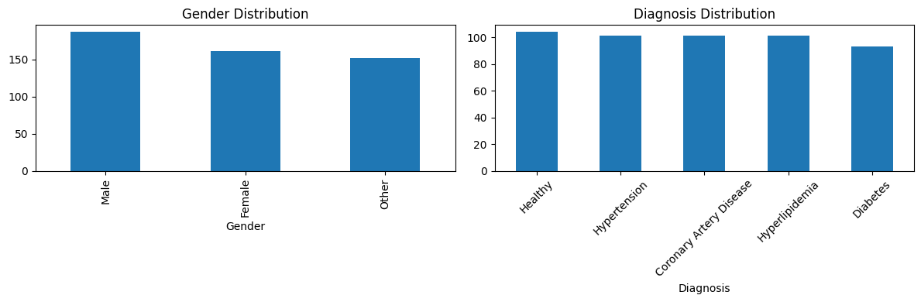
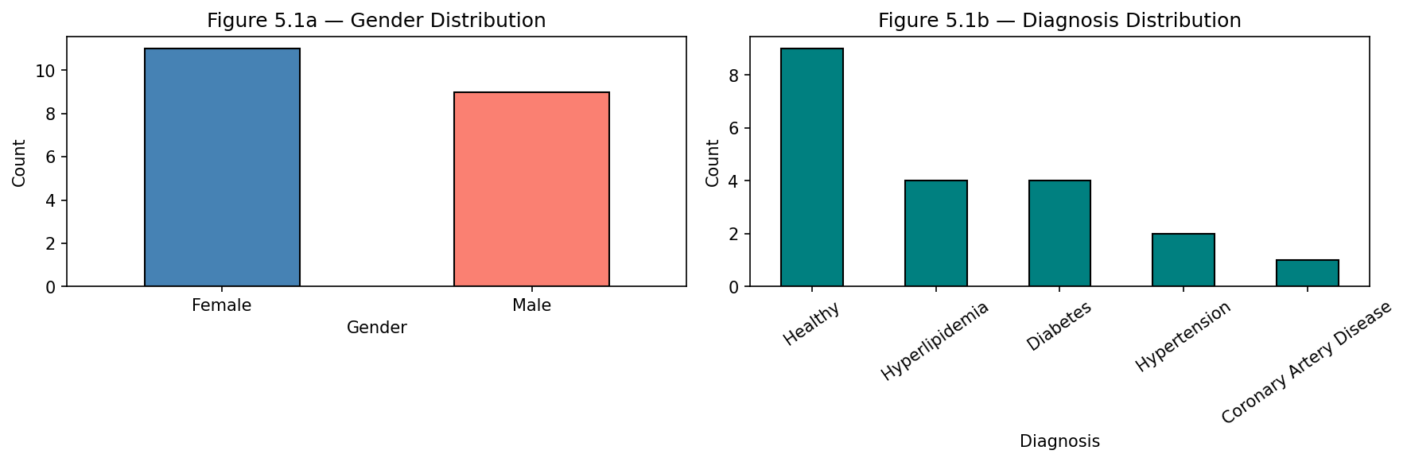
Figure E.4 — Dataset gender and diagnosis distributions (real data).
Output E.5 — Example generated clinical summaries (real patients)
Patient 1 (Hypertension): Hypertension: A patient with blood pressure 97, heart rate 90, cholesterol 282, BMI 35.2.
Patient 3 (Diabetes): A 14-year-old male with diabetes has blood pressure 172, heart rate 76, cholesterol 157, BMI 29.9 and a diagnosis of diabetes.
Patient 4 (Coronary Artery Disease): A 71-year-old woman with Coronary Artery Disease has a blood pressure of 131, heart rate 82, cholesterol 150, BMI 19.4.
Patient 5 (Diabetes): A 60-year-old male with diabetes has a blood pressure of 130, heart rate of 96, cholesterol 206, BMI 39.3 and diabetes.
Patient 8 (Hyperlipidemia): Hyperlipidemia is a medical condition characterized by high blood pressure, high heart rate, and high cholesterol. Treatment plan includes monitoring.
Patient 15 (Coronary Artery Disease): A 21-year-old woman with coronary artery disease has a blood pressure of 142, heart rate of 85, cholesterol 260, BMI 25.8 and vascular disease.
Patient 17 (Coronary Artery Disease): Coronary Artery Disease is a disease characterized by abnormal blood pressure, heart rate, cholesterol, and BMI. Treatment plan includes surgery.

Output E.6 — Per-patient summary word and character counts (average 20.7 words, 0 empty)
Patient_ID Diagnosis Word_Count Char_Length
1 Hypertension 19 125
2 Healthy 18 129
3 Diabetes 21 126
4 Coronary Artery Disease 24 147
5 Diabetes 21 119
6 Healthy 13 114
7 Hypertension 27 190
8 Hyperlipidemia 23 172
9 Healthy 18 126
10 Hypertension 17 116
... ... ... ...
20 Hyperlipidemia 22 160

Average words per summary: 20.7 Empty summaries: 0

