NAME-B.Siri Sahithi

REG NO-192121102

EXPERIMENT-1-ONLINE SHOPPING

CLASS DIAGRAM:

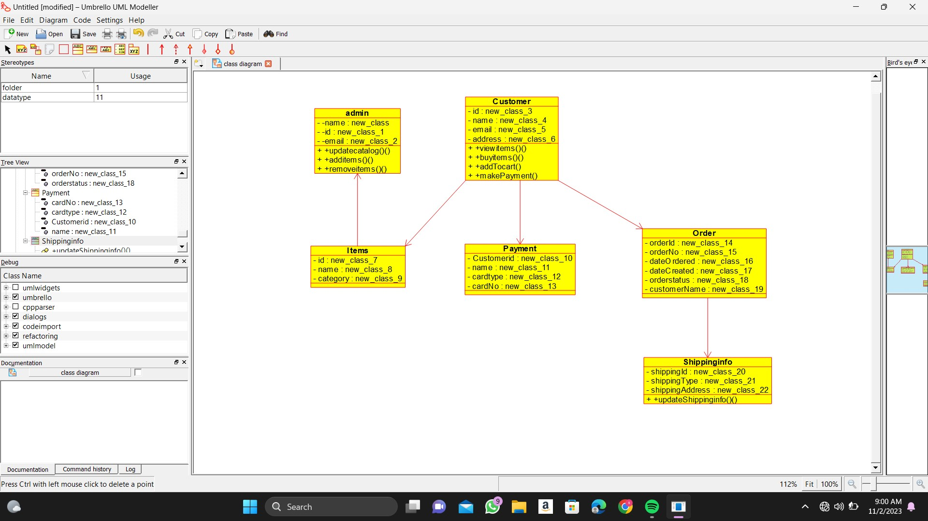

USECASE DIAGRAM:

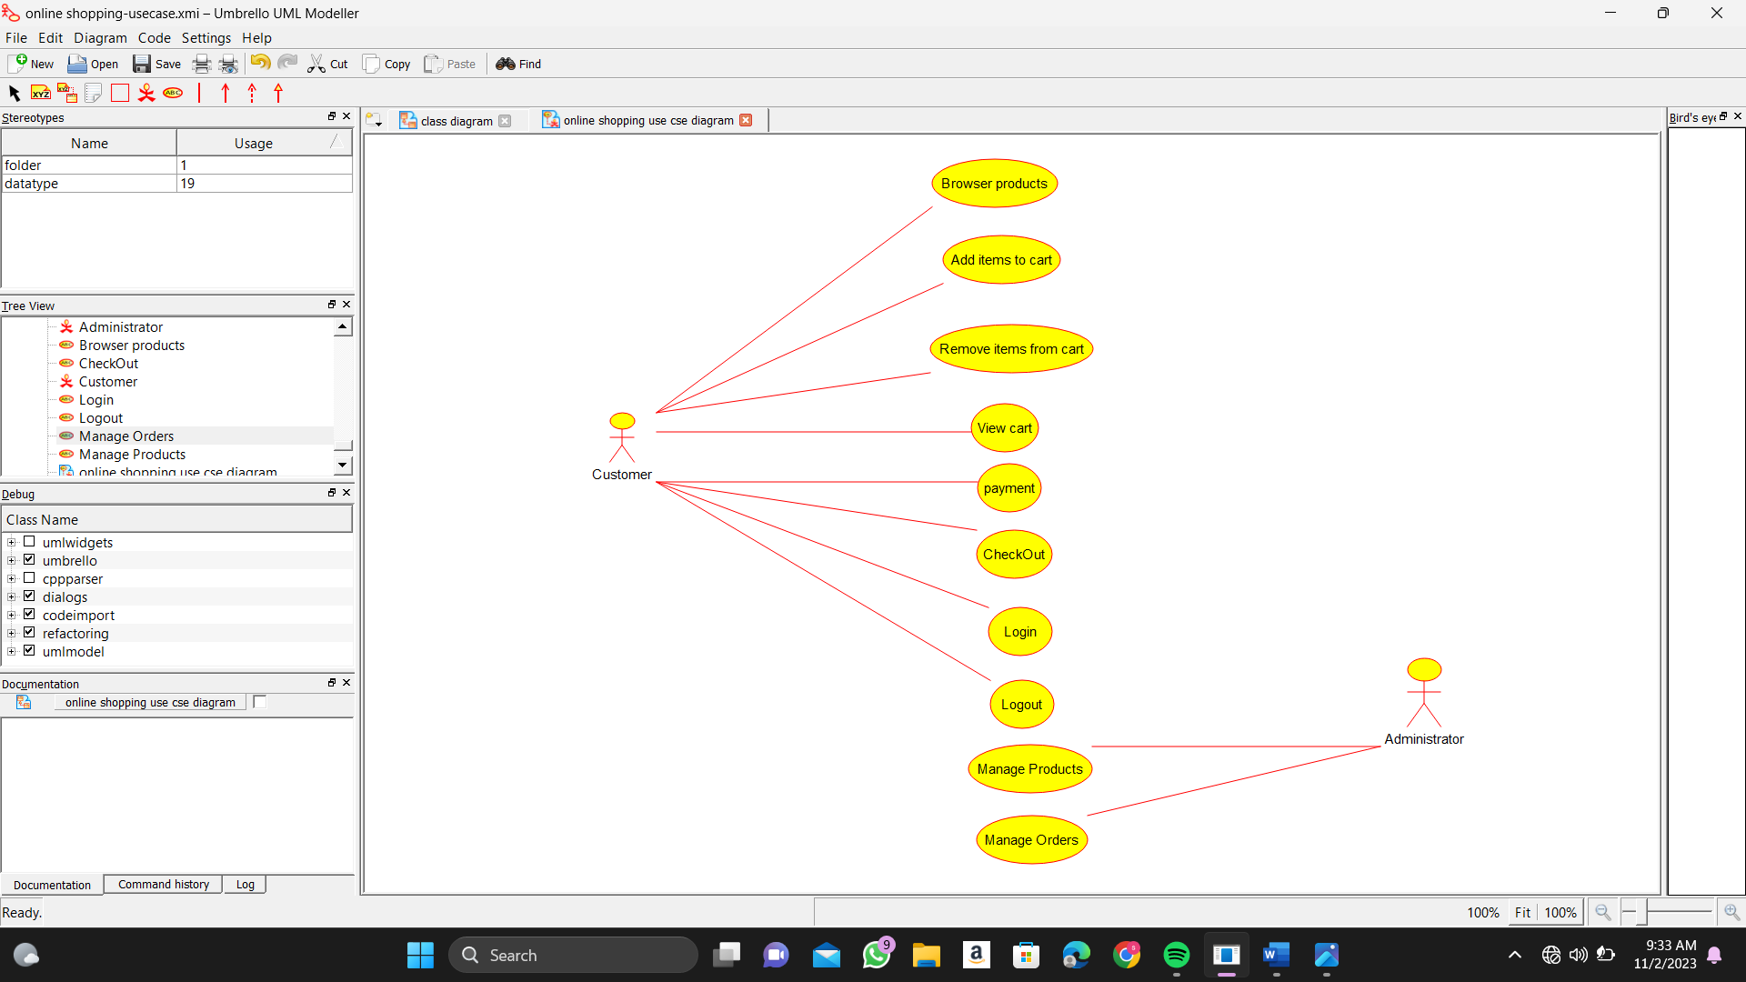

SEQUENCE DIAGRAM:

